BUNNELL BONNELL BUNNELL BONNELL BUNNELL BONNELL BUNNELL BONNELL BUNNELL B
UNNELL | THE BUNNELL/BONNELL NEWSLETTER |  |  |  | ONNE  L  L
B |  |  |  |  | B
O | Volume X, No. 3. |  |  | 1 July 1996 | U
N  N  E  L  L |  | Published by  William R. Austin  P. O. Box 62  Laceyville, PA 18623  (717) 869-2325 |  |  | N  NE  L  L
BUNNELL BONNELL BUNNELL BONNELL BUNNELL BONNELL BUNNELL BONNELL BUNNELL B

I was hopeful that someone, perhaps more closely connected to the Bunnell/Bonnell family than I, would offer to take over the Newsletter next year. So far, no luck.

* * *

Clement M. Bonnell III, 7 Deer Path, Milford, NJ 08848, is compiling a genealogy of all the descendants of Lt. Col. Abraham Bonnell CB300042 and his wife Elizabeth Foster in all lines, both male and female.

Charles E. Bunnell, 1745 Copperfield, San Antonio, TX 78251, is compiling a history of the Bunnell families who have lived in Tioga co, NY. The principal focus is on the descendants of John CB310253 and Hannah (Jayne) Bunnell, but other Bunnells and Bonnells who lived in Tioga co, NY, at some time will be included. Again, both male and female lines will be traced.

Clem and Charlie would be glad to correspond with anyone interested in these branches of the family.

* * *

Claude Bunnell spent a couple weeks in Morristown, NJ, photocopying Bonnell references in the county deed and mortgage books. After entering the information in his Database, he loaned the copies to me. For this issue, I am extracting pertinent information from the Deed Books, to the extent that I have space. With no census data available for New Jersey prior to 1830, these court records assume unusual importance. Even though most of the deeds refer to Bonnells whose identity we know, they all shed additional light on the lives and careers of your Bonnell ancestors. Please let me know if any of these references are helpful in your research.

* * * * * *

In Vol. X, No. l, I published a note about J. H. Bunnell & Co. and its founder,a telegraph operator during the Civil War. Claude Bunnell identified him as Jesse H. Bunnell CB330720, born in 1843 in Massillon, J- and Mary Bunnell.

On 5 April I received a telephone call from Dr. Joseph Jacobs of Fort Salonga, NY, who offered to provide additional information about Jesse H. Bunnell and his company. Dr. Jacobs was at one time an employee of J. H. Bunnell & Co. and now acts as a consultant. He followed up his offer by sending me a package of materials about the man and the company, extracts from which I will share with you now.

First is the obituary of Jesse H. Bunnell which appeared in ELECTRICAL WORLD on 18 February 1899:
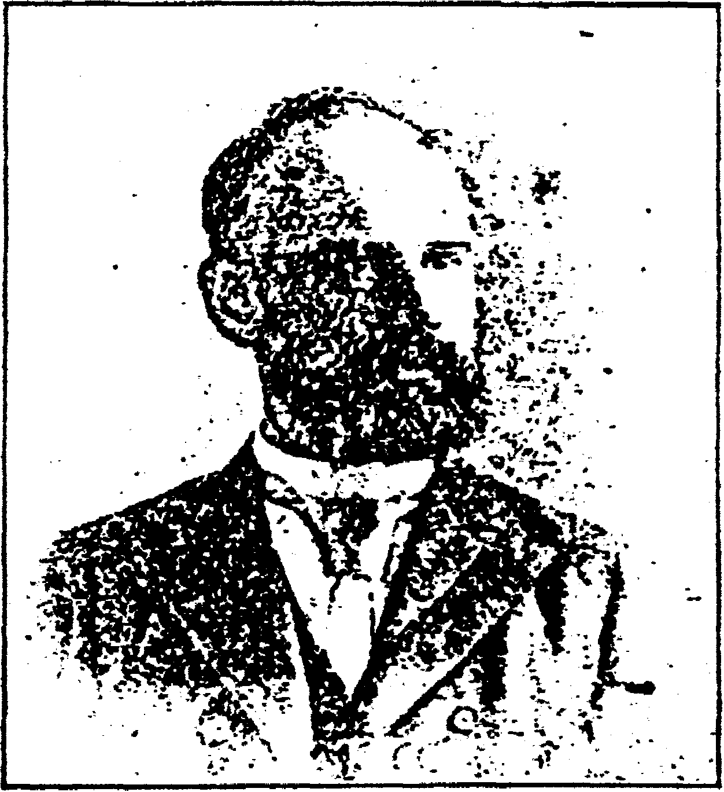
The Late Jesse H. Bunnell
MR. JESSE H. BUNNELL, head of the firm of J. H. Bunnell & Co., electrical supply dealers, New York City, died at the Hotel St. George, in Brooklyn, on the evening of February 8, from weakness following an attack of the grip. Mr. Bunnell was born in Ohio in 1843, and became a telegraph operator in early life. He was engaged in the military telegraph service during the Civil War, and was an active participant in some of the most stirring events of those memorable times. He was attached to the Army of the Potomac and the Army of the Cumberland, serving at the headquarters of Generals McClellan, Burn-side, Rosecrans, Thomas and Sherman as their personal telegrapher. At the battle of Antietam he established an office on the field, and sent and received messages under fire. After the war he returned to New York, and in 1872 he became a partner in the firm of Partrick, Bunnell & Co., of Philadelphia, manufacturers of telegraph and
electrical supplies. From 1875 to 1878 he was connected with the firm of L. G. Tillotson & Co., of New York. In the latter year he started the business bearing his name, with which he was continuously identified until the time of his death. The remains of the deceased were buried in Greenwood Cemetery. The pall bearers represented the commercial and railroad telegraphers. United States Military Telegraph Corps, the electrical press and the electrical trades. They were: Mr. A. B. Chandler, president of the Postal Telegraph Company; Mr. F. W. Jones, electrical engineer of the same company; Mr. Charles A. Tinker and James Merrihew, both general superintendents of the Western Union Telegraph Company; Colonel James Gilmore and W. J. Dealy, of the U. S. Military Telegraph Corps; Mr. Robert Stewart, superintendent of telegraphs of the Central Railroad of New Jersey; C. W. Price, editor of the "Electrical Review," and Mr. Charles McLaughlin, surviving member of the firm of J. H. Bunnell & Co. The greater part of these were also members of the Old Time Telegraphers' Association. Mr. Bunnell leaves a wife, two sons and two daughters.
Jesse H. Bunnell (Cont'd)

For the 1994 AWA conference in Rochester, NY, Dr. Jacobs prepared and presented a talk entitled J, H, BUNNELL & CO. • PAST, PRESENT, FUTURE. He generously sent me a copy of the talk, from which I have extracted the following information regarding the life of Jesse Bunnell:

Jesse was born in Massillon, OH, in 1843. By age 11 he was delivering telegraph messages, and at 13 he was a full-fledged operator serving at offices in Ohio, Pennsylvania and West Virginia from 1859 to 1861. At age 17 he set a record of 32 words per minute, as an average, when for a steady two hours he forwarded President Buchanan's last message to Congress.

After the attack on Fort Sumter in April 1861, Jesse, not yet 18 joined the Union Military Telegraph Service (UMTS) which had been recently organized by Andrew Carnegie, who was himself an operator at age 15. At the war's start operators (ops) were the army's cinderellas. They were (and remained) civilians. They were given very little support and $60 a month, less that that of a quartermaster clerk. They were often under fire, as their main duty was to relay troop movement observations and orders, in part replacing military couriers.

In December 1862 Jesse was one of 50 ops who signed a petition to USMT HQ for an increase in pay and support. As their importance was recognized they got merit raises, more regular transport and supplies.

Moving with the army, the op would cut his wire, keeping a few yards with his instrument to reattach to the line at the next stop. During battle lulls ops were kept busy receiving and relaying casualty information for the army and concerned relatives. Working long hours ops would often fall asleep at their instruments, yet always awaken when the sounder clicked their call signs.

Being young, ops were not averse to using their skills and wires for practical jokes. Early in the war, Jesse, "a great wit and very young" was fired when he pulled a hoax on Wheeling, WV, newspapers about a great Union naval loss of the "Rip Raps". Because of his great skills Jesse was soon rehired elsewhere at higher wages.

At first Jesse was assigned to the threatened Washington, DC, area in May 1861, as telegraph service was needed to connect the surrounding encampments and forts with the War Department and the president. At the end of June 1861 he was sent to Annapolis as part of a relay with the Capitol, but during that time operators were "moved from place to place as the occasion required." Jesse Bunnell's tenure on the relay might have allowed him to serve Lincoln, as his Company maintains. Lincoln did use the War Department's telegraph office as a refuge of relative peace and quiet. At a desk unofficially reserved for him, Lincoln wrote part of his Emancipation Proclamation and his Second Inaugural Address.

From about June 1862 to August 1864 Bunnell served with the Army of the Potomac as Gen. McClellan's personal telegrapher (sign MC) and with Sherman's Army of the Cumberland through the bloody battles in
Jesse H. Bunnell (Cont'd)

Tennessee and on to Atlanta. Exposure and starvation in the winter of 1864 weakened Jesse severely, forcing him to resign on 16 August 1864, when the UMTS lost one of its "ablest and bravest ops". Jesse's return to non-army work from 1864 to 1872 led him to Philadelphia and a partnership with James Partrick, a successor to Chester, Partrick & Co. Later he worked for L.G. Tillotson & Co. from 1875 to 1878.

In 1878 Jesse created J. H. Bunnell & Co. In 1879 he took Charles McLaughlin as a partner in charge of sales and administration while Jesse concentrated on manufacturing and innovation. Bunnell received a patent on 15 February 1881 for his steel lever key. Stamped from one piece of steel with minor machining, this was Bunnell's answer to the loosening of the steel trunnion inserted in the brass lever. It was so successful that the steel lever continues to this day in code keys.

In 1888 Bunnell introduced his doublespeed (sideswiper) key to help telegraphers avoid a "glass arm" (now known as carpal tunnel syndrome). Bunnell was also heavily into other electricals. Dr. Jacobs sent me a copy of an article from THE ELECTRICAL ENGINEER of 31 March 1898 describing Jesse Bunnell's patent for the Bunnell "Wave Motor", a device for converting the motion of oceanic waves to electrical energy.

In 1899 Jesse caught a severe cold which worsened. He died of heart failure on 9 February 1899 at the age of 56. He was buried in Brooklyn's Greenwood Cemetery. His partner Charles McLaughlin took over the company. In the 1920’s J. J. Ghegan became president and introduced many electrical innovations. Ghegan was succeeded by J. G. Dougherty, followed by his wife who sold the business in the early 1960’s to Inso Electronic Products, C. J. Meislich, president. In 1989 J. H. Bunnell & Co. was acquired as a division of MNJ Industrials, M. B. Jacobs, president.

The company, started in Manhattan, moved to several locations in that borough. In the 1930's it moved its operations to a number of locations in Brooklyn, then to Long Island where it is now at Kings Park.

In the 1890’s J. H. Bunnell introduced its fully functional miniature versions of its key, sounder and KOB (key on base), selling them as is or as tie pins or with bales for use as watch fobs. They were sold to ardent telegraphers and presented as special awards. Andrew Carnegie, Jesse's Civil War boss, received one at a 1908 Telegraphic dinner. RCA’s David Sarnoff and other radio luminaries were also recipients, as was President Elsenhower in 1954. As a collectible today they are extremely rare and desireable. In 1994 J. H. Bunnell & Co. issued a special limited Centennial Edition of their miniatures for collectors,

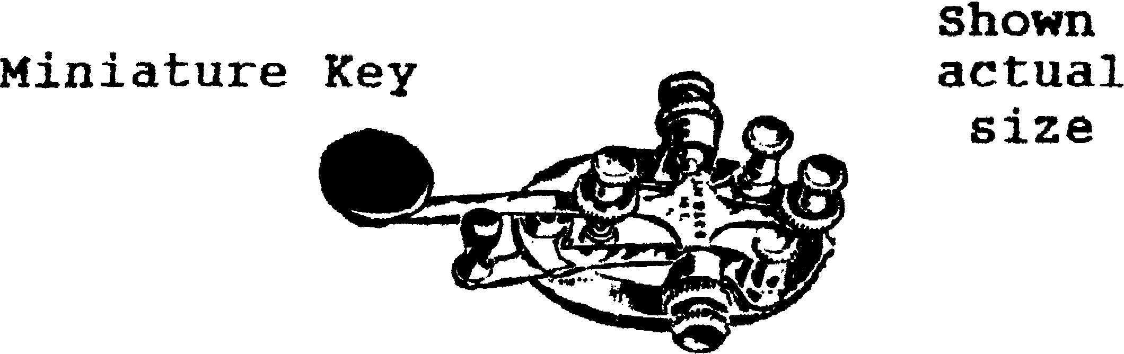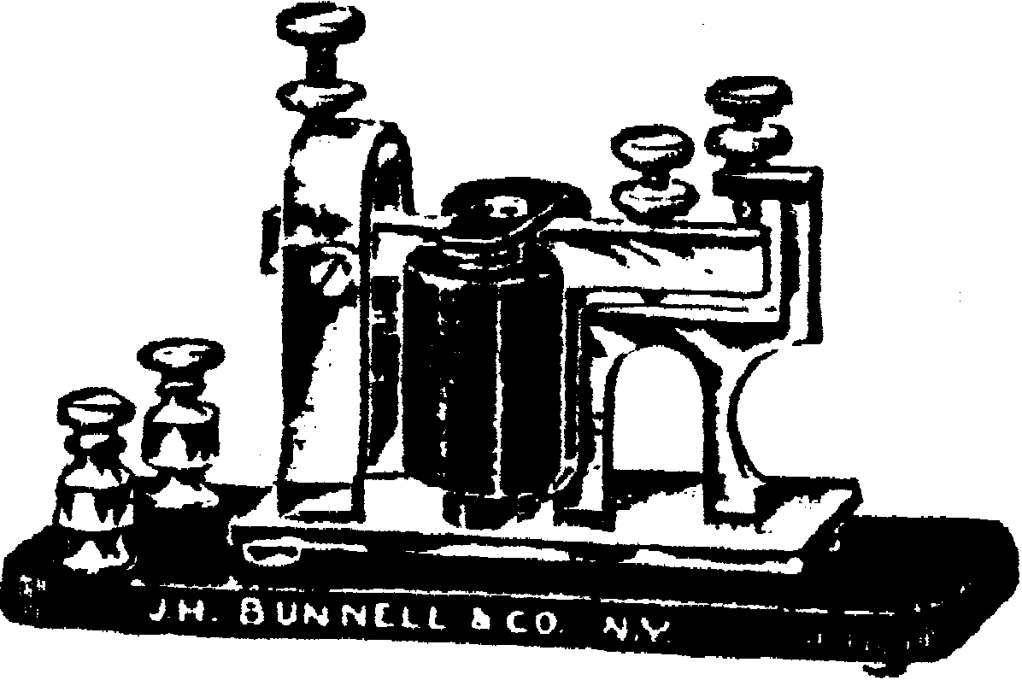Miniature Sounder
OBITUARIES

Paul Bunnell, Marstons Mills, MA, reports the death of his father. He experienced the loss of both of his parents within a period of ten months. His mother's obituary appeared in Vol. X, No. 1. Paul has the sympathy of all his friends. This obituary appeared in the Cape Cod Times, Saturday, 1 June 1996:

MARSTONS MILLS - James H. Bunnell, 75, a retired sheet metal mechanic and World War II Army veteran, died Wednesday at Cape Cod Hospital, Hyannis.
He was the husband of the late Lorraine M. (Violette) Bunnell.
Mr. Bunnell was born in Amesbury and graduated from Amesbury High School.
During World War II, he served with the 398th Army Corps of Engineers in the Pacific and Asian theaters and participated in the invasion in Normandy, where his name is inscribed on the "Wall of Liberty." He received three ribbons,
Mr. Bunnell worked in Amesbury for several years before moving to Pocoima, Calif., in 1953.
He worked as a sheet metal mechanic for the Stainless Steel Co. in Burbank, Calif., before retiring in 1971.
Mr. Bunnell then managed the Lake Shasta Camp Ground in Mt, Shasta, Calif., before becoming proprietor of the Bunnell Book Shop in Susanville, Calif., in 1974.
Mr. Bunnell moved to Beaverton, Ore., in 1977 and worked there as a product inspector for Techtronics before retiring in 1992.
He moved to Florence, Ore., in 1985, to Ryderwood, Wash., in 1992, and to Marstons Mills last year.
Mr. Bunnell loved the outdoors, camping, animals, fishing and woodworking.
Surviving are three sons, James Henry Bunnell Jr. of Valencia, Calif., Paul Joseph Bunnell of Marstons Mills and Michael Norman Bunnell of Palmdale, Calif.; two brothers, George W. Bunnell Jr. of Las Vegas and Louis Bunnell of Salem; three sisters, Marie DiDomenico of Malden, Mabel Walsh of Livonia, Mich., and Elizabeth Perkins of Newburyport; six grandchildren; and eight great-grandchildren.
Burial was yesterday in the Massachusetts National Cemetery, Bourne.
[The lineage of James Henry Bunnell CB001147 was given in Vol. X, No. 1, page 3.]

* * *

Lyda Bunnell Cloud, Owasso, OK, sent in this death notice from the Tulsa, OK, world, Thursday 16 May 1996:

OWASSO- Elbert S. "Al" Bonnel, 86, retired carpenter, died Monday. Services 11 p.m. Thursday, Ridgelawn Cemetery, Collinsville. Mowery.

[Elbert S. Bonnel CB360821 descended from the immigrant William Bunnell through Nathaniel, Nathaniel, Nathaniel, Benjamin, Jacob, Henry, Jacob, Charles W., George A., to Elbert S. Bonnel.]
This obituary was submitted by Dot Bunnell Ray, Fayetteville, NC. It appeared in the Fayetteville Observer-Times on Thursday, 9 May 1996:

JOHN S. BUNNELLS

John Sandy Bunnells, 72, of Rockfish Road, Fayetteville, died Wednesday in Highsmith-Rainey Memorial Hospital.
He was an Army veteran of World War II.
The funeral will be conducted at 2 p,m. Friday in Community Chapel Missionary Holiness Church by the Revs. Frank Dulzer and Richard Mabe. Burial will be in the church cemetery.
Mr. Bunnells is survived by his wife, Lucille M. Bunnells of the home; three sons, Johnnie H. Bunnells of Parkton, Ronnie E. Bunnells of Banner Elk and Michael R. Bunnells of Fayetteville; three brothers, Dan Bunnells of Red Springs, Bobby Bunnells of Fayetteville and Jimmy Bunnells of Raeford; two sisters, Beatrice Westbrook and Shirley Sadler, both of Fayetteville; five grandchildren; and a great-grandson.
The family will receive friends tonight from 7 to 9 at Hamilton-Porter Funeral Home of Hope Mills.

[The descent of John Sandy Bunnell CB350046 from the immigrant ancestor is as follows: William, Benjamin, Hezekiah, Hezekiah, Titus, Asa, George Washington, Alien Bragg, John Carson, to John Sandy Bunnell.]

* * * * * * * *
KBA elects
This article was submitted by John Paul Grady, Spring, TX. From the Hart County News-Herald, Munford" ville-Horse Cave, KY, on Tuesday, 28 November 1995.

Terry Bunnell
.

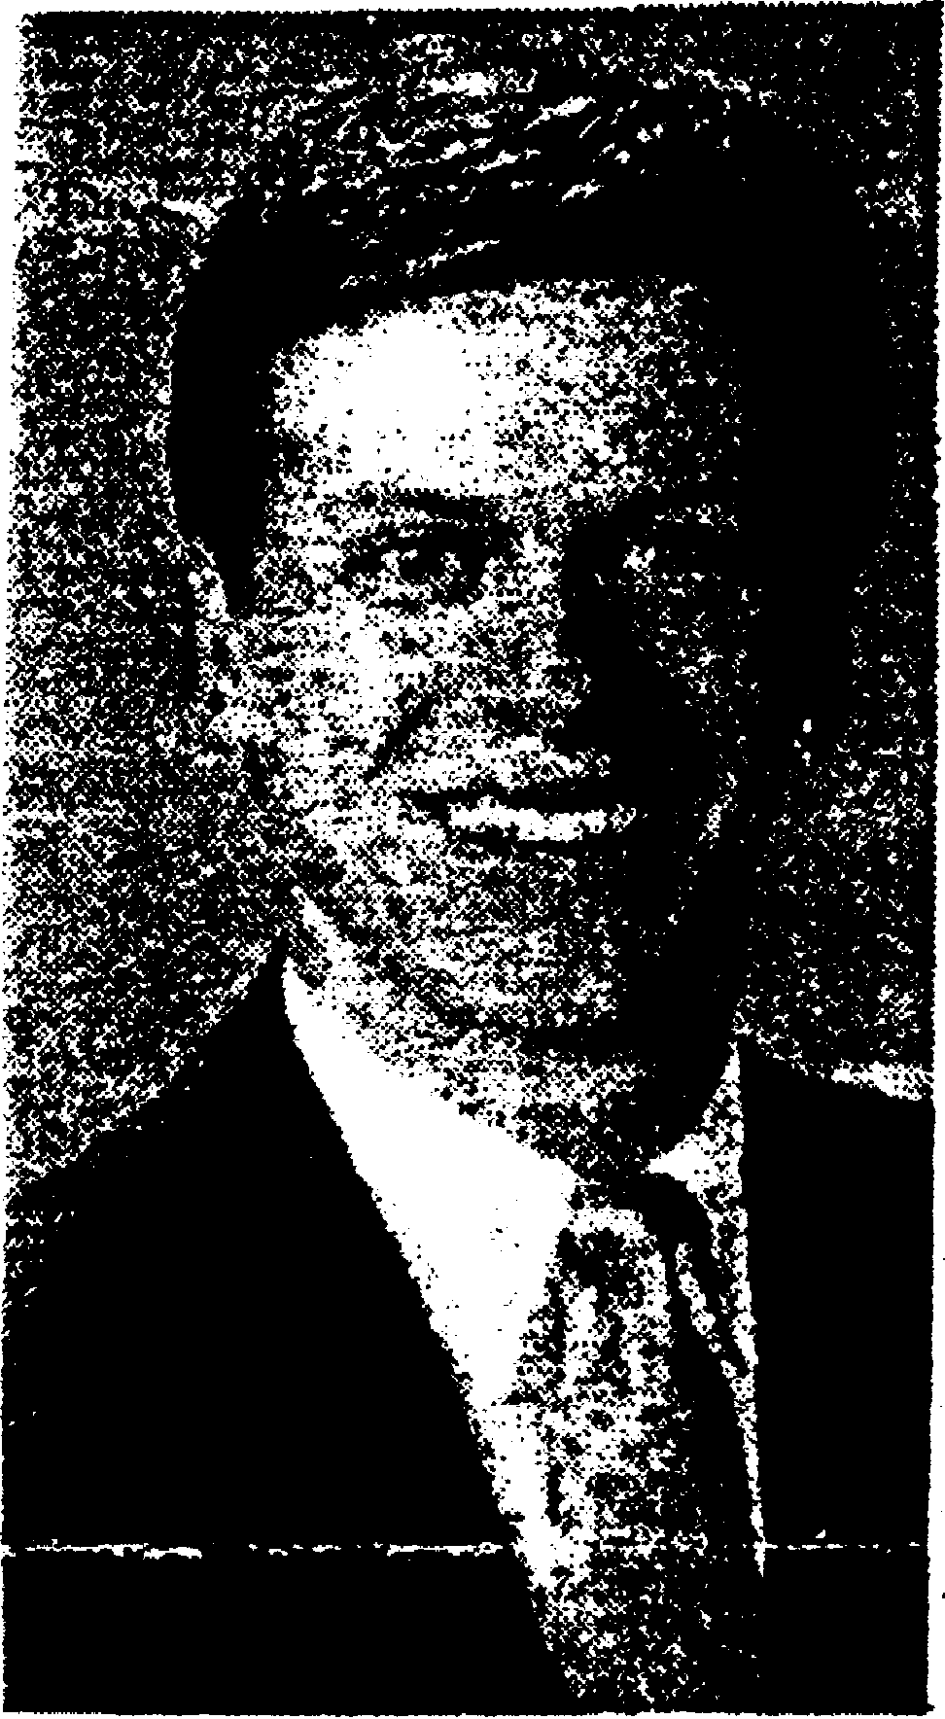
Terry Lewis Bunnell CB028112 is descended from Peter Bunnell (who was born in Virginia in 1784 and moved to Kentucky) through Samuel Washington, William Wallace, David Wallace and Paul Lewis to Terry Lewis Bunnell. Peter Bunnell’s ancestry has not been discovered. See page 36.
Terry L. Bunnell
Terry L. Bunnell, Retail Banking Manager at Trans Financial Sank, Glasgow, has recently been elected to a three year term
as a member of the Board of Directors for the Young Bankers Division (YBD) of Kentucky Bankers Association (KBA). In this position, Bunnell will represent bankers in a 12-county region of South Central Kentucky.
The Young Bankers Division is a statewide organization of bankers committed to the identification and development of future banking industry leaders. It provides members will
career building and leadership development oppor-tunities. The YBD conducts educational programs for its members to keep them abreast of the changing needs of today's bankers. YBD is active in Kentucky Special Olympic Summer Games, state legislative activities, and KBA's school classroom Personal Economics Program.
Bunnell serves in several local community organizations including:
President of the Glasgow-Barren County Chamber of Commerce, Treasurer of the Barren County Family YMCA. Treasurer of the Glasgow Lions Club, and Vice President of the Post B Travelers Protective Association. He is also a deacon at the Columbia Avenue Church of Christ and a banking instructor at the Glasgow Campus of Western Kentucky University.

NAMES ON THE LAND

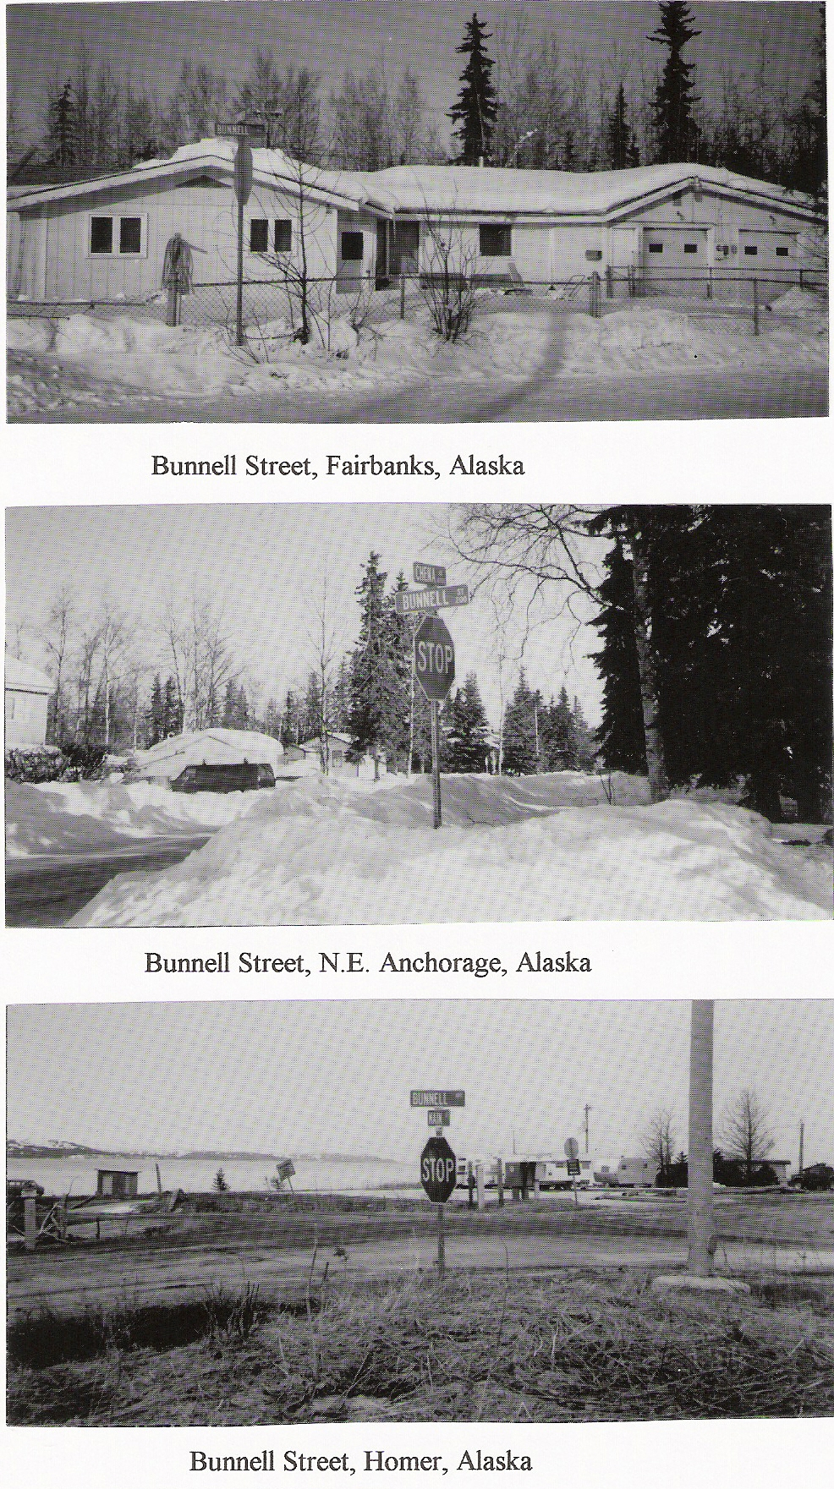
In early 1995 Clement and Alyne Bonnell, Milford, NJ, made an extended trip to Alaska. Their first objective was the Iditarod dog sled race. In addition they visited other points of interest in the state. Clem is always alert for Bonnell and Bunnell references, and he found several in Alaska.

Here are photographs of Bunnell Streets which Clem took in three Alaskan cities. The street in Fairbanks was obviously named after Charles E. Bunnell CB340113, the first president of the University of Alaska in Fairbanks. The street in Anchorage may have been named for him also, considering his long-time prominence in Alaska as a Federal Judge and college president.

Bunnell Street in Homer, however, appears to have been named after Edward Lloyd Bunnell CB340452, 1888-1966, and his second wife Maybell A.____, whose first husband was Arthur W. Berry. They owned and operated a store at 106 West Bunnell Street. The building is known today as the Inlet Trading Post and now houses, among other things, the Bunnell Street Gallery.

Edward Lloyd Bunnel’s descent is as follows: William, Nathaniel, Nathaniel, James, Stephen, Nathaniel, Isaac, Edward C. and Edward Lloyd.

* * * * * * *
I subscribe to AntiqueWeek, a weekly publication of articles about antiques and collectibles, news about upcoming auctions and shows, and other items of interest to collectors. An extensive section of classified ads from booksellers is of special interest to me.
Also, in each issue is a three or four page section on genealogy. Along with feature articles and current news and a monthly query section, each week the column Genealogy Sources provides guidance for the research of people who have encountered specific problems.
R.B., of Kansas City, MO, wrote in for help in searching for his or her ancestor Peter Bunnell, who married Susannah Erwin in Green co, KY. AntiqueWeek has graciously granted me permission to print R.B.''s question and the response. A number of my subscribers are anxious to discover the ancestry of Peter and the other Bunnells and Bonnells who came to Kentucky from Virginia about 1800. Perhaps these suggestions may offer a source that you haven't explored before,
See Newsletter, Vol. VI, No. 2, page 20.
I don't know the identity of R.B. of Kansas City, MO. Have any of you been in touch with this person.

genealogy sources
Questions, Commentary by the Genealogy Staff
This column looks at specific problems encountered In the researching process. Send question c/o Genealogy Sources, AntiqueWeek. P.O. Box 90, Knightstown. IN 46148 or Suite 220. 525-K E. Market St.. Leesburg, VA 22075 or P.O. Box 2022, Mechanicsburg, PA 17055, Note — We can't do research on a family but will try to suggest new approaches to your problem. There is no charge.
Also try to see the Annals of Augusta County by Joseph A. Waddell (1886 with later editions, reprinted at Harrisonburg, 1979) in which there is a supplement section from 1726 to 1871. This and other pertinent Augusta records may be listed in the LDS Locality Catalog under Virginia/Augusta County, if you can work through a Family History Center in your area. Augusta land, probate and court records begin in 1745. Courthouse staff will respond to simple written inquiries (with SASE) and will copy materials for a fee. Perhaps there is a BUNNELL land or court record that would refer to a place of origin. If these records are indexed, the search would not seem too difficult. You may also research in person at this Virginia courthouse from 8 a.m. to 5 p.m. weekdays (no restrictions), and staff can refer you to the (a) county genealogist.
Also check out what is available on Virginia at the National Archives-Central Plaines Region (branch, at 2312 E. Bannister Road in your city. Staff would be able to help you with ordering on loan certain materials from Washington if you need to go that route.
In Kentucky (an area to which many Augusta County residents are said to have migrated), the Hart County Historical Society, P.O. Box 606, Munfordville, KY 42765 publishes Hart County Historical Quarterly which deals largely with county history, the Civil War period and family genealogical records. Perhaps they have a surname reference card file that they would copy foryou if any BUNNELLs include your line. Then, you could follow up on any citations that sound promising for your search. (SASE with inquiry and offer to pay for copies of pertinent information.)
For England, again, at a Family History Center, see England/Staffordshire/Borough Records and Church of England for possible references to this family name as a location. If there is such, you can order what microfilm they have relating to that place to see if you can fit the information to your family. (See Genealogical Resources in English Repositories by Joy Wade Moulton.)
And, family associations include Bunnell Foundation. P.O. Box 16434, Portland, OR 97216. and The Bunnell/Bonnell Newsletter. P.O. Box 62, Laceyville, PA 18623. - ek

Roots go to Virginia
Q. - I have traced my ancestry back to Peter BUNNELL .. .BUNNEL .. .BUNEL ...BONNELL ...BONNEL ...BONEL ...BONNEUIL ,..BONNERAL ...BON-NILL. who was b. 15 June 1782 (VA), or 15 Jan 1784 (VA or OH) and died 18 Jan 1868 (Hart County. KY). He mar. (2) Susanna ERWIN, 19 June 1810 in Green County. KY (b. 5 Oct 1793 or 15 Oct 1794. Augusta County, Va; d. 8 June 1849 or 8 June 1851. Hart County. KY) and (2) Harriet (HARLOW) PERRY, in 1852 or 1853. Hart County. KY (b. ? 1818 Barren County. KY, d ?); dau. of William and Susanna (CURRY) ERWIN, mar. 1785 Augusta County. VA.
I cannot find Peter BUNNELL’s parents or siblings, arrival in America, etc., including BUNNELLS in the Revolutionary War. Some say the surname was from the English town of Bonehill, Staffordshire, England; other say derived from the village of Bonneuil-sur-Marne in France. I dnon’t know how to get information in from England, France, Sweden or Germany. R.B. Kansas City, MO.
A.–A new book that may guide you to more U.S. information sources on these early Virginia families is Virginia Genealogy Sources & Resources by Carol McGinnis (Baltimore MD: Genealogical Publishing Co. 1993). In using the many citations you may be able to better pinpoint from where the BUNNELLS came. Introductory chapters for all of Virginia and include church records, some of which contain “information about individuals who may seldom, if at all, be mentioned in court records of the period” (depending on the denomination). About the Revolutionary War (1775-83), McGinniss says about 27,000 Virginians were members of the Continental Army, and over 4,000 did militia service.” Records are at the state and national levls “in the forms of service, pension and bounty land records. There are also Public Service Claims (Patriotic Service Records) for nonmilitary…service.” Three major indesxes are cited, described and located for the researcher. These items hardly touch the total content of this book. In the county records section there are specific sources for Augusta County, which you may not have seen. A large area of Virginia was Augusta County, in this time period.

OBITUARY

Carolyn Rankin, Madison, WI, submitted this obituary from the Wisconsin State Journal of Friday, 5 April 1996:

REEDSBURG– Beatrice M. Bonnell, age 84, died unexpectedly on Tuesday, April 2f 1996 at her home. She was born on January 6, 1912 in the Town of Ironton, the daughter of Edward and Etta (Wright) Kinnamon. On October 6, 1933, she was united in marriage to Lester Bonnell. Beatrice worked as a cook at the Sauk County Health Care Center for over twenty years, she was an active and faithful member of the Bible Baptist Church. She was always willing to do for others and enjoyed cooking for her family and friends.

She is survived by six children, Jalane Robinson of Watertown, Wisconsin, William (Sheryle) Bonnell of Leavenworth, Washington, Richard (Brenda) Bonnell of Brookville, Ohio, Louann (Michael) Snyder of Stone Mountain, Georgia, James (Socorra) Bonnell and Daniel (Debra) Bonnell, all of Grand Junction, Colorado; fourteen grandchildren; eleven great-grandchildren; a sister, Leota Bellow of Baraboo; a sister-in-law, Joyce Kinnamon of Baraboo; and other relatives and friends. She was preceded in death by her husband, Lester, in November, 1979; a son-in-law, Jean Robinson; a grandson, Jamie Bonnell; and five brothers, Kenneth, Bill, Elgie, Gaylord and Lloyd Kinnamon.

Funeral services will be conducted at 11:00 a.m. on Saturday, April 6, 1996 at the BIBLE BAPTIST CHURCH in Reedsburg with Rev. Gerald Marsden officiating. Interment will be in the Oak Hill Cemetery at North Freedom. The family will receive friends from 5:00 until 8:00 p.m. at the HAMMER-HOOF FUNERAL HOME in Reedsburg.

[Mrs. Bonnell's husband, Lester Bonnell CB018059 and CB021390 was the son of William F. Bonnell CB009246, who was born in Wisconsin in March 1860. William was the eldest of six sons of _____ Bonnell, a native of New Jersey, and his wife Mary H. (_____) Bonnell, who was born in New York in June 1838. I need to leam the first name of William's father in order to carry this line back to New Jersey.]

* * * * * * *

EXTRACTS FROM THE DEED BOOKS OF MORRIS CO, NJ

Claude Bunnell photocopied these deeds last summer in Morristown. I have extracted whatever data I thought might be genealogically useful, omitting the legal boilerplate and the land descriptions which do not mention names or places. A (?) is used when I was not sure of the reading.

Deed Book B, p. 422. 1 April 1795. DANIEL SHIRTS and BETSY his wife of Mendham twp, Morris co, NJ, to ELIAS BONNEL CB310282 of the same place. For £124, 1 parcel of land in Mendham twp on the west side of Indian Brook containing 20 acres.

Deed Book D, p. 487. 29 April 1786. BENJAMIN BONNELL CB300043 of Essex co, NJ, as executor of the will of JOSIAH BROADWELL deceased, late of Morris Town, Morris co, NJ.
MORRIS CO DEED BOOKS (Cont’d)

Deed Book A, p. 17. 28 October 1765. JOSEPH FOSTER and MARY his Wife of the town of Morris, Morris co, province of east New Jersey, to BENJAMIN BONNEL CB300043 of the Borough of Elizabeth, Essex co, and said province. For £650 current money of the Province at 8 shillings the ounce, a messuage in Morris Town. Beginning at a stake corner of JACOB AKINS(?) land by Passiack River 95 links from the Bridge there, extending N78°W to the well N3°W 95 links to the road, thence N83°W 8 chains & 42 links to a post corner of MATHIAS WOODRUFF’S land, thence S45°W 71 chains to a post, thence S82°E 4 chains & 75 links to a post 1 chain from the forge Dam, thence N39°E 1 chain to the Forge Dam, thence S76°E 5 chains along the Forge Dam to the River, thence down said River the several courses thereof to the place of beginning.

Deed Book D, p. 190. 1 April 1797. MARY BONNELL (widow of JACOB BONNELL CB310235), MERCY SIMCOCK & HENRY BONNELL, heirs of the Estate of JACOB BONNELL decd. of the twp of Mendham, Morris co, NJ, to ISRAEL CANFIELD & JACOB LOSEY of Morris CO, NJ. For £137, 14 shillings proclamation money of NJ, a lot of land in Roxbury twp, Morris co, NJ, which the said JACOB BONNELL had of MARK(?) WALTON as per deed bearing date 2 April 1795 & mortgaged the same to the said ISRAEL CANFIELD & JACOB LOSEY the same date for the security of payment of £128, containing 43.33 acres on the bank of Rockaway River.

Deed Book D, p. 300. 8 December 1799. WILLIAM CAMPFIELD, sheriff of Morris co to MOSES MILLER at public vendue to exercise two writs of fieri facias against ELIAS BONNELL CB310282. One for £80 which ALEXANDER KING & HENRY BROTHERTON, executors of JOHN EVANS deceased recovered against him for debt at the session of the Inferior Court of Common Pleas held in Morristown in July 1799, plus £5, 3 shillings & 6 pence awarded by the Court for damages. The second at the suit of LEWIS KILLY(?) against ELIAS BONNELL.
For $100.50, a tract of land in Mendham twp seized from ELIAS BONNEL, bounded south by EBENEZER MILLER, east by HENRY BONNELL, north by the road leading from Calais (?) to Morristown, said to contain 25 acres.

Deed Book D, p. 478. 24 February 1801. SAMUEL BONNELL CB310238, son & heir of BENJAMIN BONNELL, Esquire CB300043, deceased, late of the twp of Springfield, Essex co, NJ, to JOHN BONNELL, Junr. CB310240 of Springfield twp, Essex co. For $250, "one forth of what is called the oald Grist mill with the whole of the priviledges thereunto belonging or otherwise appertaining as assigned & sett off to me by the commissioners authorise to make the division of my Father's estate among the heirs.”

Deed Book G, p. 435. 30 April 1803. ABRAHAM HOWELL & ABIGAIL his wife of Mendham twp, Morris co, to LUTHER BONNEL CB320443 of Mendham, Morris co, NJ. For $100, a tract of land in Mendham twp, Morris co, beginning in the road which leads North from Mendham meeting house at the southwest corner of a lot of land sold by the said ABRAHAM HOWELL to DANIEL MINTON, containing one acre strict measure.
MORRIS CO DEED BOOKS (Cont'd)

Deed Book H, p. 246. 15 March 1803. GILBERT BONNEL CB310359 and JOANNA his Wife to widow MARGARET CONKLING of Morris co, NJ. For $215, a tract of or lots of land in Morris co beginning at CALVIN BARKER'S corner at the road, thence N21°W 2 chains & 50 links the North side of the house to a corner joining JACOB MILLERS land, thence S491/2°E 1 chain & 9 links to a corner at the West end of said house on the North side of the road 45 links from said BONNEL'S house, thence S451/2°W 9 chains & 61 links to a pile of stones on the North side of the road, thence S43°E 4 chains & 61 links to the Northeast corner of GABRIEL JOHNSON'S lot, thence S44°W 2 chains to NEHEMIAH HAND'S line, thence S471/2°E 1 chain & 50 links to C. PARKER’S line, thence binding (?) on said PARKER’S line N531/2°E 9 chains & 25 links to a stake for a corner, thence N2°W 2 chains & 28 links to the West corner of said PARKER^ orchard, thence N60°E 4 chains & 5 links joining to said PARKER'S line, thence N21°W 4 chains & 50 links to the beginning. Containing 8 1/6 acres.

Deed Book H, p. 278. 19 July 1803. MARGARET CONKLING of Morris twp, Morris co, NJ, to GILBERT BONNEL CD310359, late of Morris twp, Morris co, NJ. For $215, same property as above. Witnesses to this deed were NATHANIEL BONNEL JUNr AND JACOB BONNEL.

Deed Book H, p. 280. 19 July 1803. GILBERT BONNEL CB310359 and JOANNAH his wife, of Essex co, NJ, to GABRIEL JOHNSON of Morris co. For $162.50, same property as above.

Deed Book H, p. 535. 12 May 1804. NATHANIEL BONNEL CB300154 and ANNA his wife of Mendham twp, Morris co, NJ, to NATHANIEL CLARK of Mendham twp, Morris co. For $787.50, a tract of land in Mendham twp containing 52 acres adjoining NATHANIEL CLARK'S other land and that of the widow DOTY. Witnesses: HENRY BONNEL & ISAAC CLARK.

Deed Book I, p. 164. 9 April 1804. BENJAMIN BONNEL CB003873 and ELIZABETH his wife of Morris twp, Morris co, NJ, to CALEB RUSSELL of Morris twp. For $65, a tract of land in Morris twp, being 1/3 part of lot No. 14, one of 16 10-acre lots laid off by CALEB RUSSELL in the Southwest corner of a tract of land in the Great Swamp called Staats long Morris's tract, adjoining lots of PHINEAS BOWERS and SAMUEL BRANT. Containing 3.33 acres.

Deed Book I, p. 509. 9 August 1803. DAVID BONEL CB310287 and ANNA his wife of Morris twp, Morris co, NJ, to DAVID WOOD of Morris twp, For $262.50, a tract of land in Morris twp, "it being the place whereon the said BONEL now lives," bounded North & East by Capt. JOHN OLIVER, South by the road leading from Mendham to Chatham, and West by lands of DAVID CONGER.

Deed Book L, p. 28. 10 October 1804. HENRY BONNELL CB320084 and ELIZABETH his wife of Mendham twp, Morris co, NJ, to THOMAS DELL of Mendham twp. For $300, a tract of land in Mendham twp, "It being a lot of land said HENRY BONNEL purchased of HENRY NICHOLS" adjoining lands Of HENRY BROTHERTON decd., JOHN POWERS, PHEBE LITTEL, JOHN SERRIN, and the schoolhouse lot. Containing 25 acres. Witnesses: NATHANIEL BONNELL & ELIJAH POUNDS.
MORRIS CO DEED BOOKS (Cont'd)

Deed Book L, p. 343. 24 September 1789. HENRY BROTHERTON, JOHN BROTHERTON, AARON BONNEL CB002140, ANN BONNEL, WILLIAM CRONE, BENJAMIN NICKALS, SARAH BROTHERTON, GRACE BROTHERTON, MERCY BROTHERTON, Jnr, legaties to the estate of HENRY BROTHERTON of Mendom deceased, and JAMES BROTHERTON & RICHARD DELL, executors Of the Will Of said HENRY BROTHERTON deceased, to WILLIAM BROTHERTON of Mendom, Morris co, NJ, yeoman. For £50, a tract of land in Mendom, part of the land which the said HENRY BROTHERTON died seized of, containing 15 acres. Witnesses: NATHANIEL BONNELL & DAVID BONNEL.

Deed Book M, p. 16. 6 January 1806. THOMAS BONNELL CB027863 of Morris twp, NJ, to WILLIAM BRITTIN and ABRAHAM BRITTIN of the same town. For $75, a tract of land in Morris twp adjoining lands of GEORGE CARTER, JAMES BARNET AND MOSES BRANT (one of the heirs of SOLOMON BRANT, deceased).

BENJAMIN BONNELL CB003873 of Morris co, for $75, quitclaimed all his right, title and interest in this property to the parties of the second part.

Deed Book N, p. 30. 9 July 1805. JOHN BONNEL JUNr CB310240 and NANCY his wife of Springfield twp, Essex co, NJ, to NATHANIEL BONNEL JUNr CB310358 of Morris twp, Morris co, NJ. For $379, One fourth part of what is called the Old Grist Mill. Witnesses: GABRIEL JOHNSON & STEPHEN D. BONNEL.

Deed Book P, p. 109. 10 April 1807. JOHN BONNEL SENr CB300181 and SARAH his wife of Springfield twp, Essex co, NJ, to LUKE MILLER of Chatham, Morris co, NJ. For $60, a tract of land in the Great Swamp and set off to JOHN BONNEL JUNr by the commissioners appointed to divide his father's estate, known on the map by lot No. 7 in the Swamp. Containing 3 acres. Witnesses: SALLY BONNEL CB310325 and SAMUEL CLARK.

Deed Book Q, p. 221. 18 November 1807. ELIZABETH BONNEL, widow of SAMUEL BONNEL CB001225 deceased, of Mendham, Morris co, NJ, to SAMUEL COZAD of Mendham. For $60, for a lot of land in Mount Freedom in Morris co "(which I quitclaim as my right of Dower)”.

Deed Book Q, p. 396. 10 February 1808. Doctor W. BONNEL CB300170 and EUNICE his wife of Morris co, NJ, to MILLER WALKER of Essex co, NJ. For $1350, a tract of land in Morris co at a place known as Long Hill, bounded West by lands of JONATHAN PARSONS, North by GABRIEL JOHNSON, East by the heirs of ISAAC CLARK, deed., and South by the River Pissaic. Containing 64 acres.

Deed Book R, p. 166. 1 April 1808. JABEZ MILLS and HANNAH his wife of Morris twp, Morris co, to JAMES BONNELL CB002976 of Morris twp, Morris co, NJ. For $267.50, a tract of land in Morris twp. Beginning at a stake standing in the middle of the Turnpike Road in Morris street between the house formerly owned by RECOMPENSE STANSBURY & a lot now owned by DAVID WOOLLEY, thence along said Road to DAVID WOOLLEY'S corner, thence several course back to the beginning. Containing 1/4 acre.

MORRIS CO DEED BOOKS (Cont'd)

Deed Book R, p. 341. 25 June 1808. NATHANIEL BONNEL CB300178 of Chatham twp, Morris co, NJ, to his son WILLIAM BONNEL CB310372 of Chatham twp. For $80, a tract of land in Chatham twp. Beginning at a wild cherry tree in a line of lands of JAMES BONNEL, thence N49° 45'E 9 chains & 46 links to the middle of the Road leading from the bridge near the old mill to the top of Long Hill, thence in said Road S45°E 5 chains & 20 links to a line of lands of the said JAMES BONNEL being the middle of the mouth of a Road that is laid out past NATHANIEL BONNEL'S JUNr saw mill, thence along this said last mentioned line S56⁰30’W 9 chains & 66 links to the first mentioned line, thence on said line N44⁰45’W 4 chains & 8 links to the beginning. Containing 4.43 acres. Witnesses: JOSIAH WILKISON & ENOCH BONNEL CB310356.

Deed Book R, p. 359. 3 November 1808. JOHN BONNEL CB300181 of Essex CO, NJ, to ISRAEL BONNEL CB310316 Of Chatham twp, Morris CO, NJ, son of the said JOHN BONNEL "for and in consideration of the natural love and affection which he hath and beareth unto the said ISRAEL BONNEL and for the better maintenance and livelihood of him the said ISRAEL BONNEL” gave a messuage of land in Chatham twp, Morris co, beginning at the Northeast corner of Capt. WILLIAM SPENCER'S land by the side of the Turnpike Road that leads from Elizabethtown to Morristown and on the South side of the Road. Containing 9.56 acres.

Deed Book R, p. 484. 24 April 1804. JAMES CHITESTER and PERNINA(?) his wife of Mendham twp, Morris co, to DAVID T. BONNEL CB310378 of Mendham twp. For $60, a tract of land in Mendham twp of 8 acres, adjoining DOTY'S land, HENRY BONNEL¹S CB320084 land that formerly belonged to OAKS LEACH, and the Road.

Deed Book R, p. 490. 6 July 1809. DAVID THOMPSON BONNELL CB310378 of Randolph twp, Morris co, to Capt. BENJAMIN HOLLOWAY of Morris twp, Morris co. For $60, a tract of land of 8 acres in Randolph twp, the same land purchased from JAMES CHIDESTER on 24 April 1804. [Randolph twp was formed from Mendham twp in 1805,]

Deed Book R, p. 493. 6 July 1809. DAVID THOMPSON BONNELL CB310378 and his wife [unnamed] of Randolph twp, Morris co, to Capt. BENJAMIN HOLLOWAY of Morris twp, Morris co. For $50, a lot of land in Randolph twp adjoining land sold by EBENEZER MILLER to NATHANIEL WOODRUFF, land formerly HENRY BONNELL'S CB320084, and land formerly of EZRA OWENS, being the same lot purchased by the said DAVID T. BONNELL from JOHN OWENS on 5 June 1809.

Deed Book S, p. 194. 28 September 1809. SIMEON BROADWELL & RACHEL his wife of Morris twp, Morris co, to ENOS BONNEL CB320334 of Springfield twp, Essex co, NJ. For $380, a tract of land in Springfield twp, Essex co, being lot No. 6 allotted to PHOEBE KING, late PHOEBE BONNEL CB320338 in the division of the estate of BENJAMIN BONNEL CB310239, and bounded Northeast by the Road leading from BONNEL'S old Mill to JACOB POTTER'S, Southeast by lot No. 7 belonging to the said ENOS BONNEL, Southwest by lands of BENJAMIN SPINNAGE, and Northwest by lot No. 5 belonging to the said ENOS BONNELL. Containing 12.39 acres.

MORRIS CO DEED BOOKS (Cont'd)

Deed Book S, p. 510. 28 October 1809. NATHANIEL BONNEL CB300154 and ANNA his wife of Randolph twp, Morris co, to ARCHIBALD OTIS(?). For $287.50, a tract of land in Randolph twp adjoining the road leading from EZRA BROWN'S tavern, the road that leads by NATHANIEL CLARK'S, and the Morris Turnpike Road.

Deed Book T, p. 97. 7 April 1810. WILLIAM BONNEL CB310372 and SALLY his wife of Chatham twp, Morris co, to BENJAMIN BRUEN of Chatham twp. For $246-75, a tract of land in the Great Swamp, being part of the land formerly the property of NATHANIEL BONNEL deed and known on the map by Lot No. 2, adjoining Lot No. 3, the estate of BENJAMIN BONNEL deed. Lot No. 1, and the outside line of the whole tract. Containing 11.75 acres. Witnesses JACOB BONNEL CB310365 & ENOCH BONNEL CB310356.

Deed Book T, p. 178. 18 April 1810. CALEB G. BONNEL CB310359 and JOANNA his wife of New Providence twp, Essex co, NJ, to WILLIAM BONNEL CB310372 of Chatham twp, Morris co. For $225, all one equal and undivided eighth part of a tract of land in Chatham twp, being the homestead tract of land on which NATHANIEL BONNEL, late of Chatham twp, deceased (?), bounded by lands of JAMES and JOSIAH WILKISON, the Passaic River, lands of ISAAC (?), WILLIAM SPENCER, the land of JAMES BONNEL deceased and others, also one equal undivided eighth part of and the right which the said NATHANIEL BONNEL deed had at the time of his death to the mill in Chatham twp commonly called Chatham old Mill, to which property the said CALEB G. BONNEL is entitled as one of the legaties of the said NATHANIEL BONNEL deed, and which property the said CALEB G. BONNEL engages to be free and clear from all incumbrances except the right of Dower which the widow of the said NATHANIEL BONNELL is intitled to during her natural life.

Deed Book T, p. 179. 17 April 1810. JACOB BONNEL CB310365 and MARGARET his wife of Chatham twp, Morris co, to ENOCH BONNEL CB310373 of Chatham twp. For $225, one equal undivided eighth part of the property and mill described in the previous deed, to which property the said JACOB BONNELL is entitled as one of the legatees of NATHANIEL BONNELL deceased. Witnesses: SAMUEL CLARK & WM. BONNEL.

Deed Book T, p. 342. 17 April 1810. ENOCH BONNEL CB310373 of Chatham twp, Morris co, to JACOB BONNELL CB310365 of Chatham twp. For $245, a tract of land in Morris co, in the Great Swamp, being part of a tract lately owned by NATHANIEL BONNELL deceased, and which in a division thereof was set off to the said ENOCH BONNELL, adjoining lands of DANIEL CRANE and others. Containing 11.29 acres. Witnesses: SAMUEL CLARK & WM. BONNEL.

* * * * * * * *

That's all for this time. Next quarter I’ll bring you more of the Morris co deeds. Since they have not been previously published, they will probably be more useful to you than the IGI records which are available at many Family History Centers across the country.

