

THE BUNNELL/BONNELL

NEWSLETTER

HTTP://www.bunnellfamily.us
Edited & Published by
Charles & Patricia Bunnell

Volume XVII, No. 4

A Non-Profit Publication to Assist in Sharing Family Records, Research & Genealogy

Donations are:
Printed, mailed Newsletter, issued Quarterly: $14.00/year
Electronic Newsletter, Quarterly, printable and downloadable: $10.00/year
*Email account only, yourname@bunnellfamily.us: $10.00/year
*Email account plus electronic Newsletter: $15.00/year
*Printed, mailed Newsletter plus Email account $19.00/year
*New prices effective 2004 for e-mail accounts

Queries, letters, e-mails and other material that subscribers provide us will be published free in the newsletter.

Contents:
Administrivia 46 Cemeteries 55
Correspondence 48 Biography 58
New Subscribers 49 Research Findings 59
E-Mail Addresses 49 Unattached Branches 63
Direct Lines 50 Claude’s Corner 64
Life Changes 51 William Austin’s Corrections 65
Queries 52 Post Script 65

Important Addresses:
Charlie & Pat Bunnell: P.O. Box 1801, La Plata, MD 20646-1801
William R. Austin: P.O. Box 62, Lacyville, PA 18623-0062 (Send direct lines to him)
Claude Bunnell: 408 23rd St, Ocean City, NJ 08226; Winter: 2110 Harbourside Dr, Longboat Key, FL 34228-4527
Claude’s Website: http://bunnellbonnellburnellfamily.com

Administrivia

2004 Dues:
Dues for the next year would be appreciated between now and the publication of the next newsletter, Feb. 29, 2004. The printed version is still $14 a year, which also allows you electronic access. For just the electronic version that you download, the price is still $10 a year. We have lowered the cost of the e-mail accounts to $10 a year, or $5 if added to either subscription type.
For those receiving the printed version, your mailing label shows your expiration date. For those receiving the electronic version, we’ll send you an e-mail letting you know when your subscription expires. Many of you have paid through 2004 and a couple of you have paid through 2005. We appreciate that vote of confidence.
We want to keep all dues on a calendar year basis; it greatly simplifies the necessary bookkeeping. Therefore, whenever you join, you receive that year’s back issues.
When sending your check, please make it payable to Charles Bunnell rather than the newsletter.

~~~~~~~~~~

Submitting items for the newsletter: To help us keep track of the material, please include your name, address and date on each piece of paper you submit, including photos. For newspaper articles, including obituaries, please include the name of the paper it came from to include the date, city, state and page number. As most of you know, this is the same type of info we write down when researching. If you have the capability to send in your item electronically, that would be great and save us a lot of time scanning or retyping. Just send it in as an attachment to your e-mail. But we’ll accept it in any format, so send it in!

~~~~~~~~~~

Queries: Queries are FREE and will be published when received and if room permits. Please try to keep them brief. As a first response we will use Claude Bunnell’s database and check with William Austin for information. We also want readers to add to the answers we provide. Please feel free to send your reply to the address at the end of the query. Please also send a copy to us so that we can share the information.

~~~~~~~~~~

Share the Newsletter: We’re not copyrighted, so you can share this newsletter with your local Genealogical Library or Historical Society or your family and friends. We’re not a business.

~~~~~~~~~~

Back Issues: Back Issues can be obtained for $4.00 per issue, printed; that covers copying and mailing costs. We hope to eventually have all issues on the web, and they’ll be available for free to subscribers. I have electronic versions of very few back issues and those are posted on the web. For those subscribers who don’t have web access just let us know what issue(s) you need and we’ll mail them to you at cost ($4.00).

~~~~~~~~~~

Web Page Update:

We have been updating the Files and Links page occasionally, though not with the frequency that we started with. We’ve added a “counter” to some of the pages to see how many visits we receive. This type of counter doesn’t show results on the page, but will provide data to us that we’ll share in the next newsletter. A counter that we had on the pages during the first three months of operation showed that in March of this year our pages were viewed 5100 times by 1900 different people. That’s good for a small site with limited public interest.

We have so many things we want to do on the website that some times it’s difficult to remain focused on one project. The current project we’re starting is to retype all of the early Newsletters and put them on the
members’ web page. Scanning just won’t work due to the size of the files and the time it would take you to download them. If we retype one newsletter a month, I figure it will take 5 years to complete the project. So, WE WILL ACCEPT HELP ON THIS PROJECT. If you have the back issues and are willing to type up one or two issues, send me an e-mail and let me know. If you don’t have back issues but are willing to type, we’ll send you a copy of back issue(s) to type. We’ll coordinate “who’s doing which.” For the photos etc in the newsletters, if you don’t have a scanner, we’ll scan those in and add them to the pages you type. I just ask that they be typed in MS Word, MS Works, Lotus WordPro, or WordPerfect. These will then be available for all subscribers with internet access. Wouldn’t that be handy?

~~~~~~~~~~

Circulation Data:
Number of Paid Members, Electronic Newsletter: 19
Number of Paid Members, Mailed Newsletter: 73
Courtesy copies to Libraries, Genealogy Societies: 18
Total Circulation 110

Correspondence

From: Cutshall [mailto:atgoose@suite224.net]
Sent: Saturday, October 18, 2003 11:36 AM
To: crbunnel@sprynet.com
Cc: Charlie & Pat Bunnell
Subject: Bonnell-1850 census

Listed as weavers at a boarding house in Kingsville twp. Ashtabula co. OH, b. NY are the following Bonnell females.
Ellen age 19, Salina age 16 and Martha age 17.
http://www2.suite224.net/~atgoose/
http://www.gaia.edu/genclass/kcutshall/
http://freepages.genealogy.rootsweb.com/~kandbill/index.html

Ed. Note: Salina could be No. 30561, daughter of Mahlon and Sarah (Oliver) Bonnel, but Claude’s database doesn’t show her having sisters named Ellen and Martha. I could not match the Ellen and Martha above to any in the database.

~~~~~~~~~~

-----Original Message-----
From: DJulien@aol.com [mailto:DJulien@aol.com]
Sent: Monday, September 01, 2003 2:39 AM
To: charlie@bunnellfamily.us
Subject: Bunnell

Hello,
I am not a Bunnell myself, but I just wanted to pass on some information.
Many of my family are buried in a cemetery in the country that is located north west of Frankfort, Indiana. The name of the cemetery is Bunnell Cemetery. I didn't know if you had heard of it or not.
Barb Julien

Q: Why did the genealogist's wife leave him?
A: He was spending too much time with his family.
Thanks Eunice and Chet Bunnell

New Subscribers

Elizabeth M. Marks | Steve L. Bonnell

E-Mail Addresses

This is the most current listing. ➔ indicates a new e-mail address since the last issue.

William R. Austin | Billau2@excite.com | Kay A. Cutshall | atgoose@suite224.net
Floyd L. Baldwin | floydbet@verizon.net | Julia A. Dale | jidnks@peoplestelecom.net
↓Anne M. Barrett | Rambarrett@cox.net | Betsy David | bdavid@together.net
Barbara W. Barrett | Barbchgo@aol.com | Barbara L. Davis | cimida@hotmail.com
Jean C. Bevis | jean.bevis@att.net | Joan Flavel | obj@harborside.com
↓Steve Bonnell | sbonnell@dislaughter.com | Christine Gembinski | chgemb@aol.com
Carole Bonnell | CaroleBonnell@aol.com | Marjorie C. Gibbs | margibbs@nycap.rr.com
Clem & Alyne Bonnell | cabonnell@worldnet.att.net | Brenda Bunnell Griffin | Brenway@earthlink.net
James P. Bonnell | jpb74@elite.net | Jerry Hatch | wjhatch@acninc.net
John C. Bonnell Jr. | jbon@quik.com | Jean Sayre Kane | jskane@attglobal.net
Linda A. Bonnell | labjkb@aol.com | Richard J. Lesser | rlesser3@comcast.net
Steven L. Bonnell | slbnl@kbsb.com | Doris Livingston | djlivingston@worldnet.att.net
Teri L. Bonnell | h20cruzer@msn.com | Sharon MacDougall | sharoncmac@adelphia.net
William B. Bonnell | kaboy61480@aol.com | âElizabeth M. Marks | haroldm@kconline.com
Loretta Brasche | lbrasche@galatinriver.net | Bernard V. Mayhle | male@ipeg.com
Phyllis G. Brunk | pibpgbrunk@aol.com | Elliott McConnell | ebmcc@charter.net
Cecil R. Bunnell | cecil-anna@bunnellfamily.us | Joan E. Murray | joan_m60067@yahoo.com
Charles E. Bunnell | Charlie@bunnellfamily.us | Louise B. Nemecek | lbbnemecek@worldnet.att.net
Charles R. Bunnell Sr. | crbunnell@earthlink.net | Truman L. Nicholas | Colotop@aol.com
Chester S. Bunnell | Chet-eunice@bunnellfamily.us | Jacqueline A. Ogden | bunny-jo@webTV.net
Claude A. Bunnell | cbunnel@comcast.net | Monty C. Peden | peden@hoosierlink.net
Donald H. Bunnell | dbun189510@aol.com | Albert F. Post | Aposty1@aol.com
Eris & Richard Bunnell | erisb@aol.com | Guthrie T. Pratt | rbgtpratt@msn.com
John G. Bunnell | john.bunnell@mindspring.com | Gwen & Ed Quickel | gquickel@quik.com
Kevin P. Bunnell | kevinpbun@wcox.com | Tom Randell | tomran@swbell.net
Larry L. Bunnell | llbunnell@aol.com | Lorna B. Ray | rayassoc@aol.com
Paul J. Bunnell | BunnellLoyalist@aol.com | Rosa G. Rediger | birde@bigfoot.com
Stuart C. Bunnell | scbunnell@hotmail.com | Dorothy Reeves | Dottiefay@aol.com
Tobias Bunnell | tbunnell@woh.rr.com | Rebecca West Rutledge | beckwestrutledge@pvns.net
Tobias Bunnell | toby@urbanabunnells.org | Darlene Ryan | genie@gglbbs.com
James R. Burnell | jim.burnell@state.co.us | Norma Sullivan | maxrsullivan@remconline.net
James R. Burnell | dialjeemincolo@aol.com | Gladys L. Treadway | gltreadway@juno.com
Elizabeth Chambers | ecb1@earthlink.com | Pamela Walling | PamWalling@bunnellfamily.us
Lyda G. Cloud | GrayeBC@sstelco.com | Judith Wilkins | JudithWilkins@comcast.net
Elaine V. Block Cole | evbcole@aol.com

Please keep us updated with your most current e-mail address. Sometimes we send out e-mails to all of our e-mailers to alert them of short notice events, such as items on e-bay.

Direct Lines

Direct Lines are provided by subscribers. I would recommend that you not treat them as primary source material, but the submitter may be able to provide you with his/her primary sources. William Austin will review Lines submitted to him. Send them directly to him with a request that he review them and forward them to me with any corrections. Addresses are on page 1.

Direct Line submitted by Elizabeth M. (Allen) Marks, 2105 East Street, N. Manchester, IN, 46962; Not submitted to William Austin, but validated against Claude Bunnell’s database. Information provided by Elizabeth is in standard print; data added from Claude’s database is in bold print.

William Bunnell ~ Ann Wilmot Noah Thomas Bunnell~Sarah Heaton
Nathaniel Bonnel ~ Susanna Whitehead John Henry Bunnell~Eliza C. Kercheval
Nathaniel Bonnel ~ Mary Searing Maud Elsie Bunnell~Herb Almon Dunn
James Bonnel ~ Sarah Broadwell Marian Isabel Dunn~Wesley Herman Allen
Daniel Bonnell ~ Martha Hughes Elizabeth May Allen~Harold L. Marks,Jr
Daniel Bunnell~Alice Albaugh

~~~~~~~~~
Direct Line submitted by SueAnn Harding, 23821 Walnut Street, Torrance, CA 90501-6138. Not submitted to William Austin, but validated against Claude Bunnell’s database. Information provided by SueAnn is in standard print; data added from Claude’s database is in bold print.

William Bunnell ~ Ann Wilmot David Bunnell ~ Mary Everetts
Benjamin Bunnell ~ Rebecca Mallory George A. Bunnell ~ Weighty J. Royce
Benjamin Bunnell ~ Hannah Plumb Helen G. Bunnell ~ Reuben Austin
Solomon Bunnell ~ Elizabeth Holdren Jessie I. Austin ~ Carlton L. Harding
Isaac Bunnell ~ Lanah Barkaloo Lloyd K. Harding ~ Emma E. Knights
John Bunnell ~ Hannah Jayne Kent L. Harding ~

~~~~~~~~~
Direct Line submitted by Tobias Bunnell, 214 Henry Street, Urbana, OH 17868-0157 and validated against Claude Bunnell’s database.

William Bunnell - Ann Wilmot Noah T. Bunnell - Sarah M. Heaton
Nathaniel Bunnell - Susannah Whitehead Edward F. Bunnell - Hannah Steinfield
Nathaniel Bunnell - Mary Searing Marion L. Bunnell - Nellie Comer
James Bunnell - Sarah Broadwell Dean E. Bunnell - Betty J. Kitchen
Daniel Bunnell - Martha Hughes Tobias L. Bunnell - Gina G. Addis
Daniel Bunnell - Alice Albaugh

Ed. Comments: The last two generations, Tobias & Gina, and Dean & Betty, are not in Claude’s database. Marion L. is shown as Lee Marion in the database apparently based on the US Census data. The database also shows the name as Bonnel starting with the first Nathaniel. It reverts to Bunnell with the second Daniel.

Life Changes
Obituaries, Marriages, Births

Obituaries:

From the “Ashtabula StarBeacon” (OH):

Florida - Cathryn Marie Bunnell age 54, passed away on Oct. 13, 2003. Born on September 11, 1949 in Conneaut, OH she was a graduate of University of Central Florida and long time employee of Orange News in Orlando, Florida. Preceded in death by her father, Clair I. Bunnell, she is survived by her mother Dorothy Hews Bunnell of Snellville, GA; brothers C. Michael Bunnell of Apopka, Florida; Robert H. Bunnell of West Melbourne, Florida; and sister Cyndi Troutman of Snellville, Georgia; and numerous nephews. Cremation and further arrangements are pending.

Submitted by Kay Cutshall who adds: Cathryn's grandfather was #342129=James Faye who went by J.F. or Faye [J.F. was brother of my grandmother Irene], great-grandfather # 331097=J.O, either Jedikiah or Judson depending on what information you have. J.O &/or Judson is what he went by when he was older, his father was # 320975=Aaron, #320974.
~~~~~~~~~
Marriages:

From “The Pantagraph”, Bloomington, IL, Sunday August 31, 2003:

“BONNELL-LITTLE: State Farm Park, Bloomington, was the setting for the 4 plm. May 17, 2003, wedding of Maranna Bonnell of Colfax and Steven Little of Foosland. There was a reception at Eastland Suites. Their parents are Gary and Pat Bonnell of Colfax; Dale and Connie Aldrich of Foosland; and Cliff and Pam Little of Humboldt, Tenn. Attending the bride were Christina Eyer, maid of honor; Aurora Bonnell and Meghann McGivney, bridesmaids; Makayla Crawford, flower girl. Andrew Little was best man; Skee and Troy Aldrich, groomsmen; Levi Aldrich, ring bearer; Josh Quiram, Nathan Bonny, Zach Lisenby and Adam Bean, ushers. The bride, a graduate of Ridgeview High School, has an associate degree from parkland College and is pursuing a degree in architecture at Southern Illinois University at Carbondale. She is employed in the university’s honors program. Her husband, a graduate of Gibson City-Melvin-Sibley High School, has an associate degree in civil engineering from Parkland College and a bachelor’s degree in civil engineering from SIU, where he is pursuing a master’s degree. He is employed in the civil engineering department at SIU. The couple reside in Carbondale following a wedding trip to Daytona Beach, Fla., and San Diego, Calif.”

Submitted by Lorna Bonnell Ray of Bloomington, IL.

Ed. Note: Gary Bonnell appears to be Gary Lee Bonnell, CB361767; His line would be: William, Nathaniel, Samuel, Benjamin, David, Henry, Henry, Samuel, Seymour, Marvin, Gary.

Queries

The web pages have resulted in queries frequently coming to us from non-members. Occasionally the folks making the inquiries subscribe because of the information available from our responses (often those are Charlie, William, and Claude joint endeavors), the Newsletters, and Claude’s database. For the sake of increasing membership, but mainly for sharing information (our primary reason for the web pages and the newsletter), I intend to include queries from subscribers and non-subscribers. For all queries, feel free to correspond directly with the writer requesting the information. However, I would appreciate receiving copies of the information so that we can share it with other subscribers.

Henry Bunnell (twice)
Alice Bunnell (Twice)

Irene Transue (IGTRANSUE@webtv.net) who is currently not a subscriber, is trying to research her Bunnell Line.

I haven't been able to find anything on my great grandfather Henry Bunnell and his
wife Anna VanAllen. They lived in Wyoming county when my grandmother
Alice Bertha Bunnell was born in Lovelton PA. I would appreciate it if
anyone has information on this Bunnell family. Thank you.

Then, Carol Brotzman (brotzman@dfnow.com) , the Beaver Meadows Church Historian Tuscarora Twp Bradford County, PA, wrote to outline the lineage of a Dale King whose obituary she had sent. She forwarded the following info, originally supplied by a Pam King:

My mom’s grandmother was a Bunnell, Alice Bunnell dob 03/02/1869. Alice’s mom was Anna Van Allen and her dad was Henry Bunnell. They were from Wyoming Co. PA. I saw a Henry C. Bunnell on page 38&39 [of a book Carol sent her]. His parents were John S. Bunnell and Laura May Whitcomb.

Ed. Note: I checked Claude’s database and census data and I don’t believe that Henry, father of Alice, is the Henry C., son of John and Laura Bunnell. I could not find a Henry and Anna (Van Allen) Bunnell however.

Please either respond directly to Irene and Carol with info to me, or directly to me if by regular mail.

~~~~~~~~~~

Temperance Bunnell [CB330234]
(Continued from previous Newsletter)

In the previous issue, I discussed the request by Sue Wagner for information on Temperance Bunnell and the resulting findings. In response, Joan Murray, whose book served as the basis for our research, responded by e-mail to Sue and me with some additional information, which follows:

Dear Sue, I saw the query that Charlie Bunnell put into his latest Bunnell Family Newsletter. I have written the book he refers to - Bunnell and Allied Families.

My grandmother, Rosa Bunnell England [CB341298] was a niece of Temperance Bunnell. My grandmother left us with the names of all her father's siblings, their spouses and their children. She called Temperance, Aunt Temmie. According to my grandmother, the children were named Charlie, Carey, Romeo and Bertie. Perhaps some were from the second marriage. Grandmother said nothing about Temmie's death or a second marriage. Bertie, I suspect was Albert, although could have been Alberta. It seems nearly all the siblings must have greatly admired Albert Freeland, the husband of Hannah Jayne Bunnell Freeland [CB330233] because several of them named children after him - including Margaret Bunnell [CB330230] and Harmon Clark who named a son Albert and called him Libbie; James Torry Bunnell [CB330238] and Ella Leonard, who named a son Albert [CB341292] and called him Bertie; Mary C. Bunnell [CB330240] and Russell Allen who named their daughter, Albertena and called her Allie. I suspect the child called "master" born in 1860 in Minnesota is Albert (Bertie) and died in probably infancy.

I have searched for years to track James and Temperance Tracy after 1860, and now I can see from the Bunnell NL why I never found them. I never went back to New York looking for them. I always looked farther west, thinking they followed in the footpaths of some of the other siblings.

Anyway, I am glad that part of the mystery is solved. I live about hour and a half away from where Isaac Bunnell [CB320212], the father of the above, Hannah Jayne (who my Grandmother called Aunt Jennie), their daughter, Orville Mortimer [CB330232], another sibling, John [CB330231], another sibling are all buried. About 8 years ago I managed to get a C.W. tombstone put on Orville's grave. He and John were the only ones without stones in the family plot. Orville's wife, son, and daughter are buried about 1/2 away in another cemetery in a plot which belonged to the son's wife's family. I've been out there many times to do research, and based a good part of my book upon. If you haven't seen my book, it is available at many libraries, and there are still copies available at AncestorStuff.com. Those who have my book will be happy to know that the tombstones in their plot have been up righted and repaired in recent years, since I took the photos which appear in my book. If I can answer any other questions regarding this family, I will be happy to do so.

Joan E. Murray
~~~~~~~~~~

LYMAN H. BUNNELL [CB331303]

Submitted by Sally Curtiss Fahrenthold, 2658 N. Ridgewood Ct., Wichita, KS 67220, (sallyf@cox.net)

What happened to my Lyman H. Bunnell, the brother of my great-grandfather, Asahel Cooley Bunnell [CB331304]?
Lyman H. Bunnell was born on December 16, 1843, to Henry George [CB320852] and Eliza J. (Loomis) Bunnell. He was born in New York State, probably Wyoming County (where his parents were married) or Genesee County (where his brothers Asahel and George Chapin Bunnell [CB331305] were born). There was also a sister Nellie E. Bunnell [CB331306] who was born and died in 1851.
Lyman H. Bunnell is listed in the 1850 census as age 6 in Pike, Wyoming County, NY. He is listed in the 1860 census as age 16, farm labor, again in Pike, Wyoming Co, NY.
The record of Civil War Soldiers & Sailors web site has “Leyman H. Bunnell”(index spelling), Regiment: 104 N.Y. Infantry, Union troops, Company C, Rank: Private (in and out), Film 551 roll 18. The Pike Historical Library has a note that Lyman H. Bunnell, born 1844, enlisted in 1861 in the 104 NY Infantry, served 3 years, discharged.
The obituary for his mother in Pike, NY, 1891, says that her 2 sons from Grand Rapids, Michigan, were present at her death. Both sons Asahel and George Bunnell lived in Grand Rapids in 1891. No idea where Lyman lived.
Their mother Eliza J. (Loomis) Bunnell’s husband Henry George Bunnell, had died in 1857. Eliza remarried Luther Chapin Jr. in 1865 or 1866. He had apparently died before her death in 1891. Luther Chapin Jr. was her step-brother, and the Chapin family was apparently very close to the Bunnell and Loomis families.
A family note written probably in about 1890 lists most of the Bunnell family births, marriages and deaths. Lyman H. Bunnell’s birth date is listed, but no further information.
No more information on Lyman has been found. I have explored various spellings of Lyman and Bunnell/Bonnell. Probably his middle name was Henry after his father and grandfather, as family names were used prevalently; I have tried to locate a possible Henry. The Chapin family was inter-married with the Bunnell and Loomis families; I have tried to pursue that last name.
So... Where’s Lyman? Any clues would be most welcome!

~~~~~~~~~~

MARTHA BUNNEL(L) [CB011220]

Submitted by Colleen Collier (Collierx6@aol.com). Please either respond directly to her with info to me, or directly to me if by regular mail.

Colleen is looking for the ancestry of Martha Bunnell. Colleen found a Marion County (IN) marriage record showing her name as Bounel. Between Claude’s database, Colleen’s info, and some census searching I did, we know that she was born about 1810 in Ohio, married George Metsker in 1830 in IN or OH, had at least one probably 2 children (one named James Bunnel Metsker), a granddaughter Clara Mills born in 1860, and was a widow in Noblesville, Hamilton Co., IN in 1880. We don’t know her ancestry however. A relative “seems to remember some family member was a ‘grave marker maker.” That could tie her in with the Urbana, OH Bunnells, but I could not find the connection.

~~~~~~~~~~

HARRIET BUNNELL

Submitted by Carol Peck (capeck@charter.net). Please either respond directly to her with info to me, or directly to me if by regular mail.

She is looking for a Harriett Bunnell who married Joshua Woodbury Peck 1832 at Naples, NY. She doesn’t appear in Claude’s database. Maybe someone out there has her in their database.

Cemeteries

Claude Bunnell has nearly 1400 Bonnell/Bunnell/Burnell burial sites in his database. We are going to start listing them by state, and we’ll be adding them to the web site. If you know of a burial site that we don’t list, or if you can fill in the missing information, please send the info to me either via e-mail or snail mail, and to Claude at his mailing address on the first page or to cbunnel@comcast.net, We’ll all benefit from this exchange. So, here’s the first installment from Claude’s database.

 | NAME |  |  |  |  |  | DEATH DATE |  |  |  |  |  |  |  |  |  | SP. |  | SPOUSE NAME
Fam. No. | First |  | Middle |  | Last |  | Year |  | MM/DD |  | State |  | Town/City |  | Cemetery |  | No. |  | First |  | Middle |  | Maiden
341516 | Charles |  | Birdis |  | Bonnell |  | 1915 |  | 4/18 |  | KY |  | Corydon |  | Woodsman Cm |  | 1 |  | Nettie |  | Ellen |  | White
352124 | Edward |  | Elmus |  | Bonnell |  | 2000 |  | 4/30 |  | KY |  | Henderson |  | Roselawn Cm |  | 1 |  | Mary |  | Caroline |  | Gish
352121 | John |  | Houston |  | Bonnell |  | 1921 |  |  |  | KY |  | Henderson |  | Fernwood Cm
003930 | Archibald |  | A |  | Bunnel |  | 1885 |  | 8/16 |  | KY |  | Elizabethtown |  | Elizabethtown Cm |  | 1 |  | Sarah |  | (011223) |  | Bunnell
003930 | Archibald |  | A |  | Bunnel |  | 1885 |  | 8/16 |  | KY |  | Elizabethtown |  | Elizabethtown Cm |  | 2 |  | Margaret |  |  |  | Miller
003930 | Archibald |  | A |  | Bunnel |  | 1885 |  | 8/16 |  | KY |  | Elizabethtown |  | Elizabethtown Cm |  | 3 |  | Elizabeth |  | H
006454 | Benjamin |  | Franklin |  | Bunnel |  | 1903 |  |  |  | KY |  | Harrodsburg |  | Springhill Cm |  | 1 |  | Belle |  |  |  | Freeman
005422 | Francis |  | Marion |  | Bunnel |  | 1905 |  | 11/3 |  | KY |  |  |  |  |  | 1 |  | Sarah |  | Ann |  | Leach
001888 | Samuel |  | Washington |  | Bunnel |  | 1895 |  | 9/29 |  | KY |  |  |  |  |  | 1 |  | Sarah |  | Francis |  | Smith
012801 | (Female) |  |  |  | Bunnell |  | 1900 |  | 10/31 |  | KY
012803 | (Male) |  |  |  | Bunnell |  | 1859 |  |  |  | KY
012806 | (Male) |  |  |  | Bunnell |  | 1891 |  | 11/17 |  | KY
012807 | (Male) |  |  |  | Bunnell |  | 1893 |  | 7/15 |  | KY
012788 | Alberta |  |  |  | Bunnell |  | 1903 |  | 9/6 |  | KY
012805 | Amon |  | M |  | Bunnell |  | 1915 |  | 11/20 |  | KY
007943 | Amy |  | B |  | Bunnell |  | 1901 |  | 3/23 |  | KY
011238 | Benjamin |  | D |  | Bunnell |  | 1858 |  | 11/28 |  | KY |  | New Providence |  | Presby Cm |  | 1 |  | Mary |  | (012792) |  | Bunnell
013419 | Benjamin |  |  |  | Bunnell |  | 1836 |  | 7/12 |  | KY |  | New Providence |  | Presby Cm
005523 | Bryant |  | T |  | Bunnell |  | 1903 |  | 2/21 |  | KY |  |  |  |  |  | 1 |  | Sarah |  | C.
007934 | Carlos |  |  |  | Bunnell |  | 1966 |  | 4/6 |  | KY |  | Horse Cave |  | Horse Cave Cm |  | 1 |  | Elizabeth |  | Myrrell |  | Davis
007938 | Charles |  | R |  | Bunnell |  | 1940 |  | 10/24 |  | KY |  |  |  |  |  | 1 |  | Fannie |  | R
019084 | Collista |  | Frances |  | Bunnell |  | 1971 |  | 10/11 |  | KY |  | Lexington |  |  |  | 1 |  | James |  | Marion |  | Delaney
007950 | David |  | B |  | Bunnell |  | 1943 |  | 12/8 |  | KY |  |  |  |  |  | 1 |  | Ann |  | Pearl |  | Anderson
007932 | David |  | Wallace |  | Bunnell |  | 1973 |  | 3/28 |  | KY |  |  |  | McDaniel Burying Gnd |  | 1 |  | Ruth |  | Thomas |  | Galloway
007932 | David |  | Wallace |  | Bunnell |  | 1973 |  | 3/28 |  | KY |  |  |  | McDaniel Bury Gnd |  | 2 |  | Margaret |  |  |  | Toms
 | NAME |  |  |  |  | DEATH DATE |  |  |  |  |  |  |  |  |  | SP. |  | SPOUSE NAME
Fam. No. | First | Middle |  | Last |  | Year |  | MM/DD |  | State |  | Town/City |  | Cemetery |  | No. |  | First |  | Middle |  | Maiden
012789 | Eliza | Jane |  | Bunnell |  | 1939 |  |  |  | KY
012815 | Emily | A |  | Bunnell |  | 1869 |  | 10/3 |  | KY
007942 | Emmett | L |  | Bunnell |  | 1941 |  | 1/2 |  | KY |  |  |  |  |  | 1 |  | Lena |  | M |  | Burd
006484 | Ernest | Lynnwood |  | Bunnell |  | 1952 |  | 11/28 |  | KY |  |  |  |  |  | 1 |  | Malinda |  | H |  | Bunton
012808 | Frances | B |  | Bunnell |  | 1943 |  |  |  | KY |  |  |  |  |  | 1 |  | Frances |  | B
006483 | Frederick |  |  | Bunnell |  | 1903 |  | 3/25 |  | KY |  |  |  |  |  | 1 |  | Tennessee |  |  |  | Nave
001100 | George | Gilliam |  | Bunnell |  | 1927 |  | 2/17 |  | KY |  |  |  |  |  | 1 |  | Eliza |  | C. |  | McConnell
001100 | George | Gilliam |  | Bunnell |  | 1927 |  | 2/17 |  | KY |  |  |  |  |  | 2 |  | Sarah |  | E
007941 | Henry | Rousseau |  | Bunnell |  | 1916 |  | 1/5 |  | KY |  |  |  |  |  | 1 |  | Emily |  | Susan |  | Martin
007941 | Henry | Rousseau |  | Bunnell |  | 1916 |  | 1/5 |  | KY |  |  |  |  |  | 2 |  | Celia
007947 | Howard | Leo |  | Bunnell |  | 1968 |  | 3/14 |  | KY |  |  |  |  |  | 1 |  | Grace |  |  |  | Meadows
012645 | James | A |  | Bunnell |  | 1602 |  | 7/27 |  | KY |  |  |  |  |  | 1 |  | Nora |  | C.
012809 | James | A |  | Bunnell |  | 1953 |  | 5/26 |  | KY
006497 | James | Archie |  | Bunnell |  | 1914 |  | 6/10 |  | KY |  | New Providence |  | Presby Cm |  | 1 |  | Susan |  | A
006465 | James | H |  | Bunnell |  | 1960 |  | 3/3 |  | KY |  |  |  |  |  | 1 |  | Georgia |  | M. |  | Hill
001406 | James | Harvey |  | Bunnell |  | 1897 |  | 1/28 |  | KY |  |  |  |  |  | 1 |  | Martha |  | Ann |  | Brownlee
012804 | James | Hill |  | Bunnell |  | 1905 |  | 2/16 |  | KY
005239 | James | W. |  | Bunnell |  | 1905 |  | 2/11 |  | KY |  |  |  |  |  | 1 |  | Elizabeth |  | M |  | Bunnell
012784 | Jeremiah |  |  | Bunnell |  | 1884 |  |  |  | KY
012787 | John | L |  | Bunnell |  | 18_7 |  | 12/1 |  | KY
007935 | Lawrence |  |  | Bunnell |  | 1962 |  | 7/21 |  | KY |  |  |  |  |  | 1 |  | Rena |  | Belle |  | McDaniel
012811 | Lena | M |  | Bunnell |  | 1959 |  | 12/23 |  | KY |  |  |  |  |  | 1 |  | Lena |  | M
001790 | Martha | Jane |  | Bunnell |  | 1882 |  | 7/14 |  | KY
013116 | Martha | Louise |  | Bunnell |  | 1881 |  | 1/29 |  | KY |  |  |  |  |  | 1 |  | Henry |  | Clay |  | Gupton
001556 | Mary | Mandy |  | Bunnell |  | 1856 |  | 9/7 |  | KY
012792 | Mary |  |  | Bunnell |  | 1871 |  | 9/16 |  | KY |  | New Providence |  | Presby Cm |  | 1 |  | Benjamin |  | (011238) |  | Bunnell
006523 | Paschal | Lee |  | Bunnell |  | 1880 |  | 9/28 |  | KY
012812 | Raymond |  |  | Bunnell |  | 1908 |  | 12/6 |  | KY
012813 | Rebecca | Gilliam |  | Bunnell |  | 1926 |  |  |  | KY |  |  |  |  |  | 1 |  | Rebecca
006514 | Robert | Lee |  | Bunnell |  | 1921 |  | 1/1 |  | KY |  |  |  |  |  | 1 |  | Minnie |  | H |  | Conover
012814 | Sim | L |  | Bunnell |  | 1918 |  | 4/7 |  | KY
006515 | Thomas |  |  | Bunnell |  | 1897 |  | 1/1 |  | KY |  |  |  |  |  | 1 |  | Mary |  | Jane |  | Hutchingson
000390 | William | C |  | Bunnell |  | 1833 |  | 4/14 |  | KY

 | NAME |  |  | DEATH DATE |  |  |  |  | SP. | SPOUSE NAME
Fam. No. | First | Middle | Last | Year | MM/DD | State | Town/City | Cemetery | No. | First | Middle | Maiden
013111 | William | E | Bunnell | 1885 | 9/21 | KY
011192 | William | Henry | Bunnell | 1911 | 1/9 | KY | Louisville | Cave Hill Cm | 1 | Sarah | Alice | Keller
006520 | William | T | Bunnell | 1913 | 2/17 | KY | New Providence | Presby Cm | 1 | Miriam | Ellen | Sutterfield
006520 | William | T | Bunnell | 1913 | 2/17 | KY | New Providence | Presby Cm | 2 | Martha | E
006522 | William | Wallace | Bunnell | 1918 | 1/18 | KY |  |  | 1 | Myra | Edward | Houk
004137 | William |  | Bunnell | 1862 | 1/3 | KY |  |  | 1 | Mary |  | Allen
006537 | Anthony | Wayne | Burnell | 1888 |  | KY | Richmond | Silver Creek Cm | 1 | Peggy |  | Burnett
006537 | Anthony | Wayne | Burnell | 1888 |  | KY | Richmond | Silver Creek Cm | 2 | Sally |  | Welsh
006537 | Anthony | Wayne | Burnell | 1888 |  | KY | Richmond | Silver Creek Cm | 3 | Elizabeth | Ann | Cole
331748 | Herod | Dallas | Bonnell | 1920 | 6/22 | VA | Rt 7 & Trapp Rd | Andrew Chapel Cm | 1 | Amanda | C
009691 | Joseph |  | Bonnell | 1864 | 8/15 | VA | Hampton | National Cm | 1 | Mary |  | Magee
029606 | William | T | Bonnell | 1903 | 3/8 | VA | Hampton | National Cm
001602 | Andrew | Jackson | Bunnell | 1906 | 9/5 | VA | Fredericksburg | City Cm | 1 | Jane | Somerville | Shelton
001602 | Andrew | Jackson | Bunnell | 1906 | 9/5 | VA | Fredericksburg | City Cm | 2 | Elizabeth | E | Hart
001602 | Andrew | Jackson | Bunnell | 1906 | 9/5 | VA | Fredericksburg | City Cm | 3 | Martha | T | Stewart
029732 | Arthur | G | Bunnell | 1831 | 10/28 | VA | Fredericksburg | St George Cm
320094 | Mark | John | Bunnell | 1917 | 3/21 | VA | Arlington | National Cm | 1 | Josephine | Elizabeth | Bottom
012550 | Matera | H (Tesah) | Bunnell | 1928 |  | VA | Petersburg | Blanford Cm | 1 | Robert | Emmett | Bozel
030032 | Pearl | B | Bunnell | 1998 | 5/12 | VA | Arlington | National Cm | 1 | Pearl | B
351146 | Ralph | Elmer | Bunnell | 1964 | 8/28 | VA | Arlington | National Cm
370014 | Robert | Allen | Bunnell | 1992 | 3/30 | VA | Arlington | Columbia Gnds
350547 | William | Curtis | Bunnell | 1999 | 6/5 | VA | Arlington | National Cm | 1 | Pearl |  | Barker
018366 | William | H Jr | Bunnell | 1992 | 3/31 | VA | Triangle | Quantico Nat Cm
003125 | Nathaniel | Alanson | Burnell | 1976 | 6/27 | VA | Arlington | National Cm | 1 | Adene | Harriet | Soelberg

Biography

DANIEL BUNNELL

This issue’s biography was provided by Tobias Bunnell, 214 Henry Street, Urbana, Ohio 43078, tbunnell@woh.rr.com. He says that, “I'm not sure who wrote that Biological Sketch I sent you, It was hand written on the backs of several Bunnell Monument company invoices dated September 1914. A cousin of mine, Jean Bunnell Wiley who passed away last fall had kept many family documents which I happened to inherit. She had two sons, neither in which have children of their own, so they decided to send them to me in order to keep them passed down in the family. Jean was the daughter of Leslie Clifton Bunnell, the last owner of our Monument Company which he sold in 1946.”

Daniel Bunnell ran a marble shop along an old Indian trail in Xenia, Ohio on the present site of the Dodd's Bros. Plant. Noah Bunnell learned his trade under his father at Xenia, moving to West liberty in 1860 where he conducted a shop to help out wage contributions which came to him as Methodist Minister. He convened his circuit on horseback and often would use horse and wagon carrying marble slabs which when sold would letter on the spot and erect before morning. War conditions decided Noah Bunnell to discontinue business in West Liberty and establish a shop in Bellefontaine, Ohio in 1863. Here John and Daniel learned their trade while still too small to reach a mans size carving bench, having to stand on a box. Ed was born in Bellefontaine. When the family moved to Covington, Indiana in about 1866, Daniel walked to Urbana and worked 12 and 14 hours a day lettering marble for either Runyans or Al Ross, soon taking over a half interest. This shop was located on the John Smith property now owned by the J. F. Brand heirs, N. Main street near E. Church. Moved from their to the present site of Pickenings grocery. When the Brand-Wicker brick block was being built, he was forced to relocate again, moving to a new frame building of John Smith now the Chinese laundry paying a monthly rental of $18.00.
In the fall of 1882 the Bunnell family came from Covington, Indiana. Elmer, John and Ed driving the wagon of household goods while remainder followed by train. They took up residence at 835 N. Main in the Jennings property and lived their till the following spring of 1883 moving to a small farm north of the Illinois Car and Equipment Co. formerly known as the U.S. Rolling Stock Co. Ed and Elmer begun at once to rub stone and cut bases for Daniel. Ed also teaming and working the farm and garden. In about 1890, about the time the stone contract for the Baptist church was completed and masonry work of Dugan bridge commenced, Daniel together with his brother Elmer, who had two years experience as clerk in John Rhoades and Ridge Wilkins grocery, bought out a grocery located in the S.W. corner of the square now occupies by Longs Restaurant, again later moving to where the Busy Bee Restaurant now is. This venture was conducted jointly with monument business. The grocery business was never a paying venture and in 1893 was heavily in debt and abandoned. Many years were required to return the losses caused by this venture. An increase of rental of $20.00 determined Daniel to move his monument business and gamble on owning his own building. About this time the high School burned in 1897 and the securing of the contract for brick and stonework on the new building encouraged him to build our present brick building on the land already owned by him. Work was begun in summer of 1898 and rushed to completion. " Snip" Anderson laid the brick for a horse in an even trade. The land purchase and building expenses left a heavy debt which had to be carried for years. During this time John Wright, Elmer and Ed were employed more or less continuously. Old Dutch John was a character that never failed to follow payday with a " regular" spree. A Civil War veteran who in later years would emerge periodically from the Dayton Soldiers home with his bi-monthly paycheck and visit his old friends. When well saturated and warned that Dan Bunnell would give him a good blessing out if he didn't sober up, he would loudly decry that he was not afraid of Dan Bunnell and his seven brothers. However the appearance of Dan was usually enough to render old John quite docile. A varied collection of humanity worked for and were loyal to their employer and staunch friend. The three Creary brothers, Steve, John, and Larry whose failing for strong liquor was a constant trial.
Research Findings

Carol Brotzman, the Beaver Meadows Church Historian Tuscarora Twp Bradford County, PA contacted us with a query (see that section for her questions), but after some e-mail correspondence started sending some photos and other data. Here are a couple of photos she provided.

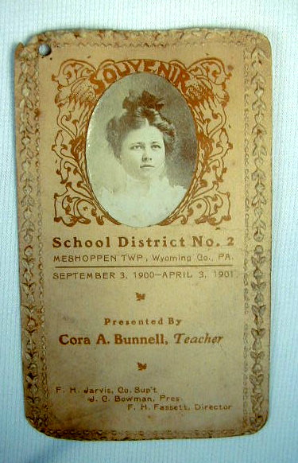
This was an item being offered on e-bay that Carol notified several folks about.

Cora A. Bunnell [CB340158] was born August 1880 in Meshoppen, Wyoming Co., PA. The 1910 census shows her as a single school teacher in Meshoppen. By the 1920 census she was living in Washington, DC and working as a government clerk. I could not locate her in any state, or D.C, in the 1930 census. Her lineage is:
William¹, Benjamin², Benjamin³, Solomon⁴, Benjamin⁵, Isaac⁶, John⁷, Elmer⁸, Cora⁹.

~~~~~~~~~~
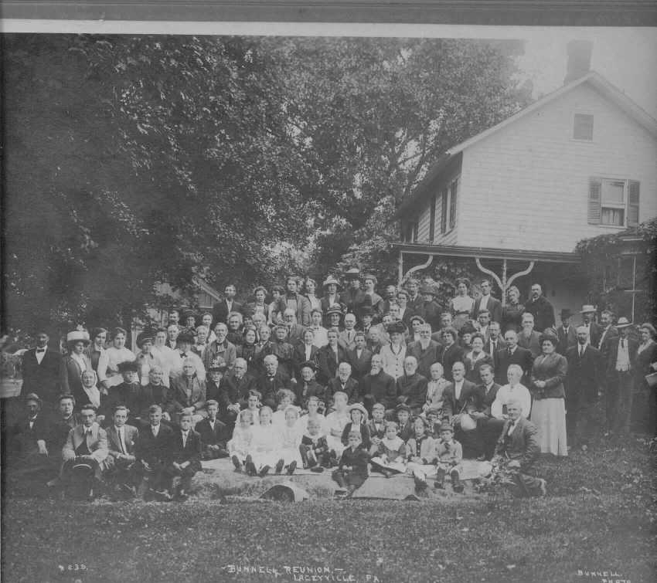
Bunnell Reunion, Laceyville, PA, 1912

Unfortunately, there are no names available. If anyone wants an electronic version of it, I can e-mail it at no cost.

~~~~~~~~~~

Boyd's
ELMIRA [NY] DIRECTORY,
FOR 1874.
Bonnell Jonathan, (Bonnell & Owen,) h 404 S Main
Bonnell & Owen, (Jonathan Bonnell and Jesse Owen,) commission merchants, 210 W Water
Bunnell Daniel K., shoemaker, John cor DeWitt h do
BOOTS AND SHOES.
Bunnell Daniel K., John cor De Witt do
COMMISSION MERCHANTS.
Bonnell & Owen, 210 W Water do
[Source: Tri-Counties Genealogy & History by Joyce M. Tice http://www.rootsweb.com/~srgp/jmtindex.htm]

History of Chemung County [Pa] 1892 - Towner
Our County and its People
A History of the Valley and County of Chemung
by Ausburn Towner, 1892
TOWN OF VAN ETTEN
Maxwell Post, NO. 454, G. A. R., was organized in March, 1884, with the following charter members: …., Alonzo Bunnell, ….
[Source: Tri-Counties Genealogy & History by Joyce M. Tice http://www.rootsweb.com/~srgp/jmtindex.htm]

1900 Bradford County [PA] Directory
Athens Township
Transcribed and Submitted by Patty DECKER Shumway
Bunnell, Henry J., (Waverly, NY) r 9, farmer 50
[Source: Tri-Counties Genealogy & History by Joyce M. Tice http://www.rootsweb.com/~srgp/jmtindex.htm]

Hanford's Tioga County [PA] 1899 Directory
Wellsboro Borough Directory
Bunnell Deck, painter, h 16 Meade
Bunnell Louisa, widow Frederick D, bds East ave

[Source: Tri-Counties Genealogy & History by Joyce M. Tice http://www.rootsweb.com/~srgp/jmtindex.htm]

Pioneer and Patriot Families of Bradford County, Pennsylvania
By Clement F. Heverly
in Two Volumes
1913 & 1915
The following is extracted from Clement F. Heverly, Pioneer and Patriot Families of Bradford County, 1770-1800, Vol. 1, Bradford Star Print, 1913. Volume 1 - Page 53
(Transcribed by Pat Raymond)
Additional Marriages, 1786 -- 1850
March 2, 1835, George Sumner of Wyalusing and Miss Lydia daughter of John and Mary (Place) Bunnell of Tunkhannock, Pa.
Vol. II - Clement F. Heverly - Pages 412-426 & 434
(Page 425)
Polly [Biles] to Chandler T. Baldwin (husband of deceased sister); Jacob P. [Biles] to Mary Bunnell
[Source: Tri-Counties Genealogy & History by Joyce M. Tice http://www.rootsweb.com/~srgp/jmtindex.htm]

1885 Seven Counties History - Bradford County PA
“HISTORY OF SEVEN COUNTIES presented by the Elmira Weekly Gazette". It is an “Outline History of Tioga and Bradford Counties in Pennsylvania, Chemung, Steuben, Tioga, Tompkins and Schuyler in New York by TOWNSHIPS, VILLAGES, BORO’S AND CITIES.” Written expressly for the Gazette Company, Elmira, N. Y. Copyright 1885. From AN OUTLINE HISTORY of Tioga and Bradford Counties in Pennsylvania, Chemung, Steuben, Tioga, Tompkins and Schuyler in New York by TOWNSHIPS, VILLAGES, BORO'S AND CITIES"
WYALUSING TOWNSHIP
The early settlers were ….. , Miles Bunnell, …..

[Source: Tri-Counties Genealogy & History by Joyce M. Tice http://www.rootsweb.com/~srgp/jmtindex.htm]

~~~~~~~~~~

Anne Barrett has provided some electronic copies of a letter written by Thomas Bunnell [CB005287]. She says that this letter is from Thomas James/Dean Bonnel, to his father Jonathan. At the time the letter was written, Thomas had married the second Elizabeth (Gaines Treadway). You will note that the letter refers to their new daughter, Eliza, born two months before. NOTE: Jonathan and his daughter, Sarah, both spell their names Bonnel on their tombstones but tombstones are so often incorrect, I don't give that a whole lot of weight. You may share copies of Thomas' letter with anyone. (God bless my grandmother (Rebecca's granddaughter) for keeping it safe all these years.) It is worth mentioning that the estate papers filed for Jonathan, Sr. contain a reference to the $200 note that Thomas asks his father to pay in this letter. One page is the actual handwritten note by Thomas Bonnel to Jesse Cox (as the letter says). The curious thing is that Thomas signs it over to his father thus:

Jonathan Bunnell you will please redeem the above note and oblige yours to . . .
Thomas Bonnel. (Actual spellings.)
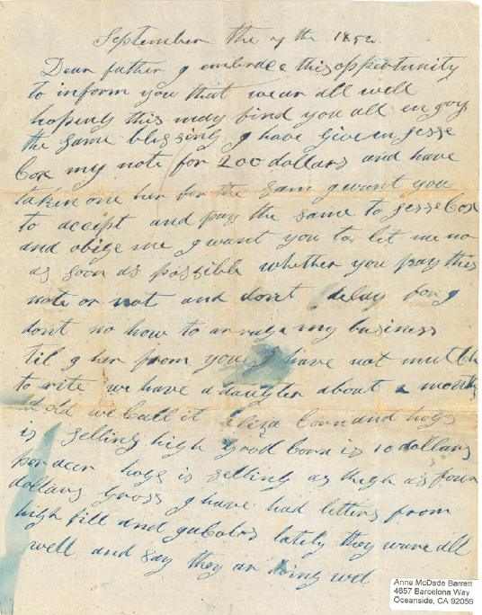
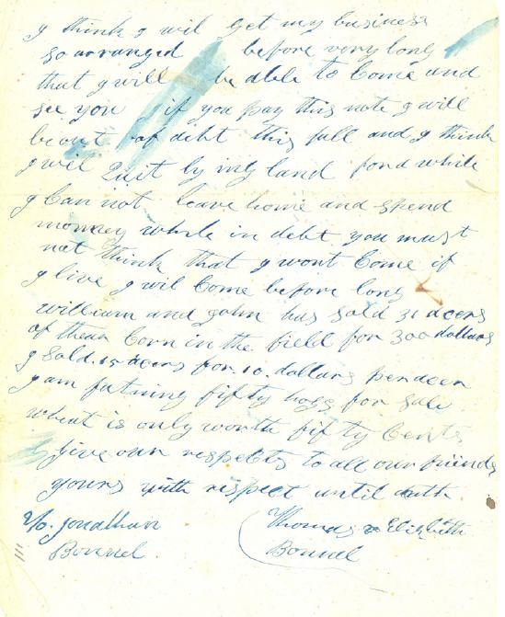

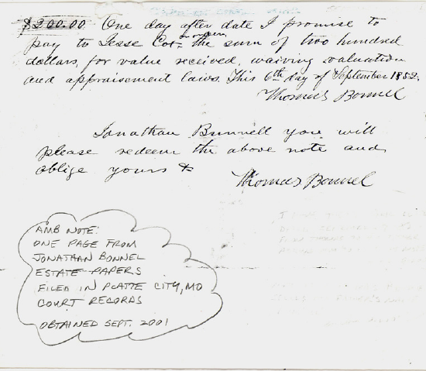
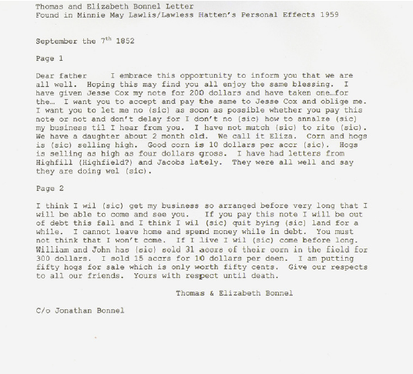

Unattached Branches

Beverly Sorenson, 1042 Whitfield Rd., Northbrook, IL 60062 sent us an advertisement from Dover Publications in Mineola, NY which featured 3 books by Deb T. Bunnell: My First French ABC Coloring Book, My First Spanish ABC Picture Coloring Book, and Spanish Search-a-Word Picture Puzzles. I checked with William Austin and Claude Bunnell, but neither one knew where she might fit into the family. I’ll go to the publishers, but they are generally protective of the author’s privacy. In the meantime, I thought I’d see if anyone knew Deb. Drop me a line or an e-mail if you do.

Claude’s Comments

Claude Bunnell, who has the extensive Bunnell/Bonnell/Burnell database available at http://bunnellbonnellburnellfamily.com/, has provided some valuable comments on the May and August issues of the newsletter. I invite everyone to do the same.

May Issue, Vol. 17, No. 2
P 20-Mrs Hannah Bunnell is wife of 004005 Martin Luther
P 20-H J Bunnell is 330273 Henry Jackson. This is his 2nd marriage.
P 20-A H Bunnell is member # 330110 Arthur Howard.
P 20-Thomas Bunnell is 001269 - m to Francis Richards
P 20-Woodlawn Cemetery:
Andrew Bonille is 011381
David K Bunnell & wife Caroline is 330014
I could not tell who were the parents of the children
P 21-Kenneth Bunnell is 005565
P 21-Wellsboro cemetery:
Frances Bonnell is wife of 001269 Thomas
Alice L (Tabor) Bunnell is wife of 330601 James M
G W Bunnell is 340774 Earl George W
James M is 330601
Libbie Bunnell is 331215 Elizabeth
Mary (Foster) Bunnell Sykes is wid of 330633 Andrew
Mary Nan Bailey Bunnell is 351284
Uretta Bunnell is wife of 320634 James M
P 21-Salem Lutheran or Hart Cemetery:
George Bonnell is 004026 & wife Philena
Charles the son is 033874 (new addition)
P 27-Fireman Bonnell is 330853 Reuben
P 29-The database lists 1378 cemeteries.

August Issue, Vol. 17, No. 3
P 35-Messie T Bunnell wid of 351425 John Joseph
P 36-Cora Bonnell was the wid of 004312 Clayron &
Oregon Hill Cem is in Pine, Lycoming Co/PA
P 37-005836 David Bonnell married Nicy Wright
P 37 Tioga Co/PA Birth Records:
342574 James W Bonnell
033878 Loren Bunel s/o 033877 Lewis (New Members)
340769 Arthur Bunnell
341994 Edna M Bunnell
P 38-I could not determine where Kirby Jr linked
P 38-Maple Grove Cm-341666 Minnie
P 38-Quinby Cem-341672 Ann
P 38-Tioga Point Cem:
028224 Brenda
320178 wife Hannah
330329 Henry
330329 wife caroline
340843 Walter 1873-1951
330273 wife Martha 1829-1899
330273 wife Mary J Pennell
340844 Maud L Bunnell
P 39-Lockwood Cem-340842 Frank
P 39-last line: 330234 Temperance b 1831 (age 19 in 1850)
Husb James Tracy b 1830 (age 20 in 1850 census W/P)
P 44-033879 Paul E Bonnell (new member-need help to identify his parentage)
003348 Ralph Daniel

Additions/Corrections to
The Bunnell/Bonnell Family in America, Vol. I
By William R. Austin

William Austin provided the following additions and corrections to Volume I of his book, “The Bunnell/Bonnell Family in America.”

Page | Item
90 | Line 6 from the bottom of the page should read:  “His wife was HANNAH THOMPSON^{[5]}, daughter of Joseph and Lydia (Bonnell) Thompson^{[7]}.”
95 | Line 5 from the bottom of the page should read:  “ELEANOR (LENA, LANAH) BARKALOW, daughter of Jacques and Jane Barkalow. She was born 17 June 1741^{[2]} in Hunterdon co. NJ, where she was baptized in the Readington church on 12 July 1741.”  Reference: Bunnell and Allied Families, by Joan England Murray, 1990, p.101.
134 | Joel⁵ Bunnell - change 1-1-9-7-4 to 1-1-9-7-5.
139 | Sally, b. about 1787 – Change 319432 to 310432.
145 | Nathaniel⁵ Bonnell – Change 1-3-1-2-4 to 1-3-1-2-5.
147 | Reference 3, line 2 – should read “…typed extract sent to me …”
161 | Reference 16 – end of line 2 – Change Claude A. Mitchell to Claude B. Mitchell.
174 | Henry, b. 1777 – Change 301374 to 310374.

Post Script


HAPPY HOLIDAYS

