
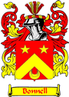
THE BUNNELL/BONNELL
ISSN: 1553-0094

NEWSLETTER

http://www.bunnellfamily.com
Charlie@bunnellfamily.com
Edited & Published by
Charles & Patricia Bunnell

Volume XXIV, No. 3 August 2010

A Non-Profit Publication to Assist in Sharing Family Records, Research & Genealogy

Donations are:
Electronic Newsletter Quarterly, printable and downloadable: $10.00/year
Printed, mailed Newsletter, issued Quarterly: $15.00/year
Email account only, yourname@bo/unnellfamily.com: $10.00/year
Email account with printed or electronic subscription No extra charge

Material provided to us is published free in the newsletter.

Contents:
Administrivia 33 Research Findings 41
Correspondence 34 Queries 42
New Members 35 Biographies 43
E-mail addresses 35 Books 46
Direct Lines 35 Post Script 46
Life Changes 35 Research Books Index B-1
Submissions 39

Important Addresses:
Charlie & Pat Bunnell: 13 Windsor Pt, Crossville, TN 38558
William R. Austin: 2720 Hamilton Dr., Endwell, NY 13760
Claude’s Website: http://www.williambunnellfamily.org/
DNA & Genealogy: Steven Bonnell, 1523 Good Shepherd Rd, Montoursville, PA 17754
E-Mail: BNL_dna@kbsb.com
DNA Website: http://www.ftdna.com/public/BNL_dna/

Administrivia

Submitting items for the newsletter: To help us keep track of the material, please include your name, address and date on each piece of paper you submit, including photos. For newspaper articles, including obituaries, please include the name of the paper it came from to include the date, city, state and page number. If you have the capability to send in your item electronically, as an attachment to your e-mail, that’s great. But we’ll accept it in any format, so send it in!

Share the Newsletter: We’re not copyrighted, so you can share this newsletter with your local Genealogical Library, Historical Society or family and friends.

Correspondence

From: Pat McKinley [mailto:patm1938@sktc.net]
Sent: Monday, June 14, 2010 7:05 PM
To: Charlie@bunnellfamily.com
Subject: David Lusk Bonnell

In the May newsletter Cherri Lusk was asking if David Lusk Bonnell was some of your family. He is my greatgrandfather. Was she just interested in DNA or family connections? David Lusk Bonnell had a son, my grandfather's brother named Thomas Lusk Bonnell, 1885- 1951 who was hit by a train while working on the right-of-way.
Was also wondering, my Bonnell's were all quite short, right around 5 ft. My mother was 4ft11 1/4 inches, she always was sure she got that 1/4 inch in there. Is this a family trait?
Thanks
Pat

[Ed. Note: I wrote her that I don’t know about the height issue in the Bonnell line. But in my Bunnell line for the past 4 or so generations a common trait seems to be the hair line. It recedes on both sides and leaves a bunch down the middle - a genetic Mohawk. That’s only for the males - so far.]

~~~~~~~

From: Steve Bonnell [mailto:sbonnell@dlslaughter.com]
Sent: Tuesday, March 09, 2010 3:18 PM
To: Charlie@bunnellfamily.com
Subject: John Bonnell

Charlie,

I am trying to get qualified to join The Sons of the American Revolution. I believe that my connection would be John Bonnell (CBID-300181). (Nathaniel, Nathaniel, Nathaniel, William)

I was reading Grover Smith’s research paper on The Descendants of Thomas Bunnell. (April 15th 2001.) He wrote that “During the Revolution John served as a private in the New Jersey Line. One source refers to him as a Captain of the Militia.”

Any idea how I could verify that? Also would you have Grover Smith’s e-mail address?

Thanks in advance for any assistance you can provide.

Steve

Steve Bonnell
D.L. Slaughter Company
2720 E. Camelback Road
Suite 250
Phoenix, AZ 85016

[Ed. Note: I told Steve that I wasn’t familiar with the requirements for membership in the SAR and I didn’t know Grover Smith. I have since found Grover’s e-mail address, grover@groversmith.com, and his website with Bonnell data is: http://www.groversmith.com/bonnell.html.]

~~~~~~~

New Members

Elvin W. Burnell | ewburnell@embarqmail.com

E-Mail Addresses

We are only showing changes to the listing provided in the November 2009 issue.

LTC John G. Bunnell | Bunnellfamily5@att.net

Direct Lines

Rodney Bonnell, May11943@aol.com or 949 Fulton Rd. N.W. Apt#1, Canton, OH 44703, provided some info, described in the Submission section, and his parentage which allowed us to send him his lineage using Claude’s database:

William Bunnell ~ Ann Wilmot Isaac Bonnell ~ Sarah Lindsey
Nathaniel Bonnell ~ Susanna Whitehead Thomas Bonnell ~ Eliza Jane Boyd
Isaac Bonnell ~ Elizabeth _________ Clarence Bonnell ~ Myrtle M_____
Abraham Bonnell ~ Mary Shinn Ralph Bonnell ~ Frances Miller
Isaac Bonnell ~ Catherine Severns Rodney L. Bonnell

~~~~~~~

Belinda Pruett, belindap@ncmodulars.com or 179 Bailey Thomas Road, Sanford NC 27332 [new address], submitted her lineage as far back as she has it. We believe that the parents of William Bunnell are Durham and Mary (?) Bunnell, but lack any proof.

William Bunnell ~ Beulah Scoggins
Mary L. Bunnell ~ James R. Fore
Joe E. Fore ~ Linda F. Oldham
Belinda Oldham

Life Changes

Obituaries:

I’m sorry to inform you that Claude Bunnell passed 5 September 2010 about 10:00 PM Eastern time. His funeral will be held on Friday, 10 September 2010. From the Chandler Funeral Home website, http://hosting-tributes-1611.tributes.com/show/Claude-Bunnell-89296418 here is his obituary.

Claude A. Bunnell, age 89 of Lima PA, formerly of Wilmington DE and Long Boat Key Fl, passed away on Sept 5, 2010 after a long illness.
He is survived by his wife of 61 years Sara Hackett Bunnell and 4 sons, Steven C, David E, Donald H, and Thomas B. Another son, Robert A predeceased him. Surviving also are 4 grandchildren, two step-grandchildren and 1 great-grandchild.
Services will be held at the CHANDLER FUNERAL HOME, 2506 Concord Pike, Wilmington DE on Friday Sept 10, 2010 at 11:00am. The family will greet friends at 10:30 am prior to the service.
In lieu of flowers, donations to ACTS Hospice, 812 N. Bethlehem Pike, Ambler, PA 19002 would be appreciated.
Cards can be sent to his family at his address:

Family of Claude Bunnell
F-201 Lima Estates
411 No. Middletown Rd.
Media, PA 19063

Clem Bunnell, acbonnell@embarqmail.com or 7 Deer Path, Milford, NJ 08848-1928, will be attending services and said that he will represent all of us.

Claude was a generous supporter of Bunnell/Bonnell/Burnell genealogy through his research, website and financial support. In 2002, the University of Delaware Messenger, Volume 11, Number 3, 2002 [www.udel.edu/PR/Messenger/02/3/bunnel.html] provided the following description of Claude’s generosity:
“…He has created scholarships at Harrington High School, American University and at his golf club. His endowment of The Bunnell Family Scholarship for science students at UD is now worth more than $462,000.
"I want to give these kids a chance to succeed in life, you know, to give them a boost to get started on a course that will prepare them for life,'' Bunnell says. "So many people helped me. It's fun to be able to give, and it's fun to give.''
This year [2002] five students are on campus because of the generosity of Claude Bunnell and his family.

Clem Bunnell advised that Claude’s son Steve has and will continue to do the programming of the website. Son Donald is a history major and will continue searching and entering data, so the project will go on.

Some comments from fellow researchers reflect the appreciation we all had for his help in our research.

Joyce Bonnell Sage--- Bonnell Family Data base # 352391 wishes to send her deepest sympathy to the family of Claude Bunnell. He will be long remembered as the man who made it all possible for us to discover our past Bonnell - Bunnell ancestors. Our thanks to him and his family for his many, many years of diligent research. Sincerely, Joyce Bonnell Sage.

Dear Charlie, Pat & Clem, Donald & Family,
I am deeply sorry to hear this sad news. For the past 25 years, Claude and others have helped me in my disconnected branch of our Bunnell/Bonnell family tree. His work was excellent and could be trusted to the highest level. He was also a wonderful man that went out of his way to help others. It saddens me very much to know he will now not be there for us.
Please express my feelings to the family. I will burn sage, tobacco, cedar, and sweet grass in his honor and for a safe journey. Best Wishes Always, Paul Bunnell, UE, Sub-Chief

Claude will certainly be missed. His contribution to the Bunnell/Bonnell family research was extraordinary. He was especially helpful to me personally in the years we worked together. Claude was an outstanding example of the self-made man, and I am glad he was granted a long life to enjoy his rewards.
Bill Austin

Am very sorry to hear of the passing of Claude--he made me aware of family I never knew existed. He will be sorely missed. I will pray for his family to get thru this loss. Another great man gone!
sincerely, Rod L. Bonnell

What a tragic loss. He will be deeply missed.
Chet, Chester 'Chet' S. Bunnell

It sounds as if Claude Bunnell was a most interesting...and thoughtful man...and we are sorry for his loss..to his family, AND, to the research into the Bunnell/Bonnell Families.. Shirley (Bonnell) Wood

~~~~~~~

John Grady, grady.john1@gmail.com or 4218 Oxhill Road, Spring, TX 77388, provided the obituary from the Glasgow [KY] Daily Times, 6 July 2010 and the Memorial Record for Judelle Pemberton Bunnell, sister-in-law of John’s wife, Geneva.

HODGENVILLE - Judelle Pemberton Bunnell, 86, of Hodgenville, passed away Monday, July 5, 2010, at her home.

She was born in Jefferson County. She was a homemaker, former employee of Washington Manufacturing Company of Cave City, Horse Cave Manufacturing and Kountry Kitchen restaurant in Hardyville. She also was a member of Larue County Church of Christ and loved flower gardening.
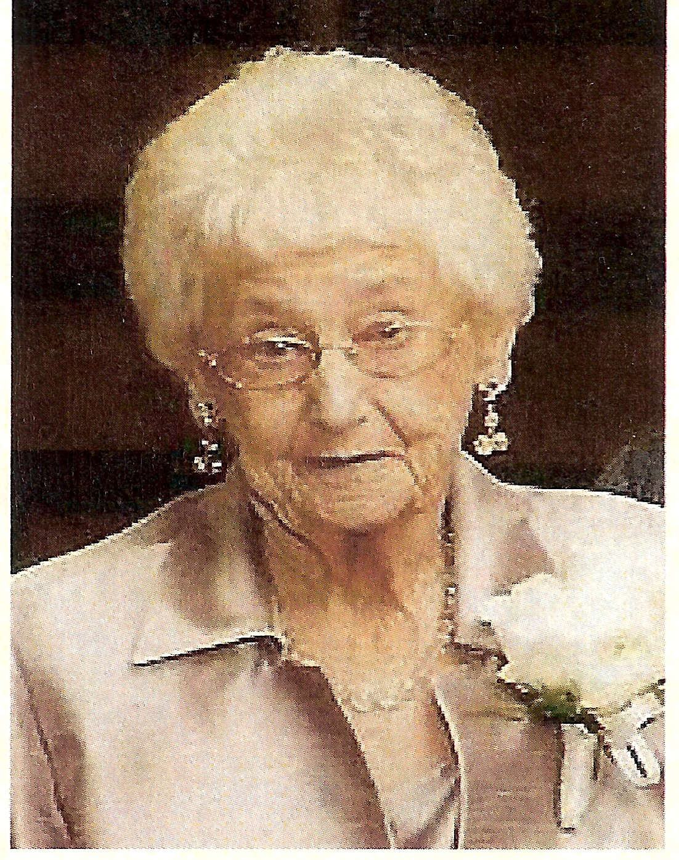
Survivors include her husband of 72 years, Sydney W. Bunnell of Hodgenville, six children: Sydney M. Bunnell and wife Sue of Cave City, James W. Bunnell and wife Jo Nell of Decatur, Ala., Judith Howell and husband William Nelson of Cave City, David L. Bunnell and wife Janice of Hardyville, Patricia Rippy and husband Billy of Russellville, and Marilyn King and husband Ernie of Bowling Green; 17 grandchildren, 26 great-grandchildren and three great-great-grandchildren; sister: Marilyn Hogan and husband Genie of Cave City; sister-in-law: Lou Reynolds of Cave City; and several nieces and nephews.

Mrs. Bunnell was preceded in death by her parents, Munford Buford Pemberton and Grace Galloway Pemberton Reynolds; her stepfather, B. R. (Burt) Reynolds Sr., stepmother, Edith Neff Pemberton; a brother, P.R. Reynolds Jr.; and a sister-in-law Geneva Reynolds.

Funeral services will be 2 p.m. Friday, July 9, 2010, in the chapel of Winn Funeral Home, Horse Cave, with burial in Horse Cave Municipal Cemetery.

Additional material from her Memorial Record:
Born: July 14, 1923; Pallbearers: Kerry Howell, Douglas Howell, Michael Boyd, Christopher Boyd, Adam King, John Douglas King. Officiating: Bro. Mike Tanaro, Bro. Craig Vincent. Congregational Singing Led by: John Paul Grady.

[Ed. Note: Sydney W. Bunnell is 013273 in Claude’s database and is one of the Kentucky Bunnells who have eluded our attempts to connect them to the immigrant William Bunnell. His lineage is: William Bonnel¹, Peter Bunnell², Samuel³, William⁴, Carlos5, Sydney⁶.]

~~~~~~~

William Austin, wra0613@gmail.com or 2720 Hamilton Drive, Endwell, NY 13760, sent a couple of obituaries from the Binghamton [NY] Press and Sun Bulletin, Aug 4, 2010:

Eleanor Connelly
of Johnson City
Eleanor Connelly, 86, passed away on August 2, 2010 after a lengthy illness. She was predeceased by her first husband, Joseph Morabito in 1951, and her second husband of 56 years, Robert Connelly, in 2009. Eleanor is survived by her devoted family, daughters and sons in law, Jo Ann and Jeff Hambright, New Cumberland, PA, Judy and Harold Coons, Red Hook, NY, and Kathleen and Bona Bunnell, Binghamton; grandchildren, Sandy and Bill DeVinney, Kevin and Kelly Hambright, and Bryan Bunnell; great grandchildren, Cade McKenzie, Chloe and Cooper Hambright, and Tyler DeVinney; she is also survived by brothers and a sister in law, Jerry Wilson, Maine, NY, Lowell and Delores Wilson, Lady Lake, FL; her sisters and a brother in law Lois and Paul Franks, Vestal, and Deanne Wells, Gloversville, NY; a sister in law, Rose Connelly, Endicott; many nieces and nephews including a special niece, Rosemary, and husband Bill Collins. Eleanor retired from Three Arrows Corporation in 1986. The family would like to thank the staff of Willow Point Nursing Home for the wonderful care Eleanor received in the last year.
Funeral services will be held at the J.F. Rice Funeral Home, Inc., 150 Main St., Johnson City, Saturday at 10 A.M. Burial will be in Calvary Cemetery, Johnson City. The family will receive friends at the funeral home, Friday from 4-6 P.M. In lieu of flowers, those wishing may make memorial contributions to the Willow Point Nursing Home Memorial Fund, 3700 Old Vestal Rd., Vestal, NY 13850 in Eleanor Connelly's memory.

[Ed. Note: Bryan Bunnell is 370545 in Claude’s database. This obit provides his mother’s name for the database. Bryan’s lineage is: William¹, Benjamin², Benjamin³, Solomon⁴, Benjamin⁵, John⁶, George⁷, Charles⁸, Benjamin⁹, Neil¹⁰, Bona¹¹, Bryan¹².]

Tammy L. Lamond of Eastampton, NJ

Tammy L. Lamond, of Eastampton, NJ passed away on Monday, August 2, 2010 at Virtua Memorial Hospital in Mt. Holly, NJ. She was 52. Born in Johnson City, NY she was a long time area resident who loved the outdoors and activities such as traveling, camping, hiking, and swimming. A veteran of the US Air Force, Tammy was also the Director of Camp Kettle Run for the Girl Scouts of America, a volunteer for the Westampton Recreation Association, and had recently received her bachelor's degree from the College of New Jersey. Daughter of the late Carole Bunnell (nee Omack), she is survived by her husband of over 32 years, Steven; her father, Jack Bunnell; 3 children, Tom Lamond, Michelle Lamond, Aimee Lamond; a granddaughter, Sophia Lamond; three sisters, Robin Kennedy (Steve), Laurie Thorn (Kenny), Lisa McKercher; a mother-in-law, Elaine Lamond; four sisters-in-law, Louise Fritz (Richard), Elaine Schnepp (Jim), Laura Miller (Howard), Barbara Purdom (Chris); and many nieces, nephews, cousins, and friends.
Funeral service will be held 2pm, Saturday at the Perinchief Chapels, 438 High St. Mt. Holly, NJ. Interment will be private. Friends may call at the funeral home on Saturday from 1 pm until time of service. In lieu of flowers, memorial contributions may be made to the Alzheimer's Association , 225 N. Michigan Ave., Fl. 17, Chicago, IL 60601.

[Ed. Note: I was unable to identify Tammy or her parents in Claude’s database. If anyone has information regarding this family, I’d appreciate hearing from you.]

~~~~~~~~

Carol Brotzman, brotzmans@epix.net or R.R. 1, Box 1206, Laceyville, PA, provided the following which was published in The Wyoming County Press Examiner [PA], from December 16 to December 22, 2009.

Alice Clark Lathrop of Springville died Wednesday, Dec. 9, 2009, in Gracious Living Estates, Montrose.
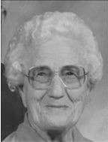
She was born on Nov. 8, 1910, in Montela, N.Y., daughter of the late Charles and Emily Blumenauer Clark.
Alice was a graduate of Ellenville High School, Class of 1928, and a 1931 graduate of Delhi Ag-Tech Teachers College and she taught school in the Delaware Valley School District, N.Y. She was a long time member of the Springville Baptist Church.
Alice was preceded in death by her husband Bunnell Lathrop on Sept. 7, 2001; brother William Floyd "Pat" Clark; and sisters Bertha Beheme, Edith Cox and Lena Hedsall.
Surviving are several nieces and nephews.
Alice and her husband opened their home to the Teachout, Cochrane, Hamman, and Wooden families who resided with them for numerous years.
Funeral and committal services were held on Saturday morning, Dec. 12, from the Springville Baptist Church with its Pastor Roger Rosenau. Interment in Bunnell Cemetery, Auburn Township. Arrangements by Sheldon-Kukuchka Funeral Home Inc., 73 West Tioga St., Tunkhannock.

[Ed. Note: Bunnell Lathrop, actually Edward Bunnell Lathrop, is the son of Louis E. and Eva Louisa (Bunnell) Lathrop. Eva is 330371 in Claude’s database. One of his nieces, Sherri Jeremiah, wrote the following: “To his family, he was called "Uncle Bunn." Not sure why he chose "Bunn" over Edward. Uncle Bunn died in 2001. He was a hard-working, devout and a truly good man. My husband, Jim, is Uncle Bunn's nephew. Jim's mother, Ruby Ursula Lathrop Jeremiah, was Bunn's younger sister (1915-1991). I only met Uncle Bunn and Aunt Alice a couple of times, but Jim speaks of them often and seems to cherish the time he spent on their dairy farm. We were so sorry to learn of Alice's passing this past December. What a wonderful legacy they left behind.”]

Submissions

William Austin, wra0613@gmail.com or 2720 Hamilton Drive, Endwell, NY 13760, provided the following from the Binghamton [NY] Press & Sun-Bulletin for May 30, 2010, commenting that this young man sounds like a real winner.

Bryan Bunnell is a senior in Johnson City, NY, High School. “A member of the concert choir and chamber singers for all of his four years at the high school, 18-year-old Bryan Bunnell has a passion for music. He picked up the violin in third grade and has played in the orchestra ever since. The son of Bona and Kathleen Bunnell, Bryan also captains the varsity swim team, heads the school’s chapter of the National Honor Society and participates in Key Club and the morning news team. Outside of school, he volunteers with the Office for Aging, delivering meals for Meals on Wheels and helping at events such as the senior picnic. He’s also the school salutatorian.

[Ed. Note: Bryan Bunnell is 370545 in Claude’s database. This article and the obituary for his grandmother, Eleanor Connelly above, provide his mother’s name for the database. Bryan’s lineage is: William¹, Benjamin², Benjamin³, Solomon⁴, Benjamin⁵, John⁶, George⁷, Charles⁸, Benjamin⁹, Neil¹⁰, Bona¹¹, Bryan¹².]
~~~~~~~

Rodney Bonnell, May11943@aol.com or 949 Fulton Rd. N.W. Apt#1, Canton, OH 44703, contacted us at the behest of Clem Bonnell, acbonnell@embarqmail.com or 7 Deer Path, Milford, NJ 08848-1928. Clem told him that they were related and that piqued Rodney’s interest. According to my computer they are 5th cousins, once removed. Rodney was two years old when his father died and he lost contact with his Bonnell kinfolk. Claude had info on Rodney and his parents, but Rodney has provided some additional data.
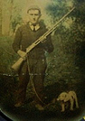
Ralph Hope Bunnell

My father was Ralph Hope Bonnell, died in 1946 and is buried at Farmington Cemetery, Farmington, OH. I was born in Crabapple, OH and we lived in Duncanwood when my father died. Both towns were mining towns and are no longer there.

My mother was Frances Mercy Miller, born April 6, 1910. She later married Ingle Dayton. She died June 10, 1980 and was buried at Warnock Cemetery, Warnock, OH.

My only sibling was Sarah Lucille [Bonnell], born Feb. 1, 1933. She married [Phillip] Elbert. She died Nov. 3, 2007 and was buried at Brookfield Cemetery, Massillon, OH.

Also I don't know if you wanted my children’s names but just in case they are Michelle Louise, Christina Kay, and Teresa Roseanne; their mothers name was Janet (King) Bunnell. We were married 7 years before divorce. Also I have a child named Andrea Hoffman, mother Janet Hoffman.

[Ed. Note: Rodney Louis Bunnell is 352676 in Claude’s database. The information above adds quite a bit of data to the database. Rodney’s lineage is displayed in that section of the newsletter.]

~~~~~~~

Paul Garrity, desangbleu@yahoo.com, from San Bernadino, CA wrote to get some information about Jeannette Bonnell (CB264541). He was doing some research for the local library on the wife of Leland Norton, for whom Norton AFB, CA was named. Between Claude’s website and Ancestry.com I was able to piece together a lot of info for him. In return, the library sent me multiple newspaper clippings about Leland and Jeannette. The photos are from one of those clippings.

Leland was born 12 March 1921 in San Bernardino. In August 1941 he joined the Royal Canadian Air Force, which was fairly common. After the Pearl Harbor attack he transferred to the US Army Air Corps effective in 1942. He served in Labrador, Presque Isle (ME), Greenland, DeRider (LA), and finally in January 1944 he was assigned to the 640th Bomb Squadron in England. Sometime in between all of those assignments, he married Jeannette Bonnell. While attacking a marshaling yard on his 16th combat mission, Captain Norton's A-20 Havoc was struck by antiaircraft fire on 27 May 1944 near Amiens, France. After ordering his crew to bail out, Captain Norton perished with his Havoc. In 1950, San Bernardino Air Force Base was renamed Norton Air Force Base in his honor. Norton AFB was closed as a result of BRAC 1988 in 1994. .
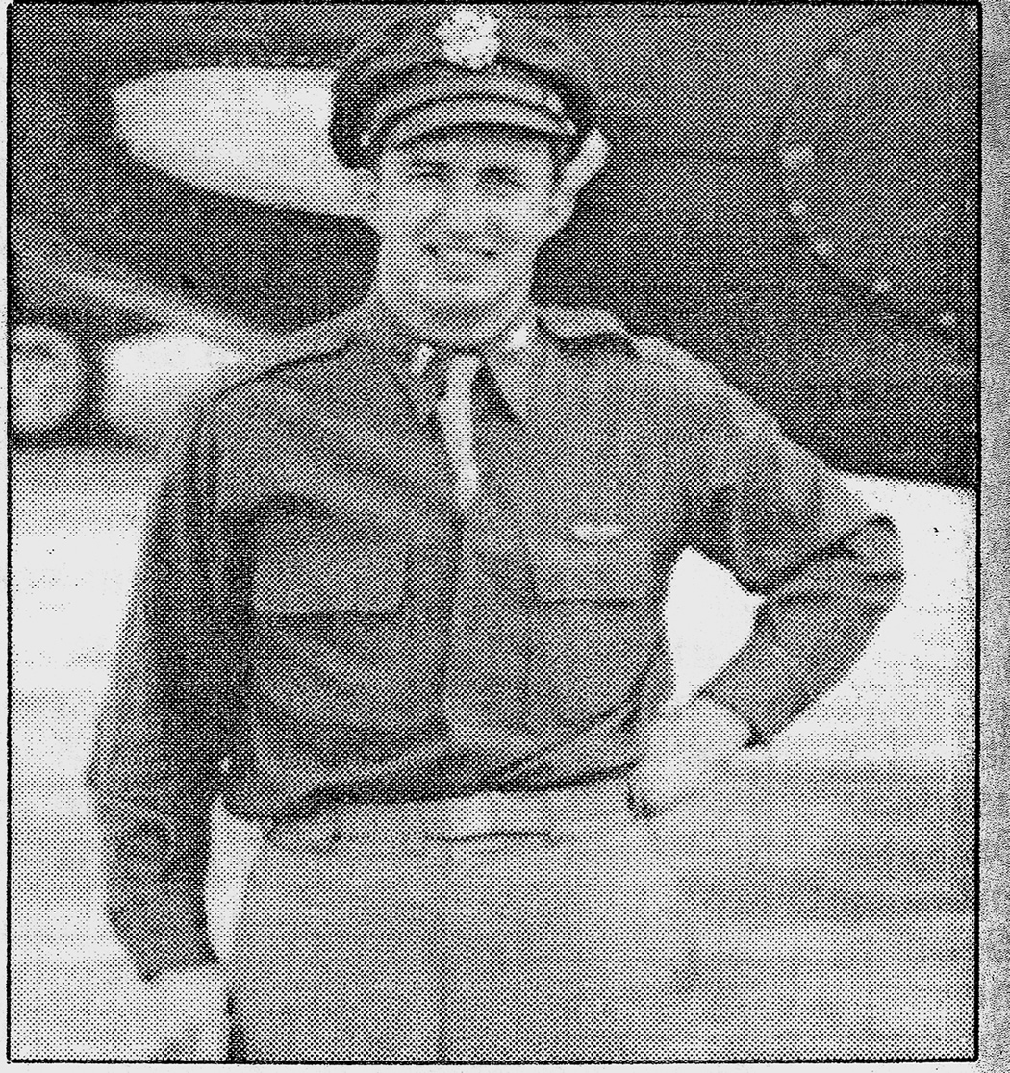
Leland F. Norton

Jeannette was actually born Jeannette Brundage, 1 Feb 1924 in E. Orange, NJ, daughter of Frank and Jeannette (Bonnell) Brundage. In the Bunnell/Bonnell newsletter, Vol. IV, October 1990, page 50 -51 an article states that information provided by Jeannette (Bonnell) Lance said that “When their daughter Nettie died 3 days after the birth of her daughter, Horace and Anna adopted their granddaughter Jeannette. Her name was changed from Brundage to Bonnell, and she was raised like a sister to her aunt Agnes.” The 1930 census shows Jeannette Bonnell to be the adopted daughter of Horace Bonnell. At this point her life becomes very interesting and Paul Garrity provided most of this information
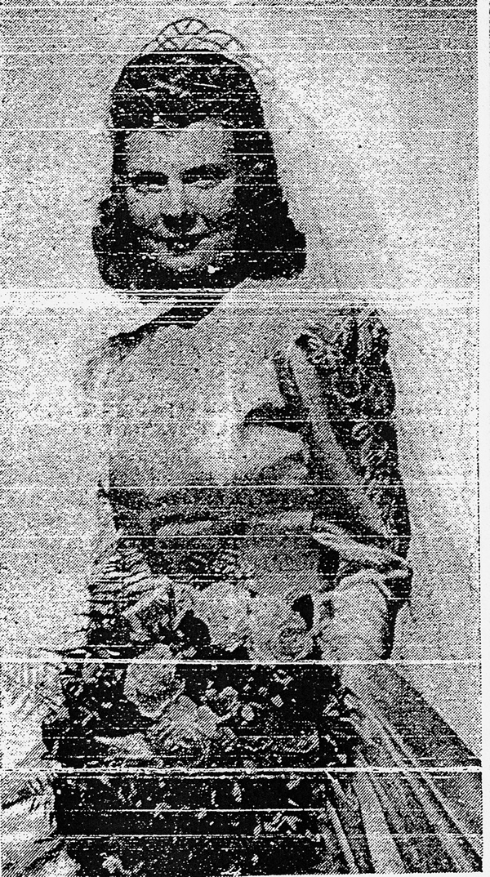
Jeannette Beatrice Bonnell - 1943 Wedding photo
In 1943 she married Leland Francis Norton. He was killed 11 months later in France.
In 1945 she married John Gill, who was a chief pilot of Eastern Airlines. It appears, based on her 3rd husband’s obituary, that she and Gill had at least two children; James H. Gill and Roberta Gill. James was a Navy Lieutenant at one time and his wife was Christina ____, of Santa Fe, New Mexico. Roberta Gill married Samuel Oliver and they were residing in Union Township, NJ by 2007. John died in 1966.
In 1970, Jeannette married Wesley L. Lance who was born on November 21, 1908, in Glen Gardner, Hunterdon County, New Jersey. Wesley was an active politician who was elected as a Republican to the New Jersey General Assembly from Hunterdon County in 1937, 1938, 1939 and 1940. He served in the NJ State Senate, resigning in 1943 to enter the U. S. Navy. Later he served again in the NJ State Senate and was a member of the NJ Bar and practiced law in Clinton, NJ for 70 years Jeannette died 30 Mar 2002. Wesley died 25 Aug 2007 and was buried in the Spruce Run Cemetery, Glen Gardner, Hunterdon Co., NJ. Jeannette’s lineage is William¹, Nathaniel², Isaac³, Abraham⁴, John⁵, John⁶, John⁷, Mahlon⁹, Horace¹⁰, Jeannette¹¹, Jeannette¹².

~~~~~~~

Ann Marie Middleton, ammidd67@att.net or 204 S. Columbian, Bay City, MI 48706, previously sent information on brothers Willard and Lafayette Bunnell, which I printed in the February issue. She has since received more information from the Winona County Historical Society in Michigan, where the Willard Bunnell House is. From the archivists, Marianne Mastenbrook and Walt Bennick, Ann received information on the Bunnell graves that were originally near the Bunnell House there.

“From what we have found out, the graves were moved from the Bunnel House property and put on the land that belonged to the Smith Family in Homer. However, these graves are only marked with "rocks" and the area is not taken care of as a Cemetery. It is very, very hard to get to and a resident of Homer provided a map for us, and if someone goes, she must lead the way. [Marianne Mastenbrook]”
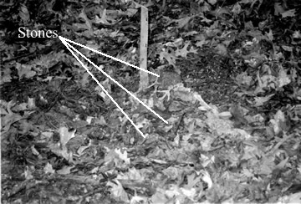
“Ann Marie - Please find photos and the Bunnell Grave Site attached. The grave site is along the top of a narrow ridge that extends up from the Bunnell House. It is leaf covered and the tomb stones are but pieces of limestone that have been placed at the head and foot of each grave. They are not marked, or at least no markings can be seen. It has been reported that there are nine graves at the site, but I counted only a couple of "markers." The markers are difficult to seen. On the b/w photos I tried contrast to enhance the stones, they are near the center of each photograph. - Walt Bennick, Archivist”

[Ed. Note: Six photos were provided; 3 color, 3 B&W, none that showed anything like a pile of stones even.]
~~~~~~~

Steve Bonnell, slbnl@KBSB.com or 1523 Good Shepherd Rd, Montoursville, PA 17754, has been corresponding with Robert Bonnell of Oswego, NY who provided the burial location for his father. Warren L. Bonnell, CB350699, was buried at St. Mary’s Catholic Church, South Corning, NY.

Research Findings

In March I wrote Claude the following:

Hi Claude,

1840 census, Marion Co., Washington Twp.[IN] shows

Ellis Bunnel 1/2/0/2/2/1 2/0/1/1

I think this might be a son of James [310264] and Elizabeth (Ellis) Bunnel, though the proof is very circumstantial. I can’t find this Ellis in the database. Did I miss him someplace?

On the same page is:

Elizabeth Bunnel 0/0/0/0/1 2/0/1/0/1
This is the widow of James Bunnel

Claude agreed and wrote:
Hi Charlie,
You sure made some great connections on the Ellis Bunnel note. I was able to connect an Ellis in the db and found his 2 children who both died single. Look at member 310264 James and see the extension of his line in the db. Many thanks for the note that made the connections. Claude.

So we have connected a branch (Ellis) to the tree.

Queries

Gwen Osborn, owltrees623@gmail.com, wants to know about her grandmother. She wrote;

I wonder if you might tell me if I can find anything on Anna Bunnel Scott McKnight. I am her granddaughter. I think [she was] born in New Jersey ,moved to Wisconsin, married Scott, he was killed in Civil War, she had three children, married Georg W. McKnight , they moved to Iowa Nebraska area and finally passed away and is buried in David City Nebraska, in 1927. I was only one year old when she passed away so I only am coming up with this information from what my family told me many years ago. The three Scott children stayed in Wisconsin under the guardianship of some one else, I always thought it was her husband's family but I guess it was someone else.

I really thank you for your time....Gwen

[Ed. Note: I could not find this Anna Bunnell. I may have found Anna McKnight in the 1910 census in David City, Butler Co., NE but I can’t be sure that it is her. The census showed her born in PA, not NJ. but it did show this as her (and his) second marriage, which took place in 1867 which makes sense with the above info. She would have been born about 1845. If you have any clues here please pass them to me and Gwen. I don’t have her snail mail address, so if you don’t use e-mail just mail me the info and I’ll get it to her.]
~~~~~~~

In the February issue, page 11, I introduced Belinda Pruett, belindap@ncmodulars.com or 179 Bailey Thomas Road, Sanford NC 27332 [new address], who is researching her Bunnell ancestors in North Carolina. She provided some additional information.

“What I do know is that Mary Lee Bunnell’s father was William P Bunnell.(Some census records shows a T instead of a P but it is a P). Her mother was Beulah Scoggin(s). Mary Lee was born August 17, 1907 and died April 20, 1993.

Her siblings: Robert “Bob” Bunnell born 04/23/1910 died 02/10/1980, Barney Leighton Bunnell born 06/13/1905 died 05/01/1963 he married Eliza Carter, Annie “Top” Bunnell born around 1913 she had children Nancy Ann and Jim John (this is all I know about her for now), Jane Bunnell, and Susan Bunnell who married a man with the last name Britt, Haywood Bunnell born 05/18/1922 died 01/24/1990 he married Doris (don’t know maiden name). William P & Beulah also had a baby girl born and died 17 Sept 1919.

Mary Lee Bunnell married James Roden Fore.

These Bunnells were from the Harnett, Moore, and Lee County areas of NC.

I do know that my father and I went to visit a church and I forget the name of the church but I saw Durham P Bunnell’s grave. I can’t be sure but I am pretty sure I saw William P Bunnell’s grave there too-anyway I do know that my dad told me this is where some of our family on the Bunnell side was buried. Therefore, I am thinking William P has to be tied in to Durham P some how-some way.

I plan to visit that church again as soon I find out the name of it and if the rain will finally go away here!”

Since that e-mail she has visited the church and graveyard (Piney Grove Church, Cameron, NC). The gravestone for William P. Bunnell is there and shows a death date of 1961. Likewise, Durham’s gravestone is there and shows a death date of 10 July 190X.

Biographies

From History of Hamilton County, Ohio, Compiled by: Henry A. Ford, A. M. and Mrs. Kate B. Ford; L. A. Williams & Co. Publishers 1881; Pages 316-317.
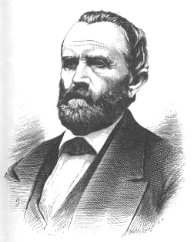
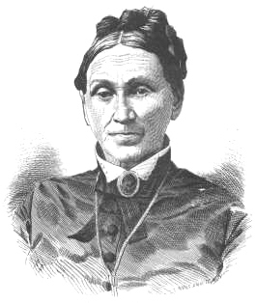
Marcus Seneca BONNELL, a prosperous farmer, occupying a beautiful residence on the dividing line between Harrison and Crosby townships, five miles northeast from Harrison and two miles northwest from New Haven, is a grandson of Aaron BONNELL who came to the Miami country in 1805, with his brothers Benjamin and Paul, and his married sisters, Rhoda and Abigail - a strong delegation for one family at one time. They were all children of Benjamin and Rachel BONNELL, who came from England and settled in New Jersey, where their family was reared. The father was drowned in the East river, near New York, with ten others. November 10, 1798, on a boat crossing from the city to Brooklyn, upon which a number of casks of rum rolled to one side and overturned the frail vessel, with the terrible results above noted. He was then seventy-five years old. His wife survived him until 1812, when she departed this life, in the eighty-fifth year of her age. Aaron, the seventh child and fifth son, was born March 4, 1759, it is believed in Essex county, New Jersey. He was a brother-in-law to Judge Othniel LOOKER, the distinguished pioneer who settled near Harrison in 1801; they having married twin sisters - Judge LOOKER, Pamelia, and Mr. BONNELL, Rachel CLARK. They had six children - two daughters and four sons, of whom the father of the subject of our sketch was one - Clark BONNELL, born November 18, 1790, in New Jersey. His father, Aaron, was the only one of the BONNELL colony who settled in Harrison (formerly Crosby) township, the others stopping in the neighborhood of Carthage and taking farms there. Aaron entered the northwest quarter of section eighteen, due north of the subsequent site of Harrison village, in the valley of the Whitewater, improved the place, and remained there until his death. During his lifetime he drew a pension as an artificer for the Government during the war of the Revolution. His wife also died upon the old place near Harrison. Some time before the death of his parents, Clark BONNELL, who had learned, in part, the trade of a shoemaker in New York State, before the removal of the family to the west, was married to Miss Elsey WYKOFF of a family residing near Harrison, on the Indiana side and removed to the village, where he pursued his trade for many years and then removed to a country neighborhood in Ross township, Butler county, five miles from Hamilton, where he continued to follow his business. Remaining here about five years, he removed to New London, Butler county, where he lost his wife by death. She was born February 7, 1794, and died in September, 1835. Her husband died in Cincinnati in 1864, in the seventy-fourth year of his age. Their children numbered nine, of whom Marcus Seneca was the third, and the oldest son. He was born upon the old place near Harrison. in a cabin where his father was then residing, November 8, 1816. He had some schooling in the poor "subscription schools" of that day, which he attended for brief periods as the pressing labors of the farm and workshop would allow and in due time learned his father's trade, beginning to help in a small way when he was but nine years of age. He did not take kindly to the business, as it was too confining, and he was strongly predisposed to farm life; so he did little at shoemaking after he was fifteen years of age. For about eight years he served as a farm hand at various places in Hamilton and Butler counties, by the month or year, and for the next two years worked Judge ANDERSON's farm in Butler county,' "on shares." Then for two years he similarly farmed the old place near Harrison, which had become the possession of his grandmother. He also managed it a similar term for the purchasers of the farm after her death - Messrs. George ARNOLD and Peter RIFFNER. The latter was father of Martha R., who became the wife of Mr. BONNELL December 8, 1842. He was now residing on a rented farm on the other side of the Whitewater, in the edge of Indiana, where he remained a year and removed to the FROST farm, on LEE's creek, in the north part of the township. This he occupied, on five-year leases, for the period of fifteen years, and so successfully that he was enabled to purchase the one-hundred-and-forty acre tract upon which he now lives, in 1856, two years before his last lease expired. To this he removed at the expiration of his lease, and here he has since resided, adding one hundred and fourteen acres to his original purchase, and making a farm of such high excellence and reputation that the award of the premium offered in 1880. by the Hamilton County Agricultural society, for "the best farm of forty or more acres, in the general plan of buildings, fields, fences, and the skill shown in drainage and general cultivation of the several kinds of crops, in care of stock, implements, and tools, etc.," was made to Mr. BONNELL, after careful inspection of his place by a committee of the society. He has, among other improvements, as many as twenty-two and one-fourth miles of under-draining. In 1860 he built the fine residence in which he now lives and which appears to advantage in our illustration of his premises. He has devoted himself to his business, taking little interest in politics and holding no public offices. He has been for many years a member of the lodge of Odd Fellows of Harrison.
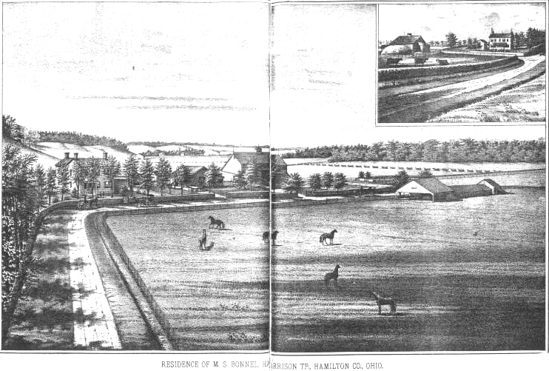
Mrs. Martha Riley BONNELL was the third daughter of Peter and Elizabeth RIFFNER, and was born February 11, 1815, at the old home near Harrison village. She is still surviving, in a hale and happy age.
Their children have been:
Elizabeth Isabel, born September 23, 1843; married John S. BOWLES of Harrison township, December 22, 1866, a farmer, who went to South America in 1874 and is believed to be dead. She now resides with her parents.
Clark Marion, born March 18, 1845; married Sarah BUTTS September 11, 1872; died January 21, 1880.
Peter RIFFNER, born April 20, 1847, died May 22, 1874.
William Riffner, born March 30, 1849, married Miss Jennie COOK December 5, 1870; lives in Henry county, Indiana, a carpenter.
Stephen Easton. born June 21, 1851; died May 6, 1875.
Elsey Alice, born May 5, 1853; married William BUTTS, a farmer of Crosby township. February 29, 1872; died March 26. 1873.
Emma Angeline, born March 21, 1855; died September 10, 1855.

~~~~~~~

Patricia (Howell) McKinley, patm1938@sktc.net or 925 Road 2, Cedar Vale, KS 67024-9052, sent a biography of her grandfather William “Billy” Bonnell. Pat goes on to say that like Billy, her parents, her husband, her and their three children have all been in the rodeos. Billy is being recommended to the Cowboy Hall of Fame in Oklahoma City. I have taken the liberty of editing the bio and hopefully have retained the meat of it.

W.S. (Billy) Bonnell was born in Mayetta, KS July 19, 1877 and began roping and breaking horses at an early age along with his two younger brothers. At the age of 12, after the death of his father, he rode a horse from Gravette, Arkansas to Ponca City, Oklahoma to work for the ranches of Moncravy and Fuller as a way of helping the family income. While cowboying on the ranch he soon perfected a method of tying a calf that was faster than others at the time. Billy and his two brothers worked with the Pawnee Bill Wild West Show and participated in the filming of a motion picture which sadly no longer exists. In fact, Billy and his wife Mary wired money to Europe for the brothers to come back to the U. S. when the European tour went bust. Billy also worked with the 101 Ranch Wild West Show and was well acquainted and traveled with many of the people there including Bill Pickett and Lucille Mulhall. In fact, he named his youngest daughter Lillian Lucille after his good friend Lucille Mulhall.
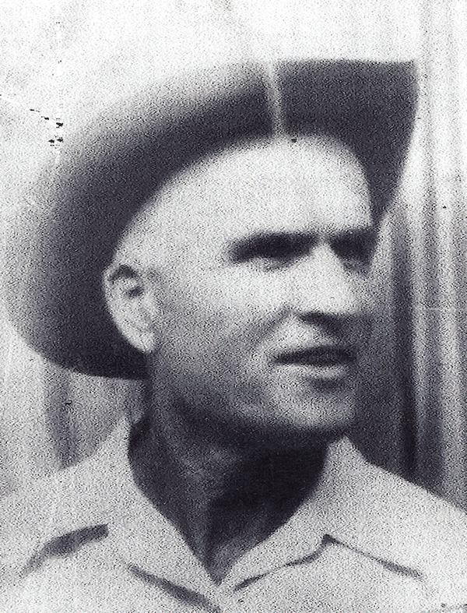William Sanford Bonnell

Billy’s horse Romeo, which he used for many years was considered one of the world’s best roping horses. Many record holders and great people rode and appreciated Romeo’s skills and personality, including Tom Mix, Buffalo Vernon, Ellison Carroll, Fred Beason, and Lucille Mulhall.
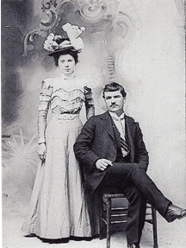
William & Mary (Nicholas)
Bonnell Wedding Photo 28 Jan 1900

Billy helped organize and produce “Ropings and Ridings” or Roundups” as many Rodeos were called then, in the south central Kansas and north central Oklahoma areas and was a co-founder of his local polo club, in Cedar Vale, KS. His first newspaper documented win that we have found in steer roping was in October 1907 in Stroud Oklahoma, at 24 seconds. He broke the current world record in calf roping in Cedar Vale, Kansas in August 1909 at 25 seconds. The original rules required much more of a roper as the calf got a much longer head start.

Billy competed at the Stampede in Calgary Canada in 1912 and is listed in the book “Man, Beast, Dust” as one of the important contestants of that year who did command performances for the visiting royal family from England. Billy booked a box car under his name to leave from Arkansas City, Kansas for the horses of the group from this area competing and traveling to the Stampede in Winnipeg, Canada in 1913. Among the group were Henry Grammer, Joe Gardner, George, Bert and Charles Weir, and Lucille Mulhall, only to find out that when returning at the custom house at the border one member had sold his horse. Whereupon Billy was detained to get the papers proving the sale and accounting or the difference in the livestock count. That year of the Stampede Bill Bonnell, Joe Gardner, W. Hale, Charles Johnson, and Bert Weir were declared the world’s champion steer roping team.

No Rodeo or roping was too big or too small for him. In the 1920’s, in his mid forties, Billy Bonnell continued to rope in more local competitions rather than traveling far away. This allowed him to attend to his family, land, and livestock obligations at home. He broke and trained horses for roping, racing, work teams and polo through the years. He taught and encouraged many young cowboys and his own daughter and granddaughter to compete and entertain in rodeos. He saw his friends at the ropings and kept pace with the winnings, even beating his friend Ben Johnson at Winfield, Kansas July of 1920. Billy continued to train horses and compete into his older age. At the age of 64 years old Billy won 2nd place at Moline, Kansas competing against ropers less than half his age. He died on June 4, 1951 at 74 years old with many paying their respects. Ben Johnson, Jr remembered him fondly to members of our family and stated that he deserved to be in the Cowboy Hall of Fame. He has become a part of local history and folklore, and is fondly remembered by his family.

[Ed. Note: The Ben Johnson, Jr mentioned above was a rodeo cowboy, Hollywood stunt man, actor, and rancher who was in several movies with John Wayne. William Sanford “Billy” Bonnell is 002590 in Claude’s database. His lineage can be seen in the Direct Lines entry by his granddaughter, Pat (Howell) McKinley.]

Books

While doing one of those “fishing expeditions” in Google Book Search I ran across one listing titled The Shapley Connection which is or was a family history and genealogy newsletter. The listing provided only a snippet of the October 1989 issue, but it was discussing a William Bonnell born in England about 1610, son of Benjamin. So I again turned to John Grady to see if he could find the full page or pages of material. As always, John came through and mailed me a copy of the article. Unfortunately the portion of the article dealing with the Bunnell Ancestry in England was directly from Ruth Duncan’s book, William Bunnell and his Descendents and from William Austin’s’ discussion of the Huguenot connection and Benjamin being the father of William. This author’s final statement was “All of which is to say that William Bunnell’s ancestry remains in doubt.” So we found no new material but we have checked off one more reference that we had been looking for.
Post Script

The attached pages are a listing of all the research “books” I currently have. Books is in quotes as many of them are CDs and others are just extracts of the pages containing Bu/Bo material. But, if you are looking for info that might be in one of these books, let me know and I’ll be glad to do a search for you. If you have high speed internet I can post it on our web page and you can download it. If you don’t use internet I can mail you the pages that are of interest to you.

This is the first issue that isn’t 20 pages long, but hopefully it still contains sufficient material to hold your interest. There certainly is a variety.

Til the November issue, keep digging and sharing. And Happy Halloween and Thanksgiving.

Charlie & Pat

