By Patricia Bunnell

BUNNELL BONNELL BUNNELL BONNELL BUNNELL BONNELL BUNNELL BONNELL B
UNNELL | THE BUNNELL/BONNELL NEWSLETTER |  |  |  | ONNE  L  L
B |  |  |  |  | B
O | Volume IV, No. 1. |  |  | 1 January 1990 | U
N  N  E  L  L |  | Published by  William R. Austin  P. O. Box 62  Laceyville, PA 18623  (717) 869-2325 |  |  | N  NE  L  L
BUNNELL BONNELL BUNNELL BONNELL BUNNELL BONNELL BUNNELL BONNELL B

CURRENT COMMENT

For this issue I am glad to report an increase in the number of news items that have been submitted. In order to include them all, the Newsletter is longer than usual and some materials have been postponed to a later issue. Keep up the good work. The more you participate, the better our Newsletter becomes.

* * *

Claude Bunnell called by attention to the fact that in the last Newsletter I gave you incorrect CB Database numbers for two of the Revolutionary soldiers. On page 2, the correct number for Amos Bunnell is CB300098, not CB 300006. On page 4, the correct number for Jacob Bonnell is CB310235, not CB300162. I’m sorry for the errors.

* * *

On the 25th of September Marian and Ralph Bunnell, CB350620, paid us a visit. Ralph was born here in Laceyville, and while he has spent almost his entire life in the Buffalo, NY, area, he and Marian have visited here often and are widely acquainted here. Besides Ralph’s Bunnell ancestry, we shared information on several other local families to which he is related.

* * *

The following day my wife and I left for a brief trip to Washington, D.C., and spent a few hours in the DAR Library, the National Archives and the Library of Congress. I didn’t find anything new and earth-shaking about the Bunnell family, but did get copies of a number of articles on the family to serve as back-up information.

* * *

On the 21st of November Jack Mowry, North East, PA, called to tell me about the TV broadcast the next evening on the educational television channels which would focus on Yosemite National Park and the role of Lafayette Bunnell in its discovery. Since we don’t have a television set, I called my daughter-in-law and asked her to tape the

program. On Thursday we went to their house for Thanksgiving dinner, and they played the tape for us. The words of Lafayette Bunnell’s journal, read by Robert Redford, served as background for the program. Thanks, Jack, for bringing it to my attention. I hope that many of you had the opportunity to see it.

* * * * * * *

NEWS ITEMS

Ruth Duncan, West Simsbury, CT, sent in two current clippings. The first is from the Hartford (CT) Courant, 27 August 1989.

Bunnell----Fay

Maria Fay and Andrew Warren Bunnell, both of Farmington, were married Aug. 12 at 12:30 p.m. The wedding ceremony and reception took place at the Webb House Barn, Wethersfield. The Rev. John Macort officiated. The bride is the daughter of John W, and Anne M. Fay of Mystic. The bridegroom is the son of Willard W. (CB360091) and Deborah W. Bunnell of Madison.
James J. Mahoney was attendant of honor; bridesmaids were Mari-Kim Bunnell, Jane E. Connelly, Jennifer A. Farrington and Annemarie Eck Rucker.
Christopher M. Hylan was best man; ushers were Douglas W. Bunnell (CB370287), Bruce W. Bunnell (CB370288), Thomas W. Bunnell and David V. Cronin Jr.
The couple left for the British Virgin Islands after the reception. They will live in Farmington.
The bride, a graduate of Northeastern University, Boston, is employed by Accountemps, Hartford. The bridegroom, a graduate of Hobart College, Geneve, N. Y., is a special worker for Community Health Center, Middletown.

* * *

The second article Ruth submitted is an obituary from the New Haven (CT) Register:

Lawrence Bunnell, 83

NEW HAVEN – a Mass of Christian burial will be celebrated Thursday at 10:30 a.m. for Lawrence V. Bunnell 9CB000608), 83, od 7733 White Fir, Houston, TX, formerly of New Haven and Guilford, who died Tuesday, Aug. 15, 1989, at his home. He was the husband of the late Rosamond Bishop Bunnell.
The Mass will be at St. Mary’s Church, Hill house Avenue. Burial will be in All Saints Cemetery, North Haven. The Sisk Brothers Funeral Home, 128 Dwight St., is in charge of arrangements.
Mr. Bunnell, son of the late Emil (CB000133) and Rose Lowenstein Bunnell, was born in New Haven, Aug 3, 1906, and lived in Houston for 16 years.
He retired in 1969 as a general merchandiser manager with the Beechnut Life Saver Co., where he worked for 39 years.
He was a former member of the Madison Country Club and past president of the New Haven Apron Club.
He leaves a daughter, Nancy McCrory of Houston, with whom he resided; and two grandchildren. He was predeceased by three brothers, Emil (CB000607), Joe (CB000606) and Richard (CB000609) Bunnell; and a sister, Amy Liotard (CB000132).

Judy Osborn, St. Petersburg, FL, also sent in two notices. First is the obituary of her grandmother, Beth E. (Bunnell) Osborn Augustine (CB350226). Mrs. Augustine was also the mother of another of our subscribers, Nina (Osborn) Roberts, Jennings, MO.

Beth E. (Bunnell) Osborn Augustine, aged 90, died on Wednesday, 25 Jan 1989 in a nursing home in Bremen, Indiana after a series of strokes suffered over the past four years. She was laid to rest next to her 2nd husband in an Augustine family plot in the Pinhook Cemetery, Pinhook, Indiana on Monday, 30 Jan 1989.
Beth was born 29 Aug 1898 in La Porte Co., Indiana the daughter of Clark Bunnell (CB340392) and his wife Etura Josephine Long. She was first married on 28 Aug 1919 to Leland John Osborn (10 Aug 1899-living), son of William Nathan and Cora Alice (Goodwin) Osborn, at Wanatah, La Porte Co., Indiana. Beth and L. J. had four children…Nina Cora, Evadna Lela, Clark Leland, and DeVerle Ross…between 1920 and 1925. They were divorced in 1935 and Beth was remarried to Elvin M. Augustine on 06 May 1942. Elvin and Beth retired from their Indiana farm to Magnolia Springs, Alabama, until Elvin’s death a few years ago when Beth decided to remain permanently again in Indiana.
Beth is survived by her daughter, Nina (Osborn) Roberts, and both of her sons. Also surviving are twelve grandchildren: Craig Richford Roberts, Judith Locke Osborn, Mark Leland Osborn, Bradford Lee Osborn, Pamela Beth (Osborn) Hartman, Celia Terese (Osborn) Larson Lewis, Donna Sue (Kruszewski) Woods, Leslie Denise (Roberts) Doty, Andrea Helaine (Osborne) Hartman, Henry Leonard Kruszewski Jr, Randall Ross Osborn, and Beth Ellen (Osborn) Schieren Whitman. We will all miss her.
Memorial gifts are being made in loving memory to the United Church of Christ, Bourbon, Indiana and the United Church of Christ, Bremen, Indiana…gifts which we know she would have wholeheartedly approved.

* * *

On a happier note, the other notice from Judy Osborn is a birth announcement:

Joseph Arthur Lewis, son of James and Celia Terese (Osborn) Larson Lewis, was born 12 April 1989, St. Petersburg, Florida. Joseph and brother James Perry Lewis are William BUNNELL descendants through their mother’s paternal grandmother Beth E. (BUNNELL) Osborn Augustine, daughter of Clark BUNNELL (Abraham Runyan, Nathaniel, Nathaniel “PegLeg”, Stephen, James, Nathaniel, Nathaniel, William) and wife Etura Josephine Long, whose pictures appeared in Vol. III, No. 1, page 6 of the Newsletter.

* * *

Kenneth H. and Patricia Bonnell, Grand Rapids, MI, wrote that their daughter Elizabeth Kay Bonnell was married on 28 October 1989 to Brian Lee Burgess, son of Vernon and Carol Burgess of Jenison, MI.

The July-August issue of The Genealogical Helper, under the heading “Here And There,” on page 163, carried the following item:

“Winners of the 1988 Genealogical Newsletter Competition sponsored by the National Genealogical Society are the Morris Area (N.J.) Genealogy Society, the Colorado Genealogical Society, Inc., and the Michigan Genealogical Council. The winners were announced on 18 May at the NGS Conference in the States in St. Paul, Minnesota.
“The Morris Area Genealogy Society, P.O. Box 105C, Convent Station, NJ 07961-0105, is the winner in Class I (societies with fewer than 300 members). The quarterly newsletter of this society formed in February 1988 provides indexes and abstracts of unpublished Morris County sources, a column on computers and genealogy, queries, and new acquisitions of the Local History and Genealogy Department of the Morristown and Morris Township Library. The editor is Sharon Holley.”

Sharon Holley is a subscriber to the Bunnell-Bonnell Newsletter, and we offer her our congratulations.

* * *

Mrs. Ralph Bunnell, Kenmore, NY, sent along the following obituary from a Buffalo, NY, newspaper:

BUNNELL—Lois A. (Clift)
Of Endicott, NY formerly of Cheektowaga, November 14, 1989; wife of the late Lewis O. Bunnell; mother of Richard and Dean (Deborah) of Endicott, NY; also survived by six grandchildren; predeceased by several brothers and sisters. Friends may call Thursday 2-4; 7-9 at the HOY FUNERAL HOME INC. 3855 Seneca St, West Seneca, where funeral services will be held Friday morning at 10:30. Friends invited.

* * *

Gary Osborn, Hobe Sound, FL, wrote, “I should have sent the following obituary long ago for my cousin who passed away two years ago.”

Charles R. “Ray” Bonnell (CB011956), 93, 3530 Tyrone Blvd., St. Petersburg, FL. Died Thursday, 29 October 1987 in Erie, PA. He was born in Waterford township, Erie Co., PA. 27 July 1894, a son of the late Jesse Coover Bonnell (CB004273) and Phoebe Blakeslee Bonnell. Mr. Bonnell was retired from Bucyrus Erie, where he had been an assembler for many years. Since retiring he had spent his winters in Florida and his summers in Erie County. His wife Sarah Crook May Bonnell died in 1973. Burial was at Waterford Cemetery.

* * *

Gary Osborn also sent an interesting article from the Okeechobee 9FL) News, Friday, 17 November 1989. A picture of Lori Beth with President Bush accompanied the article. Excerpts from the article begin on the next page:

Local girl visits with the president

Lori Beth Bonnell, of Okeechobee, was in awe when she was invited to the White House to meet with President George Bush.
Lori and her family all flew to Washington, but only Lori, her mother, Katie, and her father, Rick, were allowed to go into the White House.
With Lori Beth was Anthony Smith of Columbus, Ohio who is better known as Bumper.” Lori and Bumper represent the Sickle Cell Anemia Foundation as National Poster Children.
. . .
Lori said she was overwhelmed at the whole idea, but remembered a few things clearly. One was that the president was fun. He talked to her about his own grandchildren and pointed out pictures of his grandchildren on his desk.
. . .
President Bush signed posters of himself to Lori’s brother, Tony, and for her class at Grace Christian School.
He gave Lori Beth a stick pin with the Presidential Seal on it and his name printed on the back. She said she was very impressed with this gift.
. . .
Lori Beth has more duties coming up in the next few months as poster child. She has been chosen to throw out the first baseball at a fundraiser for Sickle Cell Anemia in February. The benefit will be held between the National and American Leagues at Boardwalk and Baseball in Orlando.

* * *

The following obituary appeared in the Towanda (PA) Daily Review on Friday, 7 April 1989:

Mildred M. Bunnell, 85

Mildred M. Bunnell, 85, of State College, PA., died Sunday morning at the Sentre Community Hospital.
She was born in State College on April 17, 1903, the daughter of the late Harry N. and Rushie Ramsey Musser. She was a graduate of State College High School, a member of the Grace Lutheran Church of State College, with her entire life spent in State College.
She was preceded in death by her husband, Millard T. Bunnell (CB001828) on Sept. 27, 1975. She is survived by two sons, Theodore Robert Bunnell (CB001865?) of Clearwater, Fla., formerly of Towanda,; and Richard Musser Bunnell (CB001829) of Boalsburg, PA.; a daughter, Mrs. J. Nancy Franks of Essex Falls, N. J.; 10 grandchildren; a brother, Harry W. Musser of Stuart, Fla.; a sister, Mariam V. Musser of Miami Shores, Fla. She was preceded in death by two brothers, Chester and Lee Musser.
Services will be held at 11 a.m. Friday at the Grace Lutheran Church, State College, with Rev. Robert M. A. L. Miller, officiating. Burial will be in Centro County Memorial Park.
The family will provide the flowers and memorials may be directed to the Grace Lutheran Church, Garner and Beaver Avenue, State College, Pa., 16801, in her memory.

The next obituary, that of Joseph J. Bunnell, appeared in the Tunkhannock (PA) New Age-Examiner on Tuesday, 17 October 1989.

J. J. BUNNELL

J. J. Bunnell (CB341679), of West Avenue, Meshoppen, died Friday evening, Oct. 13, 1989, in Tyler Memorial Hospital, Tunkhannock, following an illness.
Born in Tunkhannock Nov. 3, 1913, he was the son of the late John L. (CB330824) and Katherine Gilmartin Bunnell.
He was a retired state school auditor. He was a personal friend of Gov. Robert P. Casey. Previously, he was self-employed for more than 40 years as an egg wholesaler, operating as Bunnell’s Egg, Meshoppen.
Mr. Bunnell was a member of St. Joachim’s Roman Catholic Church, Meshoppen, and its Holy Name Society; and the Knights of Columbus, Tunkhannock.
He served as a state Democratic committeeman for Wyoming County and was a past secretary of Meshoppen Borough. He also served as an Elk Lake School Board director.
He was preceded in death by a son, Arthur (CB351340), in 1957.
Surviving are his wife, Mary, to whom he had been married 50 years; daughter and son-in-law, Dorothy (CB351341) and Charles Fix, Livingston; two sons and daughters-in-law, Charles (CB351343) and Patricia Bunnell, and John V. and Shirley Bunnell, both of Meshoppen; sisters, Margaret Bunnell (CB341680), Cranford, N. J.; Mrs. Rose McCrossen (CB341678), Meshoppen; grandchildren, Heather Fix, Stacey, Jodie and Jonathan Bunnell.
Funeral services were held Monday from Sheldon Funeral Home, Main Street, Meshoppen, with a Mass of Christian Burial in St. Joachim’s Church, with the Rev. Patrick McDowell officiating.
Interment was in the parish cemetery.

* * *

The next notice also appeared in the Tunkhannock New Age-Examiner, for Friday, 6 October 1989.

--Sgt. George L. Bunnell (CB351947), U. S. Marine Corps, recently received a certificate of commendation for outstanding performance of duty while serving as a French hornist, pianist and vocalist in the Fleet Marine Force, Pacific Band, Camp H. M. Smith, Hawaii, from January 1986 to January 1989.
He is the son of Mr. and Mrs. George L. Bunnell (CB340332), Corning, N.Y. Both are former teachers at Tunkhannock High School.
Sgt. Bunnell was commended by his commanding general for performing his duties in “an exemplary and highly professional manner.”
“Sgt. Bunnell greatly added to the band’s ability to perform in a wide variety of idioms,” the commendation says. “His dedication to self improvement and mission accomplishment set an outstanding example for all to emulate. Sgt. Bunnell’s enthusiasm, initiative and loyal dedication to duty reflect great credit upon himself and were in keeping with the highest traditions of the United States Marine Corps.”

Last is an obituary which appeared in the Press Sun-Baltimore, Binghamton, NY, on Wednesday, 16 August 1989.

Lotta D. Bunnell
Formerly of Endicott

Lotta D. Bunnell, of 87 Hillcrest St., Torrington, Conn., died Tuesday, August 15, 1989 after a short illness. She was predeceased by her husband, Horatio D. Bunnell (CB340262), in 1962. She is survived by one daughter and son-in-law, Lillia (CB351998) and Paul Boland, Torrington, Conn.; two great-grandchildren, Peter Boland and Robin Inger, both of Harwinton, Conn.; two grandchildren; several nieces. Lotta was a member of the Central United Methodist Church, Endicott.
At the family’s request there will be no calling hours. Funeral services will be held at the convenience of the family with burial in Riverhurst Cemetery. Those wishing may make contributions in her memory to the American Cancer Society, Broome county Unit, 57 Front St., Binghamton, NY 13905. Funeral arrangements are by the Coleman & Daniels Funeral Home, 300 E. Main St., Endicott, NY.

* * * * * * *

Christine D. Kraft, 404 Cattleman Ct., Lawrence, KS, asked me to insert a query seeking clues to the ancestry of her great-great-great-grandfather, Edwin Fairbanks Bunnell (CB005896). At the same time she sent in an interesting account of the lives of Edwin Bunnell and his surviving son George Woodbury Bunnell (CB000812). At the same time she sent in an interesting account of the lives of Edwin Bunnell and his surviving son George Woodbury Bunnell 9CB000812). I have elected to print the account rather than the query, and ask that anyone who can offer helpful information send it to Christine at the above address. (I have added one or two items to the account from my own notes. They are enclosed in brackets.)

A BUNNELL FAMILY OF CALIFORNIA

The first of this family to come to California was Edwin Fairbanks BUNNELL, born to unknown parents in Hartford, Hartford co, CT, on September 25, 1807. He married Adeline D. WOODBURY, daughter of Peter and Mary (WOODBURY) WOODBURY, in Francestown, Hillsborough co, NH, on May 3, 1833. According to the marriage record, he was living in Fitchburg, Worcestor co, MA. (Following their marriage they settled in Roxbury, Suffolk co, MA, where their three children were born.) By January of 1847 he was a Clerk in the Custom House at Boston. A year later we find him a member of the firm of Copeland and Co., Merchants of Boston, with partners Frank COPELAND and James B. TREADWELL. They bought and sold property in the Boston area for the next four years. Than, in December of 1852, Edwin now living in San Francisco, San Francisco co, CA, gave a power of attorney to his partner, Franklin COPELAND, to sell his Boston property. These transactions continued until the end of 1855. Family tradition says that he left his wife and son George in New Hampshire for a year with his wife’s brother, Levi WOODBURY, when he came to California.
Little is known at this point about Edwin’s life in California. One tradition holds that he owned a furniture store. Sometime

Between 1865 and 1876, he moved across the bay to Oakland, Alameda co, CA, where his wife Adeline “turned school Marm.” (In the 1880 census at Oakland he is called a dentist, a profession which he apparently followed until his death.) He died from heart disease at his home on 1955 Telegraph Avenue, Oakland, on December 11, 1891. His wife outlived him until November 8, 1897, when she died at 1305 Telegraph Avenue, Oakland. They are both buried in Mountain View Cemetery in Oakland.
Edwin and Adeline had two children that died young, Mary W. and Edwin H. Their great-granddaughter Marion had in her possession a nursery book in which was inscribed “Master Edwin H. Bunnelle from his uncle Barney, Boston, Dec. 1848.” Since Adeline had no brothers named Barney, he may have been a brother of Edwin’s. Mary died March 18, 1841, in Roxbury, MA, at the age of seven. We do not know when or where Edwin H. died, but he did not grow to manhood.

The third child, George Woodbury BUNNELL, was born February 25, 1840, in Roxbury. In about 1861 he married Alice Theresa BAKER, daughter of Enos and Hannah (HOAG) BAKER. (She was born 16 November 1840, in Bradford, Merrimack co, NH.) George taught himself the classic languages, and in 1866 was awarded an honorary Master of Arts degree from the College of California in Oakland. The following year he received an honorary A.M. Degree from Harvard. In 1872 he joined the staff of California College as an Assistant professor of Ancient Languages. The very next year the College moved to Berkeley, Alameda co, CA, and eventually became the University of California, Berkeley, that is so well known today.
In 1875 George took on a new title, Professor of Greek Language and Literature. Unlike his father, who was apparently friendly and outgoing, a “man about town,” George was rather reclusive and fiery. These traits seem to have been his undoing, and in April of 1893 he was asked to resign his position. His supporters asked the regents to reconsider, but to no avail, and his chair was declared vacant. George was deeply hurt and withdrew to his home at 2901 Telegraph Avenue in Oakland. Twenty-three years later, in 1916, the Regents of the University decided an injustice had been done and appointed him Professor of Greek Emeritus, without salary, an action which greatly pleased him.
George was an agnostic. When his grandchildren were sent across the street to the Unitarian Church on Sundays, he would waylay them on their return, take them into his study, and admonish them with, “Now you must understand that everything you hjeard there is just nonsense, nothing.” George had heart disease, like his father, and after his wife died of a cerebral hemorrhage September 1, 1925, his own health quickly worsened. His agnosticism apparently changed at this point, because he believed his wife had gone on to an afterlife. He developed pneumonia and died just a few months later, January 6, 1926, at his home. George and Alice are both buried in Mountain View Cemetery, Oakland next to George’s parents. In 1928 his sons and daughter dedicated a marble chair in the University’s Greek Theater to his memory.

George and Alice had four children: Woodbury (CB005894) (1866-1903), Adelina (CB00595) (1968-1946), Edwin H. (CB000811) (1870-1948/9), and George Woodbury Jr. (CB001146) (C1874-1958). Edwin was a doctor. George Jr. was an engineer in the Army.

Adelina was born December 7, 1868, in Fruitvale, Alameda co, CA, and married a San Francisco lawyer, Albert Howell ELLIOTT on June 9, 1894, in Contra Costa co, CA. He was son of Charles Wesley and Emmagene (CONVIS) ELLIOTT. The couple lived in Oakland, where he was active in city politics.
Adelina had a strong character, and seemed to enjoy defying the convention of the day. She rode her horse astride, and was hooted at by the men who saw her. She also owned one of the first cars in the Bay area, which she drove at any speed she liked, meaning fast, just about anywhere she liked, including the hills of San Francisco. Because there weren’t many cars available, she occasionally was called on to chauffeur dignitaries in parades. She drove up and down California, and later, when cars became more common, she was frequently stopped for speeding, and always charmed the policeman out of giving her a ticket. When they went riding in the car, they got all dressed up, and when the car gave out, they all got out and pushed or helped put it back together, fancy clothes and all. Albert didn’t drive, but he loved to honk the horn at anything that got in the way.
Adelina and Albert, or “Bert,” as he was known, had a cabin at Mt. Herman in the Santa Cruz Mountains. They were at that cabin with their two children, Alice and Albert Jr., and perhaps some Bunnell cousins, when the 1906 earthquake struck San Francisco.
Because of his work for the Japanese Association of America (a rather unpopular cause at the time), Bert and Adelina were invited to tour Japan As representatives of that association in 1936. They took the opportunity to tour China as well.
Bert died on January 18, 1940, in Oakland following a stroke. Adelina lived as a widow for six years until her death on May 15, 1946, in Oakland. She and her husband are also buried at Mountain View Cemetery.

* * * * * * *

By coincidence, at the same time, Bill Bunnell, CB002111, Tombstone, AZ, sent me the military record of George Woodbury Bunnell, Jr., Adelina’s brother:
He was born 4 December 1874 at Oakland, Alameda co, CA. He obtained a B.S. degree from the University of California in 1895. Graduating in 1899 from the U.S. Military Academy at West Point, he served as a 2nd Lt., Artillery, as a recruiting officer in the Boston, MA, area until 1901, when he resigned his commission and entered private industry. He worked with Lackawanna Steel Co. in New York and President Power Construction Co., a subsidiary of New England Power Co. from 1911 to 1917. In August 1917 he was appointed Colonel of the 101st Engineers, AEF. He served in France through the war and was awarded the Distinguished Service Medal. He retired from active service in April 1919 as Colonel and went back to work for private industry. He was married twice. He died at his home in Norwell, Plymouth co, MA, at age 83 on 14 August 1958. He is the only member of the Bunnell/Bonnell family, of whom I am aware, who attended the U.S. Military Academy.

* * * * * * *

The last issue included the obituary of W. Wallace Smith, whose wife was Rosamond Bunnell. Nona Bassett, Merced, CA, sent me not only her lineage, but also a picture of Rosamond and her husband. Rosamond’s Bunnell descent is as follows:

CB260001 William Bunnell m. Ann Wilmot
CB270004 Benjamin Bunnell m. Rebecca Mallory
CB280011 Nathaniel Bunnell m. Desire Peck
CB290021 Abner Bunnell m. Elizabeth Preston
CB300041 Abner Bunnell m. Sarah Atwater
CB310026 Chester Bunnell m. Ann Atwood
CB320356 Charles E. Bunnell m. Margaret Maria Barlow
CB330496 Joseph Almie Bunnell m. Sarah Jane Headlee
CB340470 George Everett Bunnell m. Rosetta E. Palmer,
Their daughter,
Rosamond B. Bunnell was born 19 January 1898 in Corning, Adams co, IA. On 12 November 1924 she married William Wallace Smith, son of Joseph Smith III and Ada Rachel Clark.

Here is a picture of Mr. and Mrs. Smith, along with pictures of three generations of her Bunnell ancestors, which were also sent to me by Nona Bassett.
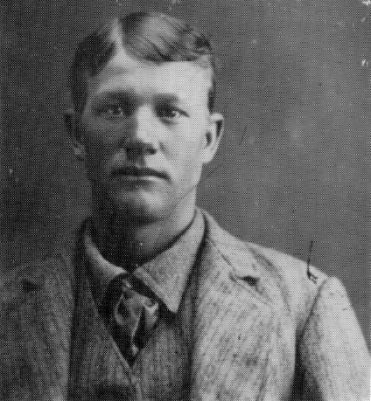
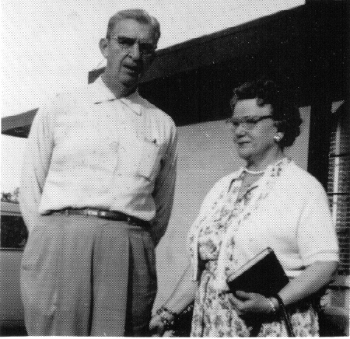

W. W. Smith and his wife Her father
Rosamond (Bunnell) Smith George Everett Bunnell
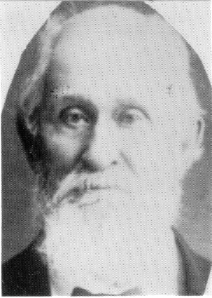
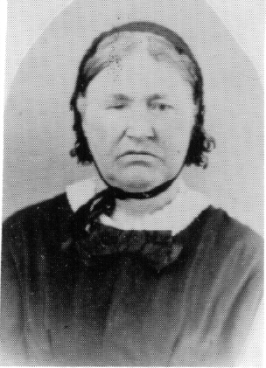
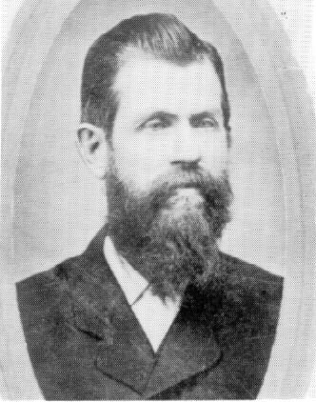

Joseph Almie Charles E. Margaret Maria
Bunnell Bunnell (Barlow) Bunnell

INTERNATIONAL GENEALOGICAL INDEX

PENNSYLVANIA (Concluded) - 1988 Update (submitted by Geneva Draper)

(Philadelphia county, 1682 – original county)

Philadelphia county – Marriages:
Bonnell, Edward Ruth Thompson 06 Nov 1742*
Bonnell, Jane Thomas Cooper 1778?

Philadelphia, Philadelphia county – Marriages:
Bonnell, Charles Mary Brehault 04 Sep 1788
Bonnell, Eward Ruth Thomson 06 Nov 1742*
Bonnell, Jane Thomas Cooper 05 Apr 1787?
Bownell, Martha Nethaniel Walton 26 Nov 1685
Bonnell, Mary Matheas Jantz 30 Jan 1781
Bonnell, Sallie Sherrerd Henry Howard Houston 09 Apr 1856
Bonnell, Samuel Kitty Hughes 26 Mar 1779

(Pike county, formed 1814 from Northampton)

Pike county – Births:
Bunnell, Gershom Benjamin Bunnell/Catherine Barry M 15 Dec 1803

Lackawaxen, Pike county – Births:
Bonnell, Jacob M 25 Nov 1832

(Potter county, formed 1804 from Lycoming)

Bingham Summit, Potter county – Births:
Bunnell, Mary Melissa M 11 Feb 1899
Marcus Fayette Bunnell/Eva Miller

Ulysses, Potter county – Marriages:
Bunnell, Mary Melessia Claude Clayton Young 23 Aug 1919

(Susquehanna county, formed 1810 from Luzerne)

Susquehanna county – Births:
Bonnell, Thomas John Bonnell/Betsy Pandy M 15 Jan 1775

Herrick township, Susquehanna county – Births:
Bunnell, Abigail Martin Bunnell/Irene F 1835
Bunnell, Andrew Putnam Martin Bunnell/Irene M 1838
Bunnell, Anna A. Martin Bunnell/Irene F 1844
Bunnell, Charles Henry M 23 Sep 1868

Andrew Putnam Bunnell/Mary Elizabeth Regean*
(The mother’s name should be Mary Elizabeth Rezeau – wra)

Herrick township, Susquehanna county - Births (Cont’d):
Bunnell, Cornelius A. Martin Bunnell/Irene M 1832
Bunnell, Daniel Martin Bunnell/Irene M 1842
Bunnell, Lewis M. Martin Bunnell/Irene M 1833
Bunnell, Lydia E. Martin Bunnell/Irene F 1840
Bunnell, Martin E. M 1866
Andrew Putnam Bunnell/Mary Elizabeth Regean*
Bunnell, Sarah F 16 May 1864
Andrew Putnam Bunnell/Mary Elizabeth Regean*
Bunnell, Sarah A. Martin Bunnell/Irene F 1831

Rush, Susquehanna county – Marriages:
Bonnell, David Abigail Balch 01 Mar 1849

(Venango county, formed 1800 from Allegheny, Lycoming)

Venango county – Births:
Bunnell, Catherine Alfred Bunnell/Rachel F 1834

Franklin, Venango county – Marriages:
Bunnell, Adaline George Albert Grove 01 May 1895
Bunnell, Emily James Stroble Myers 08 Apr 1834

Polk, Venango county – Births:
Bunnell, Adaline Samuel Bunnell/Sarah Seaton F 07 Sep 1878

(Washington county, formed 1781 from Westmoreland)

Washington county – Births:
Bonnell, Aaron Moses Bonnell/Hannah Buchingham M 14 Feb 1804
Bonnell, Ann Moses Bonnell/Hannah Buchingham F 01 Sep 1800
Bonnell, Elizabeth Moses Bonnell/Hannah Buchingham F 17 Apr 1814
Bonnell, Esther Moses Bonnell/Hannah Buchingham F 23 Dec 1807
Bonnell, Henry Moses Bonnell/Hannah Buchingham M 27 Oct 1809
Bonnell, Jane Moses Bonnell/Hannah Buchingham F 16 Mar 1802
Bonnell, John Moses Bonnell/Hannah Buchingham M 18 Oct 1811
Bonnell, Levi Moses Bonnell/Hannah Buchingham M 07 Jan 1799
Bonnell, William B. Moses Bonnell/Hannah Buchingham M 19 Oct 1805

Washington county – Marriages:
Bonnell, Benjamin Rachel Mongsmith 02 Nov 1803
Bonnell, Henry Margaret Burrell 04 Feb 1801
Bonnell, Moses Hannah Buchingham 22 Mar 1798

Washington, Washington county – Marriages:
Bunnell, Gersham Sarah Kellogg 01 Jan 1823
(This record is incorrect; see Lancaster county – wra)
Bunnell, Lydia George Sumner 22 Mar 1835
(This record is incorrect; see Luzerne county – wra)

(Wayne county, formed 1798 from Northampton)

Bethany, Wayne county – Marriages:
Bunnell, Eleanor Isaac Parsons Olmsted 17 Aug 1828

(Wyoming county, formed 1842 from Luzerne)

Wyoming county – Marriages:
Bunnell, John Rebecca Place 1846
Bunnell, William Emma Keeney 21 Feb 1878

Russell Hill, Wyoming county – Births:
Bunnell, Eleanor Roena F 01 Jul 1868
Aaron Bunnell/Clementine Lane
Bunnell, John Walter Aaron Bunnell/Clementine Lane M 12 Aug 1871
Bunnell, Minnie Josephine F 01 Nov 1865
Aaron Bunnell/Clementine Lane
Bunnell, Rebecca Benjamin Bunnell/Catherine Barry F 18 Oct 1784
(This record is incorrect. Rebecca Bunnell, like all of her siblings, was born in
Middle Smithfield twp, in what is now Monroe co, PA – wra.)

Washington township, Wyoming county – Births:
Bunnell, Amanda John Bunnell/Rebecca Place F 1847
Bunnell, Anna John Bunnell/Rebecca Place F Feb 1860
Bunnell, Ella John Bunnell/Rebecca Place F Nov 1869
Bunnell, Sarah John Bunnell/Rebecca Place F 1849
Bunnell, William John Bunnell/Rebecca Place M Jun 1851

(York county, formed 1749 from Lancaster)

York, Christ Lutheran Church, York county – Christenings:
Boneil, Hannah Daniel Boneil/Elizabeth F 02 Dec 1762

* * * * * * *

ADVERTISEMENT

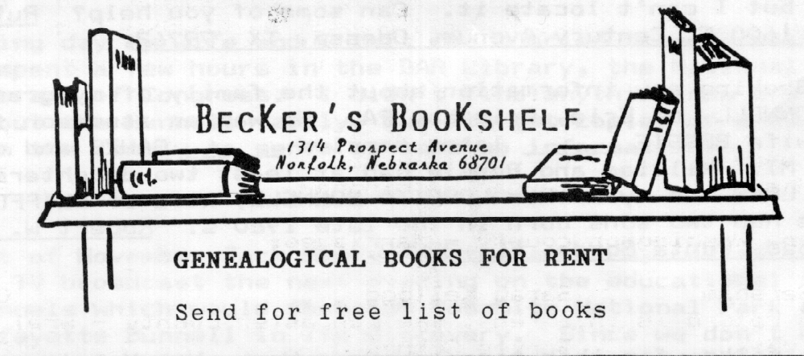

MILES BUNNELL – Another Clue

For those of you who have been searching for the ancestry of MILES BUNNELL, CB004126, who married Amelia Doud, another clue has turned up.
John S. Butler, Stillwater, OK, writes that he is researching the Mains family. Mr. Butler says, “Nehemiah Mains and his wife, Phoebe Bunnell, left Hartford co, CT around 1795 for NE Pennsylvania into Luzerne co. They later headed SW into Centre and then Clearfield co, PA Census 1790 that there were both n umerous Mains and numerous Bunnell families in Hartford co, CT. I know from the first Census 1790 that there were both numerous Mains and Numerous Bunnell families in Hartford co, CT. I know who Nehemiah’s father was but I could find no birth record of Phoebe or her parents.
The History of Susquehanna Co, PA, by Emily C. Blackman, on page 286, says, “Nehemiah Maine took up land under the Connecticut title in 1799, just east of the Reuben Wells homestead, but was not long after located in Dimock. . . . David Doud lived on the Kingsley firm, but was probably soon after on the Wyalusing. His son-in-law, Miles Bunnell, lived near N. Maine. Mr. M. sold his right to B. Bostwick, who sold to R. Wells, Sr.” Susq uehanna co was part of Luzerne at the time.
I suggest that Phoebe Bunnell was a sister or near relative of Miles, and that Miles Bunnell and Nehemiah Maine (or Mains) were brothers-in-law. Can anyone verify or disprove that?

* * * * * * *

QUERIES

The name and address of the inquirer are included with each query. However, if you are able to provide the inquirer with the information requested, I would appreciate your sending me a copy of your reply.

1. BENJAMIN BUNNELL, CB310242, and his wife MARY OZIER had six children in Wyoming co, PA. Their oldest daughter, AMANDA, b. 1810, m. 1825 ABRAM LUCE. The John A. Biles manuscript says that Amanda was an adopted daughter, and review of the census records and other documents lends support to the statement. Does anyone have information which would suggest who Amanda’s natural parents were? Tom Field, 728 Fern Road, Glenside, PA 19038.

2. Does anyone have a copy of the bible records of DAVID BUNNELL, CB310276, (b. March 1764, NJ, son of STEPHEN BUNNELL, CB300135, and MARY DANIELS)? DAVID married ELIZABETH PRICE (b. June 1768, MD, daughter of VEAZEY PRICE and ANN BARTON). This bible record was passed down through the Bunnell, Richardson and Anderson families, but I can’t locate it. Can some of you help? Ruthelle H. Finnerty, 1600 E. Century Avenue, Odessa, TX 79762.

3. Seeking any information about the family of my grandfather, WILLIAM BONNELL, of Erie, Erie co, PA. He was an assessor for Erie co. His wife BESSIE ______ later married ______ GAUZE and died in Bay City, MI. William and Bessie had at least two daughters, FANNY 9BONNELL0 LONG and my mother LORETTA BONNELL, wife of CLIFFORD STEEL. The Steels had two sons born in the late 1920’s. Robert W. Steel, 284 Wilmers Road, Punta Gorda, FL 33982.

* * * * * * *

That’s all folks, for this time. Have a Happy New Year!

