BUNNELL BONNELL BUNNELL BONNELL BUNNELL BONNELL BUNNELL BONNELL BUNNELL B
Retyped by Marjorie Gibbs
U O
N N
N N
E THE BUNNELL/BONNELL NEWSLETTER E
L L

B B
O Volume V, No. 1. 1 January 1991 O
N Published by N
N William R. Austen N
E P. O. Box 62 E
L Laceyville, PA 18623 L
L (717) 869-2325 L

BUNNELL BONNELL BUNNELL BONNELL BUNNELL BONNELL BUNNELL BONNELL BUNNELL B

CURRENT WEDDINGS AND BIRTHS

Florence Buck, Starucca, PA and Skaneateles, NY, called to tell me that her grandson, Andrew Lynne Buck, of Skaneateles, NY, married Cathryn Sue Keene, of Gilbertsville, NY, on 18 August 1990 in the Presbyterian Church in Gilbertsville. Andrew is a great great great great grandson of Miles and Amelia (Doud) Bunnell, whose ancestry was established in the Newsletter, Vol. IV, Nos. 2 and 3.

Mrs. Buck also reported that another grandson and his wife, Alan and Sue (Jones) Chaffee, now living near Melbourne, Australia (see Newsletter Vol. IV, No. 3), became the parents of Madeline Grace Chaffee, born 4 September 1990. They have another daughter, Emily Faith, born in October 1987.

* * *

Mrs. Ralph Bunnell, Kenmore, NY, wrote to say that Ralph's brother, Richard Llewellyn Bunnell, CB351619, and his wife Overine (Ehman) Bunnell, have two new great grandchildren, grandchildren of their daughter Karen Lee, Mrs. Michael Parsons:

Lindsay Nicole Bowen, daughter of Marvin and Sandra Kay (Parsons) Bowen, was born 4 June 1990 in South Carolina.

Joshua Allen Kruse, son of Kenneth and Pamela Jean (Parsons) Kruse, was born 16 September 1990 in South Carolina.

* * *

Jack Mowry, North East, PA, attended the wedding of his grandson Peter Strouse to Sheryl Johnston 29 September 1990 at the Community Church in Haslett, MI. Peter, son of Jack's eldest daughter Susan, Mrs. William York, is a great great grandson of Albert Bunnell,
CB 330701, and Harriet Adelia (Overfield) Bunnell of Meshoppen, Wyoming co., PA.

* * * * * * *
Page 1

THE LITERARY COUSINS

This quarter we note the literary creativity of several members of the Bunnell/Bonnell family.

First is the new book by Joan England Murray, Bunnell And Allied Families. It is an interesting and well-written account of all the known ancestors of Rosa Sarah (Bunnell) England, Joan Murray's paternal grandmother. The book is thoroughly researched, with footnotes on each page to identify the source of her information. The bibliography lists 329 sources, and the book is provided with a complete name index.

Joan has enlived her book not only with family photographs, but also with many copies of documents (deeds, Civil War records, marriage licenses, newspapers clippings, etc.) significant to the family history. In addition, in a feature which I like very much, she has given us the historical background against which the family story was enacted. Altogether an excellent work of which Joan should be very proud. {Incidentally, for Newsletter subscribers who have not yet ordered the book, Joan has offered to extend the pre-publication price. Just let her know that you subscribe to the Newsletter.}

I would offer a couple of corrections on pages 34 and 35, The Third Generation of Bunnells. Benjamin and Hannah (Plumb) Bunnell did not move to New Milford, CT until
the purchase of the land there in 1714. Their life was spent in New Haven until that time, with the exception of a brief sojourn in Elizabethtown, NJ, where they may have intended to settle. All of their children were born in New Haven except Gershom, who was born 1 May 1707 "in Elizabethtown in east Jersey," according to the New Haven vital records. Isaac was born in New Haven in 1713 after their return. The children's births were all listed in the New Haven vital records as they occurred. However, after the move to New Milford, they were all listed again there, giving rise to the impression that they were born there. Only Keziah, Benjamin's daughter by his second wife, was born in New Milford.

Also, there is a typographical error on page 35 – Benjamin Bunnell died in New Milford on 20 August 1749, not 29 August 1649.

* * *

Another fine book, published in 1978, but which has only just come to my attention is DAY UNTO DAY, a Study of the Day Family in America, by Margery Frances Day Hanson. I found an ad for the book in the GENEALOGICAL HELPER. The ad indicated that one of the families covered was "Bonnell," so I ordered a copy. It is a beautiful book, filled with pictures. Since it is a history of Mrs. Hanson's father's ancestry, the Bonnell portion comprises only a small part of the book. Mr. Day was descended from Joanna Bonnell who married Moses Day in January 1785 in Chatham, NJ. Joanna was the daughter of John Bonnell CB300181 and Sarah Carter, his wife. The Bonnell segment includes a picture of the home of John and Sarah Bonnell in Chatham and a copy of John's extensive will and inventory of his estate, all of which were new to me.

After I purchased the book, Mrs. Hanson wrote me a thank you note, which has initiated a very pleasant correspondence. Her book includes

Page 2

THE LITERARY COUSINS (Cont'd)

the Huguenot ancestry, which all of you know I reject, and I have explained my reasoning to her. She has expressed her willingness to regard the parentage of William as "on hold," but she is reluctant to dismiss the Huguenot ancestry completely unless I can prove a different one. I invite all of you to join the debate, until we find something definitive one way or the other to print in the Newsletter.
* * *

Our colleague Paul J. Bunnell, A.G., U.E., CB001408, announces the publication of his third book. Previous Newsletters have told you about first, THUNDER OVER NEW ENGLAND, BENJAMIN BONNELL, THE LOYALIST, and more recently about the NEW LOYALIST INDEX. Now Paul has released his third book, GUIDE TO RESEARCHING YOUR LOYALIST ANCESTORS, published by Heritage Books, Inc., 1540E Pointer Ridge Place, Bowie, MD 10716-1859. The book costs $15.00 plus $3.00 shipping and handling, and may be ordered either from the publisher or from the author at the following address:

Paul J. Bunnell, A.G., U.E.
31 Timber Lane
Marstons Mills, MA 02648

* * *

Ruth Bunnell, West Simsbury, CT, writes to inform us that she has sold all the copies of her book WILLIAM BUNNELL AND HIS DESCENDANTS, and does not foresee another printing.

* * *

Just as I was putting this issue of the Newsletter together I received a letter from Beverly Sorensen, Northbrook, IL, enclosing a notice of another Bunnell author, her nephew, Eugene Harvey Bunnell, CB360926, who is Father Adam Bunnell, a member of the Franciscan Order. His book, BEFORE INFALLIBILITY, Liberal Catholicism in Biedermeier Vienna, has just been published by Fairleigh Dickinson University Press. According to the brochure, it "is the study of two nineteenth-century priests who tried to transform their church through a new formulation of ancient Truth. Anton Guenther, a Roman Catholic theologian, challenged the pantheistic idealism dominant in the German intellectual world of his day. Johann Emanuel Veith, a medical doctor and convert from Judaism, joined the clergy and found in Guenther's system of contrapositional dualism the thought that undergirded his prolific homiletic output." The brochure goes on to say, "Before Infallibility is an indispensable theological, philosophical, and historical work, written with a great deal of love for Roman Catholicism and from a pluralistic perspective. It is the author's conviction that that the struggle for Truth and meaning demands humility and the willingness to listen with an openness to being changed, and that the study of any era can move beyond quaint antiquarianism to valuable contemporary insight." [What a useful thought for our genealogical studies.]

Father Adam was born in Minnesota. His theological wok was done in Vienna, Austria, and his doctoral work was completed at the Center for

Page 3

THE LITERARY COUSINS (Cont'd)

Austrian Studies at the University of Minnesota. He taught for many years at the St. Paul Seminary, now a part of St. Thomas College, in St. Paul, MN. For the last five years he was a professor of history at Regis College in Denver, CO, where he also served as head of the honors program and chaplain. This fall he accepted a position at Bellarmine College in Louisville, KY, where he is teaching European history and working with the Honors Program. He lives at the Franciscan friary at Mount Saint Francis, IN just across the Ohio River from Louisville. There he works with the Mary Anderson Center for the Arts, building a place for artists to come and spend some time creating and exchanging ideas with each other and with the Franciscan. Father Adam's Bunnell ancestry is as follows:

William Bunnell m. Ann Wilmot
Benjamin Bunnell m. Rebecca Mallory
Nathaniel Bunnell m. Desire Peck
Joseph Bunnell m. Hannah Hotchkiss
Joel Bunnell m. Martha _______
Raphael Bunnell m. Sally Stanley
Cornelius Bunnell m. Sally Kyser
William Bunnell m. Mary Buckmiller
Eugene Harvey Bunnell m. Ellen Peterson
Arnold Glenn Bunnell m. Helen Ostertag
Eugene Harvey Bunnell (Father Adam Bunnell).

* * * * * * *

Mrs. Lila Bunnell, Winsted, CT, has submitted the following additions to Ruth Duncan's book, WILLIAM BUNNELL AND HIS DESCENDANTS:

Page 363

962.i. STEPHEN PALMER (12) BUNNELL, son of Ralph, was born 3 November 1962 in Grants, New Mexico. He married LISA DARLENE MUMA of Rigby, Idaho, 19 June 1986 at the Idaho Falls Temple of the Church of Jesus Christ of Latter-day Saints, Idaho Falls, Idaho.
Children:
i. KYLE STEPHEN (13) BUNNELL, b 15 March 1989 Rexburg, Idaho.
ii. NICOLE SHAREE, b. 29 August 1990 Rexburg, Idaho.

also on Page 363.

963.i. ALAN BRADLEY (12) BUNNELL, son of Edward, was born 4 Jan. 1961 in Reno, Nevada. He married PAMELA TODERO 15 April 1988 at the First Church Of Christ Congregational, Suffield, Conn.

* * * * * * *

Page 4

ISAAC BONNELL – A CORRECTION

Claude Bunnell has been working on the Bonnells of Guernsey co, OH, gathering the data necessary to construct a complete lineage of the family there and to identify the Isaac Bonnell, CB005633, who appears to be the progenitor of this branch of the family. In a recent telephone conversation Claude suggested several of the Isaacs who appear in the New Jersey records as possible candidates. To consider his suggestions, and to check other possibilities, I listed all the Isaac Bonnells recorded in New Jersey who were not certainly excluded from consideration by the known facts about them. While I did not come to a definite conclusion on the point in question, I was able to narrow the field a bit, and I shared my results with Claude for his further study.
In the process, however, I discovered that two of the Isaac Bonnells have been confused in all our studies and publications. This article is intended to straighten out the confusion and to demonstrate the reasoning behind it.

In Volume III, No. 2, page 4, of the Newsletter, I referred to ISAAC BONNELL, CB300164, son of Abraham and Mary (Shinn) Bonnell, discussing his supposed marriage to and divorce from Elizabeth Dorn, showing that Isaac's wife was not Elizabeth, but rather her sister Puah Abigail Woodruff.

Now, as a result of my study of all these Isaacs, I have to say that, while we now have the right wife, we have her married to the wrong husband.

Isaac Bonnell, CB300164, and #71 in Ruth Duncan's WILLIAM BUNNELL AND HIS DESCENDANTS, was the son of Abraham and Mary (Shinn) Bonnell. This is proved by Abraham's will, dated 28 January 1768 and proved 1 April 1768, in which each of the named four sons, including Isaac, was given £5. Isaac and his mother Mary were named co-executors of the estate. Abraham had lived for many years in Kingwood, Hunterdon co, NJ, where he died. His four sons, if not born there, were certainly raised in Kingwood.

I can find no other contemporary record which refers without question to this Isaac. However, he is probably the Isaac Bonnell of Kingwood, NJ, who appears in 1778 in the REVOLUTIONARY CENSUS OF NEW JERSEY, by Ken Stryker-Rodda. If so, he cannot be the Isaac Bonnell of Elizabethtown, Essex co, NJ who married Puah Abigail Woodruff.

Now let's step back a generation and consider another Isaac Bonnell, cousin of Abraham. This Isaac, CB290027 and Duncan's #8iv, was the son of Nathaniel Bonnell and Mary Searing. He was born about 1702 in Elizabethtown. In 1736 he inherited land in Elizabeth left to him by his father.

Again, we have no other record that definitely applies to this man. However, it is clear that his residence was Elizabethtown.

Page 5

ISAAC BONNELL (Cont'd)

Many years ago, on 2 November 1959 to be exact, Homer Baldwin copied and sent me "Wade, Bonnell & Crane Bible Records from Bible owned by Helen Bertha Crane, 220 South Broad St., Elizabeth, N.J. Copied by Evelyn Leary Ogden." I presume he found them in a DAR collection, though Homer did not say so. The record is as follows:

"Children of Isaac Bonnell
1. Hannah Bonnell, b. Oct. 19, 1735.
2. David " , b. Feb. 24, 1739.
3. William " , b. Nov. 28 1740.
4. Sarah " , b. July 26, 1740?
5. Isaac " , b. Dec. 8, 1743.
6. Susan " , b. July 12, 1745.
7. Mary " , b. Sept. 25 1748.
8. Samuel " , b. Oct. 1, 1750.

Deaths.
Sarah, wife of Nathaniel Crane, d. May 15, 1832.
David E. Wade, d. Nov. 26, 1832.
Isaac Bonnell, d. Mar. 1833."

I know of no other Isaac Bonnell, in Elizabeth, or elsewhere, to whom this record can apply. I believe these are the children of Isaac, son of Nathaniel.

In the Genealogical Magazine of New Jersey, Vol. 43, page 30, the article on New Jersey Rateables, by Kenn Stryker-Rodda, lists, under Essex County, Elizabeth Township, Town Ward, for both January 1779 and February 1780, Isaac Bonnel, householder, exempt, and Isaac Bonnel Jr, householder.

These records almost certainly apply to the two Isaacs, father and son, in the Bible record. The father I believe to be Isaac, son of Nathaniel. Born about 1702, he would have been exempt from military service by reason of age. Isaac Jr, born 8 December 1743, at 34 years would not have been exempt.

The Bible record gives both the birth date, 8 December 1743, and the death date, March 1833 of Isaac Jr, CB300194. This, without question, is the Isaac Bonnell who married Puah Abigail Woodruff.

From "Inscriptions on Tombstones and Monuments in the Burying Grounds of the First Presbyterian Church and St. John's Church at Elizabeth, New Jersey. 1664-1892," by Wm. Ogden Wheeler & Edmund D. Halsey – 1892, we note that gravestone #1734 in the First Presbyterian Churchyard reads:

"The Grave of NOAH BONNELL who died April 3rd 1856 in the 86th year of his age. Also His Father ISAAC BONNELL died March 12th 1833 in the 90th year of his age."

This corresponds precisely with the birth and death dates given in the Bible.

Page 6

ISAAC BONNELL (Cont'd)

In "WOODRUFF CHRONCILES, a genealogy. The Long Island-New Jersey Family of John Woodruffe, the Immigrant Ancestor to America, "Volume II, compiled by Ceylon Newton Woodruff and Maurine R. Herod – 1971, we find:

"Children of Timothy(5) Woodruff, 1715-1798, #602, and his wife Elizabeth (daughter of Seth Parsons), 1712-1776, #601.

GENERATION VI

. . .
3. Puah(6) Abigail Woodruff, born ca. 1745, died (S.R.) on June 13, 1777. She m. Isaac Bonnell of ElizabethTown who was born in 1744 and who died March 12, 1883, aged 90, (W&H) #1734.

THE NEW ENGLAND HISTORIC GENEALOGICAL REGISTER, Vol. 44, on page 357, has an article entitled, "Record Book of the First Presbyterian Church of Elizabethtown, Essex County (now Elizabeth, Union County), New Jersey." communicated by Edmund Janes Cleveland, of Hartford, Conn. Under the heading, "DEATHS E.TOWN" is listed,

"Wife of Isaac Bonnel June 13, 1777"

The will of Timothy Woodruff of Elizabethtown, dated 6 February 1786, and proved 4 February 1799, as abstracted in "New Jersey Post-Revolutionary Documents, Calendar of Wills—1796-1800," provides, among other things, "Grandsons, David and Seth Bonnel, each 40 shillings, when 21. Grandson, Noah Bonnel and granddaughter, Betsey Bonnel, each £5, when of age. Said Bonnel grandchildren being the children of Isaac Bonnel."

Isaac Bonnell appears in the 1830 census in Elizabeth: one male between 40 and 50 and one male between 80 and 90.

In summary, ISAAC BONNELL, husband of Puah Abigail Woodruff and father of Noah, David, Seth and Betsy, was the son of Isaac, not Abraham, as proved by the Bible record. Careful study of all the possibilities makes it clear that Isaac, the father, was CB29 0027, Duncan's #8iv, son of Nathaniel and Mary (Searing) Bonnell. This family was always of Elizabethtown, but none of Abraham's descendants seem to have resided there.

Those of you who have purchased WILLIAM BUNNELL AND HIS DESCENDANTS may wish to enter this correction, since the line is carried down for several generations.

* * * * * * *

Page 7

Jerry Hatch, Chicago, IL, shares with us the following little story of young love unfulfilled:
Sibbel J. Bunnell 1832 – 1876

Sibbel Jane Bunnell was born at Port Byron, NY, 16 February 1832, daughter of Joseph Bunnell, CB320846, and Ann Cooper. In about 1848-50 Sibbel stitched two samplers, one of which is shown here with her picture. The other sampler bears the initials "B.C." in addition to Sibbel's name. The story is that Sibbel had fallen in love with B. Chapman, but her parents broke up the engagement. In spite, Sibbel later eloped with Samuel Devore, whom she married 18 December 1851. Sibbel's mother never forgave her. The end of the love story – Sibbel and B. Chapman are buried near each other, as the Devore and Chapman burial plots are adjacent at Mount Pleasant, Old Port Byron, Town of Mentz, Cayuga co, NY.

This tale was recoded years ago by Marion Ryal Lambert, great granddaughter of Sibbel Bunnell Devore, and aunt of Robert Ferris. Jerry Hatch wrote hat he visited his distant Bunnell cousins, Bob and Shirley Ferris, Hornell, NY, on a recent vacation family research trip. Bob shared notes, photos and samplers relating to his great great grandmother, Sibbel Bunnell Devore [William(1), Nathaniel(2), Joseph(3), David(4), David Elias(5), Henry(6), Joseph(7), Sibbel(8)].

Sibbel J. Bunnell and Samuel Devore had three children: Clara Joan Devore, b. 23 June 1853, d. 6 October 1922, m. 25 February 1874 George Washington Ryal; Livona Devore, b. 1854, thought to have d. young; and Sherman E. Devore, b. 9 September 1861-2, d. September 1927, m. 10 July 1895 Margie W. Loveless.
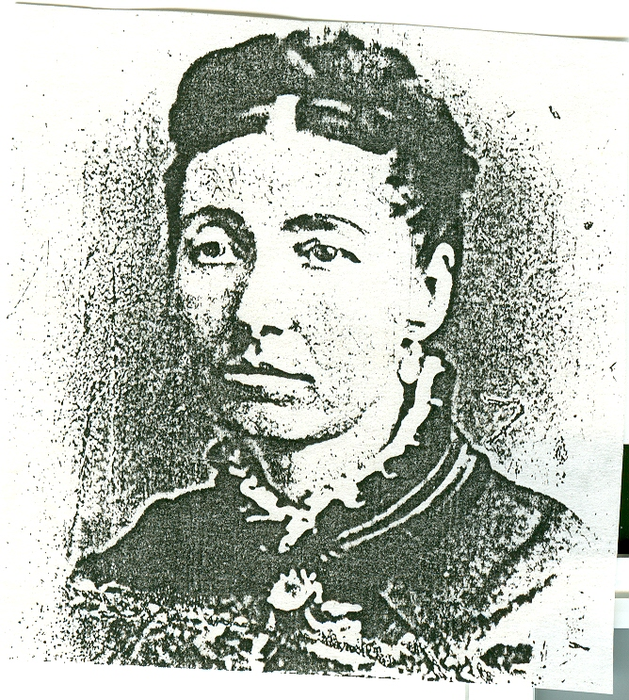
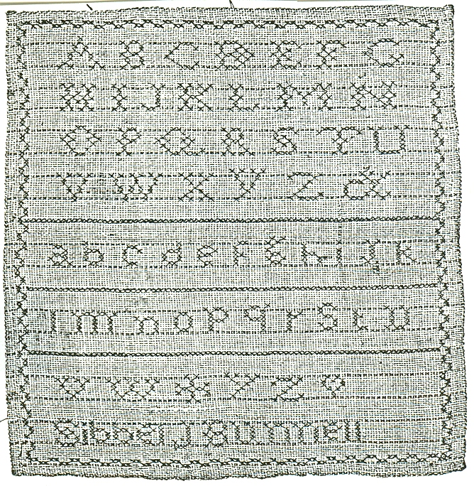

* * * * * * *
Page 8
OBITUARIES

Mabel Bunnell Daniels, Beacon, IA, submitted the following from the Keokuk County News Review, Sigourney, IA:
GOLDIE GROVE – SIGOURNEY

Goldie GROVE, 86, died Wednesday, May 8, 1990, at the Sigourney Health Center in Sigourney. she was born January 31, 1904, in Sigourney to John [CB008933] and Angeline TATE BUNNELL.
She was united in marriage to Vaughn BELL on April 26, 1922, in South English. He died November 17, 1976. She was united in marriage to Roy GROVE on May 17, 1979 in Galt, Missouri.
She attended schools in Tioga and Des Moines. She worked as a practical nurse at the Sigourney hospital, Keokuk County Hospital, The Manor House and as a private nurse.
She was a member of the Sigourney Christian Church and taught Sunday School for 56 years. She was a member of the V.F.W. Aux., Audubon flower and Garden Club, C.F.W. and Eastern Star.
She is survived by her husband, Roy; two stepsons, Jack GROVE of North English and Garth GROVE of Drakesville; 10 grandchildren; two stepgrandchildren; 14 great grandchildren; four step great grandchildren and one sister, Ethel KILGUS of Monroe, Michigan.
She was preceded in death by her parents, first husband, Vaughn, two sons, Gerald BELL and Bill BELL and two brothers, Alfert [CB008934] and Homer [CB007286] BUNNELL.
Funeral services will be held Friday at 10:30 A.M. at the Sigourney Christian Church with Rev. Joel AURAND officiating. Burial will be in the Pleasant Grove Cemetery in Sigourney.
Memorials may be made to the Christian Church or the American Cancer Society.

[Mrs. Grove's father John Cyrus Bunnell, CB008933, was the son of Benjamin Franklin Bunnell, CB000331, and Lieuvera C. Johnson; grandson of Benjamin P. Bunnell, CB005872, and Lucy Ellen Simmons. Who were the parents of Benjamin P. Bunnell? – wra]
* * *
The next obituary, from the 1 August 1990 issue of the North East (PA) Breeze, was sent in by E. Jack Mowry, North East, PA.

Dale Bunnell, 79, local's father, dies

Services were held July 25 in Sebastian, Fla., for Dale Lane Bunnell, 79, of 9797 Honeysuckle Drive, Sebastian, formerly of Corry. He passed away July 22, 1990 at Humana Hospital in Sebastian.
Mr. Bunnell was born in Butler on Sept. 18 2920 [sic], and had been a resident of Sebastian for 17 years, moving there from Corry. He had worked for Raymond Manufacturing of Corry as a foreman for 17 years.
He was a 50-year member of Masons, a life member of the Elks lodge and belonged to the Moose lodge, all in Corry. He served with the Pennsylvania National Guard.
He leaves his wife of 28 years, Lucille Bunnell; a son, John McGerl of North East; three daughters, Carol Dunlop of Clearwater, Fla., Ruby

Page 9
OBITUARIES (Cont'd)

Eimers of Ripley and Gail Bolinger of Largo, Fla.; 17 grandchildren and 16 great-grandchildren.
Interment was at West Lawn Cemetery in Columbus. Bracken Funeral Home in Corry handled local funeral arrangements.

[I have not found any other reference to Dale Lane Bunnell. Does anyone have more information about him? – wra]
* * * * * * *
QUERIES

The name and address of the inquirer are included with each query. However, if you are able to provide the inquirer with the information requested, I would appreciate your sending me a copy of your reply.

1. Seeking parents of DAVID BONNELL, CB995836, b. KY ca 1792/93, m. ------McCall?, who d. early. The 1830 Fed. census shows David in Parrishes Grove, Warren co, IN; the 1840 census shows him in Columbus, Bartholomew co, IN; and in 1850 he appears in Marshall twp. Platte co, MO, living with Charles F. and Elizabeth Shell. In 1860 David was living in Leavenworth co, KS, with his son-in-law and daughter, Lewis and Louisa Cox. Had at least four children: JAMES P.; b. 1817; LOUISA JANE, b. 6 July 1825, m. 30 Sept. 1841 Lewis Cox, d. 11 Oct. 1907; MARY ADELINE, b. 23 Dec. 1831, m. 16 Feb. 1849 William Thomas Paslay, d. 5 Jan. 1925. Would also like to know name of David's wife. Marjorie C. Gibbs, P. O. Box 55, Union Springs, NY.

2. Who were the parents of DUNCAN M. BONNELL, b. March 1827 in OH. His father was b. in VA and his mother in NJ. He m. ELIZABETH ------ in 1852. He appears in the 1860, 1870 and 1880 census in Guernsey co, OH. Six children. Mary Jo Bonnell, 2440 Camino Tassajara, Danville, CA 94526.

3. JOHN MILLEDGE BRANNEN, b. GA, and his wife ELIZA BONNELL, appear in the 1850 census in Columbia co, FL with their daughter ELIZA E., age 4. Can anyone give me any clues regarding the parents of ELIZA (BONNELL) BRANNEN? Barbara Waters Barrett, 6461 W. Raven Street, Chicago, IL 60641.

4. DAVID LORENZO BUNNELL, son of AMOS, married MARTHA KUNKLE in the 1860's in Susquehanna co, PA. His seventh cousin, KIRBY BUNNELL, son of EPHRAIM, married Martha's sister MARY FRANCIS KUNKLE in the 1870's. Martha and Mary Frances were daughters of JOHN HOUSTON and SARAH (SPRAGLE) KUNKLE and granddaughters of JOHN and REBECCA (Houston) KUNKLE. John Kunkle was born in 1776. Does anyone have information about John Kunkle's parents or birthplace? David Merrilees, 7 Colonial Hills Parkway, Creve Coeur, MO 63141.

5. WILLIAM P. BONNELL, b. Dec. 1840, son of JOHN BALL and PHOEBE (STAGG) BONNELL, married (second) JOSEPHINE MELLISA WILLIAMS on 2 July 1866 at Newark, NJ. His first wife was ANNA J. TIER. I need anything on Josephine. Bonnie Jacobsen, 31944 Linda Ladera, Yucaipa, CA 92399.

* * * * * * *
Page 10

Who Was Dr. Bunnell?

I received the following comments with subscription renewals:

From Jan Clemmer, Salem OR – "In the NPB presentation of 'The Civil War', did you notice the photo of an embalming establishment owned & operated by Doctor Bunnell? How could we go about tracing it?"

and from Mary B. Spies, Spokane, WA – "While watching the CIVIL WAR epic on TV last week I noticed 'Bunnel'! apparently an embalmer, did anyone else notice that? seems to me it was in the 3rd show."

Thank you both. I did not see the TV program, but from everything I have read, it was very well done. I don't know who Dr. Bunnell was, but I seemed to remember a picture of a Civil War embalming establishment. After digging through my notes and files, I found the picture, sent to me around 1970 by Doris (Bunnelle) Thomas, Garden Grove, CA. She labeled the picture "Photograph of a Field Mortuary from a book on the Civil War 'They Who Fought Here,' by Bell Irvin Wiley and Hirst D. Milhollen, MacMillan Co., 1959, NY."

The picture she sent is reproduced here. since I am not sure how well it will show up, the printing over the door reads in a circle, "Embalming the Dead", with "Dr. Bunnell" across the middle. There are other words within the circle which are not legible. The large sign to the left reads:

FREE FROM ODOR E M B A L M I N G DOCTOR
OR INFECTION BUNNELL

Can anyone furnish more information about the good Doctor?

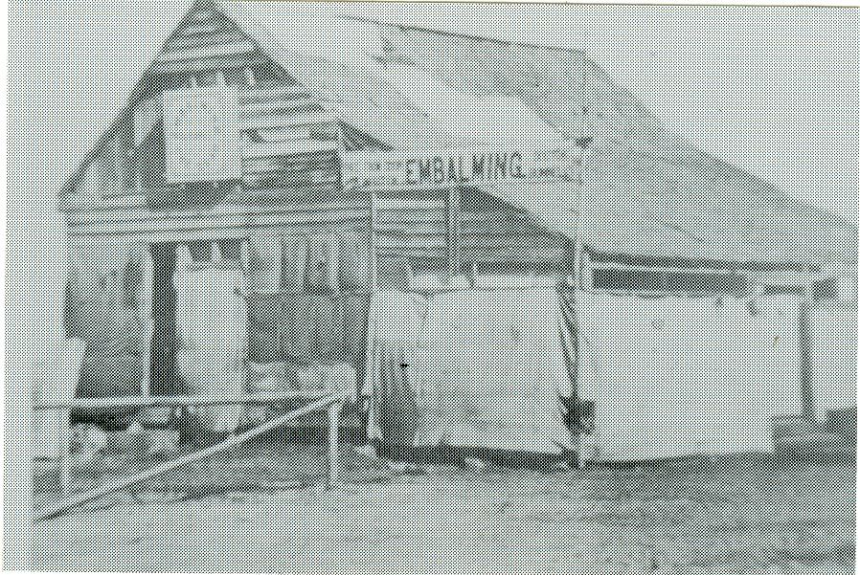

Page 11

INTERNATIONAL GENEALOGICAL INDEX

OHIO – 1988 Update Submitted by Jerry Hatch

[Coshocton county - formed 1811 from Muskingum
- Coshocton county – Marriages:
Bonnell, Alice Angeline | William Wiltshire | 06 Feb 1871
Bunnell, Hester J. | Robert Dewitt | 15 Sep 1870
Bonnell, Margaret V. | T. J. Cook | 19 Dec 1870
Bunell, Samuel C. | Francis E. Olivier | 09 Aug 1858

[Cuyahoga county – formed in 1810 from Geauga]
- Cuyahoga county – Marriages:
Bunnel, Anna S. | Oliver Terrel | 08 Nov 1815
Bunnell, Daniel L. | Frances Griffen | 05 Mar 1849
Bonnell, E. | Maria L. Hall | 03 Jul 1877
Bonnell, Edward A. | Anna Londergan | 21 Feb 1876
Bunnel, Electa | Matthias Rush | 26 May 1827
Bunnel, Eli | Sally N. Covert | 27 Nov 1832
Bunnell, Frank H. | Elsie H. Shields | 27 Dec 1876
Bunnel, Issabel | James Palmer | 29 Sep 1823
Bunnel, Ithamer W. | Margaret A. Wood | 16 Aug 1830
Bunill, Jabez L. | Lavina Strong | 20 Jun 1833
Bunnell, Lucina B. | Lewis Smith | 28 Sep 1842
Bunnel, Sally M. | Jacob Sweet | 18 Apr 1841
Bonnell, Spencer R. | Adah R. Jones | 07 May 1883

[Defiance county – formed in 1845 from Williams, Henry & Paulding]
- Defiance county – Marriages:
Bunnell, Isabella | Benjamin F. Casebeer | 04 Jun 1874
Bunnel, Joseph | Nancy Worts | 25 Nov 1852
Bunnel, Sarah L. | Theodore S. Comparret | 11 Jan 1852

[Delaware county – formed in 1808 from Franklin]
- Delaware county – Marriages:
Bunnell, Jesse | Julia Stratton | 17 Feb 1842
Bunnell, Lucinda | Stephen Slaugler | 24 Dec 1846

[Franklin county – formed in 1803 from Ross and Wayne]
- Franklin county – Marriages:
Bonnel, Mary | Philip Bletz | 02 Aug 1853

[Geauga county – formed in 1805 from Trumbull]
- Geauga county – Marriages:
Bunnell, Anna E. | Milo H. White | 17 Feb 1868
Bunnell, Edward S. | Flora Moss | 26 Aug1879
Bunnell, Levi | Hannah Brunson | 19 Jul 1809

Page 12

[Greene county – formed in 1803 from Hamilton and Ross]
- Greene county – Marriages:
Bunnel, Alice | John M. Seldomridge | 31 May 1850
Bunnel, Alice A. | John M. Seldomridge | 27 May 1850
Bunnell, Callie A. | Courtland W. Rapp | 20 Jun 1867
Bunnell, Daniel | Alice Albaugh | 10 Mar 1818
Bunnell, Daniel | Alice Albaugh | 12 Mar 1818
Bunnel, Daniel | Alma Larew | 21 Jan 1834
Bunnel,Daniel C. | Savilla Bowers | 15 Jun 1848
Bunnell, M. L. (h) | Millie Sweet | 21 Jan 1868
Bunell, Margaret | John Smith | 13 Jan 1823
Bunnell, Noah T. | Sarah M. Heaton | 10 Mar 1846
Bunnell, Ora G. | Mary Woodard | 27 Aug 1885
Bunnell, Samuel | Eliza Conwell | 24 Sep 1839
Bunnell, Thomas | Martha Eacton | 10 Mar 1846
[Guernsey county – formed 1810 from Belmont]
- Guernsey county – Marriages:
Bonnell, Alice M. | John M. Reynolds | 17 May 1883
Bonnell, Ann E. | James Gardner | 18 Feb 1873
Bonnell, Annie L. | David R. Smith | 31 Aug 1873
Bonnell, Callie | D. M. Garwood | 22 Feb 1883
Bonnell, Caroline | William Hixenebaugh | 27 Nov 1879
Bonnell, Catharine | John Wherry | 27 Feb 1823
Bonnell, Charles J. | Anna R. Davis | 27 Feb 1878
Bonnell, Charles L. | Martha J. Hall | 01 Jan 1861
Bonnell, Chas. L. | Martha Hull | 15 Jan 1861
Bonnell, Cindrilla | Frances Helm | 08 Jul 1843
Bonnell, Clara Ann | Joseph Bishard | 24 Dec 1879
Bonnell, Daniel | Eliza I. Catherwood | 18 Feb 1854
Bonnel, Daniel | Eliza J. Catherwood | 21 Feb 1854
Bonnell, Eliza Jane | Wesley Brown | 07 Jun 1842
Bunnell, Emma | Henry H. Feaster | 25 Dec 1879
Bonnell, G. W. | Mary G. Sarchet | 01 Jan 1884
Bonnell, G. W. | Jennie Hammond | 23 Apr 1884
Bunnell, George M. | Cavey Ann Anderson | 04 Nov 1839
Bunill, Isaac N. | Mary Ann Rosengrant | 09 May 1848
Bunnel, John | Mary McCollum | 28 Jan 1822
Bonnell, John F. | Martha G. Tulles | 10 Sep 1874
Bonnell, John H. | Hannah Jane Thomas | 09 Jul 1865
Bonnell, John M. | Elizabeth Orr | 26 Jan 1854
Bonnel, John W. | Nannie C. Stewart | 30 Jan 1879
Bonnell, Joseph L. | Hannah Turkle | 06 Mar 1856
Bonnell, L. F. | Emily McMurry | 01 Nov 1853
Bonnell, Lemuel L. | Maria Durrheifer | 31 Mar 1842
Bunnell, Leviney | James Poggett | 26 Feb 1837
Bonnell, Lewis | Levina Sunnefrank | 24 Feb 1853
Bonnell, Loella J. | Joel M. Oxley | 23 Dec 1880
Bonnel, Loyd L. | Maria L. Sarchet | 30 Sep 1847
Bonnell, Ludlow J. | Margaret Allison | 26 Jun 1873
Bonnell, Malinda | William H. Smith | 27 Apr 1843
Bonnell, Mary | Benjamin Clark | 04 Feb 1847
Bonnell, Mary C. | Seaberry Clark | 11 Nov 1883
Bonnell, Mary E. | John Landman | 28 Dec 1882
Page 13
- Guernsey county – Marriages (Cont'd):
Bonnell, Mattie | Geo. W. Combs | 25 Apr 1877
Bunnell, Minerva Jane | Richard Lanning | 01 Dec 1836
Bonnell, Nancy J. | David Allinder | 23 Jul 1871
Bunnell, Nancy Jane | John Dugan | 24 Oct 1849
Bonnel, Obediah | Emma D. McCollum | 27 Dec 1882
Bonnell, Perry | Lizzi Brader | 02 Oct 1879
Bonnell, Priscilla M. | James Henry | 11 Feb 1862
Bonnell, Samuel S. | Eliza Ann Bracker | 08 Nov 1855
Bonnell, Sarah A. | J. F. McCoy | 25 Jan 1883
Bonnell, Sarah E. | Aaron Schooly | 01 Jan 1872
Bonnell, Sarah E. | Henry Stewart | 25 Dec 1878
Bonnell, Serepta | John Ogier | 15 Oct 1884
Bonnell, snowden L. | Sarah A. Newland | 18 Mar 1876
Bonnell, Theodore M. | Margaret Elizabeth Harris | 18 Jul 1841
Bonnell, Thomas C. | Eliza J. Boyd | 26 Mar 1872
Bonnell,Thomas J. | Emma V. Dunlap | 19 Jul 1882
Bonnell, Troilus F. | Sarah M. Gray | 03 Dec 1861
Bonnell, W. H. H. | Hattie A. Oliver | 31 Jan 1884
Bonnell, W. Scott | Frank L. McFarland (wife) | 21 Jul 1878
Bonnell, William | Hannah Dixon | 25 Sep 1850
Bonnell, William A. | Minerva Stewart | 15 Mar 1883
Bonnell, William H. H. | Mary Jane Tetirick | 14 Aug 1866
Bonnell, Wm. | Margaret Ross | 10 Dec 1846

Guernsey county – Births:
Bonnell, Clarence L.  Bonnell, Clementine | Thomas C. Bonnell/Eliza Boyd  John H. Bonnell/Hannah J. Thomas | M  F | 12 Feb 1873  05 Jan 1876
Bonnell, Emma O. | John M. Bonnell/Elizabeth | F | 04 Nov 1869
Bonnell, Irene | John H. Bonnell/Thomas | F | 25 Nov 1873
Bonnell, Maggie May | John M. Bonnell/Elisabeth Orr | F | 13 Mar 1875
Bonnell, Minnie | Swinden S. Bonnell/Sarah Newland | F | Feb 1876
Bonnell, Vinton | Samuel S. Bonnell/Eliza A. Bracken | M | 09 Apr 1871

* * * * * * *
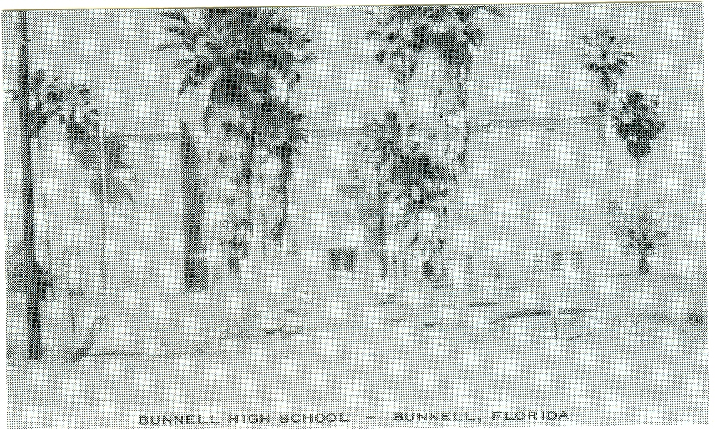

NAMES
ON THE LAND

Dot Bunnell Ray, of
Fayetteville, NC,
submitted this post
card, sent to her
many years ago by
her brother, Weldon
Matthew Bunnell.
More about Bunnell,
FL, in another
issue.

Page 14

