Retyped by Marjorie Gibbs
BUNNELL BONNELL BUNNELL BONNELL BUNNELL BONNELL BUNNELL BONNELL BUNNELL B
U O
N N
N N
E THE BUNNELL/BONNELL NEWSLETTER E
L L
L L

B B
O Volume V, No. 3. 1 July 1991 O
N Published by N
N William R. Austen N
E P. O. Box 62 E
L Laceyville, PA 18623 L
L (717) 869-2325 L
BUNNELL BONNELL BUNNELL BONNELL BUNNELL BONNELL BUNNELL BONNELL BUNNELL B

I found a very handy program to use in indexing the Newsletter. The four issues of the first volume are complete, and I will index the rest of the volumes as time permits. PLEASE LET ME KNOW if you would like
to have a copy of the index. I have no feel as to how many of you would want one. For a few, I could simply run off copies on the computer. Otherwise, I might have to have them printed.

SOME OTHER BONNELLS

Most of the focus of the Bunnell/Bonnell Newsletter so far has been on the descendants of William and Ann (Wilmot) Bunnell regardless of how they spelled the name. We have identified a good many "unattached branches" most of which probably belong to this line if we can just find the missing links.

However, there are a few Bonnell families in the United States and Canada which we know definitely are not part of William's clan. While space does not permit a lengthy treatment at this time, I want to introduce them to those of you who are not already familiar with them.

1. As you know, I have never been able to subscribe to the belief that William Bunnell was a member of a Huguenot family. There is one group of Bonnells in this country who are of Huguenot ancestry without question:

DANIEL BONNELL, CB002297, was born in France about 1774 to Huguenot parents, JEAN AND MARIE (LALON) BONNELL. When he was about 20 years old he married MARIE IZAMBART. Soon after, they escaped to England where it is believed they lived in London for a short time before removing to the American colonies. They arrived in the Charleston, SC, area about 1690 and settled on or near the Santee River. He took out naturalization papers in 1692. Both Daniel and Marie died before 5 February 1699 when the estate of Marie Bonnell was administered by Elisha Prileau.

There are still a great many gaps in our knowledge of the history of this family. Daniel and Marie had several children. Probably among them was a son JOHN, who married (first) HONORA WHITE (or BARTON) and (second) PATIENCE WINDHAM. John had a numerous progeny. His sons

Page 29

Daniel and Anthony both served as officers in the Revolutionary Army. Their half-brother John, on the other hand, was a Loyalist who served with the British forces. Anthony's descendants spread out to Georgia, Alabama and Texas. John removed to Nova Scotia after the Revolution. Some of his descendants can be found in Alberta and British Columbia. Just prior to 1900 many of his descendants moved to Essex co, MA, where their children and grandchildren can be found today. WILLIAM LAWRENCE BONNELL, whose name appears on the Vietnam Wall in Washington, DC (see newsletter Vol. III, No. 4, p. 6) was a member of this branch of the family.

2. ROBERT BONNELL, CB003377, was born in 1781 in Staffordshire, England. In early life he removed to Lamaline, Newfoundland. A WILLIAM BONNELL, who was born in 1794 and who may have been Robert's brother, also moved to Lamaline. Claude Bunnell has included many of their descendants in his Database. Recently I was fortunate in making contact with Eric Hillier, of Kitchener, Ontario, who is compiling extensive data on the families of Lamaline, Newfoundland. The Bonnell and Hillier families were both numerous there and frequently intermarried. Eric is sharing his data on the Bonnell families with me. The best-known representative of this branch of the family was Dr. JOHN SUTHERLAND BONNELL, CB02180. pastor of the Fifth Avenue Presbyterian Church in New York City from 1935 until 1962. During that time he inherited a weekly radio program from Dr. Harry Emerson Fosdick, and for 20 years he preached to 3,000,000 listeners each week over station WABC. From 1966 to 1969 he served as president of Union Theological Seminary in Manhattan. He had a long and distinguished career as a lecturer and author.

3. ROBERT BONNELL, CB00281, merchant of Gloucester co, NJ, was born in 1675 (where?) . He married (first) ESTHER WARDELL, and (second) FRANCES GOODWIN (CHANDERS). Many of his descendants lived in the Philadelphia area. Much remains to be done in researching this family.

* * * * * * *

MILESTONES

From the New Haven, CT, Register, April 1991, submitted by Ruth Duncan, West Simsbury, CT:

Bunnell – deBille

Lucy Bunnell of Townsend Avenue, New Haven, announces the engagement of her daughter, Ruth, to William deBille of New Haven. He is the son of Mary DeBille of Willcox, Ariz.
The future bride, manager at Van Heusen in Branford, is the daughter also of the late Wesley Bunnell Jr. Her future husband is a stock broker at Peoples Securities, Bridgeport.
A Sept. 21 wedding is planned.

[Ruth did not know where Wesley Bunnell fits in. Neither do I. Can anyone help? – wra]

* * * * * * *

Page 30

MILESTONES (Cont'd):

Claude Bunnell, Longboat Key, FL provided this notice from an Ohio Newspaper, probably Cambridge, co, OH. It was apparently printed during the week of 1 to 8 September 1990:

40th anniversary
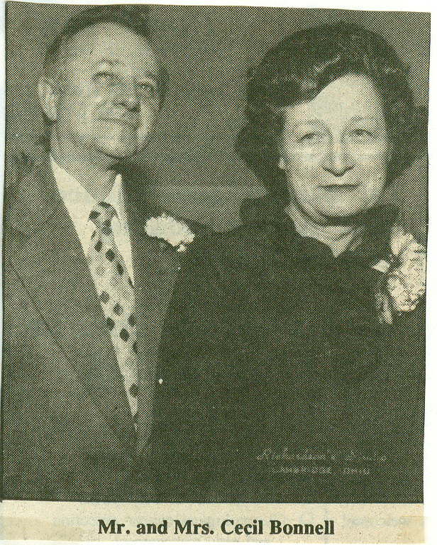

Cecil E. and Shirley Bonnell of 714 S. Sixth St,
Cambridge, will celebrate their 40th wedding
anniversary on Sept. 8.
Due to ill health, no celebration is planned. They
would appreciate hearing from family and friends.
On Sept. 8, 1950, Shirley Grudier, daughter of the
late Thomas H..and Goldie Grudier, and Cecil E.
Bonnell, son of the late Homer W. and Belle Bonnell,
were united in marriage at Beckett Avenue Methodist
Church by the late Rev. James Martin.
Mrs. Donald Burris and the late Virgil Bonnell were
attendants.
Mrs. Bonnell is retired and was co-founder of
Answerfone of Cambridge.
Mr. Bonnell is retired from the former Phillips
Products and Centrex of Findlay. He has been owner/
operator of Cecil Bonnell Realty since 1951. He is a
member of Guernsey Lodge 632 F&AM and Scottish
Rite Valley of Cambridge. The couple are active members
of Beckett Avenue United Methodist Church.
They are the parents of one son, Jack Bonnell of Cambridge. Their grandchildren are Benjamin, Heather, Kenneth and James Bonnell

[Cecil E. Bonnell, CB009747, was the son of Homer Bonnell, CB009603. His Bonnell ancestry is given with the obituary of Chester H. Bonnell elsewhere in this issue. - wra]

* * * * * * *

SOME MILITARY HISTORY

The collections of the Connecticut Historical Society, Volumes IX and X, consist of "Rolls of Connecticut Men in the French and Indian War, 1755-1762." These rolls contain the names of 13 men of the Bunnell family who served in the colonial troops in this war. For a full account of the war in which they served, I recommend "Montcalm and Wolfe," by Francis Parkman, 1884.
Since the muster rolls identify individual soldiers only by name, with spelling which sometimes varies wildly, it is not always easy to tell which person by that name was the soldier. It would appear that three Bunnell families accounted for 11 of the 13 men on the rolls.

Page 31

SOME MILITARY HISTORY (Cont'd):

The largest group included five of the sons and one grandson of Nathaniel Bunnell, CB280011, (son of Benjamin, son of William):

EBENEZER, CB290020, the oldest, served for 18 days as a Lieutenant in Capt. Samuel Hull's Company, Col. Benjamin Hall's Regiment at the time of the alarm for relief of Fort William Henry and parts adjacent in August 1757. Many descendants.

His brother PARMINEAS, CB2900176, had the most extensive service of all. He enlisted on 17 April 1755 in the Third Company, Major Isaac Foote, of the Second Regiment of Connecticut Troops commanded by Col Elizur Goodrich. He served for a short time until he was wounded. A few weeks later, on 30 May 1755, he enlisted in Capt. Street Hall's Company in the regiment of Connecticut men under Major Eliezer Fitch, paid by the colony of New York. He appears to have served until 2 December of that year. In 1756 he enlisted again, in the Sixth Company, Capt. Israel Woodward, of the Second Regiment commanded by Col. David Wooster. He took part in the expedition against Crown Point, and was mustered out on 5 December. His brother Joseph was also a member of this company. In 1757 he served from 4 March to 23 November in the Thirteenth company, Capt. Ephraim Preston, in Col. Phineas Lyman's Regiment. He was back in service on 29 March 1758 in the Seventh Company, Capt. Eldad Lewis, of the Second Regiment, now commanded by Col. Nathan Whiting. He was discharged on 10 November 1758. His son Parmineas, Jr., served in the same company. Finally, he enlisted once more on 26 March 1759 in the Fourth Company, Capt. Joel Clark, in Col. Whiting's Second Regiment. His brother Joseph was with him again in the same company. Parmineas died in service 25 November 1759. He left one son and several daughters. He had no Bunnell grandsons, and any descendants living today would come through his daughters of granddaughters.

PARMINEAS, JR., CB3000321, served with his father in the Seventh Company, Capt. Eldad Lewis, in Col. Nathan's Whiting's Second Regiment. He enlisted on 3 April and died in service on 23 August. He was 16 years old.

JAIRUS, CB1290017, brother of Ebenezer and Permineas, Sr., also died in service. He enlisted on 18 April 1758 in the Ninth Company, Capt. James Wadsworth, in Col. Nathan Whiting's Second Regiment. He served until his death on 29 July 1758. Many descendants.

JOSEPH, CB290018, served in the same company as his brother Parmineas in the 1756 expedition against Crown Point. He enlisted 3 April 1756 in the Sixth Company, Capt. Israel Woodward, in Col. David Wooster's Second Regiment. He was discharged on 12 November 1756. In 1757 he responded to the alarm for the relief of Fort William Henry and parts adjacent, serving for 18 days in the militia company of Capt. John Barnum in Col. Andrew Burr's regiment. He enlisted again with Parmineas on 26 March 1759 in the Fourth Company, Capt. Joel Clark, in the Second Regiment commanded by Col. Nathan Whiting, and served until 7 December. He appears once more on the muster rolls in 1762 in the Fourth Company, Capt. John Patterson and later Capt. Roger Enos, in the detachment that joined Capt. Hugh Ledlie's Tenth Company at Crown Point from 3 September until 3 December 1762. Many descendants.

Page 32

SOME MILITARY HISTORY (Cont'd):

STEPHEN, CB290043, was a half-brother to the others. He served from 16 March to 3 December 1762 in the Seventh Company, Capt. Eldad Lewis, in the Second Regiment, Col. Nathan Whiting commanding. His only son died in service in the Revolution, and any descendants would be through his daughters. NOTE: Claude Bunnell did not identify the soldier in the muster rolls with this Stephen. Instead, he assigned the number CB002034 to the soldier, parentage unknown. I see no reason to question this identity however.

* * *

The next group of service men were sons of Gershom Bunnell, CB20 00005, (son of Benjamin, son of Benjamin, son of William):

GERSHOM CB300013, enlisted in the campaign of 1758 on 3 April in the First Company, David Wooster, Colonel and Captain, in Col. Wooster's Fourth Regiment of Connecticut troops. He was discharged on 15 November 1758. His name is spelled Bunhill on the muster roll, and Claude Bunnell assigned the number CB001159, but I think there can be little or no doubt of his identity. He is said to have married Margaret Tomer. No children have been identified for them, although Ruth Duncan, in her book, "WILLIAM BUNNELL AND HIS DESCENDANTS,' suggests that he might have been the father of Joseph CB310013, and a Gershom.

Gershom's brother SOLOMON, CB300017, served from 16 April until 3 December 1759 in the Fifth Company, Capt. Samuel Hubbel in the Third Regiment under Col. David Wooster. He may have had descendants, but none have been certainly identified as yet.

The third brother, ISAAC, CB300020, is identified by Claude Bunnell as the Isaac Bunnell who served from 10 April to 6 December 1761 in the Second Company led by Lt. Col. James Smedley in Col. Nathan Whiting's Second Regiment of Connecticut troops. I suggest that Isaac Bunnell, CB300006, in the following group of brothers is also a possibility. Except for this muster roll, I have not seen any reference to indicate that either of these Isaacs served in the French and Indian War. They each had two brothers who served in the war. CB300020 was 16 years old at the time; CB200006 was 27. They both served in the American Revolution,CB300020 on the British side as a Captain in the Prince of Wales Regiment. CB300006, on the other hand was a private in the rebel forces in Capt. Jesse Curtis's Company in Col. Noahdiah Hooker's regiment. I think we need more evidence to decide which Isaac is the correct one. Both left many descendants.

* * *

The last group of brothers were the sons of Benjamin, CB290003, (son of Benjamin, son of Benjamin, son of William):

ISAAC, CB300006. He is possibly the Isaac Bunnell who served in 1761. See the discussion regarding Isaac in the group of brothers above.

Page 33

SOME MILITARY HISTORY (Concl'd):

LUKE, CB300007, served in the campaign of 1756 in the Seventh Company, Capt. David Baldwin, in the First Regiment under Major-General Phineas Lyman. This company sailed from Milford, CT, to New York and Albany, proceeded to the Half Moon, and worked at Fort George. There was much sickness and death from dysentery. (The Journal of Peter Pond, a member of this company, was published in The Connecticut Magazine, Vol. 10, p. 239.) The muster roll of Capt. Baldwin's company states that Luke was sick at Fort Edward. He died at Canaan, Litchfield co., CT, 23 October 1756 while still in service. He was 20 years old and left no descendants.

CHARLES CB300008, was born 15 September 1738. He served in Capt. Baldwin's Company in the campaign of 1758. "FAMILIES OF ANCIENT NEW HAVEN," by D. L. Jacobus, and "THE HISTORY OF THE OLD TOWN OF DERBY, CONNECTICUT, 1642-1880," by Samuel Orcutt and Ambrose Beardsley, both quote the Derby Vital Records, saying he died 26 July 1758, "being killed by the enemy, between Fort Edward and Lake George, in the twentieth year of his age, in the king's service." Charles was one of the soldiers who were admitted to his Majesty's Hospital at Fort Edward in the period between 3 July and 24 August 1758. If he died in the hospital as the result of wounds received, this is consistent with the above statement.

However, a Cas Bunnell, CB000429, from Col. Whiting's Regiment was sent to the hospital at Albany some time between 2 June and 31 October 1759. This abbreviation must stand for Charles. If this is the same person, and it probably is, it means that he survived his hospitalization in 1758, enlisted again for the 1759 campaign, and died in the hospital that year instead. Like his brother Luke, Charles left no descendants.

* * *

Two other Bunnells appear in the muster rolls of the French and Indian War:

TITUS, CB300052, was the son of Hezekiah, CB290012, (son of Hezekiah, son of Benjamin, son of William). In 1757 he responded to the alarm for the relief of Fort William Henry and parts adjacent and served for 16 days in Capt. William Pitkin, Jr.'s company, Col. Joseph Pitkin's Regiment. The following year he enlisted 0n 24 May in the Tenth Company, Capt. Josiah Lee, in the First Regiment under Major-General Phineas Lyman. He was discharged on 14 November 1758. Many descendants.

EDWARD BUNNELL, CB00075, served in the campaign of 1759 in the Fifth Company, Capt. John Stanton of Groton, in the Fourth Regiment commanded by Eleazer Fitch of Windham. I have no idea who he was. I know of no Edwards in the Bunnell family this early. Also, there were no Bunnells that I am aware of in eastern Connecticut at this time. Usually, the troops were enlisted from the same area as the officers. Perhaps the copyist misread his name and he was not a Bunnell at all.

* * * * * * *

Page 34

OBITUARIES

Ruth Duncan, West Simsbury, CT, sent in the following obituary, which appeared in the Hartford, CT Courant, 30 May 1991:

JOHNSON, Carl Herbert Johnson, 93, of 18 Cherokee Road, Middlefield, died Tuesday (May 28) at home. He was the widower of May (Bunnell) Johnson. A New Britain native, he lived in Middlefield since 1943. A World War I U.S. Navy veteran, he was employed at the former Tuttle & Bailey, New Britain, for 40 years, retiring in 1962. He was a member of the First Lutheran Church, New Britain, Middlefield Seniors, and the AARP. Surviving is a niece Mrs. Justine Brennen of New York City. . .

[May (Mary J.) Bunnell, daughter of Charles, CB003548, and Josephine (Heil) Bunnell, was born in 1897 in Meridan, New Haven co, Ct. She married Carl Herbert Johnson on 9 October 1922 in Hartford co, CT. –
Ref: CB Database. Who were the parents of Charles Bunnell?]

* * *

This clipping from the Daily Jeffersonian, A Guernsey co, Ohio, newspaper, was submitted by Claude Bunnell, Longboat Key, FL:

BONNELL SERVICES
NEWCOMERSTOWN—Services have been scheduled for 11 a.m. Monday at Addy Funeral Home for Chester Bonnell, 79, of 453 N. College St., Newcomerstown, who died Thursday (Sept. 6, 1990) at Guernsey Memorial Hospital following a lengthy illness.
The Rev. Ray Snyder will officiate services and burial will be in Guernsey Memory Gardens, Cambridge.
Friends may call from 2 to 4 and 7 to 9 p.m. Sunday at the funeral home.
He was born Dec. 3 1910, in Guernsey County, son of the late Homer B. and Belle Tedrick Bonnell. He retired in 1975 as a school bus mechanic and driver for Newcomerstown schools with 28 years of service.
He was preceded in death by two brothers, one sister and one grandchild.
Mr. Bonnell leaves his wife, Mary Moore Bonnell, whom he married March 31, 1934; one son Ronald Bonnell of Lima; two sisters, Mrs. Audrey McDowell and Faye Culbertson, both of Cambridge; two brothers, Eugene Bonnell of Cambridge and Robert Bonnell of Spring Hill, Fla.; four grandchildren and three great-grandchildren.

[Chester H. Bonnell, CB009165, son of Homer Bonnell CB009603. Homer was apparently the adopted stepson of George W. Bonnell, CB005649, son of Isaac Bonnell, CB005633, who settled in Guernsey co, OH, about 18112. Isaac Bonnell's parentage is the subject of intensive research by Claude Bunnell and others.]

* * * * * * *

Page 35

FAMILY REUNIONS

I received a flier from Phyllis Brunk, West Carrollton, OH, as reminder of the 1991 reunion of the descendants of Bert and Lucy Bunnell to be held 2 June 1992 at 50 Springs of Rt. 73 at Caesar's Creek, OH. A notice of this reunion was published in last quarter's Newsletter. Next Year's reunion will be held from 12:00 noon till ?? at the same place on 7 June 1992. I will remind you again next April.

Let me remind you also that the descendants of George Washington and Winnie Jane Smith Bunnell will hold their 1991 reunion on Sunday, 22 September at Bethany Community Center near Stedman, NC. For information, write to Mrs. John A., Ray, 2816 Arlington Avenue, Fayetteville, NC 28303.

Lyda Graye Cloud, P. O. Box 63, Locust Grove, OK 7452, sent in a notice of another reunion this year, the reunion of "Bunnell/Walters, to be held on Saturday, 3 August 1991, at the home of Bob and Cheri Bunnell at Foyil, Rogers co, OK. Dinner will be promptly at 12:30 p.m. The main course is smoked pig by the Bob Bunnell family. "Everyone please bring a covered dish, perhaps some can bring a dessert, and everyone bring your own table service, some type of refreshments, as I imagine it will be warm and don't forget some lawn chairs or cover for the ground to sit on. If you are a musician plan to entertain us. If you have photo albums of the past perhaps you'd like to share them." For more information, call Bob and Cheri Bunnell on (918) 341-2200 or Lyda Graye Cloud on (918) 479-8892 after 5:30 p.m.

I hope to receive reports from each of these reunions. Are there any others being held this year that you are aware of?
* * * * * * *

QUERIES

The name and address of the inquirer are included with each query. However, if you are able to provide the inquirer with the information requested, I would appreciate your sending me a copy of your reply.

1. Seeking parentage of OLIVER HARTLEY BONNELL, CB010013, and his wife JENNIE WILLIAMS. Oliver was born 18 June 1858 in New Brunswick, Canada, and died 30 June 1940 in Livingston, Park co, MT. Jennie was born 20 February 1860 in New York. They were married about 1880-82 and had four children, Lena, Hartley, Lee and Clyde Bonnell, born in Chamberlain, Brule co., SD. Jennie died 31 March 1893 in Livingston, MT, and Oliver married (second) LUCY M. ________. Oliver and Lucy had two sons, Burton and Frank Bonnell. I would appreciate hearing from any descendants of Oliver Bonnell. Carole Bonnell, 2217 41 Ave Ct E, Spanaway, WA 98387.

* * * * * * *

Page 36

BUNNELL, FLORIDA

On the next two pages you will find a report sent to me by Philip and Phyllis Bunnelle, of Santa Clara, CA. In April 1991 they visited Bunnell, FL, and the report details what they learned there. The full report includes several pages of pictures, etc. With limited space, I have been able to include only one page of pictures, mounted on a sheet of the Bunnell, FL letterhead. (Mrs. Ralph Bunnell of Kenmore, NY, also sent me a picture of the Bunnell Motel, which she took several years ago.)

ALVAH ALONZO BUNNELL, CB005947, for whom the town was named, was born 22 August 1855 at Newburg (should this be Newberry, Alachua co?), FL (or at Darien McIntosh co, Ga). He was the son of ELI BUNNELL.

ELI BUNNELL was born 12 June 1819 in Standeel Lawn (or Standeck Laun), Canada. [I have been unable to identify this place under either name.] On 15 January 1853, at Darien, McIntosh co, GA, Eli married MARY ANN PHOEBE CAULDER, who was born 30 November 1829 at Darien, GA. She died 15 September 1864? at The Thicket, Darien, GA, and he died 12 September 1883, also at The Thicket. Their three children were raised by a first cousin, Theodore P. Pease and wife. The children were:

1. Alva Alonzo, b. 22 Aug. 1855.
2. Emma Pease, b. 20 Feb. 1858; m. A. D. Curry; d. 22 Nov. 1903.
3. Theodora Augusta, b. 26 Nov. 1866; m. Fleming Spivey Way; d. 2 Jan. 1936.

ALVAH ALONZO served as a drummer boy with the Confederate forces about 1865. On 14 October 1877, at Hastings, Saint Johns co, FL, he married SUSAN CYNTHIA GODWIN. She was born 24 February 1857 in Georgia just across the line from Lake City, FL. In the late 1880's he established a cypress shingle mill along the railroad in Flagler co, FL, and proposed to furnish wood for the woodburning locomotives. It was called the Bunnell Stop. the present city of Bunnell evolved from this simple beginning. Alvah moved to Miami, Dada co, FL, about the turn of the century. His wife died thee 10 September 1931, and he died, also in Miami, 21 March 1944. Their children were:

1. Alonzo Messer, b. 8 Feb. 1879; d. 17 Apr. 1963.
2. Mary Augusta, b. 4 Feb. 1881; m. J. Frank Vann.
3. Luther Eliphs, b. 29 Oct. 1882; d. 4 Aug. 1952.
4. George Eli, b. 17 Aug. 1884; d. 16 Sept. 1934.
5. Theodore Curry, b. 25 May 1886; d. 6 Apr. 1942.
6. Alvah Gilbert, b. 4 Mar. 1888; d. 13 Dec. 1974.
7. Gussie McDonnell, b. 7 Apr. ????; d. 22 Aug. 1938.
8. susie Angeline, b. 23 Dec. 1892; m. Elmer Hall.
9. Emmett Pease, b. 5 July 1895; d. 14 Oct. 1971.
10. Otis Way, b. 5 April ????; d. 27 Aug. 1962.

Page 37

BUNNELL, FL
April 1991

In April of this year Phyllis and I visited the town of Bunnell, Florida. This quiet little town is located near the east coast of Florida, between St. Augustine and Daytona Beach.

According to one source, the town was founded about 1881 by Alvah A. Bunnell, who built a saw mill there. Another source says that he operated a cypress shingle mill around the turn of the century and prevailed on the railroad to make stops at his plant. For lack of a better name, they called it the Bunnell stop. By 1903 the settlement, then called Bunnell, was big enough to have a post office. Alvah moved on to Miami about that time, and no other Bunnell seems to have been involved in subsequent development of the town, nor is one living there now.

Real estate promoters pushed the development of the area, and in 1913 Bunnell was incorporated as a town. Two years later there were 40 registered voters there. In 1917 it became the country seat of newly formed Flagler County.

Flagler county has an area of 519 square miles, with 21 miles of ocean frontage. Much of the area is covered by dense growths of pine, cypress and palmetto. Although still one of the least densely populated counties in Florida, it claims to be the fifth fastest growing county in the U.S. The population of the county in the latest census was reportedly 34, 000.

In the 1930's Bunnell was a lumber and turpentine town, with the turpentine produced from pine resin. Pines are still grown for pulp wood and the rural area to the west and south is noted for potatoes and cabbage, as well as raising livestock.

Once the leading city in the county, Bunnell is now a backwater, with new real estate developments taking place elsewhere, most notably Palm Coast, an ITT community development to the north, and to a lesser degree, Flagler Beach to the east.

In 1988 Bunnell had a population of 2,300, with businesses mainly engaged in local retailing. Current businesses include:

Bunnell Auto Detailing, Bunnell Auto Mart, Bunnell Auto Supply, Bunnell Automobile Machine Radiator, Bunnell Bail Bonds, Inc., Bunnell Cypress Co., Bunnell Dry Cleaners, Bunnell Feed & Supply Co., Bunnell Plaza, Bunnell Restaurant & Motel, Bunnell Feed & Supply, Bunnell Thriftway Grocery, and Bunnell Tire Sales.

The Bunnell City Hall is a distinctive-looking building built by the WPA in 1937. It is constructed of hand-cut blocks of coquina, a soft, whitish limestone composed of broken shells and coral. The building is set well back from the highway, with a small lake and fountain in front. The city's name is spelled out in large block letters in front of the lake. Appropriately, the City Hall is featured on the city seal. There's also the Bunnell Fire and Police Department and the Bunnell Waterworks.

The Bunnell Post Office (Zip 32110) services 5,500 customers. After checking his directory, the Postmaster noted that this is the only Bunnell Post Office in the U.S.

Townspeople were very friendly, especially after we told them our name. The clerk at the City Hall gave us a copy of their letterhead and a city calender off the wall. We were told that there had been T-shirts emblazoned with the notation "Where the Hill is Bunnell?" Unfortunately, they are no longer in stock, but we're still trying to get our hands on an old one.

Phil Bunnelle

Page 38

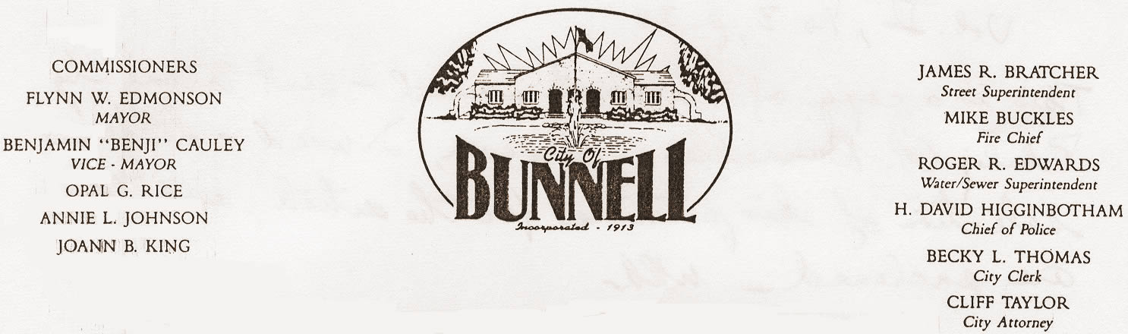

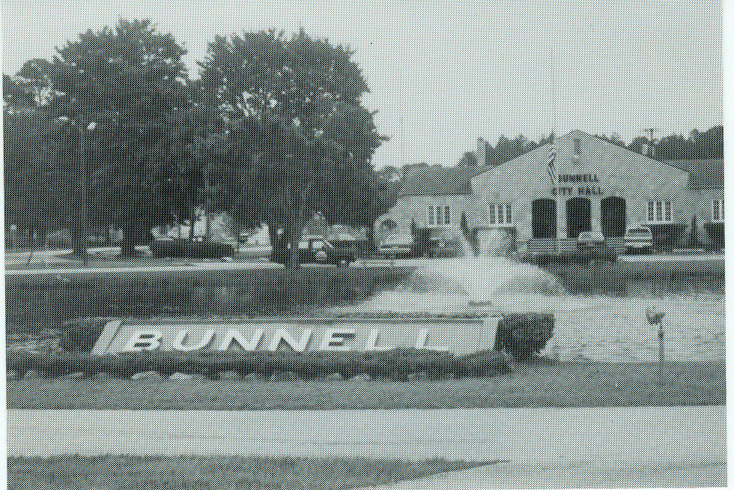

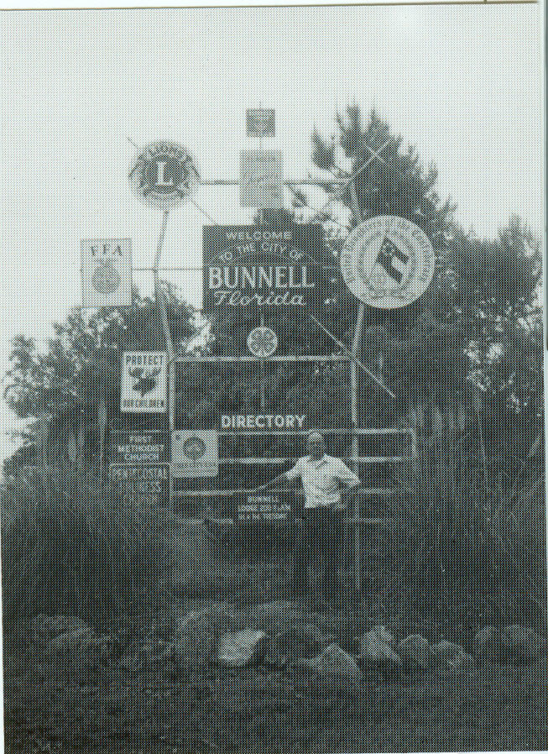
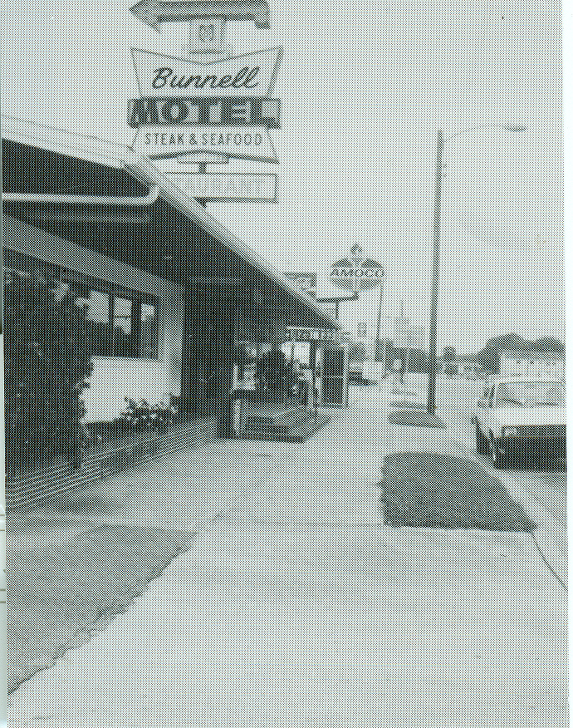

P.O. Box 756 .Bunnell, FL 32110 .904/437-2417 .Fax: 904-437-6616
Page 39

INTERNATIONAL GENEALOGICAL INDEX

OHIO – 1988 Update (Cont'd) Submitted by Jerry Hatch

[Monroe county – formed in 1813 from Belmont, Wash. & Guernsey]
- Monroe county – Marriages:

Bonnell, George W. | Amanda J. McCracken | 10 Sep 1867
Bunnell, Vachel | Alice Hubbard | 07 Nov 1875

[Montgomery county – formed in 1803 from Hamilton & Ross]
- Montgomery county – Marriages:

Bonnell, James | Elizabeth Ellis | 1806

[Muskingum county – formed in 1804 from Washington & Fairfield]
- Muskingum county – Marriages:

Bonnell, L. | Mary Jane Applegate | 18 Nov 1857
Bonnell, L. D. | Emma L. Evitt | 20 Oct 1874

[Portage county – formed in 1807 from Trumbull]
- Portage county Marriages:

Bunnell, Almira | George H. Ballard | 11 Nov 1857
Bunnell, Benjamin T. | Lucy E. Simmons | 21 Oct 1837
Bunnell, Eunice | Peter Haynes | 19 Dec 1819
Bunnel, Hannah H. | Ebenezer M. McIntosh | 20 Mar 1844
Bunnell, James | Mariah Witherell | 11 Feb 1851

[Preble county – formed in 1808 from Montgomery & Butler]
- Preble county – Marriages:

Bunnel, Richard | Susan Corwin | 30 Dec 1852

[Richland county – formed in 1813 from Knox]
- Plymouth, Richland county – Marriages:

Bunnell, Edward Salmon | Elizabeth Blakeslee | 15 Jun 1862

[Ross county – formed in 1798 from North West Territory]
- Ross county – Marriages:

Bunnell, Abigail W. | Wilson Brown | 21 Mar 1848
Bunnell, Eliza Ann | Leonard W. Brinley | 06 Mar 1844

[Sandusky county – formed in 1820 from Huron]
- Sandusky county – Marriages:

Bunnell, Charles E. | Clara A. Dewey | 11 May 1871
Bonnell, Daniel | Louisa Seaman | 13 Jun 1872
Bonnell, E. N. | Sarah Clink | 09 May 1869

Page 40

[Seneca county – formed in 1824 from Wayne, Franklin and Delaware]

- Seneca county – Births:

Bonnell, Emma | Moses Bonnell/Susan J. | F | 01 Sep 1869
Bonnell, G. R. | J. A. Bonnell/Catharine E. Gettinger | M | 01 Jun 1870
Bonnell, Harry | Barnett W. Bonnell/Mary Gorsuch | M | 29 Oct 1874
Bonnell, James Frederick | John G. Bonnell/Catharine E. Gittenger | M | 15 Mar 1874
Bonnell, John A. | James Bonnell/Mary Egbert | M | 15 Mar 1874
Bonnel, Margret E. | Jacob Bonnell/Sarah A. Norris | F | 14 Oct 1870
Bonnell, Mary | Barnett W. Bonnell/Mary Gorsuch | F | 02 Jan 1869
Bonnell, Minnie | John Bonnell/Emma Vosbalgh | F | 08 Mar 1871
Bonnell, Susan | Christian Bonnell/Margarett Goesuch | F | 05 Mar 1870
Bonnell, William E. | J. P. Bonnell/Elen Egbert | M | 07 Feb 1870

- Seneca county – Marriages:

Bonnell, Alfred | Emma Norris | 06 May 1869
Bponnell, Annah A. | John W. Strickling | 22 Mar 1877
Bonnell, Bernard | Mary Gorsett | 11 Sep 1859
Bonnell, Christian | Mary Hollepeter | 30 Oct 1884
Bonnell, Elsie | S. A. Wonders | 02 May 1883
Bonnell, Flora | William L. Hahn | 18 Mar 1876
Bonnell, Jacob F. | Sarah T. Norris | 03 Oct 1861
Bonnell, James | Mary E. Egbert | 26 Nov 1868
Bonnell, John | Catharine E. Gittinger | 13 Mar 1857
Bonnell, John H. | Emma Vosburg | 26 May1870
Bonnell, Maggie J. | Evan M. Goetschines | 17 Dec 1879
Bonnell, Margaret J. | Daniel Callon | 27 Dec 1863
Bunnel, Mary | Samuel Slaughterbuch | 09 Jun 1872

[Shelby county – formed in 1819 from Miami]
- Shelby county – Marriages:

Bunnelle, George H. | Mary L. Beeman | 15 Jun 1864

[Stark county – formed in 1809 from Old Indian Lands]
- Stark county – Births:

Bonnel, Charles Frederic | William Bonnel/Catherine Schell | M | 24 Oct 1833

- Stark county – Marriages:

Bunnel, J. M. | Mary Burd | 28 May 1865
Bunnell, Mary | Henry L. Atwood | 19 Mar 1877

[Summit county – formed in 1840 from Portage, Medina & Stark]
- Summit county – Births:

Bunnell, Charles S. | Edward Bunnell/ Charlott Soutom | M | 28 Apr 1875

Page 41
- Summit county – Marriages:

Bunnell, Frederick W. | Maria Mansur | 12 Jan 1845
Bunnell, George | Mary Cross | 25 Sep 1872
Bunnell, Ida | Willie H. Chapman | 11 Aug 1878
Bunnell, Ira | Mary Ross | 17 Nov 1842

[Trumbull county – formed in 1800 from Jefferson & Western Reserve]

- Trumbull county – Marriages:

Bunnel, Charles | Almyra Green | 28 Nov 1819
Bunnell, Charles A. | Tryphena Bablet | 29 Mar 1827
Bunnell, O. M. | Nancy Palmer | 27 Nov 1860

[Tuscarawas county – formed in 1808 from Jefferson & Muskingum]

- Tuscarawas county – Marriages:

Bonnell, Thomas G. | Margaret Hursey | 06 Nov 1879

[Union county – formed in 1820 from Franklin, Madison, Logan & Delaware]

- Union county – Marriages

Bonnell, Mary E. | George B. Gregg | 18 Mar 1884

* * * * * * *
Follow-up notes on "A few strays"

In the last Newsletter I threw out the names of two Bunnells and a Bonnell that I had read about but could not identify. Here is what I have learned about them:

- DAVID BUNNELL, diver-photographer, whose picture appeared in the National Geographic, is one of the sons of Claude Bunnell, the compiler of our Bunnell/Bonnell/Burnell/etc. Database. Claude called to tell me that his son David Edward Bunnell, CB370013, pursues this activity as an avocation.

-HEZEKIAH W. BONNELL, the New York City Alderman. Claude Bunnell also provided more information about this man. In Claude's Database he is CB002959. He was born 16 August 1799 in Essex co, NJ and died 3 June 1843 in Manhattan, NY. His wife was Susannah _____. They had two children who died in early childhood, and probably others. Claude found the 1830 census in Manhattan which suggests that there were several older children. He had a brother David Bonnel, who died in Newark, Essex co, NJ, in 1837, and a brother Stephen who was a baker in New York City. We have not yet learned who their parents were.

-Lt. JOHN BUNNELL, head of the Narcotics Team in Portland, OR. Philip Bunnelle, Santa Clara, CA sent me a newspaper review of the TV program "American Detective," which was broadcast in early May. The reviewer panned the program series, but Phil, who saw the program, did not think it was so bad. so far, I have no information on the Lieutenant's family.
* * * * * * *
Page 42 (The End)

