Retyped by Marjorie Gibbs

BUNNELL BONNELL BUNNELL BONNELL BUNNELL BONNELL BUNNELL BONNELL BUNNELL B
U O
N N
N N
E THE BUNNELL/BONNELL NEWSLETTER E
L L
L L

B B
O Volume V, No. 4. 1 October 1991 O
N Published by N
N William R. Austen N
E P. O. Box 62 E
L Laceyville, PA 18623 L
L (717) 869-2325 L
BUNNELL BONNELL BUNNELL BONNELL BUNNELL BONNELL BUNNELL BONNELL BUNNELL B

COMMENT

I hope you had a pleasant summer. Here at Camelot the weather has been so favorable for swimming that we have spent a great deal of time in the pool. I'm afraid this has had a negative effect on all the other things we should be doing, but, as my wife says, "You can't swim in December." With all this beautiful weather, the ground has become very dry, and now we need about three days of steady rain. Some people are never satisfied!

* * *

In Volume V, No. 1, I printed a notice of the new book, BUNNELL AND ALLIED FAMILIES, by Joan England Murray. What I didn't do is give you Joan's address. In an effort to make amends, I sent her address to those of you I thought might be interested, and some of you have purchased her book. However, she is still getting inquiries in a round-about way, and has asked me to print her address in the Newsletter.

Mrs. Joan E. Murray
1281 N. Linden Ave.
Palatine, IL 60067

* * * * * *

A RECENT INQUIRY

Over the last thirty years almost 350 people have sent me information about the Bunnell/Bonnell family. Much of it has consisted of their ancestral lines worked out to the immigrant Bunnell. However, there have also been many, many fragments of unconnected data which I have tried to keep track of until I could find a way to fit them in. I recently received an inquiry from Carol Rilling, Sierra Vista, AZ, and thought you might be interested in seeing how some of these fragments come together.

Page 43

A RECENT INQUIRY (Cont'd)

Mrs. Rilling's letter read as follows:

"Would you be willing to tell me if you have anything on the following relative?

HENRY BONNELL
b. ca. 1740? New Jersey?
m. Hannah _________? b. c. 1736
d. 23 Aug. 1764 (age 28)
Connecticut Farms, New Jersey
d. +9 April 1777_ New Jersey

Henry Bonnell had a daughter, Esther, b. c. 1765; m. Moses(6) Thompson; d. 6 Oct. 1796 New Jersey.

These families are found in Essex County, New Jersey in towns like Elizabethtown, Westfield, Connecticut Farms, Union Township, etc."

I do not have the answer for Mrs. Rilling in my compiled records of the descendants of William Bunnell or in the unattached families. However, I keep a notebook of miscellaneous unconnected notes and pieced together some of them as follows:

1. On page 452 of Volume II, THE PASSAIC VALLEY, NEW JERSEY, by John Whitehead, LL.D., 1901, we find: "William Baker, Jr., was born in Westfield, February 20 1788, and married Jane R. Thompson, who was born May 3, 1790, daughter of Moses and Esther A. (Bonnell) Thompson, the former being a son of Hezekiah Thompson, who is mentioned in history on account of his valiant service in the War of the Revolution."

2. One item of a collection copied by Homer E. Baldwin and sent to me on 6 November 1959: "In Hezekiah Thompson Family Bible, N.J. in possession of Donald Beam, 35 Stiles St., Elizabeth, N.J.

Moses Thompson, b. Nov. 6, 1764, departed this life July 14, 1809; Esther Bonnell, wife of Moses Thompson, b. Oct. 5, 1765, and departed this life Oct. 6, 1796."

3. Letter from Robert L. Ross 10 December 1970: ". . . Also I have the following records of Bonnell marriages.

1) Moses Thompson, son of Hezekiah and Jane (Ross) Thompson married as his first wife, Esther Bonnell dau. of Henry Bonnell 2nd. They had Nancy and Jane R (b. 1790). Moses married second Polly Winans and had 6 children."

4. Several people, including Homer Baldwin, Philip Lacy and Marilyn Lynch sent me copies of cemetery inscriptions in the Connecticut Farms Presbyterian Church cemetery in what is now Union co, NJ. Included was: "Hannah Bonnel, wife of Henry, d. Aug. 223, 1764, age 28 yrs."

Page 44

A RECENT INQUIRY (Cont'd)

5. From a letter written to Miss Marian E. Biles, 12 June 1960 and passed on to me by Miss Biles. The letter is signed "Marcia."

"I have been able to do something with the Clark family. . . . As you know Pheobe Winans' mother was a Clark. I think you told me about the will of Jotham Clark, her father. We have gone through the wills of New Jersey, as they are published in the New Jersey archives. This is the Clark family as we trace it.

IV. Jotham (son of John, son of Richard, son of Richard), born 1700-05, died in Elizabeth in 1772. Left a wife Sarah _____. His will mentions
. . .
8. Hannah, married Henry Bunnell, deceased by 1772."

6. Homer Baldwin, Mrs. John Hegeman and Marilyn Lynch each sent me a copy of the abstract of the will of Henry Bonnell taken from the Calendar of Wills in the New Jersey Archives, First Series, Vol. XXXIV, 1771-1780. I have not seen the printed archives myself, and each of the copies I have varies slightly from the others. Piecing them together, this is probably a fairly accurate version of the abstract:

9 Apr. 1772, Bonnel, Henry, of Borough of Elizabeth, Essex Co., Will of. All real and personal estate to be sold. Wife Prudence £30 (£24?), and the rest of the money to be used to bring up my children. sons Abner & Henry to be bound out to trades when they are old enough. Executors, Daniel Wade and Elias Whitehead, my 2 brothers-in-law. Wit: Timothy Whitehead, Sarah Whitehead, Joanna Whitehead. Proved Aug. 9, 1777. Lib. 19, p. 181.

7. A Family Group Sheet compiled by Mrs. John Hegeman for ABNER BUNNELL says he was born 5 October 1760 in Essex co, NJ, and died 26 April 1835 at Union Village (Shaker) Warren co, OH, age 74. He came to Warren co, OH, about 1804 and joined the Shakers about 1805. The source of Mrs. Hegeman's data is given as the microfilmed Shaker records at the Warren co, OH, Museum.

- That is all the pertinent data from my book of miscellaneous notes, so now we turn to Claude Bunnell's Database. He has

HENRY BUNNELLL, CB300091, d. Aug. 1777 in Elizabethtown, Essex co, NJ.
he married (1) Hannah Clark, b. 1736; d. 23 Aug 1764.
(2) Prudence Whitehead, b. 173x; d. 29 Sept. 1784.
Children:
CB310336 Abner, b. 5 Oct. 1760
CB310337 Henry, b. 176x.

As references Claude lists the following:

From the New Jersey Archives, First Series, Vols. 32, 32, 34:

20 Dec. 1754, Essex co., Henry was administrator for the probate of the estate of Isaac Ward.
1763, Elizabeth Boro, Essex co, he was witness on a will.
1765, Elizabeth Boro, Essex co, he made the inventory for the probate of an estate.
26 July 1779, Elizabeth, Essex co, Timothy Whitehead lists his daughter Prudence Bonnel in his will.

Page 45

A RECENT INQUIRY, (Concl'd)

From the GENEALOGICAL MAGAZINE OF NEW JERSEY:

24 July 1764 New Providence, Essex co, NJ, the funeral service for his wife Hannah was conducted by Rev. Jonathan Elmer of the Presbyterian Church.

From the PROCEEDINGS of the New Jersey Historical Society:

1764, Union co, NJ, wife Hannah was buried in the Connecticut Farms Churchyard at the age of 28.

From the Essex co probate records:

1772, Elizabeth, Essex co, Will of Jotham Clark lists daughter Hannah, wife of Henry Bunnell.
9 Aug. 1777, Elizabeth Boro, Essex co, Will of Henry Bonnel, lists wife Prudence and sons Abner and Henry underage.
26 July 1779, Elizabeth, Essex co, Will of Timothy Whitehead lists daughter Prudence Bonnel.

- From all these fragments we can compile the following, keeping in mind that much of the data comes from handwritten copies, none is directly from primary documents, and the evidence for the connection of the various items is mostly circumstantial.

HENRY BONNEL, 2d, CB300091, parentage unknown, was born probably in Elizabethtown, Essex (now Union) co, NJ, sometime around the year 1730. By the end of 1754 he was old enough to serve as administrator of the estate of Isaac Ward (a relative?). He married (first) HANNAH CLARK, daughter of Jotham and Sarah Clark. She was born about 1736 and died 23 August 1764. She was buried in the Presbyterian Churchyard at Connecticut Farms (now New Providence), NJ. Henry married (second) PRUDENCE WHITEHEAD, daughter of Timothy Whitehead. Henry wrote his will 9 April 1772 in the Borough of Elizabeth, Essex co. He died before 9 August 1777 when the will was probated. The will mentions his wife Prudence, children, including specifically sons Abner and Henry, underage, and brothers-in-law Daniel Wade and Elias Whitehead. His widow Prudence died 29 September 1784.

Children:
1. Abner, b. 5 Oct. 1760.
2. Henry b. ?
3. Esther A., b. 5 Oct. 1765; m. Moses Thompson; d. 6 Oct. 1796.
Children, (surname Thompson):
1. Nancy. 2. Jane R.
Perhaps other daughters not specifically mentioned in the will or other children born after the will was written in 1772.

In pursuing the search for Henry's ancestry, there are a number of clues lurking in all of this, the most intriguing of which is the reference by Robert L. Ross that Esther Bonnell was the daughter of Henry Bonnell the 2nd! Who was Henry Bonnell the 1st?

* * * * * * *
Page 46

GOLDEN WEDDING ANNIVERSARY

Paul J. Bunnell, Marstons Mills, MA, wrote that his parents celebrated their 50th wedding anniversary on 7 June 1991.

JAMES HENRY BUNNEL, SR., CB001147, son of George Woodbury and Maria (Bertogli) Bunnell, was born 20 January 1921 in Amesbury, MA.

LORRAINE MURIEL VIOLETTE, daughter of Albert and Alma (Belanger) Violette, was born 6 May 1925 in Beverly, MA.

James and Lorraine were married 7 June 1941 at St. Joseph Catholic Church, Amesbury, MA. They have three sons, all born in Amesbury:
James Henry, b. 20 Sept. 1942.
Paul Joseph, b. 28 July 1946.
Michael Norman, b. 6 Jan. 1953.

In 1953, shortly after their last son Michael was born, the Bunnells moved to the San Fernando Valley, Los Angeles, CA, to seek better employment opportunities. Lockheed Aircraft Co. was the biggest employer, and that's where Jim found work. After one more job change, Jim finally retired from Stainless Steel Corp. in Burbank, Ca. After the sons were married, Jim and Lorraine moved to northern California. Always in love with the outdoors and camping, they spend most of their time with Mother Nature.

They made one more move, to Oregon, in the 1970's. Today they live in the small coastal community of Florence, where their backyard is attached to a State Park filled with hiking trails, streams and pine trees and sand dunes.

Besides being a wonderful loving father to his three sons, Jim's accomplishments have been many and varied. He was a long distance track runner in high school and a champion ping pong player. During Word War II he took part in the D-Day invasion in Europe and finished his service in the Pacific Theater at the surrender of Japan. He was a stainless steel engineer of metal works, an excellent carpenter and outdoorsman, aircraft builder, bookstore owner, campground caretaker at Mt. Shasta, CA, and an adventurer of the northwest.

For their anniversary, many friends and family members met at the home of their son Michael in Palmdale, CA. The anniversary party was the first family reunion between east and west coast relatives in the past ten years. Following the party, Jim and Lorraine left for a trip to Alaska, a place they had always wanted to visit. The trip was a surprise gift from their sons.

Jim is a great-great-great grandson of Benjamin Bonnell, the Loyalist, CB006839, about whom Paul wrote in his book, THUNDER OVER NEW ENGLAND.

* * * * * *

Page 47

Florence Buck sent in the following article from THE WEEKLY ALMANAC, Honesdale, PA. It is a pleasure to reprint it for you:

Kenneth M. Bunnell Serves With Both Patience And Persistence

Kenneth M. Bunnell had told his wife, Betty, last year that would be his last Flag Day program. Twenty-one years was long enough, he thought then. She knew better. It wasn't long before he was writing his 22nd program.
The flag day program is one of the dimensions of Boy Scouting and other community service to which Mr. Bunnell has given his time and talents. It was an outgrowth of scouting when he and members of Troop 103 sought a way to properly dispose of old flags, according to the flag code. The first program was held at Gravity Park at the Horseshoe at the edge of Honesdale. Howard Loring and Mr. Bunnell got an old wind-up phonograph, using records to play bugle calls. Then the program moved to the Elks Home, and eventually to the Fair Ave. location.
A program that involved just a handful of scouts and adults grew to a major community production involving many veterans groups, girl and boy scouts, and public officials.
The Flag Day program reflects much of the life of Kenneth Bunnell.
He was born just upstream from this year's Flag Day program site in the old Kimble House, a hotel, where the Fairway Restaurant is today. He is the only child of Mervin L. Bunnell and the late Esther M. Pease Bunnell.
After graduating from Honesdale High School in 1937 he went to work at Lange's Cutrite Store located in the theatre building. He was there for eight years before moving on to Bunting's Market, where Stendor's Market is today, staying there three years. He had been working at Allen's Ice Cream Store on Main St. for three years, when Robert Fisch convinced him to give banking a try. So, for the next 33 years, he was at Honesdale National Bank, retiring as a vice president and trust officer.
He is married to the former Betty Theis of Tyler Hill. They have three children: Marilynn Jaggers of Honesdale, James of Bethany, and Susan Graziadio of White Mills.
As a scout, and scouter, he has given 57 years. He joined Troop 1, attended the National Jamboree in 1937; earned the Eagle badge and four palms; and, has been a scoutmaster or assistant scoutmaster at Troop 2, which at the time was sponsored by the First Presbyterian Church, Honesdale; and Troop 103 at Central Methodist Church. He has been a committeeman, and served various capacities of the District.
"You know, I left scouting for 23 years," he said. He became involved in girl scouts; the Central Methodist Church on the administrative board, and served there as treasurer for 27 years. He was the auditor for the school district and the borough for 18 years; served as borough treasurer for 15 years; was exalted ruler of the Elks Lodge where he was involved for 20 years; a trustee and was treasurer for the Wayne County Historical Society.
In recent years, he has given time to the Stourbridge Railroad tours of the Wayne County Chamber of Commerce. He has risen there now to conductor. His granddaughter, Colleen Bunnell, serves with him as his coach captain.

[Kenneth M. Bunnell, CB361048, is the son of Marvin L. Bunnell, CB351449, whose picture appears in Volume IV, No. 2, of the Newsletter, on the occasion of his 100th birthday.]

* * * * * * *

Page 48

BUCKINGHAM LODGE IN BONNELL PARK

Lynn E. Arnold, Cincinnati, OH, has submitted several clippings and pictures telling the story of the house built by Aaron Bonnell in 1852 on Camargo Road, Indian Hill, Hamilton co, OH, just outside of Cincinnati.

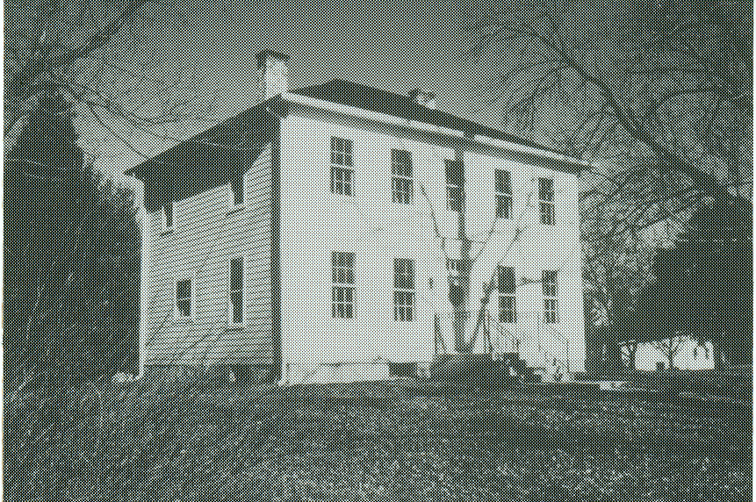 | Aaron Bonnell CB005596, son of Moses Bonnell CB002142 and Hannah (Buckingham) Bonnell, purchased 185 acres of land in Symmes twp, Hamilton co, for $1200 in 1832. In 1837 Aaron married Margaret Dackey. They lived in a log cabin until 1852, when the present house was built, mostly from lumber on the acreage. All but the front is walnut weather boarding. The front is pine. The house is a fine example of Italianate block architecture popular between 1840 and 1860. A porch was added
later, probably at or before the turn of the century. It has since been removed. A large frame barn which stood west of the house burned many years ago.

After Aaron's death in 1882 the property was divided among his four sons, George Dackey, William Jones, Leandrew A.. and Moses F. Bonnell. William Jones Bonnell CB005600 lived all his life in this house. He married Florence Buckingham in 1882. They had two children, Lola Louise and Harold Lee Bonnell. William died in 1922 and Florence in 1932. Lola never married, but continued to live in the old homestead for the rest of her life.

She was deeply proud of her Bonnell and Buckingham heritage, and she loved her little farm, now consisting of 13 acres. She managed the farm herself, raising her own produce, which she generously shared with neighbors and friends. She owned a cow named Lilly Bell and her calf and also several chickens, each of which had a name. David Meyer remembers that as a boy he cut her grass for $1 with a hand push mower and that he had strict orders to steer carefully around the little crosses that marked the graves of those feathered pets. The henhouse still stands amid a clump of over-grown shrubbery. A cistern with an old crank handle pump still exists by the roadside.

The Bonnell house was left to the village of Indian Hill by Lola Bonnell when she died in 1966, with the stipulation that the house be called Buckingham Lodge and the adjoining 13 acres be called Bonnell Park. ". . . my intention in naming said Park Bonnell Park and said building Buckingham lodge . . . to preserve in perpetuity the said Indian Hill pioneer names."

Page 49

BUCKINGHAM LODGE IN BONNELL PARK (Concl'd)

In 1988 the village scheduled the house for demolition, planning to develop the land for home sites. The Indian Hill Historical Society, in the person of its president, Virginia White, went to the village officials and asked them to allow the Society to preserve the home and restore it. She acted not a moment too soon, since the demolition crew began its work that very day.

The CINCINNATI ENQUIRER, 17 July 1990, quoted Ginny White: "The home's old wood mantel above the fireplace already had been hauled away. But we save the remainder of the house. We then raised $35,000 from our membership. The village matched that amount. The restoration costs will be around $70,000. We plan to make the home a museum open to the public and also will offer it as a meeting place for small groups."

We can be grateful toe the Indian Hill Historical society for preserving this lovely old home, so different in its design from the Rural Gothic style of the Bunnell House at Homer, MN, built about the same time, and preserved by the Winona County Historical Society. (Newsletter Vol. IV, No. 2)

* * * * * * *

OBITUARIES

This obituary appeared in the Tunkhannock, PA, New Age-Examiner on Tuesday, 25 June 1991:

ETHEL DOUGHERTY

Ethel Bunnell Dougherty, of Meshoppen, died at home Friday afternoon, June 21, 1991.
Born in Auburn Twp., Susquehanna County, Aug. 30, 1901, she was a daughter of the late Clifford and Annie McGavin Bunnell. She was employed by various dress factories in the Meshoppen, Tunkhannock and Stevensville areas. She was a member of the Meshoppen United Methodist Church.
She was preceded in death by her husband, Harry, in 1972; brother, Ralph Bunnell; and sister, Mae Watkins.
Surviving are sisters, Mrs. Lena Stang, Meshoppen; Mrs. Mildred Shafer, Glen Spey, N.Y.; five nieces, Mrs. Theophelia Lyons, Tunkhannock; Lurline Stang, Meshoppen; Carol Murray, Wilkes-Barre; nephews, Richard Stang and Arthur Bunnell, both of Meshoppen; Clifford Watkins, Wilkes-Barre; Robert Shafer, Kentucky; Jack Shafer and Jay Shafer, both of Glen Spey, N.Y.
Funeral services were held Monday from the Sheldon Funeral Home, Main Street Meshoppen, with the Rev. Kenneth Bitler, of Meshoppen United Methodist Church officiating.
Interment, Overfield cemetery, Meshoppen.

[Her father Clifford A. Bunnell CB330369 was son of George CB320264, son of James CB310261, son of Benjamin CB300045, son of Solomon CB290004, son of Benjamin CB280006, son of Benjamin CB270004, son of William the immigrant CB260001.]

* * *

Page 50

OBITUARIES (Con't)

Mabel Daniels, Beacon, IA, submitted the obituary of her brother Alvah C. Bunnell, CB007294. He was the son of Alfert Lewis Bunnell, CB008934, son of John Cyrus Bunnell, CB008933, son of Constant, Philetus Bunnell who changed his name to Benjamin Franklin Bunnell, CB000331, son of Benjamin P. Bunnell, CB005872, whose ancestry is still unknown.

Al C. Bunnell

Al C. Bunnell, 129 New Street, Stockbridge, age 70, died Monday, April 22, 1991 at Appleton Medical Center after a brave battle against cancer.
He was born July 2, 1920 in Iowa, the son of the late Alfred and Violet (Moore) Bunnell. He had attended schools in Wellman, Iowa. He had served in the U.S. Navy during World War II. He was married on June 4, 1939 to Avis Clubb in Lancaster, Mo.
After marriage the couple had lived in Iowa later moving to Wisconsin and had resided in Stockbridge for the past 34 years.
Mr. Bunnell had worked as a machinist at Tecumseh Products in New Holstein for 27 years retiring in 1982. He was a member of the Stockbridge American Legion Post No. 128, a charter member of La-Tec Association of Machinists and Aerospace Workers. He also enjoyed hunting and fishing, metal detecting, traveling and playing cards.
Survivors include his wife, Avis; two daughters and a son-in-law: Mrs. Donald (Judy) Karls, Jericho; Linda Laughrin and her fiance, George Struebing, Brillion; five sons and four daughters-in-law: Larry and Wendie Bunnell, International Falls, Minn.; Clayton and Ruth Bunnell, Hilbert; Daryl and Dianna Bunnell, Appleton; Richard and Barbara Bunnell, Stockbridge; and Roger Bunnell, Houston, Texas; also a daughter-in-law, Mary Ann Link, Brillion; 27 grandchildren, 19 great-grandchildren, two sisters, three brothers.
He was preceded in death by his parents, a brother and a sister.
Services were Wednesday, April 24, 1991 at the Sansom Funeral Home in Stockbridge with the Rev. David Warner of Faith United Methodist Church, Brillion, officiating.
In accordance with Mr. Bunnell's wishes, his body is being cremated. In lieu of flowers, memorials may be given in Mr. Bunnell's name at the funeral home.

* * *

Joan Murray, Palatine, IL, sent us this obituary. She received it from a friend who knows she researches Bunnells. Batavia, Geneva and Elgin are in Kane co, IL, and Lombard is in neighboring Du Page co, just west of Chicago. Northlake is in Cook co, IL.

Letha M. Bunnell, 66 of Batavia, formerly of Elgin, died Sunday, June 16 [1991], at Delnor-Community Hospital, Geneva.
She was born July 28, 1924, in Richland, Iowa, the daughter of Walter M. and Effie M. Jones Cox.
She was active member of the Elgin Bible Church and the church board, and she also taught Sunday School.
Surviving are a son, James (Debbie) Bunnell of Phoenix, Ariz.; a granddaughter, Jennifer Lee of Phoenix; a sister-in-law, Frances Hartung of Lombard; two brothers, Leo Cox of Elgin, and Gerald Cox of Sigourney, Iowa; and several nieces and nephews.

Page 51

OBITUARIES – Letha M. Bunnell (Cont'd)

She was preceded in death by her husband, Ruppert, in 1986; a sister, Elsie Kiser; and her parents.
Services will be at 1 p.m. Wednesday at Schmidt-Madison Funeral Home, Elgin, the Rev. Raymond L. Johnson officiating. Burial will be at Fairview Memorial Park, Northlake.
Memorials may be made to The Homestead in Batavia.

[Letha Bunnell's husband, Rupert Bunnell, was born 16 April 1819 and died in May 1986, according to his listing in Social Security Deaths compiled by Cambridge Statistical Research Associates, Inc. The National Registry of Living Bunnells, 1990 edition, lists Rupert Bunnell (actually his widow) living at 700 W. Fabyan Pkwy, Batavia, IL, 60510. Son James does not appear in the Registry in Arizona.

Claude Bunnell's Database lists only one Rupert Bunnell, CB001955, who appeared in the telephone directory in 1949 living at 1516 W. Victoria St., Chicago, Cook co, IL. This is probably the same Rupert. Can anyone add anything more to this family?}

* * *

In Volume !V, No. 4, of the Newsletter I reprinted an article about the induction into the Mansfield University Alumni Athletic Hall of Fame of George Lewis "Duke" Bunnell, CB340332. Notice of his death appeared in the Tunkhannock, PA, NEW AGE-EXAMINER for Friday, 9 August 1991, in the regular column on local athletics, "Casty's Lines," by Stew Casterline:

"Jim Welch Sr. called Wednesday with the news that George 'Duke' Bunnell had passed away in New York State. Bunnell was probably the greatest coach in the history of Tunkhannock High School and anyone who every played for him will testify to that fact.
Coach Bunnell, a native of Meshoppen, graduated from Mansfield and came to THS in 1934 and coached until 1957. He spent two years in the Marines during WWII but in the 21 years that he coached football the Tigers went 117-59-12. He is best remembered for the stretch from 1953 to 1957 when the locals compiled a phenomenal record of 42-1-1. In fact. the Class of 1958 went 27-0-1 during their three years of varsity football.
He was also an outstanding baseball coach and led the Tigers to seven District 12 titles, six Back Mountain League titles and one Suburban title in his last year at the helm.
In addition, Bunnell led the1957 Tiger volleyball team to a state title and also spend six years coaching basketball, and one year he doubled as track and baseball coach.
I was only 10 when 'Coach' moved on to Wellsville, N.Y., and the only thing I ever did for him was carry water, but from all I've heard from his former players, he was truly a legend.
Condolences to his wife, Diane, and their son. He'll be remembered forever in Tigertown."

[George Lewis "Duke" Bunnell CB340332 was the son of Lewis M. CB330368, son of George CB320264. See bottom of page 50 for further lineage.]

* * * * * * *

Page 52

ON A HAPPIER NOTE,
Dot Ray, Fayetteville, NC, submitted this wedding notice, together with an explanation of the relationship of all the Bunnells mentioned.

The bride is the granddaughter of John Grady Bunnell, Sr. The bridesmaids, Tiffany and Melanie Bunnell and one of the child attendants, Meredith Bunnell, are the daughters of John Grady Bunnell, Jr. The other attendants, Haley and Hannah Bunnell, are the daughters of Dr. Owen Steven Bunnell, son of John Grady Bunnell, Sr.

Hines, Fayetteville Observer-Times Sunday
Gooding July 14, 1991
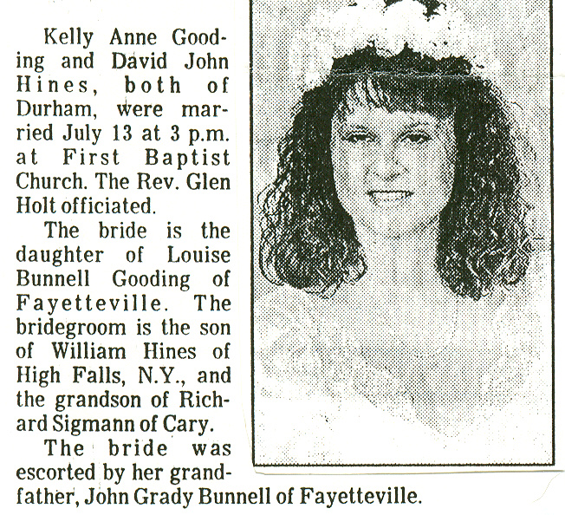

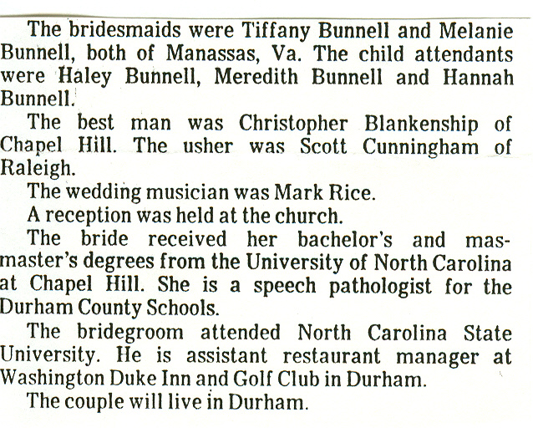

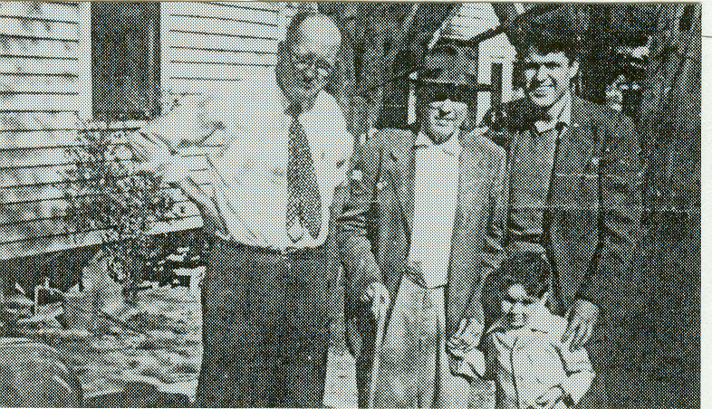

Along with the wedding notice,
Dot sent in a picture of four
generations of Bunnells taken
about 1950

Left to Right:

Thomas Jefferson Bunnell, 1892-1965; Daniel Milton Bunnell CB331143, 1859-1951; John Grady Bunnell, Sr., b. 1917, grandfather of the bride; and, in front, John Grady Bunnell, Jr., b. 1947, father of the bridesmaids. Dot Ray herself is a granddaughter of Daniel Milton Bunnell.

Daniel Milton Bunnell was the son of George Washington Bunnell, CB320747, and grandson of Asa Bunnell CB310131. Asa was born in Farmington, CT, son of Tutus and Sybil (Yale) Bunnell. Asa and his brother Titus Jefferson Bunnell moved to North Carolina about 185 or 1820 and founded a large branch of the family in that state.
* * * * * * *
Page 53

INTERNATIONAL GENEALOGICAL INDEX
Ohio – 1988 Update (Concl'd)

[Van Wert county – formed in 1820 from Indian Territory]
- Van Wert county – Births:

Bonnell | John Bonnell/Elisa Roberts | F | 18 Oct 1870
Bonnell, Dora B. | John Bonnel/Eliza Roberts | F | 04 Jul 1872
Bonnell, Maggie | John Bonnell/Eliza Roberts | F | 17 Apr 1874

[Warren county – formed in 1803 from Hamilton]
- Warren county – Marriages:

Bunnel, Abigail | George Kever | 24 Mar 1808
Bunnel, Alfred | Jane Probasco | 15 Jan 1829
Bunnell, America | George W. Hormel | 10 Apr 1856
Bunnell, Archibald S. | Hanna Maria Schnorf | 13 Sep 1851
Bunnell, Barzilla | Nancy S. Williams | 01 Nov 1821
Bunnel, Benjamin | Mariah Allen | 05 Mar1820
Bunnell, Caroline E. | Israel H. Harris | 12 Nov 1852
Bunnel, Catherine | John Bunnel | 10 Nov 1818
Bunnell, Christena | Henry Weeker | 08 Feb 1850
Bunnel, Cytha Ann | Henry Earnheart | 20 Nov 1846
Bunnell, Daniel David | Mary Coulson | 12 Apr 1845
Bunel, David | Mary Coulson | 02 Mar 1845
Bunnel, Elijah | Rachel Ford | 31 Jul 1823
Bunnell, Eliza Ann | Eber Pugh | 22 Sep 1836
Bunnel, Elizabeth | Nathaniel Bunnel | 06 Nov 1821
Bunnell, Elizabeth | Edmund Geoghegan | 02 Dec 1821
Bunnell, Elizabeth Ann | Thompson Lamb | 13 Feb 1848
Bunnel, Ephraim | Patsey Price | 15 Mar 1827
Bunnell, Harriet | J. H. Evans | 29 Sep 1853
Bunnell, Henry | Christian Fox | 05 Apr 1814
Bunnell, Isaac | Hester lamb | 13 Sep 1845
Bunnell, Isaac | M. Ballard | 13 Jan 1853
Bunnel, James | Charlott Gustin | 30 Nov 1844
Bunnel, Jane | Lowry Snook | 29 Jan 1828
Bunnel, John | Catherine Bunnel | 19 Nov 1818
Bunnel, John | Ivia Clymer | 11 Sep 1831
Bunnel, John | Nancy J. Crossley | 22 Dec 1861
Bunnell, John | Maggie A. Beedle | 02 Feb 1865
Bunnell, John D. | Mary Emma Miltenberger | 25 Aug 1864
Bunnel, Jonas | Nancy Willis | 08 Sep 1816
Bunnel, Julia Ann | Nicholas Pence | 06 Sep 1829
Bunnell, Lucinda | Michael M. Boyer | 09 Dec 1856
Bunnel, Margaret | James Holden | 07 Nov 1847
Bunnell, Margaret Ann | William Probasco | 10 Sep 1847
Bonnell, Margaret C. | Hird Phipps | 19 Nov 1843
Bunnel, Maria | Jeffrey Brown | 02 Feb 1832
Bunnel, Martha | John Hagerman | 18 Oct 1848
Bunnell, Mary | Saml. Wood | 01 Jun 1820
Bunnell, Mary | John Harkraider | 27 Apr 1852
Bunnel, Mary Ann | Abraham Allen | 22 Feb 1832
Bunnell, Mary Caroline | Thomas Scott | 31 Dec 1854
Bunnell, Mary Jane | Rufus Swain | 07 Oct 1858

Page 54

- Warren county – Marriages (Cont'd)

Bunnel, Merit | Harietta King | 08 Jan 1828
Bunnel, Nancy | Curtis Reed | 18 Dec 1817
Bunnel, Nancy | Adam Fuge | 11 Sep 1818
Bunnel, Nathaniel | Elizabeth Bunnel | 06 Nov 1821
Bunnel, Noah | Catherine Conley | 28 Dec 1821
Bunnel, Oliver | Maggie Coulson | 14 Sep 1859
Bunnel, Polly | John Gillis | 05 Mar 1816
Bonnell Rhoda | George Bowers | 23 Sep 1813
Bunnell, Rhoda | James M. Keever | 02 Sep 1857
Bunnell, Ruth Jane | Francis H. McClung | 05 Sep 1850
Bunnel, Sally | Ezekiel Loud | 12 Nov 1820
Bunnell, Sarah Ann | Aaron Padget | 21 Oct 1845
Bunnell, Sarah M. | James Bercaw | 30 Feb 1860
Bunnel, Sytha | Samuel Hays | 18 Dec 1818
Bunnell, William | Linda Ball | 20 Aug 1822
Bunnel, William | Mary Cassaday | 17 Aug 1826
Bunnel, William | Ivy Fox | 12 Feb 1845
- Warren county – Births:

Bunnell, Abram | David Bunnell/Elizabeth Price | M | 14 Feb 1816
Bunnell, Alfred | David Bunnell/Elizabeth Price | M | 1812
Bunnell, Barzilla | David Bunnell/Elizabeth Price | M | 1800
Bunnell, James D. | George Bunnell/Sarah | M | 16 Nov 1822
Bunnell, John | David Bunnell/Elizabeth Price | M | 1814
Bunnell, John | David Bunnell/Elizabeth Price | M | 14 Feb 1816
Bunnell, Nancy | David Bunnell/Elizabeth Price | F | Jan 1810
Bunnell, Rhoda |  | F | 29 Aug 1838
Bunnell, Sarah | David Bunnell/Elizabeth Price | F | Oct 1801
Bunnell, Susan |  | F | 27 Dec 1855
Bunnell, Veasey Price | David Bunnell/Elizabeth | M | 06 May 1809

- Lebanon, Warren county –Marriages:

Bunnell, Newton Loomer | Lelie Maria Stokes | 12 Mar 1901

- Redlion, Warren county – Births:

Bunnell, George E. | James Bunnell/Charlotte | M | 12 Dec 1849
[Wayne county – formed in 1808 from Columbiana]
- Wayne county – Marriages:

Bunnell, Ann | Silvester Parmeter | 15 Mar 1840
Bonnell, Christian | Margaret E. Goruch | 30 Sep 1849
Bonnell, Elizabeth | Joel Overholtzer | 14 Apr 1844

[Williams county – formed in 1820 from Henry]
- Williams county – Marriages:

Bunnell, James R. | Margaret Boyers | 23 Feb 1859

Page 55

[Wood county – formed in 1820 from Indian Lands]

- Wood county – Marriages

Bonnel, Aaron | Sarah J. Wisner | 09 Dec 1847
Bonnell, Aaron | Aseneth Snyder | 02 Jun 1850
Bonnell, Harriet | Thomas Wisner | 30 Jun 1850
Bonnel, Henry | Mary Hiles | 27 Apr 1845
Bonnel, Joanna N. | John Hatfield | 27 Feb 1848
Bonnell, John A. | Charlotte or Lottie Frances Bronson | 1849
Bonnell, John A. | Charlotte Beanson | 27 Feb 1853
Bonnel, Moses | Susan J. Pearkey | 30 Nov 1851

[Wyandot county – formed in 1845 from Marion, Crawford, Hardin and Hancock]

- Wyandot county – Marriages:

Bunnell, Charles E. | Sarah Gelbaugh | 10 Jan 1878
Bunnel, J. N. (h) | K. D. Worley | 02 Feb 1864
Bunnell, Noah | Mary H. Carens | 24 Mar 1858
Bunnel, Noah | Mary H. Covens | 25 Mar 1858
Bunnell, Noah | Margaret Shaffer | 31 Dec 1865

* * * * * * *

QUERIES

The name and address of the inquirer are included with each query. However, if you are able to provide the inquirer with the information requested, I would appreciate your sending me a copy of your reply.

1. REBECCA BONNELL, b. 1805 in GA (probably Burke co) m. about 1824 GREEN BELL b. 1794 in GA (probably Burke co.) They lived in Burke co, GA until he died in 1866. REBECCA BONNELL BELL then disappears from Burke co., An obituary of one of her sons relates that she lived until the middle 1870's. I have never found the parents or siblings of Rebecca, or where she went after the death of her husband. any information regarding either REBECCA BONNELL, or GREEN BELL, would be helpful.
Arnold Davis, P. O. Box 1527, Ocala, FL 32678-1527.

2. I would like to correspond with anyone researching PRICE, BARTON, BUCKLES, DICE, MORRISONS AND COON/KUHN. Linda L. Doty, 1643 Foxgrove Court, Upland, CA 91786.

3. Seeking the ancestry of my father FREDERICK HARTSOK BUNNELL. He was born 8 Dec. 1897 in Washington, DC, son of FRANKLIN and ELIZABETH (CARR or CORR) BUNNELL. The parents died when he was an infant, and he was raised by two cousins, FRANCES and JOANNE E. CORR, in Richmond, VA. In his Database, Claude A. Bunnell has a FRANKLIN BONNELL, CB006412, b. 1864 in VA, living in 1880 with his parents SAMUEL and PERMILIA BONNELL, in Center twp. Chautauqua co, KS. Could this be the same FRANKLIN? Louise B. Nemecek, 4640 Leonard Pkwy, Richmond , VA 23226.

Page 56 (The End)

