BUNNELL BONNELL BUNNELL BONNELL BUNNELL BONNELL BUNNELL BONNELL BUNNELL B
UNNELL | THE BUNNELL/BONNELL NEWSLETTER |  |  |  | ONNE  L  L
B |  |  |  |  | B
O | Volume No. VI, No. 4 |  |  | 1 October 1992 | U
N  N  E  L  L |  | Published by  William R. Austin  P. O. Box 62  Laceyville, PA 18623  (717) 869-2325 |  |  | N  NE  L  L
BUNNELL BONNELL BUNNELL BONNELL BUNNELL BONNELL BUNNELL BONNELL BUNNELL B

In Volume II, No. 1, I printed a suggestion by Judith Osborn, St. Petersburg, FL, for the establishment of a family association for the descendants of William Bunnell. At the time, I received little or no response from my subscribers. I still think it would be a great idea. I belong to both the Bisbee and Haskell Family Associations, and they both have annual national reunions. It seems to me that the Bunnells and Bonnells ought to follow suit. What do you think? I would appreciate a response from each of you.

Along this line, I might mention a reunion we held this summer of my Bisbee cousins, my mother's family. We hadn't met each other for many years, except occasionally at funerals, etc. Pat and I decided to break the ice by inviting all my first cousins here to Camelot on 25 July. The response amazed me. Of 17 cousins, 16 were here. One cousin had a prior engagement that prevented his coming. With the families they brought, there were 62 of us all together. We had a great time. Now I think it would be fun to organize a Bunnell reunion.

A Bunnell family association was formed some years ago under the leadership of David Bunnell of Portland, OR. I would think this would be a good base to build on, but I have been unable to get in touch with Dave since I started the Newsletter. Perhaps one or more of you might be in a position to bring us together.
*******

THE FIRST CENSUS OF THE UNITED STATES – 1790

One of the most valuable genealogical tools we have is the United States census. Listed below are all the Bunnell, Bonnell and Burnell entries, with their various spellings, which I have found in the surviving records of the 1790 census. Most of these I copied directly from the printed volumes of the census. Others come from Claude Bunnell's Database, particularly the various Burnell spellings. Please let me know if you discover any that I have missed.

Unfortunately, not all the 1790 census still exists. The surviving returns for 1790 are published in HEADS OF FAMILIES AT THE FIRST CENSUS OF THE UNITED STATES TAKEN IN THE YEAR 1790. They cover Connecticut, Maine, Maryland, Massachusetts, New Hampshire, New York, North
The 1790 Census (Cont'd)

Carolina, Pennsylvania, Rhode Island, South Carolina and Vermont. Missing are Delaware, Georgia, Kentucky, New Jersey, Tennessee and Virginia. Of greatest concern to us is the loss of the 1790 New Jersey census. (The New Jersey census returns for 1800, 1810 and 1820 are also lost.) The list below would be considerably longer if we could add the New Jersey Bonnells.

The first column gives the state, followed by the county and the town. Next is the six-digit CB# from Claude's Database, then the name of the Head of Family as it appears in the return. The last column shows the enumeration of the family in five categories, as follows:
Free White Males of 16 years & upwards including Heads of Families
Free White Males under 16 years
Free White Females, including Heads of Families
All other Free Persons
Slaves

NH CHESHIRE CLAIRMONT 310111 ABEL BUNNELL 11-2-2-0-0
CT N EW HAVEN CHESHIRE 290021 ABNER BUNNELL 1-0-1-00
CT NEW HAVEN CHESHIRE 300041 ABNER, 2ND BUNNEL 2-2-4-00
NY ALBANY FREEHOLD 300076 ABRAHAM BUNNEL 1-1-3-0-0
CT HARTFORD SOUTHINGTON 300098 AMOS BUNNELL 1-1-3-0-0
CT HARTFORD BRISTOL 310114 BELA BUNNELL 2-0-2-0-0
CT NEW HAVEN DERBY 310100 BENJAMIN BUNNELL 1-2-1-0-0
PA NORTHAMPTON LOW SMITHFIELD 300045 BENJAMIN BUNNEL 2-1-7-0-0
MD WASHINGTON 292 BENJAMIN BUNNEL 2-1-1-0-0
CT NEW HAVEN DERBY 310099 CHARLES BUNNEL 1-2-1-0-0
PA PHILADELPHIA PHILADELPHIA 2435 CHARLES BUNNELL 1-2-1-0-0
NY WASHINGTON WESTFIELD 4693 COLBURN BANEL 1-1-1-0-0
CT HARTFORD BRISTOL 300049 DANIEL BUNNEL 2-1-4-0-0
CT HARTFORD BRISTOL 310107 DANIEL, JR BUNEL 1-1-2-0-0
CT NEW HAVEN CHESHIRE 300081 DAVID BUNNEL 2-9-6-0-0
MA SUFFOLK CHELSEA 750 EBEN’R BUNELL 1-2-2-0-0
CT NEW HAVEN CHESHIRE 310165 EBENEZER BUNNIL 1-1-2-0-0
NC CURRITUCK EDENTON 4100 EDWARD BUNNELL 1-1-6-0-0
NC CURRITUCK EDENTON 10499 EMELY BURNAL 2-0-1-0-0
CT NEW HAVEN CHESHIRE 300083 ENEAS BUNNEL 1-2-4-0-0
CT LITCHFIELD LITCHFIELD 300118 FRADRICK BUNNEL 2-1-2-0-0
CT MIDDLESEX EAST HADDAM 965 FRANK BUNNEL 0-0-0-4-0
CT FAIRFIELD DANBURY 310012 GERSHOM BUNNEL 1-1-1-0-0
CT NEWHAVEN DERBY 310002 HANNAH BUNNET 0-1-2-0-0
CT NEW HAVEN DERBY 1206 HANNAH BUNNELS 0-0-1-0-0
CT FAIRFIELD STAMFORD 3881 HANNAH BUNNEL 0-0-2-0-0
CT LITCHFIELD WATERTOWN 310105 HEZEKIAH BUNNEL 1-0-2-0-0
CT NEW HAVEN DERBY 300006 ISAAC BUNNEL 1-1-2-0-0
PA NORTHAMPTON LOW SMITHFIELD 300044 ISAAC BUNNEL 4-4-3-0-0
CT NEW HAVEN CHESHIRE 300040 ISRAEL BUNNEL 2-5-3-0-0
CT NEW HAVEN BRANFORD 310135 JACOB BUNNEL 1-1-2-0-0
CT NEW HAVEN BRANFORD 300056 JACOB BUNNEL 4-0-2-0-0\
PA BUCKS 1380 JAMES BUNNELL 1-0-0-0-0
PA NORTHAMPTON DELAWARE 3022 JAMES BONNEL 2-3-3-0-0
CT NEW HAVEN BRANFORD 300073 JERUS BUNNEL 3-1-6-0-0
CT FAIRFIELD BROOKFIELD 300022 JOB BUNNELL 1-3-4-0-0
CT MIDDLESEX MIDDLETOWN 300097 JOEL BUNNELL 1-2-4-0-0
The 1790 Census (Cont’d)

CT NEW HAVEN CHESHIRE 1490 JOEL BUNNEL 1-1-2-0-0
CT NEW HAVEN MILFORD 10974 JOHN BUNNEL 1-5-1-0-0
CT NEW HAVEN CHESHIRE 300037 JOHN BUNNEL 1-0-5-0-0
CT NEW HAVEN BRANFORD 300075 JOHN BUNNELLL 1-3-3-0-0
PA LANCASTER LANCASTER 3091 JOHN BONNEL 1-0-5-0-0
ME CUMBERLAND 10846 JONATHAN BURNEL 2-2-4-0-0
NC BURKE MORGAN 20080 JONATHAN BANELL 2-0-2-0-0
MA NANTUCKET SHERBURN 4163 JONATHAN BURNELL
MA HAMPSHIRE BLANDFORD 1604 JONATHAN BUNNELL 1-6-5-0-0
CT NEW HAVEN BRANFORD 300057 JOSEP BUNNEL 2-1-6-0-0
CT HARTFORD FARMINGTON 300116 JOSEPH BUNNEL 1-0-3-0-0
CT HARTFORD SOUTHINGTON 290018 JOSEPH BUNNEL 2-0-1-0-0
MA SUFFOLK CHELSEA 1625 JOSEPH BUNNELL 1-1-2-0-0
MA SUFFOLK HINGHAM 1628 JOSEPH BUNNELL 1-0-2-0-0
MA HAMPSHIRE CHESTERFIELD 4165 JOSEPH BURNELL
MD BALTIMORE 20185 LEWIS BERNAL 3-2-5-0-3
CT NEW HAVEN CHESHIRE 300063 LOUIS BUNNEL 0-0-1-0-0
CT NEW HAVEN DERBY 310001 LUKE BUNNEL 1-0-2-0-0
MA HAMPSHIRE CHESTERFIELD 4168 MANASSEH BURNELL
CT HARTFORD BRISTOL 310121 NATHANIEL BUNNEL 1-1-2-0-0
NY DUCHESS CLINTON 310042 NOAH BUNNEL 3-0-2-0-0
MD WASHINGTON 1881 PETER BUNELL 2-4-2-0-0
CT NEW HAVEN DERBY 3010101 RUBEN BUNNEL 1-0-2-0-0
CT NEW HAVEN CHESHIRE 300085 SAMUEL BUNNIL 101010909
SC CHARLESTON CHARLESTON 3427 SAMUEL BONNELL 2-0-4-0-0
MA ESSEX LYNN 4177 SAMUEL BURNELL
MA SUFFOLK ROXBURY 4102 SILVANUS BUNILL 1-5-4-0-0
VT CHITTENDEN 20645 SOLOMON BURNEL 2-0-4-0-0
CT NEW HAVEN NEW HAVEN 11027 THOMAS BUNEL 4-3-4-0-0
MD ANN ARUNDEL 4076 THOMAS BONELL 1-1-1-0-0
CT HARTFORD BRISTOL 300052 TITUS BUNNEL 2-1-2-0-0
CT NEW HAVEN CHESHIRE 300084 UNICE BUNNEL 0-1-4-0-0
CT FAIRFIELD NORWALK 10112 VALENTINE VONEL 1-0-2-0-0
CT NEW HAVEN DERBY 310003 WILLIAM BUNNEL 1-2-3-0-0

A few of the names on the list call for comment. First, all CB numbers of 290000 or higher represent individuals whose descent from the immigrant William Bunnell has been determined. They fall in the fourth, fifth and sixth generations from William.

Going down the list: Emely Burnal is a male. He is apparently the same person whose name was read as Conbley Bunnell CB004144 in the 1800 census of Currituck co, NC, 21010-10101. The will of Embly Bunnell of Currituck co, NC, was written 12 November 1802 and proved 31 January 1803.

Eneas Bunnel represents Enos Bunnell.

Frank Bunnel of East Haddam was non-white, with four members in his family. He may have been Indian or Black, and may have been a freed slave.
The 1790 Census (Cont'd)

Hannah Bunnet, is a misreading for Hannah Bunnel. She was Hannah Tyler, widow of Isaac Bunnell, CB310002.

I suspect that Hannah Bunnels and Hannah Bunnet are the same person, who somehow got counted twice in the 1790 census, but that is just a guess.

Jerus Bunnel represents Jairus Bunneli.

Joel Bunnel, CB001480, is unidentified as to parentage in the Database. However, after considerable study I am convinced that this is a misreading for Jehiel Bunnell, CB300087. Both the census numbers and the location fit Jehiel’s family perfectly, and there seems to be no other Joel who could fit.

Unice Bunnel represents Eunice Bunnell. She was Eunice Rowe, widow of Reuben Bunnell.

I would be glad to respond to any questions or comments you may have about this data. Any information you can provide about the persons not identified as descendants of William would be particularly appreciated.

* * * * * *

OBITUARY
This obituary was sent to me by Ruth Duncan. It appeared in the New Haven (CT) Register:

ALBERT BUNNELL, 84
Wallingford — A service will be held Wednesday for Albert Bunnell, 84, of 1370 Durham Road, who died Friday, July 10, 1992, at the Coccomo Memorial Health Care Center, Meriden. He was the husband of Elizabeth Gardner Bunnell.

The service will be at 10:30 a.m. in St. Paul's Episcopal Church, Wallingford. Burial will be in the New Northford Cemetery, Northford section of North Branford. The B.C. Bailey Funeral Home, 273 S. Elm St., is in charge of the arrangements.

Mr. Bunnell, son of the late Henry E. and Mary McLean Bunnell, was born in Northford May 31, 1908. Before his retirement in 1973, be was employed by Pratt & Whitney Aircraft.

He was a member of St. Paul's Episcopal Church, the Wallingford Rod and Gun Club and the Wallingford Elks.

Besides his wife, he is survived by two daughters, Jane Smith of Wallingford and Ellen Shea of Mesa, Ariz. He was predeceased by six sisters and a brother.

Memorial contributions may be made to the St. Paul's Episcopal Church Anniversary Campaign, 65 N. Main St., Wallingford 06492.

[Albert Ira Bunnell, CB341614, is number 761 in Ruth's book, WILLIAM BUNNELL AND HIS DESCENDANTS. His descent from William is as follows:
William, Benjamin, Nathaniel, Jairus, John, Augustus Bames, Henry, Henry Ellsworth, Albert Ira.]

* * * * * *
Marjorie and Robert Gibbs, Union Springs, NY, write that they have just returned from three weeks in Iowa, Missouri, Nebraska and Kansas and have a thorough knowledge of the cemeteries, libraries, historical societies and court houses of much of those states where there were Bonnells. Marjorie plans to organize the material as time permits and furnish it to us. Meanwhile, as an hors d'oeuvre, they sent along several brochures for the Herbert Bonnell Museum in Weston, MO., which I share with you below.
Hours
The Herbert Bonnell Museum is open May 1st - October 31st, Saturday and Sunday 1:00 p.m. to 5:00 p.m. Appointments can be made for weekday showings by calling 816-386-5583, 386-5587. Museum is air-conditioned for your comfort.
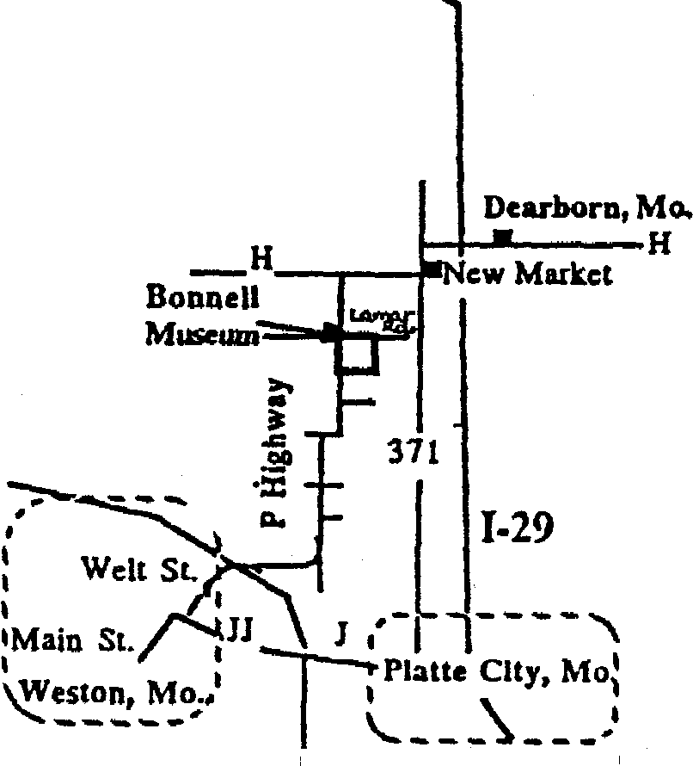

Directions
The Herbert Bonnell Museum can be reached from the Dearborn exit off 1-29, half way between Kansas City and St. Joseph, Missouri. Froa» Dearborn, take H Highway west one mile to Mo. 371, south one mile through New Market, then west again on H two miles to P Highway. Go one mile south to the first crossroads, then east on Lamar Road one-half mile to the farm.
From Downtown Weston, take Welt St north to its junction with Highway 45, where Welt becomes Highway P, Take P 5-1/2 miles north to the fifth crossroads, and east on ^{l} Lamar Road one-half mile to the farm.

Preserved For All...

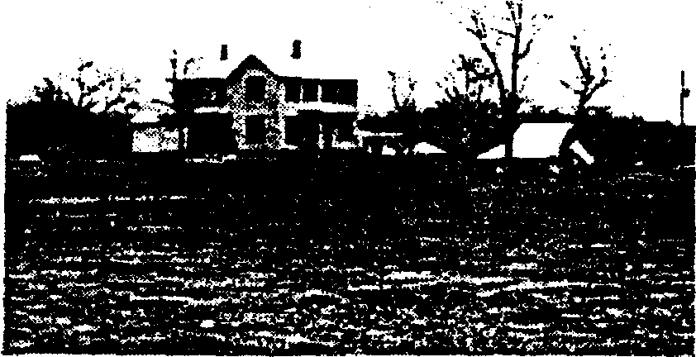
The Herbert Bonnell Museum
Herbert Bonnell cherished the farm his family settled on in 1874, his art, and the arrowheads he collected in the area- A generous man, he shared his pencil drawings and showed his arrowheads to friends all his life.He wanted to continue to share after his death in 1984.

Through the generosity of Mr. Bonnell, the house and farm he loved are now open to the public at no charge.
Displayed inside the house are the many items needed to run a household and farm during the late 1800's. Outbuildings contain many rare objects and tools from a time when the farm was nearly self-supporting.

Bring a picnic lunch and relax in the meadow or under the trees surrounding a natural waterfall. Come visit the working farm Herbert Bonnell loved so much.

Herbert Bonnell Museum (Cont'd

In searching through my notes and through Claude Bunnell's Database, I could not find any reference to Herbert Bonnell. Noting from the brochure that Herbert died in 1984, I checked the listing of Social Security Deaths, and found Herbert Bonnell, born 6 October 1893, died November 1984 in Weston, Platte co, MO. For further information about him and his family, we will wait for Marjorie's report.

Last year Bob and Marjorie visited Indiana and Kentucky and sent in to the Newsletter pages of Bunnell and Bonnell data they obtained there. It has been extremely useful in developing the Kentucky families which were highlighted in the April issue. Vol. VI, No. 2.

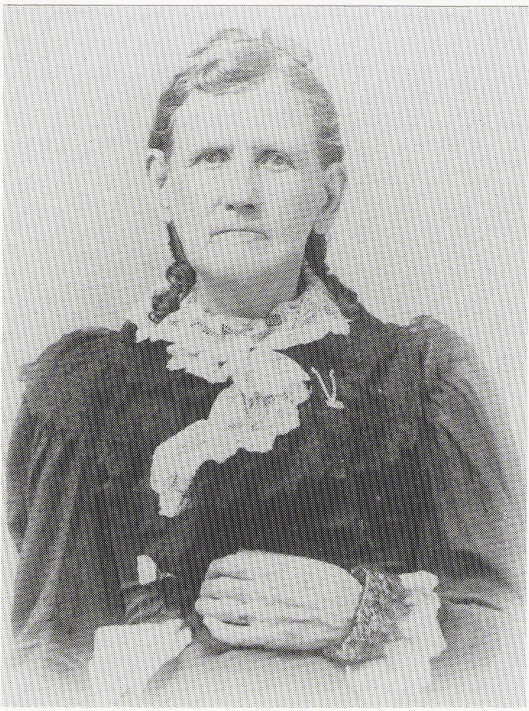
Marjorie is the great-great granddaughter of Louisa J. Bonnell and Lewis J. Cox. Louisa's father, David Bunnell or Bonnell was born in Virginia or Kentucky in 1792. After the birth of a son in 1817, David and his family moved to Warren co, IN, then to Bartholomew co, IN, then to Platte co, MO, then to Leavenworth co, KS, where he appears in the 1860 census living with Lewis and Louisa Cox.

So far, we have not been able to determine who David's parents were. There are several indicators which suggest that he should have been closely related to the Jonathan Bonnell who married Rebecca Dean. However, no actual connection has been found, unless Marjorle has discovered it during her recent trip.

Here is a picture of Louisa J. Bonnell, daughter of David. She was born 6 July 1825 in Indiana, and died 11 October 1907 in Kansas. She married Lewis Cox on 30 September 1841. She and Lewis were the parents of nine children.

* * * * * * *

Can anyone identify THEODORE VINCENT BONNELL, b. 1915, who married Ruby Pauline Pennington on 21 July 1939 in Washington, DC? They had three daughters, Linda Pauline, b. 5 April 1941, Marilyn Ann, b. 25 January 1945, and Barbara Lee, b. 3 May 1946. Ref: THE KEENEY UPDATE, Vol. VII, No. 3, September 1990, page 3.

* * * * * *
Abstracts from the Alumni Directory of the Montrose, PA, High school, as published in the Montrose High School yearbook, ACTA, for 1964.

Key to each entry: name of alumnus; name of husband or wife; children (3-2, for instance, indicating that he is the parent of 3 boys and 2 girls); present address; occupation.

[Note: Montrose High School graduated its first class in 1888.]

1889 - BUNNELL, FANNIE L. (d) - Former librarian

1891 - BUNNELL, WILLARD (d) - Irene Wall - 2-0 - Attorney

1892 - BUNNELL, HELEN M. (d) - J. C. Tourtellot - 0-0

1894 - BUNNELL A. LOUISE (d) – Clayton Washburn - 0-2 - Artist
BUNNELL, CHARLES (d) - 0-1 - Pres. of College in Alaska.
Educator, Founder of College of Alaska, Fairbanks, Alaska

1898 - PERIGO, FLORA M. (d) – Jesse Bunnell - 1-2

1916 - JOHNSON, STEPHEN (d) - Beulah Reed (d); Eva Bunnell - 0-0 –
Aircraft mfg.; auto repairman

1918 - BUNNELL, EVA - Steve Johnson - 0-0 - 309 North Prospect St., Washington, N.J. - Retired school teacher

1922 - BUNNELL, FRANCES - John R. McCormack - 0-0 - 32 Mllford Street, Binghamton, Mew York - Stenographer, May Bros.

1924 – BUNNELL, MILDRED - Dudley Snyder - 0-1 - Valley Stream, Long Island, New York - Teacher, Valley Stream Public Schools

1925 - BUNNELL, FREDERICK - Pauline Corson - 2-2 - Glen Mills, Penna. • Works with juvenile boys overseas

1932 - BUNNELL, RALPH - Mavis Cronk - 1-3 - R.D. #5, Montrose, Pa. -Building Contractor-Plumbing and Heating

1933 - CAMERON, HELENE - Wayne Bunnell - 1-0 - Box 291D, Fort Myers, Florida – secretary

1937 - OLIN, HELEN - Paul Bunnell - 2-2 - R.F.D., Springville, Pa. – Housewife
OVERFIELD, ETHEL - Leonard Bunnell - 0-0 - 39 cherry St., Montrose, Pa. " Clerk, U.S. Dept of Agric.

1938 - BUNNELL, THELMA - Robert Heitsman - 1-1 - Springville, Pena. –Housewife

1950 – GRAHAM, BERNARD - Glendora Bunnell - 1-2 - R.F.D. #5, Montrose, Pa. - Ordained minister; also IBM employee

1955 - BUNNELL, DONNA –R.F.D. #5. Montrose, Pa. - Factory employee, Endicott Johnson
* * * * * * *
MORE ON KENTUCKY BUNNELLS

In the April 1992 issue of the Newsletter I printed references which suggested that the father of many of the Kentucky Bunnells and Bonnells might have been a William who cane from Virginia. Here is another reference to a William in Virginia, sent to me by Christine Kraft of Lawrence, KS. She found it on page 808 of THE 1787 CENSUS OF VIRGINIA, compiled by Netti-Schreiner-Yantis and Florence Speakman Love and published by Genealogical Books in Print, Springfield, VA, 1987.

Rockbridge Co., VA Personal Property Tax, List B, 1787. William BONNELL charged with tax for himself, 1 horse and 1 cattle.

If the Virginia tax lists are similar to those of other states I have seen for this period, the list gives no indication as to whether this William Bonnell was single or was married with a family.

* * *

I just received a letter from Joan Murray of Palatine, IL. She says:

"Yesterday I was at the Milwaukee Public Library doing research, when I came across some Bunnells in a set of four volumes, 'Cemetery Records, Mercer County, Kentucky, Harrodsburg Historical Society, July 1969-70.'
Vol. I, 1969: New Providence Presbyterian Cemetery -Benjamin Bunnel - d. 12 July 1836, age 7 months
Mary Bunnel - (wife of Benjamin) b. 21 May 1808, died 16 Sept 1914
J. A. Bunnel - d. 10 June 1914, age 78 years
William T. Bunnel - April 13, 1847 - 17 Fob 1913
Miriam E. Bunnel - (wife of William) b. 13 Feb 1850 died 5 July 1889
Mattie E. Bunnel - 24 Aug 1869 - 21 Aug 1913

Vol. Ill, 1970 - Springhill Cemetery (Harrodsburg City Cemetery) - B. F. Bunnell, 1851 - 1903

Vol. II, 1969 - Ebenezer church of Christ Cemetery -
David B. Bunnell - 1881 - 1943
Annie Peach Bunnell - 1885 - 19-
L. W. Bunnell - 7 March 1868 - 28 Nov 1952
M. H. Bunnell - (wife of L. W.) 22 June 1863 - 5 Feb 1910
Tennessee Bunnell - 16 Sep 1849 - 22 July 1922
Frederick Bunnell - 18 March 1844 - 25 March 1903

Joan goes on to say:

"As an aside, anyone searching Mercer County, Kentucky, should also check into the Pleasant Hill Shaker records (which are available through the Eastern Kentucky University.) I went through 19 reels of their microfilm about 10-12 years ago as my Bantas lived in the Shaker community. At that time I found Bunnells in the records, but did not copy any of it as I was inundated with copying all the Banta material I found in the records.
Kentucky (Cont'd)

"I don't know who these Bunnells are, but they may have come into that area from either Virginia or Pennsylvania. My Bantas who lived there were born in New Jersey, moved into Pennsylvania and then went to Kentucky in 1780. There was a huge Dutch group in Mercer County, Kentucky with Somerset County, NJ roots. Perhaps this information will be of some use to some Bunnell struggling out there."

In the article in the April Newsletter I mentioned a couple of Bunnells who appeared in the 1850 and 1880 census records in the Pleasant Hill Shaker Community. If anyone has the time and interest to search the Shaker records which Joan mentions, I would be glad to publish the findings.

I was ultimately successful, I think, in identifying each of the burial records listed above. However, there are some significant differences between these records and data I have received from other sources.

The first two records are for BENJAMIN BUNNEL and MARY BUNNEL, wife of Benjamin. I believe that the statement that Benjamin died 12 July 1836, age 7 months, is in error. If I am correct, this is BENJAMIN D. BUNNELL CB011238, son of Samuel and Elizabeth (Sutterfield) Bunnell, who was born 2 September 1799. He married his cousin MARY BUNNELL, daughter of William and Mary (Allen) Bunnell. He died of typhoid on 28 November 1858. Mary, born 21 May 1808, died 16 September 1871, not 1914 when she would have been 106 years old. This information was sent to me by Marjorie Gibbs, who did extensive research in a variety of Mercer co records.

J. A. BUNNEL, the next record, is JAMES A. BUNNELL CB006497, son of Benjamin and Mary.

The record for WILLIAM T. BUNNELL CB006520, son of Samuel and Nancy Ann (Harris) Bunnell, gives me more precise birth and death dates than I had previously. Other sources give his year of birth as 1845, 1846 or 1847. (Samuel and Nancy had 11 children, and the birth dates of nearly all of them are disputed.) This record is probably the most authentic.

MIRIAM E., wife of WILLIAM, died 5 July 1889, or 5 July 1887 according to the information sent by Marjorie Gibbs.

WILLIAM T. married (second) in 1892 in Mercer co MARTHA _____, who survived him. She is probably the MATTIE E. BUNNEL listed in the record above.

B. F. BUNNELL, buried in Springhill Cemetery, is certainly BENJAMIN F. Bunnell CB006454, brother of William T. His gravestone says he was born in 1851. Other sources list his birth as occurring in June 1846, about 1847, or in 1850. Since he appears in the 1850 census in Mercer co living with his parents, I conclude that one of the earlier dates is more likely than 1851.

Turning to the burials in Ebenezer Church of Christ Cemetery, I'll start at the bottom of the list. FREDERICK BUNNELL CB006483, was a brother of William T. and Benjamin F. His record also gives me more precise dates of birth and death. He married TENNESSEE NAVE, whose death record I did not have before.
Kentucky (Cont'd)

L. W. BUNNELL was LYNNWOOD W. BUNNELL CB006484, son of Frederick and Tennessee. He married MALINDA H. BUNTON, the M. H. BUNNELL of this record.

I was unable to identify DAVID B. AND ANNIE PEACH BUNNELL from the records already compiled in my computer. I turned to Claude Bunnell's Database and found DAVID BUNNELL CB007950 who was born in September 1881 in Kentucky. He married in 1904, in Mercer co, KY, ANN PEARL ANDERSON, who was born in 1885 in Kentucky. Claude's reference for the marriage record is page 380, vol. 20 of the vital records of Mercer co. David and Ann had a son Leslie, born in 1905, who appears with them in the 1910 census in South Elkhorn, Fayette co, KY. The person who copied the gravestone apparently misread Pearl as Peach,

The Database lists David's father as FRANK BURMELL CB007949, born in June 1849 in Kentucky, married in 1875 BELLE ____, who was born in June 1856 in Kentucky. Frank's parentage is unknown in the Database. The only reference cited for this couple is the 1900 census for District 1, Point, Henderson co, KY, where Frank was listed as a day laborer. Their two sons were living with them: David, already mentioned, and Benjamin F. CB007951, born in November 1883.

Comparing this data to information already compiled, it seems clear that FRANK BURMELL CB007949 was the same person as BENJAMIN F. BUNNELL CB006454, whose name was almost certainly Benjamin Franklin Bunnell. Benjamin married BELLE FREEMAN in Mercer co, KY. They appear in the 1880 census in McAfee, Mercer co, with their first two children, Edward and Ella Pearl. Belle appears as a widow in the 1910 census, again in McAfee, Mercer co, with the notation that she was the mother of four living children. Who were the other two? I submit that they were David B. and Benjamin F., Jr. Could it have been some kind of construction job that took Benjamin (or B. F., or Frank) to Henderson co where he was working as a day laborer in 1900?

This illustrates the importance of bringing together all the miscellaneous scraps of information whatever the source. Many times I have been able to make connections by comparing fragments that taken by themselves were meaningless. I am grateful to Joan for sending in these records, and encourage all of you to keep on submitting any Bunnell/Bonne 11 items you find, however insignificant they might seem.

INTERNATIONAL GENEALOGICAL INDEX

CONNECTICUT- 1988 Update submitted by Jerry Hatch

[New Haven county - Cont'd]

>Guilford, New Haven county - Marriages:

Bunnell, Jane E. Samuel H. Hale 24 Nov 1850
Bunnell, Sarah Ann George Derrick 06 May 1822

>Hamden, New Haven county–Births:

Bunnell, Elmer M 30 Mar 1887
Sherman Elmer Bunnell/Margaret Jane Maguire
Bunnell, Walter M 19 May 1884
Sherman Elmer Bunnell/Margaret Jane Maguire

>Hamden, New Haven county–Marriages:

Bunnell, Sherman Elmer Margaret Jane Maguire 24 Sep 1883

>Humphreybille, New Haven county–Marriages:

Bunnell, Jane E. Isaac Losee 15 Oct 1848

>Meriden, New Haven county–Births:

Bunnell, William Austin James Bunnell/ M 21 Nov 1882

>Meriden, New Haven county–Marriages:

Bunnell, Jesse H. Ruth Ann Parker 14 Oct 1836

>Millford, New Haven county–Births:

Bunnell, Abigail Benjamin Bunnell/Mehetabeel F 03 Dec 1726
Bunnell, Abigaill Benjamin Bunnell/Mehitabeel F 12 Jun 1734
Bunnell, Benjamin Benjamin Bunnell/ M 07 Mar 1731
Bunnle, Charles Benjamin Bunnle/ M 15 Sep 1738
Bunnell, Hannah Gershom Bunnell/ F 15 Jun 1734
Bunnell, Isaac Benjamin Bunnell/Mehitabeel M 12 Jun 1734
Bunnle, Louis Benjamin Bunnle/ F 18 Sep 1740
Bunnell, Luke Benjamin Bunnell/ M 20 Sep 1736
Bunnell, margat Gershom Bunnell/ F 15 Jun 1729
Bunnell, Mary Samuel Bunnell/ F 06 Apr 1663 *
Bunnell, Mary Samuel Bunnell/ F 20 Oct 1667 *
Bunnell, Mehetabeel Benjamin Bunnell/ F 20 Feb 1727
Bunnell, Mercy Benjamin Bunnell/ F 30 Aug 1729
Bunnell, Rebeckah Gersom Bunnell/ F 28 Dec 1730
Bunnell, Samuel Samuel Bunnell/ M 26 Jun 1665 *

* These were the children of Samuel Burwell, not Bunnell–wra.

>Milford, New Haven county–Marriages:

Bunnell, Benjamin Patience Miles 27 Aug 1717 *
Bunnell, Benjamin Mehitabel Baldwin 13 Apr 1726

* This marriage appears also in New Milford, Litchfield co.

>Naugatuck, New Haven county–Christenings:

Bunnel, Elizabeth Wm. Bunnel/Clarissa F 19 Jul 1829
Bunnel, Frideric William Wm. Bunnel/Clarissa M 19 Jul 1829
Bunnel, Harriot Wm. Bunnel/Clarissa F 19 Jul 1829
Bunnell, Minerva Stevens Wm. Bunnel/ClarissaF 02 May 1833
>New Haven, New Haven county–Births:

Bunnell, Albert Austin M 26 Aug 1915
William Austin Bunnell/Grace Etta Bunnell
Bunnill, Anna Benjamin Bunnill/ F 11 Oct 1695
Bunnell, Annah Beniamin Bunnell/ F 08 Jan 1677
Bunnell, Beniamin Beniamin Bunnell/ M 04 Jan 1675
Bunnell, Benjamin William Bunnell/Ann Wilmot M 1642
Bunnill, Benjamin Benjamin Bunnill/ M 30 Apr 1704
Bunill, Daniel Hezekiah Bunnill/ M 03 Nov 1729
Bunnill, Ebenezer William Bunnill/ M 29 Aug 1653
Bunell, Hannah Benjamin Bunell F 11 Apr 1702
Bunnell, Hezekiah Benjamin Bunnell/ M 23 Mar 1681
Bunnell, Hezekiah Hezekiah Bunnell/ M 11 Mar 1726
Bunnell, Israell Benjamin Bunnell/ M 12 Mar 1689
Bunnell, Israell Israell Bunnell/ M 07 Nov 1715
Bunnell, Jesse Hezekiah Bunnell/ M 26 Jan 1731
Bunwell, Jesse Hezekiah Bunwell/Esther Bristol M 26 jan 1731
Bunel, John Israel Bunel/ M 04 Sep 1717
Bunnill, Judith Benjamin Bunnill/ F 13 Apr 1672
Bunnell, Lucas P. William Bunnell/Pierpont M Aug 1840
Bunill, Mary William Bunnill/ F 04 May 1650
Bunell, Nathaniell Beniamin Bunnell/ M May 1686
Bunnell, Nellie F 15 Jul 1862
Bunnell, Rachell Beniamin Bunnell/ F 16 Dec 1683
Bunnell, Rebecca Benjamin Bunnell/Rebecca Mallory F 19 Feb 1667
Bunnill, Rebeckah Benjamin Bunnill/ F 19 Jan 1667
Bunell, Rebeckah Benjamin Bunnell/ F 11 Feb 1668
Bunnill, Rebeckah Benjamin Bunnill/ F 11 Feb 1668
Bunell, Rebeckah Benjamin Bunell/ F 08 Mar 1701
Bunnell, Solomon Benjamin Bunell/ M 27 Oct 1705
Bunnell, Wesley Coe Wesley Coe Bunnell/Ruth Allinger M 30 Jul 1941

>New Haven, New Haven county–Christenings:

Bunnell, Nathaniel Benjamin Bunnell/Rebecca Mallory M 27 Apr 1690

>New Haven, New Haven county–Marriages:

Bunnel, Anna Nathaniel Mix 02 Jan 1723
Bunnell, Benjamin Rebecca Mallory 1666
Bunnell, Catharine Henry Wilson 01 Jun 1828
Bunnell, Chloe Amherst J. Fitch 13 Apr 1851
Bunnell, Cyrus R. Grace E. Sanger 06 Sep 1846
Bunnell, Deliverance Johanna Barnes 25 Dec 1730
Bunnell, Desire William Sanford 09 May 1733
Bunnell, Elizabeth Edmund Dorman 19 Sep 1700
Bunnell, Esther Miles Tuttle 15 Nov 1825
Bunnell, Geo. H. Harriet E. Fitch 11 Oct 1847
Bunnell, Hannah Elizabeth Samuel Berry Carter 04 Apr 1852
Bunnell, Hezekiah Esther Bristol 06 Jul 1726
Bunnell, Lois Anson Granniss 19 Oct 1821
Bunnill, Mary Eleazer Peck 31 Oct 1671
>New Haven, New Haven county–Marriages (Cont’d):

Bunnell, Mary Ann Alfred Phelps 25 Dec 1843
Bunnill, Nathan Susanna Whitehead 03 Jan 1667
Bunnell, Nathaniel Susanna Whitehead 03 Jan 1665
Bunnill, Nathaniell Susannah Whitehead 03 Jan 1665
Bunnell, Nellie Fred H. Alling 15 oct 1887
Bunnill, Patience Caleb Grannis 27 Nov 1745 *
Bunnell, Rufus Elezabeth Finch 17 Mar 1850
Bunnell, William Ann Wilmot 1640 #

* This marriage appears also in Wallingford, New Haven co.
# This marriage also appears in Wallingford, New Haven co., however both locations are in error. They were married before coming to New Haven colony–wra.

>North Branford, New Haven county–Births:

Bunnell, A. George Bunnell/Fanny M 31 Jan 1830
Bunnell, George W.. George Bunnell/Fanny M 03 Aug 1837
Bunnell, Hannah E.. George Bunnell/Fanny F 03 Jul 1832
Bunnell, Major Major A.. George Bunnell/Fanny M 31 Jan 1830

>North Branford, New Haven county–Marriages:

Bunnell, Abigail Asa Jones 27 Jan 1763
Bunnell, Anna Zina Ball Dec 1839
Bunnel, Jacob Hannah Hotchkiss 28 Mar 1786
Bunnell, Joseph Abigail Hale Aug 1803
Bunnell, Mary M. Seth Bradley 07 Oct 1838
Bunnell, Nancy W. John P. Langdon 06 Jan 1845
Bunnell, Selina Charles Fool or Foot 24 Apr 1843
Bunnell, Wyllys Catharine Palmer 27 may 1853

>Northford, New Haven county–Births:

Bunnel, Oliver B. Henry Bunnel/Abigail Williams Munson M 20 sep 1869

>North Haven, New Haven county–Marriages:

Bunnell, Warham Anna Pierson Stillman 23 Sep 1805 *

* This marriage appears also in Wallingford, New Haven co.

>Oxford, New Haven county–Births:

Bunnell, David Bunnell/Polly M 07 May 1797
Bunnell, Truman Bunnell/Anna F 13 Aug 1800
Bunnell, David Bunnell/Polly M 02 Sep 1800
Bunnell, Alma Luke Bunnell/Sarah F 1795
Bunnell, Catharine Thomas Bunnell/Temperance F 07 Jul 1827
Bunnell, Charles Burr Erastus Bunnell/Charlotte M 08 Nov 1822
Bunnell, Charles Burr Erastus Bunnell/Charolette M 08 Nov 1822
Bunnell, Chester Benjamin Bunnell/Mary M 12 Apr 1788
Bunnell, Harvey Luke Bunnell/Sarah M 06 Jul 1799
Bunnell, Isaac Collins Nathan Bunnell/Currance M Dec 1802
Bunnell, Joel Luke Bunnell/Sarah M 14 Oct 1796
>Oxford, New Haven county–Births: (Cont’d):

Bunnell, Leverett Luke Bunnell/Sarah M 13 May 1792
Bunnell, Lewis Truman Bunnell/Anna M 16 Jun 1798
Bunnell, Lockwood David Bunnell/Polly M 25 Nov 1798
Bunnell, Nathan Isaac Bunnell/Ann Collins M 1782
Bunnell, Polly Truman Bunnell/Anna F 28 Jun 1796
Bunnell, Renas Benjamin Bunnell/Mary M 14 May 1799
Bunnell, Reuben Benjamin Bunnell/Mary M 30 Oct 1795

>Oxford, New Haven county: Marriages:

Bunnell, Isaac Hannah Tyler 22 Oct 1780

* * * * * * *
OBITUARY

Myrtle Hatala, Kansas City, ks, submitted this from The Kansas City Star, Thursday, 23 July 1992:

Winchester — Daisy B. Bonnel, 90, died July 20, 1992, in a nursing home in Winchester, where she lived. Graveside services will be at 11 a.m. Saturday at the Effingham (Kan.) Cemetery. Friends may call from 10 to 11 a.m. Saturday at the O’Trimble chapel, Effingham. Mrs. Bonnel was born in Monrovia, Kan., and lived in Effingham and Glen Haven, Colo., before moving to Winchester 10 years ago. She was postmaster of Glen Haven, retiring in 1972. She was a member of the National Association of Retired Federal Employees and the National Association of Retired Postmasters. She was a member of the Order of the Eastern Star in Loveland, Colo. Her husband, Claude Bonnel, died in 1982. Survivors include two daughters, Mary C. Burnett, Thornton, Colo., and Melinda Lynn Ryder, Colorado, and two grandchildren.

[Can anyone identify this family? It is not familiar to me.]

* * * * * *
More Strays, can anyone identify them?

-PHOEBA BUNNEL CB012225, daughter of JESSE, was born 1 December 1852 in Portage co, OH. On 3 July 1870, in Labette co, KS, she married GEORGE WASHINGTON THARP. PHOEBA died 25 July 1926 in Burden, Cowley co, KS.

* * *

-JOSEPH HARRIS married MERCY BUNNELL, original settlers of Welsh Bush, Utica, NY. Their son WILLIAM HARRIS was born in 1790 at Utica, NY. "It has been assumed, but never proved, that she was of the New Jersey family of Bunnells."
* * * * * * *

That's all for this year. Enjoy your holidays, send in whatever Bunnell and Bonnell information you find, and don't forget to let me know what you think about forming a Bunnell/Bonnel Family Association.

