BUNNELL BONNELL BUNNELL BONNELL BUNNELL BONNELL BUNNELL BONNELL BUNNELL B
UNNELL | THE BUNNELL/BONNELL NEWSLETTER |  |  |  | ONNE  L  L
B |  |  |  |  | B
O | Volume VIII, No. 1. |  |  | 1 January 1994 | U
N  N  E  L  L |  | Published by  William R. Austin  P. O. Box 62  Laceyville, PA 18623  (717) 869-2325 |  |  | N  NE  L  L
BUNNELL BONNELL BUNNELL BONNELL BUNNELL BONNELL BUNNELL BONNELL BUNNELL B

COMMENT

This issue of the Newsletter illustrates to a striking degree the cooperative nature of our research efforts. I sit in the middle trying to weave all the strands into a coherent whole, but my subscribers and other correspondents provide most of the actual research I need to work with. So far I have corresponded with 435 people. Some want only to know what I can tell them about their own ancestry, but many others have shared their years of research with me, and continue to contribute their efforts today. The Newsletter is my attempt to make this available to as many people as possible.

*******
WHO WAS ARCHIBALD BONNELL - PART II
When I started working on this article for the October Newsletter I thought it would be helpful to organize and present the information on hand to stimulate further research on this family. In a way I was right, but the result has not been what I expected. For what follows I am indebted to the extensive research done by Jack P. Dean, of Jackson, MS, one of Archibald's descendants.

Since Part I of this article was published Jack has sent me a lot of important material, including the wills of Anthony Bonnell, Sr. and Jr., as well as much useful data on William Bonnell, son of Anthony, Sr., and on Archibald's family as well. The suggestions I had planned to offer no longer seem probable.

First, it is necessary for me to correct the account of Archibald's life and family which I printed last time:

Y-l. CB005192. ARCHIBALD BONNELL was born in Burke co, GA, on 1 January 1802. He married (first), probably about 1823, JULIA REBECCA ELLISON, daughter of Robert and Sarah (Hargraves) Ellison. She was born about 1804 in Burke co, GA. They appear in the- 1830 census in District 68, Burke co, GA: 200001-01001, with 4 slaves, and in the 1840 census in District 724, Muscogee co, GA: 002001-110101, with 6 slaves. Julia Rebecca died 17 September 1844 in Muscogee co, GA, "in her 40th year," and Archibald married (second) a widow, name unknown, who lived only a few months after their marriage. On 26 July 1846, in
WHO WAS ARCHIBALD BONNELL (Cont'd)

Muscogee co, GA, he married ANN ELIZA SWEET (freeman), who was born 31 December 1812 in Marion co, SC. She was the mother of two children, Sarah E. and Tandy R. Freeman, by her first husband, Tandy R. Freeman, Sr. They appear in the 1850 census in Harris District, Muscogee co, GA, and in 1860 in Eufaula, Barbour co, AL. By January 1868 they were living in Shelby co, TX, although they do not appear in the 1870 census for Shelby co. Ann Eliza died 12 October 1877 and Archibald died 18 June 1879, both in Shelby co, TX, where they were buried.

Children (by first wife):
1. daughter, b. 1824-5. (from 1830 and 1840 census).
2. son, b. 1825-8.
3. John, b. about 1828-9, Burke co, GA; m. Louisa Jackson Austin;
d. 9 July 1864.
4. Sarah, b. 1831; d. 4 Sept. 1846.
5. Narcissa Frances, b. 3 Oct. 1838, Muscogee co, GA;
m. Dr. I. Perry Webb.

Children (by third wife):
6. Laodicea Eudora, b. 12 Apr. 1848; m. (first) Cicero Glenn Stovall; m. (second) Andrew Jackson DeFee; d. 15 Jan. 1920.
7. Orra Tichnor, b. 31 Jan. 1850, Muscogee co, GA; m. William Joseph "Buck" Pearce; d. 2 Oct. 1931 (or 1933).
8. Mary N., b. Sept. 1852, Barbour co, AL; m. William Benjamin Pearce; d. after 1900.
9. Louisa, b. 15 Nov. 1853, Barbour co, AL; m. W. J. Matthews;
d. 20 Sept. 1917.
10. Archibald E., b . 10 Mar. 1857, Barbour co, AL; d. 10 Feb. 1925, unmarried/ in Shelby co, TX.
11. Willie N., b. about 1858, Barbour co, AL; m. Charley Dean.

To resolve some questions about the census records I was quoting, I went to a library in Elmira, NY, which has a complete set of the Federal census on microfilm. I was hoping to find that one of the two Archibald Bonnells in the 1830 census was a misreading in the index, which would eliminate a little of the confusion. That didn't pan out either. The 1830 census for Burke co, GA, shows clearly that there were two Archibalds, one on page 135 and one on page 147.

The Archibald on page 147 matches up with our subject, both when we compare the1830 census with the 1840 census in Muscogee co, and when we compare it to the family as we know it. The only anomaly is the indication that Archibald's age was between 30 and 40, when he was actually 28.

The Archibald on page 135, 01101-31001, does not match our subject and his family, although the parents were of similar age in each case. It is interesting to note, however, that Anthony Mills, Archibald's fellow administrator in the estate of Anthony Bonnell, Sr. is also listed on page 135, as are Elizabeth Mills and Archibald Mills.

The 1820 census of Burke co does not include an Archibald Bonnell, but does show an Anthony Bonnell. His age is given as 26 to 45. He does not appear in the 1830 census, but he can be found in the 1840 census in Burke co, when his age is given as 40 to 50. Together they suggest
WHO WAS ARCHIBALD BONNELL (Cont'd)

a birth year of 1790 to 1794. In 1820 Anthony had in his household a male of 18 to 26 years. This could not have been a son, but might possibly have been a brother. Could it have been this Archibald? The page on which Anthony appeared in 1820 also has the names of at least 7 other persons who appear on page 135 of the 1830 census with Archibald.

Although it is not apparent how this Anthony is related to the family of Anthony, Sr., his descendants can be traced to the present day. Many of them are still living in Burke co. It does seem logical to assume, from the proximity to the Mills family in both 1820 and 1830 that the relationship with the senior Anthony is a close one. My opinion, for now at least, is that the Archibald on page 135 is the administrator of the estate of Anthony, Sr., and that we must look elsewhere for the ancestry of Archibald of page 147, our subject.

I still believe that he must fit into this overall family somehow, but I'm at a loss as to how. The information submitted by Jack Dean adds substantially to our knowledge of the Georgia Bonnell family. Data contributed by Arnold Davis is also helpful. However, further research and additional study are required to find meaningful answers, in a future issue of the Newsletter I will focus on the family of Anthony Bonnell, Sr. For the present, he seems not to be the direct ancestor of Archibald, our subject.

* * * * * *

Although our research has not led us to the parentage of Archibald Bonnell, other efforts have been more successful.

>Becky Rutledge, Waterbury, VT, photographed the gravestone of Seth Bunnell in Derby Center Cemetery, Derby, VT. (See the article in the October 1993 Newsletter.) The stone says, "SETH BUNNEL died March 2, 1841, aged 70 yrs." Since Seth Bunnell CB310116, son of Jesse, was baptized 9 December 1770, I believe the gravestone and the family traditions previously cited together provide sufficient evidence that the two are the same person.

Buried beside Seth in Derby are Harriet E. Spencer and her husband Rev. Jesse W. Spencer. This indicates that she is properly placed as Seth’s daughter. Harriet died 24 October 1842 at 34 years of age – thus she was born about 1808.

* * *

>Bill Bunnell, Concord, NH, through correspondence with United Daughters of the Confederacy in Richmond, VA, has learned that Eli Bunnell CB02578, who was born in Canada or Vermont, and who married in Georgia, served in the armed forces of the confederacy. He was detailed for 30 days by special orders dated 31 August 1864 to report to Capt. F. L. Dancy, Post Quartermaster for Tax in Kind, at Lake city, FL, for duty in the Quartermaster Department. He was about 45 years old at the time.
MORE ANSWERS:

The July '93 Newsletter carried the obituary of Donald W. Bunnell, who died in Oregon, WI, 7 April 1993. Judy Bruce, of Monument, co, put me in touch with Emery Francis Bunnell and his wife Connie, of Colorado Springs, CO. Emery Francis is one of the surviving brothers mentioned in the obituary. Mrs. Bunnell has written a couple of times to provide more data on the family.

In the meantime Clement Bonnell, Milford, NJ, has been in touch with several members of this family. He notified me that Donald W. Bunnell was the son of Emery Clayton Bunnell CB341662. His descent from the immigrant ancestor is therefore as follows: William, Benjamin, Benjamin, Soloman, Isaac, Henry, James, Jacob Walter, Emery Clayton, Donald W.

* * *

Clem has continued his research on the family of Sharon Kay Bunnell of Trenton, NE, whose listing in the 1971 issue of OUTSTANDING AMERICAN HIGH SCHOOL STUDENTS I printed in the April 1993 Newsletter. In July 1993 I reported on Clem's identification of the family. Recently he sent me a package of data which fills in many details on this branch and brings it up to date. Another result of his investigation is to bring me another subscriber, Viola Bunnell Coy, Sharon Kay Bunnell's aunt.

* * *

Clem Bonnell also identified for us the Gus T. Bonnell whose obituary appeared in the October 1993 issue. He was Gustavus Bonnell CB361061 whose descent is as follows: William, Nathaniel, Nathaniel, Nathaniel, John, Jonathan, Alva, Sylvanus Sylvester, Edmund William, William Wallace, Gustavus Bonnell. Clem had previously researched and passed along to me the records of Sylvanus Sylvester Bonnell and his descendants.

* * *

Clem tells me he is pursuing information on several other of the unidentified obituaries published recently, and that we can expect further reports.

* * *

Marjorie Gibbs, Union Springs, NY, informs me that Daisy B. Bonnel, whose obituary appeared in the Newsletter of October 1992, was the widow of Claude E. Bonnell CB001425. Claude was a descendant of Jonathan Bonnell CB001601, one of the early settlers in Mercer co, KY, whose parentage we have been seeking unsuccessfully so far. Claude's descent is: Jonathan, William S., Charles Frederick, Benjamin Edward, Claude E. Bonnell.

* * *
AND YET ANOTHER ANSWER:

Althea Statum, Catoosa, OK, sent in data on the descendants of her great great great grandfather, Theodore M. Bonnell CB012453 of Guernsey co, OH. Among them was an Everett Lee Bonnell CB006077, son of Lowell W., grandson of Benjamin Franklin, great grandson of Theodore M., great great grandson of Jonathan and great great great grandson of Isaac Bonnell CB005633. Althea said that she had been told that Everett Lee Bonnell was the Lee Bonnell who married Gail storm. If so, this would answer the question raised by Gwen Quickel in the January 1993 issue of the Newsletter. Gwen's husband, Edward Charles Quickel, and Everett Lee Bonnell were fourth cousins once removed through their common descent from Isaac Bonnell.

Records in my file indicate that Everett Lee Bonnell was born 24 November 1918 in Indiana and died in May 1986 in California. He is listed as Lee Bonnell in the Social Security death index. He married Josephine Owassa Cottle. Gail Storm may have been a second wife, or, more likely, Gail Storm may be the stage name adopted by Josephine (Cottle) Bonnell.

* * *

My thanks to all of you. Keep up the good work.

* * * * * * *

Guthrie Pratt, Erie, PA, sent in this clipping from AntiqueWeek, of Monday, 13 September 1993. Can anyone identify this Tracy Bunnell of Madison, WI? Note that her parents moved from Northampton, MA, to Madison, WI, and that Tracy studied at the Maryland Institute College of Art.

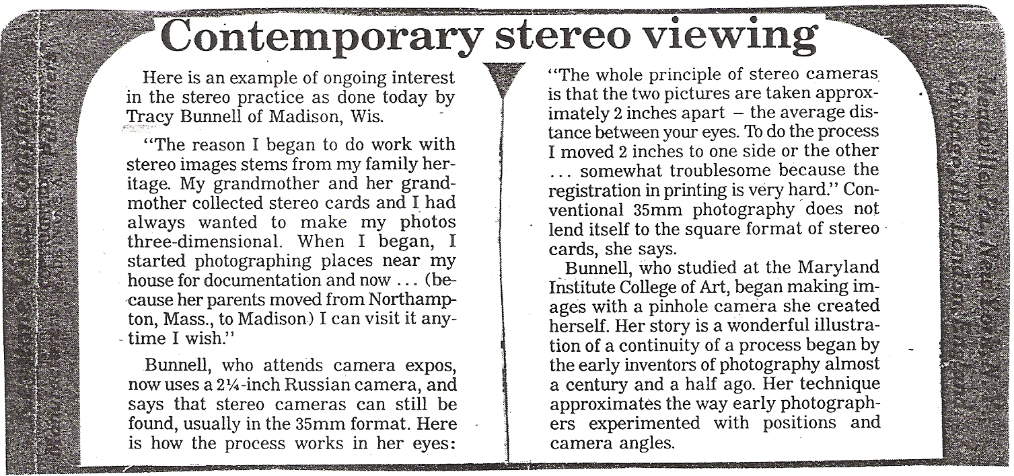
MILESTONES
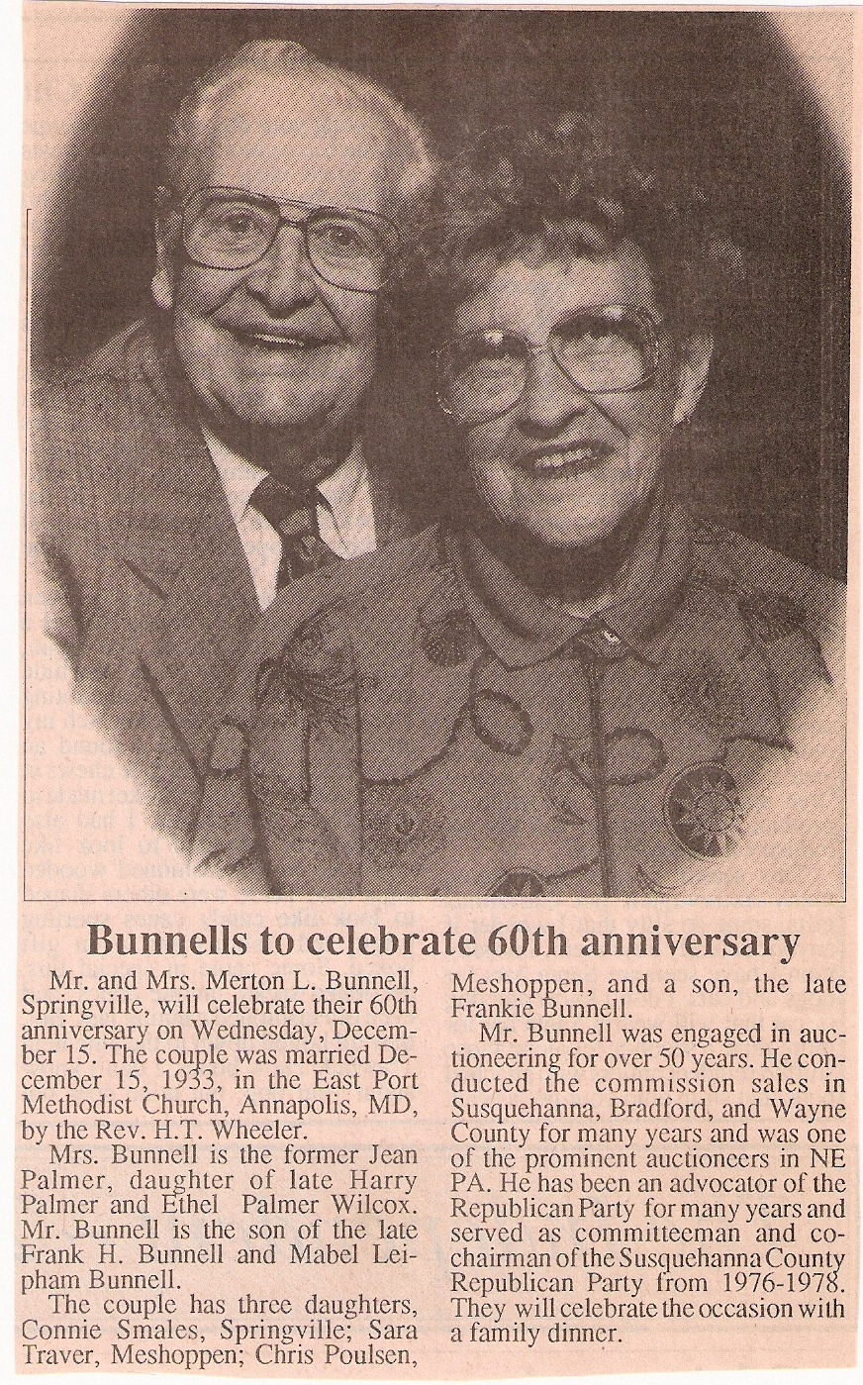
Here is a clipping from the
Susquehanna County, PA, Inde-
pendent, 8 December 1993.

Mr. Bunnell's descent from the
immigrant ancestor is as
follows: William, Benjamin,
Benjamin, Solomon, Benjamin,
John, James, Nelson George,
Frank Howard, and Merton L.
CB350082.
My wife and I are auction
addicts, and we attended
many auctions conducted by
Mert Bunnell. At the last of his
that we attended I bought a
milk bottle from the Home-
stead Dairy, J. H. Bunnell,
Dalton, PA. James Harding
Bunnell, the owner of the
dairy was Mert's uncle.

*******

QUERY

Several subscribers and correspondents are descended from John Bonnell CB004113, who served in the Pennsylvania militia in the Revolution. At that time he lived in what is now Dauphin co. PA, but was then still part of Lancaster co. In 1794 he and his family moved to Jersey Shore, Lycoming co, PA, and in 1800 to Erie co, PA, where he remained until his death in 1845. Loretta Brasche, Galesburg, IL, has been trying to locate his grave. I was able to supply her this quote from english and ALLIED FAMILIES, by Helen H. Russell: "John Bonnell lived to a great age and died at Erie. He was buried at Waterford about fifteen miles from Erie." Loretta has been unable to locate any record of his burial in Waterford or the vicinity. Can anyone help?

*******
OBITUARIES

This was submitted by Esther Simrell, Conklin, NY, from the Susquehanna County (PA) independent, Wednesday, 16 June 1993.

FRANCES MCCORMACK, 90, of Binghamton, N.Y. died Wednesday, June 9, 1993 at Our Lady of Lourdes Hospital, Binghamton, N. Y. She was born in Bridgewater Township, Susquehanna County, Pa. She was the daughter of the late Bruce and Grace (Ely) Bunnell. She was predeceased by her husband John.
Mrs. McCormack was a secretary with the New York state Hospital, Binghamton, for many years. She was a graduate of Montrose High School in 1922, was a member of the Veterans of WWI Auxiliary in Binghamton, the Binghamton Grange and Pomona Grange, the NYS Retirees and a sustaining member of the Republican National Committeemen. She is survived by nieces, nephews and cousins.
Funeral and committal services will be held Saturday at 2 p.m. from the Bartron Funeral Home, Inc., at 74 Church St., Montrose, with the Rev. Richard Jagger of the Hop Bottom United Methodist Church officiating. Interment will be in the Dimock Cemetery, Dimock, Pa.

[Mrs. McCormack's father, Byron Bruce Bunnell CB340126, was descended as follows: William, Benjamin, Benjamin, Gershom, Joseph, James, James Andrew, Frederick Hall, Byron Bruce Bunnell.]

* * *

Clifton Cilley, Colebrook, NH, one of our most active contributors, submitted this obituary:

KATHERINE E. FERGUSON, 70, of Claremont, died Tuesday, September 14, 1993 at the Dartmouth-Hitchcock Medical Center in Lebanon following a brief illness.
Born in Colebrook on March 10, 1923, she was the daughter of Newton and Marion (Murphy) Bunnell.
Mrs. Ferguson was a longtime resident of Claremont and had been employed for many years as a waitress at the Claremont Junction Restaurant.
Family members include her husband, Francis Ferguson of Claremont; two sons, Gary Coolidge of Claremont and Philip Coolidge of Elizabethtown, Kentucky; four daughters, Katherine Maccioli of Bennington, Vermont, Donna Therrien and Jacqueline Ferguson, both of Claremont, Frances Hemingway of Romulus, New York; 11 grandchildren; six great-grandchildren; five brothers, Norman, Herman, George, Donald, and Paul Bunnell, all of Claremont; two sisters, Elsie Bailey of Morgantown, West Virginia and Roseanna Gratacos of Claremont; and several nieces and nephews.
Graveside services were held September 17 in Mountain View Cemetery conducted by the Reverend Kevin Cross, Pastor of the First Baptist Church.
Contributions in memory of Mrs. Ferguson may be made to the American Cancer Society, in care of Jacqueline Whitcomb, 10 East Park Street, Claremont 03743 or the Sullivan county Hospice, p.o. box 1247, Claremont 03743.

[Mrs. Ferguson's father, Newton Burl Bunnell CB008225, was the son or Alva and the grandson of Horatio Nelson Bunnell. Horatio's parentage has not been identified yet, but in the last issue I speculated that he may have been the son of Seth Bunnell CB310116.]
Jack Mowry, North East, PA, sent in this from the Erie (PA) Sun-Times;
[The photocopy I received was made too close to the edge of the paper, and there were a couple of names I could not make out.]

MILDRED A. BONNELL
Former Waterford resident [Waterford, Erie co, PA]

NILES, Ohio—Mildred A. Bonnell, 89, of Shepherd of the Valley Nursing Home in Nlles, Ohio, formerly of Washington, D.C., and Waterford, died Monday, April 5, 1993, at the nursing home.
She was born April 20, 1903, in Kane, Pa., a daughter of Carl P. and ____ Munson Anderson.
She was married to Ward E. Bonnell, who died in 1963.
She had been employed by the U.S. Government as a stenographer, Washington.
Survivors include two sisters, Eldora Beach of Ocala, Fla., and Mad__ Davis of Youngstown, Ohio.
She was preceded in death by two sisters, Geneva Kupp and Lauretta Miller; four brothers, Vernon, Everett, Glen and Boyd Anderson.
Services will be held at 10:30 a.m., Tuesday at the Rupp Funeral Home, Waterford, with the Rev. Philip Anderson officiating.
Burial will be in the Waterford Cemetery.
Memorials may be sent to the Multiple Sclerosis Society, the American Heart Association, or the Shepherd of the Valley Nursing Home, 1500 McKinley Ave., Niles, Ohio 44446.
Arrangements were handled by the Davis Funeral Home, Youngstown, Ohio.

[Mrs. Bonnell was a cousin of Jack Mowry's wife, Virginia. Mrs. Bonnell's husband. Ward Emmett Bonnell CB011959, was a descendant of the John Bonnell CB004113 who served in the Revolution from what is now Harrisburg, PA. He moved to Lycoming co, PA and then to Erie co, PA, where he died as a very old man. In spite of a lot of research to date, John's ancestry has not been determined. The descent is as follows: John, William, George Washington, Jesse Coover, Ward Emmett Bonnell.]

* * *

From The Susquehanna County, PA, Independent, Wednesday, 13 October 1993:

LENA STANG, RR 1, Meshoppen, died Monday, October 4, 1993 at the Carpenter Care Center, Tunkhannock.
Born Dec. 21, 1902, in Auburn Township, Susquehanna Co., she was the daughter of the late Clifford and Annie McGavin Bunnell.
she was preceded in death by her husband, Lester S. Stang, in 1983.
Surviving are sons[sic], Richard Stang and daughter, Lurline Stang, both of Meshoppen; sister, Mildred Shafer, Glen Spey, N.Y.; three grandchildren; four great-grandchildren.
Funeral services were held on Thursday, October 7, 1993 from the Sheldon-Kukuchka Funeral Home, 73 W. Tioga St., Tunkhannock, with Drue G. Corbett, pastor of the Springville Baptist Church, officating.
Interment, Sunnyside Cemetery, Tunkhannock. ,

[Mrs. Stang's father, Clifford A. Bunnell CB330369, was descended as follows: William, Benjamin, Benjamin, Solomon, Benjamin, James, George, Clifford A. Bunnell.]
Ronald J. Meyers, Sr., of Van Wert, OH, shares with us this portrait of his great great grandfather, John Bonnell
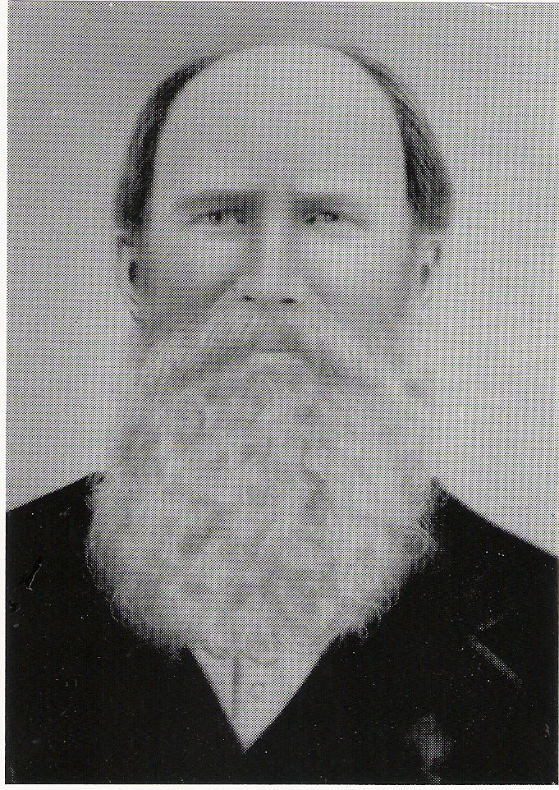
CB331602. John's descent was as follows: William, Nathaniel, Isaac, Abraham, Abraham, John, Charles, and John CB331602. John was born 15 June 1835 at Three Forks Community (now Center Point), Harrison co, VA (now Doddridge co, MV). On 11 September 1856 he married (first) PHILOTHATA DAVIS. They were the parents of three children, but the marriage ended in divorce. As his second wife, John married, before 1865, ELIZA ROBERTS, who had previously married Abraham Ash, from whom she was divorced.

Around the year 1866 John and Eliza moved to Union twp. Van Wert co, OH, where he was a farmer. I have not found the date of John's death, but Eliza died 13 September 1912 in Toledo, Lucas co, OH. Her obituary stated that "she was married to John Bonnel and came to Ohio 46 years ago. They located in Van Wert co, OH, where she resided until she was taken to Toledo 21 years ago, to be treated for her mind. Mrs. Bonnell was the mother of 13 children, 7 of whom survive her. They, with 23 grandchildren and 6 great-grandchildren are left to mourn. She was ever a consistent member of the old Quaker Church." John's first wife, Philothata also remarried, on 16 September 1880 to Richard Weekly. She died 14 February 1913.

*******

Here's another outstanding young Bunnell whose ancestry needs to be traced. Perhaps we will be as successful in this case as we were when Clem Bonnell tracked down the family of Sharon Kay Bunnell in the April Newsletter.

WHO'S WHO AMONG AMERICAN HIGH SCHOOL STUDENTS, 1976-1977, Eleventh Annual Edition, Vol. II, copyright 1977.

Who's Who, inc. students featured in this volume attended school in the following states: Kentucky, Ohio, Pennsylvania, Virginia and West Virginia.

p. 48. [I have expanded the abbreviations to make them clearer-wra]

BUNNELL, Pamela K; Shawnee HS; Louisville, KY; Chorus; Girl scouts; Honor Roll; Junior National Honor Society; Madrigal; School Musical; School Play; Beta Club; German Club; Powder Puff Football; College; professional.
GERSHOM

In the July 1993 issue I began a series of articles to discuss some of the elusive early representatives of common names in the Bunnell/ Bonnell family. This time the subject will be several Gershoms from the late eighteenth century.

The name GERSHOM appears for the first time in the Bunnell/Bonnell family in 1707, when Benjamin and Hannah (Plumb) Bunnell gave that name to their fifth child and third son. I find no indication that the name had ever been used in the families of any of young Gershom's ancestors in either paternal or maternal lines.

Benjamin and Hannah were natives of New Haven, CT, and all of Gershom's siblings were born there. However, the vital records of New Haven clearly state that Gershom was born 1 May 1707 "at Elizabethtown in east Jersey." From some slight evidence in the New Haven real estate records, there is reason to believe that Benjamin and Hannah took their family to Elizabethtown (where Benjamin's uncle Nathaniel settled in 1665) with the intent to establish their home there. They did not do so, however, but their visit lasted long enough for son Gershom to be born there. A deed dated 24 March 1713 shows that they were living back in New Haven, and Hannah's last child, Isaac, was born there in August 1713. In 1714 the family moved from New Haven to New Milford, CT, and their history belongs to New Milford from then on.

[After they were established in New Milford, the birth dates of all the children were entered again into the records there. Casual review makes it appear they were born in New Milford, and the error has been repeated a number of times in print.]

GERSHOM BUNNELL CB290005, the first of the name, was born 1 May 1707 in Elizabethtown, Essex (now Union) co, NJ. He returned to New Haven, CT, with his parents before 1713 and moved with them to New Milford, CT, in 1714. No other record with respect to Gershom has been found until his marriage to margaret johnson, daughter of George and Hannah (Dorman) Johnson on 1 January 1728/9 at Stratford, CT.

During their thirty years of married life Gershom and Margaret moved a number of times. Milford, Redding, Huntingdon, and finally Danbury, CT, were all home to them for varying periods. Gershom died at Danbury 8 July 1758.

Gershorm and Margaret were the parents of 13 children. Their fourth child and first son was another gershom BUNNELL CB300013. He was baptized 30 April 1732 at Milford, New Haven co, CT. There can be little doubt that this is the Gershom Bunhill CB011159 who joined the First Company, Fourth Regiment of Connecticut Troops under Col. David Wooster on 3 April 1758 for service in the French and Indian War. Donald Lines Jacobus states that this is the Gershom Bunnel CB310012 who appeared in the 1790 census in Danbury, Fairfield co, CT, as one male over 16, one under 16 and one female. I see no reason to question his determination in this matter. That is the last contemporary record that has come to my attention regarding this Gershom.
GERSHOM (Cont'd)

However, a number of other references in the genealogical literature need to be considered. Ruth Duncan, in her book william bunnell and his descendants, says that Gershom's wife was MARGARET TOMER. She goes on to say, "No proof has been found to verify that the following were Gershom's children, however, I think that they could have been his." Two children are indicated, i. Joseph, m. Esther Gilbert, and ii. Gershom. Joseph's line is carried down a number of generations in her book., but there is no further mention of his brother Gershom. Ruth lists as references for her material on Gershom CB300013 and his family FAMILIES OF ANCIENT NEW HAVEN, by Jacobus, and Mrs. Harriet Stocker. Jacobus gives only the baptism in 1732 and the census record in 1790, so I assume the rest of the information must have come from Mrs. Stocker, on what authority I haven't discovered.

A note sent to me by Claude Bunnell indicates that Margaret Tomer was of Westfield, Essex (now Union) co, NJ, according to an LDS Archive record. On this basis Claude concludes that this Gershom moved to New Jersey, married Margaret Tomer there and appears in the tax records and probate records of Essex co, NJ, until his death there in 1786. Although I haven't seen the LDS Archive record, if I take it at face value I come to a different conclusion: I believe that Gershom CB300013 remained in Connecticut and had a family there, but that his wife must have been other than Margaret Tomer. Margaret Tomer married a Gershom Bonnell who springs from some so-far-unidentified branch of the Nathaniel Bonnell family in New Jersey. There are several reasonable possibilities.

Back to Gershom CB300013 in Connecticut. Among the file of Biles letters, I find the following in a letter dated 13 July 1907 from Rufus W. Bunnell, CB330153, Stratford, CT, to John A. Biles: "The Gershom who settled in Danbury, Conn. is not No. 22 [CB290005], but his son No. 163 [CB300013], and either No. 163 'or a son of his' was the refugee." There is no indication where the quotation 'or a son of his' was taken from.

John A. Biles's manuscript, on page 192, has the following:

"Gershom (Benjamin Benjamin William)

Where Gershom resided after leaving Redding I have not learned, but I find repeated reference and mention of several sons' names in or about Danbury, Conn. during the Revolutionary War period. Gershom Jr. his eldest son was a loyalist in Danbury and, removed to Nova Scotia. His brother Isaac also belonged to the loyalist faction and removed to Digby, N.S. about 1784. I still find some trace of their descendants."

The GENEALOGICAL AND FAMILY HISTORY OF THE STATE OF CONNECTICUT, published by Lewis Historical Publishing Company, 1911, in Vol. II, page 783, includes the following in the article on the Bunnell family:

"(IV) Gershom, son of Sergeant Benjamin (2) Bunnell, was born at New Milford [sic]. May 1, 1708 [sic]. He married, at Stratford, Fairfield county, January 17, 1728-29, Margaret Johnson. Their descendants lived in Danbury and other towns in Fairfield county.
GERSHOM (Cont'd)

(VI) Joseph, grandson of Gershom Bunnell, lived in Danbury, Fairfield county. He was a soldier in the revolution, . . . Gershom Bunnell, his brother, was in Daribury in 1790, according to the federal census, and had one son under sixteen and one female in his family."
This history is notoriously unreliable in many details. Note the double error regarding place and date of birth of Gershom IV. If we assume, however, that there is some basis of fact here, this paragraph tells us that Joseph and Gershom Bunnell were brothers and that they were the grandsons of the first Gershom Bunnell. Generation V is left out of the account, so we have to guess at who their father was. Grandfather Gershom had eight sons. The families of sons Joseph, Noah, Isaac and Job are well accounted for, leaving sons Gershom, baptized 30 April 1732, Solomon, bapt. 5 August 1739, Nathaniel, baptized 17 October 1743, and John, born 11 November 1746, as potentially the father of VI Joseph and Gershoro.

Gershom, Jr., "or a son of his,” is supposed to have been a Loyalist who removed to Canada at the time of the Revolution. In Claude Bunnell's Database we find Gershom Bonnell CB010506, born 1761 in Connecticut, settled in New Brunswick, m. Lavinia ____, and died in New Brunswick in February 1846. The reference quoted in the Database is The New Royalist Index, by Paul Bunnell. I have not seen this book itself, but Paul's article on Loyalists in the Bunnell/Bonne 11 Newsletter, Vol. II, No. 1, says the following about Gershom Bunnell:

"B. in CT; d. just before 6 Feb. 1846 in New Brunswick. Wife, Lavinia Coy, dau. of Edward and Amy (Titus) of Gageton, NB. She was 85 when Gershom died. He was possibly the son or grandson of Gershom and Margaret (Johnson) Bunnell. If he were their son he would have been 113 years old when he died.

"He received his land grant in Burton, Sunbury co, MB. At age 92 he asked for assistance of £10 because he was in a destitute condition. The New Brunswick House of Assembly granted his request because of his service as a Private under Capt. Elyath Miller in Delancey's Brigade on 24 Dec. 1779."

From this Information we can deduce several points. First, the age tells us that the Loyalist was not Gershom, Jr., CB300013. This is confirmed by this Gershom's residence in Danbury, CT, in 1790.
/
Several sources suggest that the Loyalist Gershom may have been the son of Gershom, Jr. I don't know the source of Claude's birthdate of 1761, but if the Loyalist died in 1846, and he was 92 years old some time before that when he applied for assistance, he could not have been born after 1754. The early 1750's would represent a logical time for Gershom, Jr., to have had a son. I note in the Database another Gershom Bunnell CB300187, born 175x in Milford, CT. No relationship is shown to any other person and there are no Notes in the Database to indicate the source of this information. It could represent the son of Gershom, Jr., who grew up to become the Loyalist.
Ruth Duncan believes that the Joseph Bunnell who married Esther Gilbert had a brother Gershom and that they were both the sons of Gershom, Jr.
GERSHOM (Cont'd)

If this is the Loyalist Gershom, I would have to agree that the only one of Gershom, Sr.'s sons who could have been the father was Gershom, Jr., baptized in 1732. The other three sons whose families are not accounted for would have been too young to have had a son born in the early 1750's.

There is one difficulty in making brothers Joseph and Gershom the sons of Gershom, Jr. Joseph CB013196 served in the army on the Patriot side during the Revolution. He applied for and received a pension in 1818 in Fairfield co, CT, when he said he was 72 years old. His birth would therefore have occurred in 1746, too early to have been the son of Gershom, Jr. There are a lot of loose ends which need to be checked out further before a final determination is made.

We can't be sure that the Patriot Joseph and the Loyalist Gershom were brothers. There may be an error in the age given in the 1818 pension report. We need to know the date when Loyalist Gershom applied for assistance at age 92, and was that age correct? etc. etc. etc. I would love to resolve this point so that the many descendants of Joseph we have in our files could finally be properly placed among the descendants of William Bunnell.

Now for the New Jersey Gershom. This is probably the Gershom Bonnell who married Margaret Tomer of Westfield, NJ. IGI records show that Gershom Bonell had a daughter Hannah baptized on 31 October 1762 and Gershom Bonnel had a daughter Mary baptized on 23 June 1765, both in the Presbyterian Church, Westfield, Union co, NJ. Gershom Bounell appears on the tax records in Westfield, NJ, in March 1779, February 1780, and again in 1781. Claude's Database further reports that Gershom died in March 1786 in Westfield, citing the probate record found in PBN-NJ013-V28-P366. Seven children are listed in the probate documents, Jacob, the only son, Susanna, Abigail, Phebe, Mary, Joanna, and Hannah.

Assuming that this Gershom was born in Essex co, NJ, some time in the 1730's or thereabouts, where could he fit? My best guess, and it is only that, is that he was the son of one of the sons of Isaac Bonnell CB280014. Isaac had five sons. The second son, Abraham moved to Hunterdon co, MJ, and had a large progeny. We don't know whether any or the other four sons, Isaac CB290053, Jacob CB290054, John CB290055, or William CB290056 ever married or had children. However, any of these, born between 1697 and 1706 in Elizabeth, Essex co, NJ, could have been Gershom's father. I don't really see any other likely possibilities. Isaac CB290053 died 14 February 1736 "in ye 38th year of his age." John CB290055 appears in 1731 as a debtor to the estate of Benjamin Spinning. I haven't found any records regarding their brothers Jacob and William except the statement that they were the sons of Isaac. Gersbom named his only son Jacob; did he name his son after his own father? It's pretty thin, but I don't have anything better to offer.

* * * * * * *
INTERNATIONAL GENEALOGICAL INDEX
NEW YORK–1988 Update Submitted by Jerry Hatch

>Syracuse, Onondaga county–Births:
Bunnell, Jabe Collins Isaac Collins Bunnell/Patients Twitchel M 18 Dec 1832

[Ontario county–formed 1789 from Montgomery]

>Canandaigua, Ontario county–Births:

Bunnell, Charles Chester Bunnell/Anne Atwood M 04 Jul 1805
Bunnell, Henry Chester Bunnell/Anne Atwood M 1811

[Orange county–original county]

>Machackemeck, Orange county, Dutch Reformed Church–Christenings:

Bunbel, Jacob James Bunel/Elizabeth Shimer M 24 Aug 1800
Bunnel, Lena James Bunnel/Elizabeth Shimer F 22 Jan 1786
Bunnel, Pheby James Bunnel/Elizabeth Shimar F 13 Jun 1795

[Oswego county–formed 1816 from Oneida and Onondaga]

>Oswego, Oswego county, First Presbyterian Church–Marriages:

Bunnell, Amasa Catharine Gilchrist 10 May 1842

[Otsego county–formed 1791 from Montgomery]

>Otsego county–Births:

Bunnell, Charles Arthur Charles Alonzo Bunnell/Helen Ester Buchanan M 1866
Bunnell, Edgar Charles Alonzo Bunnell/Helen Ester Buchanan M 1862

>Otsego county–Marriages:

Bunnell, Lucius Alonzo Josephine Fling 27 Jul 1901

>Richfield Springs, Otsego county–Births:

Bunnell, George Wellington Charles Alonzo Bunnell/Helen Ester Buchanan M 1862

>Springfield Center, Otsego county, First Baptist Church of Springfield–Christenings:

Bunnel, Joseph M 01 May 1802

[Putnam county–formed 1812 from Dutchess]

>Brewster, Putnam county–Marriages:

Bunnell, Myron Edward Lottie Estelle Lee 27 Nov 1879
The End

