BUNNELL BONNELL BUNNELL BONNELL BUNNELL BONNELL BUNNELL BONNELL BUNNELL B
UNNELL | THE BUNNELL/BONNELL NEWSLETTER |  |  |  | ONNE  L  L
B |  |  |  |  | B
O | Volume IX, No. 1. |  |  | 1 January 1995 | U
N  N  E  L  L |  | Published by  William R. Austin  P. O. Box 62  Laceyville, PA 18623  (717) 869-2325 |  |  | N  NE  L  L
BUNNELL BONNELL BUNNELL BONNELL BUNNELL BONNELL BUNNELL BONNELL BUNNELL B

COMMENT

I don't usually care to begin the Newsletter with obituaries, but it is with deep regret that I must report the death of two of our long-term subscribers. Also, two subscribers report the death of brothers.

In October I received the following note from Kenneth E. Martin of Sacramento, CA:

"I would like to inform you that my mother, Nona Irene Bassett, passed away on August 11, 1994. At this time all of her genealogy is being given to the Mormon Church in Merced. I would like to thank you for all the help you have given her over the years. I believe she saved a lot of people with her hard work and those in Heaven are jumping for joy to see and meet her. We, her family, that greatly loved her, will miss her terribly. Again thank you and may God bless you."

NONA IRENE ZUIDERDUIN was born 20 September 1915 in Independence, Polk co, OR, daughter of Gerrett and Lydia Jane (Bunnell) Zuiderduin. She married (first) on 30 August 1935 Malcolm Palmer Martin, and (second) on 14 May 1944 Ernest Ray Bassett. She was the mother of six children: Malcolm Palmer Martin, stillborn 30 July 1936; Leland Edward Martin, 23 Jan. 1938; Kenneth Elvin Martin, 12 June 1939; Eugene Kay Martin, 3 July 1942; Sherry Elaine Bassett, 27 Aug. 1946; and Deanne Irene Bassett, 13 June 1948.

Nona began her research on the Bunnell family over 30 years ago. I first heard from her in April 1961. Over the years she sent me over 1100 pages of data she had gathered, including many pictures of the family. Her own picture, along with her Bunnell lineage, was printed in Volume IV, No. 3, of the Newsletter. She was descended from William through Benjamin, Nathaniel, Abner, Abner, Chester, Charles, Charles Barlow and Lydia Jane (Bunnell) Zuiderduin. She did great work in compiling all the descendants of Charles Barlow Bunnell CB330494. I shall miss her letters.

* * *
I also received notice of the death of Ival E. Paulsen of Lowell, MI. He died 3 August 1994 and was buried in Lakeside Cemetery. He was born 27 Dec. 1913, son of Emil August and Murll Mae (Bunnell) Paulsen. His wife, the former Euphemia Abbey, survives him. Ival was one of the first subscribers to the Newsletter in 1987. In 1989 he became Treasurer of the Western Michigan Genealogy Society in Grand Rapids, Ml, but the following year he suffered two strokes which left him partially paralyzed. His descent from William the immigrant was through Benjamin, Hezekiah, Hezekiah, Daniel, Miles, David M., George, and Murll Mae (Bunnell) Paulsen.

* * *

While Lyda Graye Cloud, of Locust Grove, OK, was traveling in the East, as I reported in the last Newsletter, her youngest brother Robert Kenaston "Bob" Bunnell CB360055 died in Tulsa, OK. When she returned home Lyda sent me this obituary:

ROBERT KENASTON "BOB" BUNNELL

Graveside services for Bob Bunnell were conducted at 10:00 o'clock September 8, 1994 at Chelsea Cemetery, Chelsea, OK. under the direction of Musgrove-Merriott-snith Funeral Services.

Bunnell, 61, died Tuesday, September 6, 1994 at St. Francis Hospital in Tulsa, OK.

He was born May 7, 1933 in Prior, Mayes co, OK, the son of Frank and Lizzie Robinson Bunnell. He married Cherie Lots Smith on March 24, 1958 in the town of Claremore, Rogers co, OK. They have made their home in Foyil, Rogers co., OK, since 1961.

He was self-employed construction worker and raised horses and cattle. A member of the Washington Baptist Church, he was active in the Gideon Organization, a past president of Chelsea Round Up Club, member of the Chelsea Boosters Club, Chelsea 4-H and FFA Clubs. He and his wife owned and operated Bob's Gibble Gas and the Foyil Grocery Store.

Preceding him in death were his parents, Frank Rhea and Lizzie Mary (Robinson) Bunnell, and five brothers, Ithel Wayne Bunnell, Paul Bunnell, Ray Ferril Bunnell and two who died in infancy.

Survivors are his wife Cherie of the home; sons and daughter-in-law Robert Bunnell, Jr., of Claremore and Jim R. and Jan Bunnell of Chelsea; daughter and son-in-law Lisbeth and Thomas Salmons of Lake Charles, LA; brother Norman Bunnell of Turley, OK; sisters Lucille Purdom and Bernice Tyler of Tulsa, Evelyn Pense of Alhambra, CA, Euletta Foreman and Lyda cloud of Locust Grove, OK, and Mary Freund of DeLand, FL; nine grandchildren and four great-grandchildren.

Memorials may be made to the Foyil Historical Society, c/o Billie Franklin, 6426 N. E. Edgewater Road, Claremore, OK 74017.

* * *
Mable Daniels, Beacon, IA, informed me that her brother Lester j. Bunnell CB007295 died 31 October 1994. His obituary appeared in the Oskaloosa Herald, Oskaloosa, IA:

LESTER J. BUNNELL
OSKALOOSA — Lester J. Bunnell, 73. of 214 North Market Street, Oskaloosa, died on Monday, Oct. 31, 1994 at his home. He was born Oct. 29, 1921 in Washington County to Alfert and Violet Moore Bunnell. He owned and operated Bunnell gas stations until retiring in 1978. He was a former member of the Eagles Lodge.

Survivors include a daughter. Donna Bunnell Smith of New Sharon; three sons and two daughters-in-law, Al and Deb Bunnell of Oskaloosa, Gary and Ellen Bunnell of Centerville and Delbert Bunnell of Oskaloosa; two brothers and a sister-in-law, Donald and Kathy Bunnell of Leland, Ill. and Max Bunnell of Apple River, Ill.; two sisters and brothers-in-law, Dorothy and Jack Lanphier of Oskaloosa, and Mabel and Gene Daniels of Beacon; 14 grandchildren; eight great grandchildren; three step great grandchildren; and a special friend, Lola June Acord. He was preceded in death by his parents; two brothers. Earl and Alvah; and one half sister. Hazel Frisk.
Graveside memorial services will be held Saturday, Nov. 5 at 10:30 a.m. at Garrett cemetery at Delta, with the Rev. Stephen Hess officiating. The Bates Funeral Chapel in Oskaloosa is in charge of arrangements. Memorials may be made to the American Heart Association.

[Lester J. Bunnell was the son of Alfert Lewis, son of John Cyrus, son of Benjamin Franklin, son of Benjamin P. Bunnell CB005872, who may have been the Benjamin Bonnell, son of Thomas, son of John Bonnell CB004113. John, of Dauphin, Lycoming and Erie counties, PA, is the subject of much searching for his antecedents.]
* * * * * * *

DAVID BONNELL of Bedford co, PA

DAVID BONNELL CB004085 was born in the 1760's apparently in New Jersey. He married MARY ANN MASTERS in New Jersey. At the time of the 1800 census they were living in Londonderry twp, Bedford co, PA. He is listed as David Bundle, with 1 male and 2 females under 10, a male and a female from 10 to 16, 1 male from 16 to 26, and 1 male and 1 female from 26 to 45. In 1804 he appears as executor of the will of Henry Amerine, Sr., of Bedford co. On 1 February 1810 he was appointed by Pennsylvania Governor Simon Snyder to the position of Justice of the Peace in the district including Londonderry , twp, Bedford co. David Bonnell appears in the 1810 census in Londonderry twp with 1 male under 10, 1 between 10 to 16, 2 between 16 to 26, and 1 male over 45; also, 2 females under 10, 1 between 10 to 16, 2 between 16 to 26, 1 between 26 to 45, and 1 female over 45. In 1813 he witnessed the will of John Hains in Bedford co. David and Mary Ann appear in the 1820 census of Londonderry twp living alone, both over 45. The 1830 census of Londonderry twp lists them as 1 male and 1 female between 60 and 70. In 1834 he sold land in Bedford co to C. Wolford, and in 1835 he bought land from George Karchner, again in Bedford co. He died before April 1838, when his sons Henry and John, as administrators of his estate, petitioned for the sale of his real estate.
DAVID BONNELL (Cont'd)
Children:
1. John, b. 25 April 1788.
2. Henry, b. 1795 (or about 1800).
others.

In an effort to place this David Bonnell among the New Jersey Bonnells, it is necessary to establish a tentative birth date, with nothing to go on but the census records. These at least are consistent. In 1800 he is said to be between 26 and 45 years of age, thus born between 1755 and 1774. In 1810 he was over 45, or born before 1765. In 1820 he was again over 45, or born before 1775. In 1830 he was listed as between 60 and 70, or born between 1760 and 1770. Putting all these together places his year of birth as between 1760 and 1765.

So far I have found only one David Bonnell in New Jersey who could be a possible match for this David. Information about him is very limited, but here is what I have:

ISAAC BONNELL CB300194 (Isaac, Nathaniel, Nathaniel, William), was born 8 December 1743 at Elizabeth, Essex (now union) co, NJ. He married Puah Abigail Woodruff, daughter of Timothy and Elizabeth (Parsons) Woodruff. She was born about 1745 and died 13 June 1777. They had four children: DAVID CB310341; Noah, b. about 1770, d. 3 April 1856 in the 86th year of his age; Seth, b. about 1775/6, still living in 1850; and Betsy. All four children were mentioned by name in the will of their grandfather Timothy Woodruff. Apparently they were all minors when the will was written on 6 February 1786 since the legacies were all to be given when they became 21 years of age. David was to have 40 shillings when he turned 21. This would mean that he was born after 6 February 1765.

If the census of 1810 can be taken as literally true, this would preclude David, son of Isaac, from being the David of Bedford co, PA, since that census tells us he was born before 1765. Census records in 1800, 1820 and 1830 would all allow a birth date between 1765 and 1770. Age records in the census tend to be very flexible, however, and we can't exclude this possibility.

I have found only one other reference which appears to refer to David, son of Isaac. He is probably the David Bonnell who was listed in the militia census in Essex co, NJ, in 1793.

David Bonnell and Mary Ann Masters are said to have been married in New Jersey before they moved to Bedford co, PA. I have tried to find a Masters family in Elizabeth, but without success. (My resources are rather limited.) There were Masters who lived in Shrewsbury, Monmouth co, NJ, in the early 1700's. Also, the "official Register of the Officer's and Men of New Jersey in the Revolutionary War," by William S. Stryker, lists Benjamin, Jesse and William Masters in the Sussex co militia, and Edward Masters in the Morris co militia. Further investigation of these Masters families might pay dividends.

The descendants of David and Mary Ann (Masters) Bonnell represent the largest unattached branch in my files. I would be delighted if someone could find proof that he is the same person as David, son of Isaac. However, so far we have only the match of name and approximate age, so
it's still nothing but a possibility.

* * * * * * *
One of my subscribers In salem, OR, sent in a clipping from a recent (November 1994) issue of the Portland Oregonian. Following is an extract from the article.
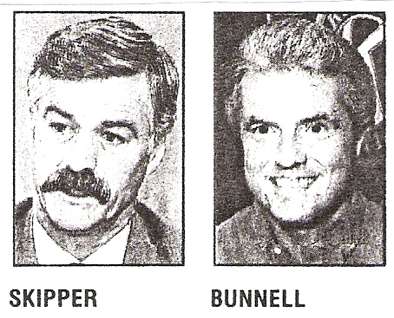
Multnomah County Sheriff Bob Skipper announced Monday he will resign Nov. 30 in order to keep retirement benefits he would lose under newly passed Measure 8.
Using the county's home rule charter, skipper, 55, appointed Chief Deputy John Bunnell, 50, as acting sheriff until county commissioners call a special election.
…
When John Bunnell becomes acting Multnomah County sheriff Dec. 1, it will mark yet another step in his 26-year ascent in the department.
Bunnell, 50; entered the sheriff's department in 1969 and worked his way from recruit to detective to captain. In July, he was appointed chief deputy of corrections.

Bunnell has directed the department's special investigations unit, worked in internal affairs and headed the special services division from January to June of this year. He also has worked in street patrol and narcotics.
…
The sheriff's office has 700 employees and a $53 million budget. Nearly half of the budget is dedicated to corrections.
…
Bunnell received national attention when he hosted the now-defunct ABC television series "American Detective" in 1992-93 and appeared in the Fox network series "COPS." "COPS" is still being aired, but Bunnell, who ended his participation in 1989, is only seen in the episodes currently in syndication.
Bunnell said he would plow ahead into the sheriff's job. "I'm not going to look at myself as an acting or interim sheriff," Bunnell said. "I'm going to view myself as sheriff on Dec. 1."
…
Bunnell said he will concentrate on expanding jail space to house more criminals…
“Some highly important decisions in the field of correction are going to have to be made in the next few years,” Bunnell said.

[I first made reference to John Bunnell in Newsletter Vol. V, Nos. 2 and 3, when several of you commented on his appearance in “American Detective.” However, I still have not learned anything about his ancestry.]

* * * * * * * *
Claude Mitchell, Muskegon, MI, sent me this clipping about Paul and Joyce Bunnell. Paul Robert Bunnell CB370333, son of Carl Ted and Marian Louise (Dillabaugh) Bunnell, was born 28 November 1930 at Muskegon, MI. On 16 April 1949, in Kent co, MI, he married Joyce Adelle Gilbert, daughter of LeRoy and Julia (Dart) Gilbert. She was born 25 July 1932 at Sand Lake, MI. Paul served in the U. S. Army from 1952 to 1954, as a head cook at Fort Sill, OK. For the next seven years he worked for Kroger Foods as a meat manager, in November 1961 Paul and Joyce, in partnership with his brother and sister-in-law, Forrest and Joan Bunnell, bought the Holton Food Market in Holton, MI. As the article sets forth, their lives have centered around the Market for 33 years. The Bunnell/Bonnell Newsletter joins their many friends in wishing them a long and happy retirement.

Paul's descent from the immigrant ancestor is as follows: William Bunnell, Benjamin, Nathaniel, Abner, Abner, Chester, Chester, Ambrose, William Ezra, John Arthur, Carl Ted, Paul Robert Bunnell.
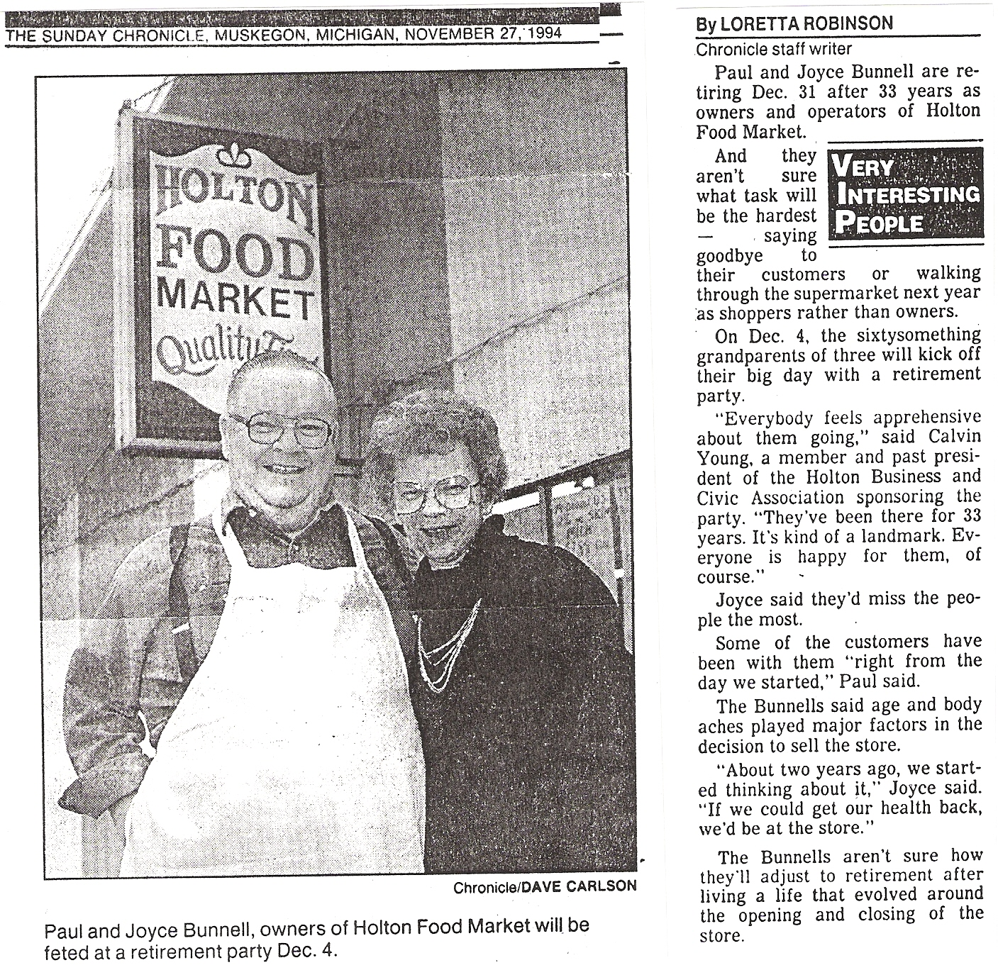

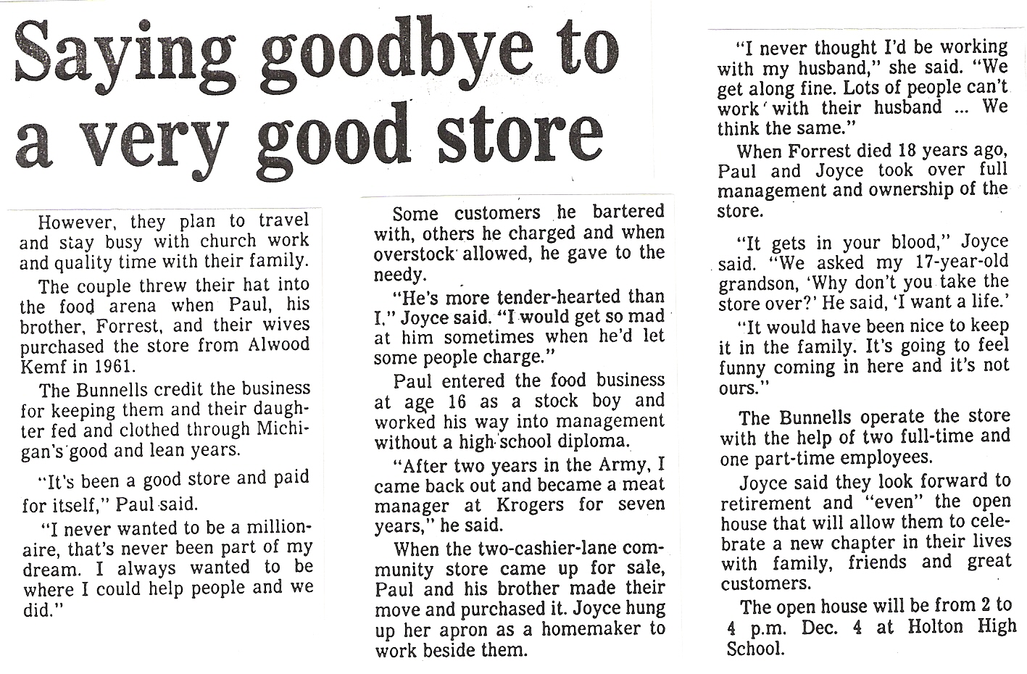
* * * * * * *

James P. Bonnell, Merced, CA, sent in several pages of Bonnell references gathered from "Gleanings From the West Fields," the newsletter of the Genealogical Society of the West Fields, in Westfield, NJ. Some of the names mentioned I could identify for sure, but many of them I could not. Here are the references that need further identification. (Vol., No., and pg references are to •'Gleanings From the West Fields".)

Records of the Springfield Presbyterian Church: 1818 - 1943 Marriages:
Mr. TUBS to Sarah BONNELL, both of Springfield, 3 March 1832.
(Vol. X, No. 1, pg 3)
[CB Database assigns number CB003435 to Sarah, but has no further information.]

Deaths:
Mrs. Abby BONNELL, Consumption, 7 July 1823. (Vol. X, No. 3, pg 26).
[Claude Bunnell suggests that this may be Abigail Woodruff, wife of Charles Bonnel CB320411. They were married in Essex co, NJ, on 8 August 1807. I am inclined to agree, but proof is needed.]

Wid. ——- BONNELL, 83, Old Age, 4 April 1824. (Vol. X, No. 3, pg 26)
[Could this possibly refer to Mary Simpson, second and surviving wife of Nathaniel Bonnell CB300178?]
Records of The Springfield Presbyterian Church: 1818–1943 Deaths (Cont'd):

Ephraim BONNELL, Fever, 3 March 1826. (Vol. X, No. 3, pg 35).
[I would guess that this is the person who appears in Claude's Database as CB000888. He is listed in various tax lists in Essex co between 1811 and 1821. He served in the U.S. Infantry in 1814 and 1815. His widow Sarah and daughter Hannah were counted in the 1850 census. But who are his parents?]
* * *

Manual of The First Presbyterian Church of Elizabeth - 1858:

Charity w. Caleb BONNELL, 22 Jun 1817, she d. 7 Mar 1848. (Vol. XII, No. 1, pg 5).
[Caleb Bonnell CB002398 married Charity Price 26 Sept. 1795 in Lyon's Farms Baptist Church, They were both residents of Elizabethtown. They appear in the 1830 and 1840 census in Union twp, Essex co. Who are his parents?]

Arthur N. BONNELL, 5 June 1836. (Vol. XII, No. 4, pg 27).
[This, I believe, is the same person as Arthur V. Bonnel CB004398 who was born in 1820. 5 June 1836 is apparently the date when he was baptized or joined the church. He married Phebe T. Meeker who was born 17 September 1819 and died 25 April 1893. They appear in the 1850 census in Elizabeth. On 21 August 1858 they transferred to the Presbyterian Church in Madison, Morris co, NJ, and they appear in the 1860 and 1870 census in Chatham, Morris co. He died 26 January, 1890, age 72 years, 6 months. Again, who were his parents?]

Mary C. BONNEL, 5 June 1836, dismissed 4 Nov. 1841. (Vol. XII, No. 4, pg 28). [Miss or Mrs.? I can't identify her at all.]

Phebe T., w. Newell BONNELL, 25 June 1837. (Vol. XII, No. 4, pg 29).
[I have no record of a male Newell Bonnell.]

Elizabeth bonnell, 3 Dec. 1837, dismissed 3 Jan. 1857. (same page).
[I'm unable to identify her.]

Caleb C. BONNEL, 16 June 1842, d. 28 Oct. 1849. (Vol. XII, No. 5, pg 34).
[This may well be CB002398, husband of Charity Price, above.]

Henrietta F. BONNEL, 14 May 1843. (Vol. XII, No. 6, pg 40).
[I can't identify her.]

[Can anyone offer further information about any of these people?]

* * * * *

William B. Bunnell, Concord, NH, rented a video tape, "Where the Rivers Flow North," 1993. THOMAS A. BUNNELL, Location director, was listed in the credits at the end. The tape was filmed in northern Vermont and New Hampshire. Does anyone know this Thomas?

* * * * * * *
An Old Family Bible

In Volume VII, No. 3, I published an article about the 50th Wedding Anniversary of Laurence and Eloise Bunnell, of Rush, PA. Last August my wife and I called on Laurence and Eloise. They filled me in on many details of his branch of the family and showed us pictures and family records. In November they returned the call and came to see us here at Camelot. Laurence CB350160 descends from William Bunnell through Benjamin, Benjamin, Gershom, Joseph, James, Ephraim Kirby, Kirby C., and Jesse Dwight to Laurence Kirby Bunnell.

Among the records made available was the Bible of Laurence's great grandfather Ephraim Kirby Bunnell CB320152. It is the Illustrated Polyglot Family Bible, published by William Flint, 1869. The family record begins on 6 August 1872:

This day Being 74 years old I transfer my Family Record from my Old Bible in to my new Bible. Ephm K. Bunnell.

Marriages
Ephm K. Bunnell Married his first Wife Roene Griswold Dec. 31st 1823.

Ephm K. Bunnell Married his 2nd Wife Cornelia Stone March 6 1828.

Kirby C. Bunnell married Mary Frances Kunkel
Lewis H. Bunnell Married Dora Van Sice
Minnie J. Bunnell married Will Adams, then later O. H. Buck
Jennie Bunnell married Clarence Gary June 15, 1904
Ralph Bunnell married Helen Stark
Jesse Bunnell m. Flora Perigo Apr. 23, 1905

Births
Father Bunnell Born Dec. 21 1768
Azuba his Wife Born April 16
Wm Stone Born April 6 1798
Ephm K. Bunnell Born Aug 6th 1798
Avis Bunnell Born June 1st 1800
Elijah Bunnell Born June 6th 1803
Lucy Bunnell Born Feb 23th 1805
Matilda Bunnell Born July 24th 1807
Dotha Bunnell Born June 19th 1810
James A. Bunnell Born July 13 1813
Samuel Bunnell Born June 16 1816
My Childrens Births and Wifes Births
Cornelia my 2nd Wife May 2nd 1811
Emily Bunnell Born Nov 23 1830
Cornelia J. Bunnell Born Feb 14 1833
Martha Matilda Bunnell Born July 26 1885 Died Jan 24-1906
Wm H. Bunnell Born May 11, 1837
Harry D. Bunnell Born July 15, 1840
Avis A. Bunnell Born Dec 31 1842
Kirby C. Bunnell Born Dec 1st 1849
Edwin Stone Borne Oct 9th 1823
Bible of Ephraim Kirby Bunnell (Cont'd)

Deaths
My mother Azuba Bunnell Died June 16th 1816
My Father James Bunnell Died Aug 5th 1841 Aged 72
Cornelia J. Hosford Died Oct 5th 1858
Matild Way Died Aug 5th 1853 Aged 46
Harry Stone Died July 21st 1848 Aged 33
My wife Cornelia Died Oct l8th 1872
Eunice Stone Died Aug 27th 1869
[Here the handwriting changes-wra]
My Father Eph K. Bunnell Died June 3 1881
Kirby C. Bunnell Died July 29 - 1923
Kirby C. Bunnell's Children births
Minnie J. Bunnell born Mar 9th 1875
Lewis H. Bunnell " Dec 19th 1878 '
Ella Bunnell " Aug 5th 1876
Jesse D. Bunnell & Jennie twins born March 26th 1882
Ralph K. Bunnell Bom Dec. 18 – 1890

Ella Bunnell died Nov 4th 1880
Ralph K. Bunnell Died Fob 12th 1929
Laurence Kirby Bunnell (son of Jesse & Flora Bunnell) Born Feb 5 1909
Kirby Ralph Bunnell (son of Ralph & Helen Bunnell) Born March 5, 1926
Edward Louis " " " " " Born Oct. 23, 1927
Lewis H. Bunnell died Feb 13|, 1948
Dora Van Sice (his wife) | died April 1, 1948

Memorandum
Flora Perigo Bunnell born Jan 7, 1881 Died July 4, 1955
Jesse D. Bunnell born Mar 26], 1882 died Nov 19, 1958

* * * * * *
This obituary was sent in by Marjorie Gibbs, Union Springs, NY. It appeared in the Syracuse Post-Standard on Monday, 19 September 1994.

FULTON -Frederick C. Bonnell, 45, of 102 Leitch St., died Friday at home after a long illness.
He was a Fulton native and served in the U.S. Army.
Surviving are a son, Brian of Fulton; a daughter Laura of Fulton; his mother Beulah of Hannibal; four sisters, Barbara Morisson and Kathleen Haresign, both of Fulton, Nancy Wright of Martville, and Marsha Quigley of Hannibal; two brothers, Kurtis of Fulton, and George of Syracuse; and several aunts, uncles and cousins.
A memorial service will be at the Young & Son Funeral Home, 322 Oneida St., at a time to be announced.
Burial will be in Mount Adnah Cemetery.

[Frederick Charles Bonnell is descended from William Bunnell through Nathaniel Bonnell, Isaac, Abraham, Abraham, John, Charles, Floyd Neely, John W., Jesse Norril, and George Curtis CB360564 to Frederick Charles Bonnell.-wra]
* ******
Lyda Graye Cloud, Locust Grove, OK, sent in these two obituaries, of father and son. The first appeared in the Tulsa, OK, World, Thursday, 29 September 1994:

BONNELL—Robert A. "Bob," Jr., born November 28, 1919 in Tulsa, OK, passed away Tuesday, September 27, 1994. He was a 1937 graduate Tulsa central High School. Entered the Army, April 22, 1943, serving as a Flight Instructor for 53 months instructing in BT-9's, BT-13's and AT-6's. Employed by Sinclair Oil Co., August 7, 1939. Bob retired from Atlantic-Richfield, July 1, 1985. He was a member of Joynor Class of First United Methodist Church, Tulsa Men's Club, Oak's Country Club and the Society of Petroleum Engineers. He is survived by: wife, Gwen of the home; son, R. Dow Bonnell of Virginia; sister, Betty Cherrington of Tulsa; grandson, Robert Bonnell; granddaughter, Elizabeth Bonnell; step-daughter, Judy Popejoy Redford; step-sons. Brad and Doug Popejoy, all of Tulsa; step-grandchildren. Brad Popejoy Jr., U.S. Navy, Brody Taylor of Austin, TX, Sarah Popejoy, Billy Popejoy, Tonia Kallam, Tracy Kallam and Laura Popejoy. Bob will be deeply missed by his family and friends. Service 1 p.m., Friday, First United Methodist Church. Interment Memorial Park Cemetery. Ninde Garden Chapel, 742-5556.

[Bob CB020824 was descended from Isaac Bonnell CB005633, of New Jersey, Virginia, Pennsylvania and Guernsey co, OH, through Jonathan, George W., Vachel, Thomas, Robert A., Sr., to Robert A. Bonnell, Jr.-wra]

* * *

The son's obituary appeared in the Tulsa World on Thursday, 10 November 1994.

BONNELL— Robert Dow, born January 8, 1950 in Midland, TX, died November 7, 1994 in Tulsa. A 1972 graduate of the University of Arkansas with a Bachelor's degree in Political Science, Dow obtained his Juris Doctorate in 1974 from the University of Tulsa. Dow was an Eagle Scout, a member of Sigma Phi Epsilon and the Oklahoma Bar Association. As an Attorney he worked on such cases as IBM vs. Telex, Homestake and Royal Globe Life insurance. dow was a descendent of pioneer Oklahoma families: the Bonnells of Tulsa and the Dows of Yukon. He was preceded in death by his mother, Lois Dow Bonnell and his father, Robert A. Bonnell Jr. He is survived by: his wife. Aline, Gladstone, VA; son, Robert and daughter, Mary Elizabeth, both of Broken Arrow; step-mother, Gwen Bonnell, Tulsa; aunt, Betty Cherrington, Tulsa; step-daughter, Robin Branch, Gladstone, VA; step-sister, Judy Popejoy Redford; step-brothers. Brad and Doug Popejoy, all of Tulsa. Dow will be remembered for his love of fun and his generous nature. He will be missed by his family and many friends. Service 3 p.m., Thursday, Memorial Park Cemetery Chapel. Ninde Garden Chapel, 742-5556.

* * * * * * *

The analysis of Nathaniel Bunnells and Bonnells needs further work. I expect to return to it in future issues. Much of the difficulty seems connected with the early settlement of Mendham and Hanover twps, Morris co, NJ. If that can be unravelled we will probably solve the ancestry of a number of the other unattached Bonnell branches also.

* * * * * * *
INTERNATIONAL GENEALOGICAL INDEX

GEORGIA–1988 Update Submitted by Jerry Hatch

[BULLOCH county–formed 1796 from Franklin]

>Bulloch county–Births:

Bonnell, Anthony Anthony Bonnell/Rebecca Mills M 1809
Bonnell, Mary Anthony Bonnell/Rebecca Mills F 1811

>Bullock county–Marriages:

Bonnell, Anthony Elizabeth 1798
Bonnell, Anthony Rebecca Mills 1808
Bonnell, Jane Benjamin Lane 1824
Bonnell, Mary Bird L. Newton Jan 1827

[Burke county–formed 1777 from St. George Parish]

>Burke county–census:

Bonnell, Anthony William Bonnel/ M 05 Age 1850
Bonnell, George William Bonnell/ M 01 Age 1850
Bonnell, Jane William Bonnell/ F 03 Age 1850
Bonnell, Susan William Bonnell/ F 04 Age 1850

[Emanuel county–Births:

Bonnell, Anna Anthony Bonnell/Rebecca Mills F 1816
Bonnell, Cassandra Anthony Bonnell/Rebecca Mills F 1813
Bonnell, William Anthony Bonnell/Rebecca Mills M 1820

>Emanuel county–Marriages:

Bonnell, Cassandra Jeptha Purvis 1829

[Lowndes county–formed 1825 from Irwin]]

>Lowndes county–Births:

Bonnell, Jane Anthony Bonnell/Elizabeth F 1804

[Screven county–formed 1793 from Burke and Effingham]

>Screven county–Births:

Bonnell, Anthony Anthony Bonnell/Mary Ann M 1770
Bonnell, Daniel Anthony Bonnell/Mary Ann M 1777
Bonnell, Elizabeth Anthony Bonnell/Mary Ann F 1772
Bonnell, Honor Anthony Bonnell/Mary Ann F 1780
Bonnell, Rebecca Anthony Bonnell/Mary Ann F 1775
Bonnell, Sarah Ann Anthony Bonnell/Elizabeth F 1799
Bonnell, William Anthony Bonnell/Mary Ann M 1774
>Screven county–Marriages:

Bonnell, Anthony Mary Ann 1769
Bonnell, Martha Allen Faircloth 15 Apr 1826
Bonnell, Martha Allen Faircloth 15 Apr 1826
Bonnell, Sarah Ann Granville Beville 1818

>Sylvania, Screven county–Marriages:

Bonnell, Loraine B. Marion Harlan Hughes 19 Aug 1916

[Upson County–Formed 1824 from Crawford And Pike]

>Upson county–Marriages:

Bonnel, Abraham Adrai Adaline Freeman 09 Jan 1842
* * * *
IOWA–1988 Update Submitted by Jerry Hatch

[Davis county–formed 1844 from Van Buren]

>Davis county–Births:

Bunnel, Cleo Lily Samuel Bunnel/Eliza Grady 14 Feb 1888

>Bloomfield, Davis county–Marriages:

Bunnell, Dianah Geo. Hedrick 16 Dec 1849

[Harrison county–formed 1851 from Pottawattamie]

>Logan, Harrison county–Marriages:

Binnall, Thomas Rosalie Agnes Boone 24 May 1898

>Woodbine, Harrison county–Births:

Binnall, Charles Samuel Thomas M. Binnall/Rosalie Agnes Boone M 09 Aug 1900
Binnall, Frederick Clifford John Nathaniel Binnall/Margaret Cunnningham M 25 Apr 1892
Binnall, James William John Binnall/Margaret Cunningham M 31 Jan 1882
Binnall, Lee Arden Thomas M. Binnall/Rosalie Agnes Boone M 05 Jul 1902
Binnall, Vern Albert John Binnall/Stella Maude Prater M 17 Jun 1905

[Lee county–formed 1836 from Des Moines]

>Dover, Lee county–Births:

Bonnell, Frank S. James H. Bonnell/Rachel Ann Buffington M 19 Feb 1855
Bonnell, Horace U. Frank Bonnell/Willella Peoples M 27 Feb 1882

IOWA Cont’d

>Fort Madison, Lee county–Marriages:

Bonnell, Frank Willella Peoples 03 Feb 1876

>West Point, Lee county–Births:

Bunnell, Martha Jane David Edwin Bunnell/Sarah Heller Conrad F 22 Sep 1846

[Marion county–formed 1845 from Washington]

>Marion county–Marriages:

Bonnell, John W. Rosella A. Adams 25 Nov 1863

[Polk county–formed 1846 from Indian Lands]

>Des Moines, Polk county–Marriages:

Benell, Catherine Elizabeth J.W. McCray 15 Aug 1871

[Shelby county–formed 1853 from Cass]

>Shelby county–Marriages:

Bunnell, Joseph Almie Sarah Jane Headlee 14 Aug 1856

[Pottawattamie county–formed 1848 from Indian Lands]

>Oakland, Pottawattamie county–Marriages:

Bunnell, Francis Lucretia Rufus Henry Mills 04 Oct 1882

[Wapello county–formed 1843 from Indian Lands]

>Ottumwa, Wapello county–Births:

Benell, Luella May John Benell/Sophia Emeline Martin F 04 Feb 1870

* * *

NEVADA–1988 Update Submitted by Jerry Hatch

[Elko county–formed 1869 from Lander]

>Elko, Elko county–Marriages:

Bunnell, Vinna Frederick Mills Knowles 09 Apr 1940

* * * * * * * *
The End

